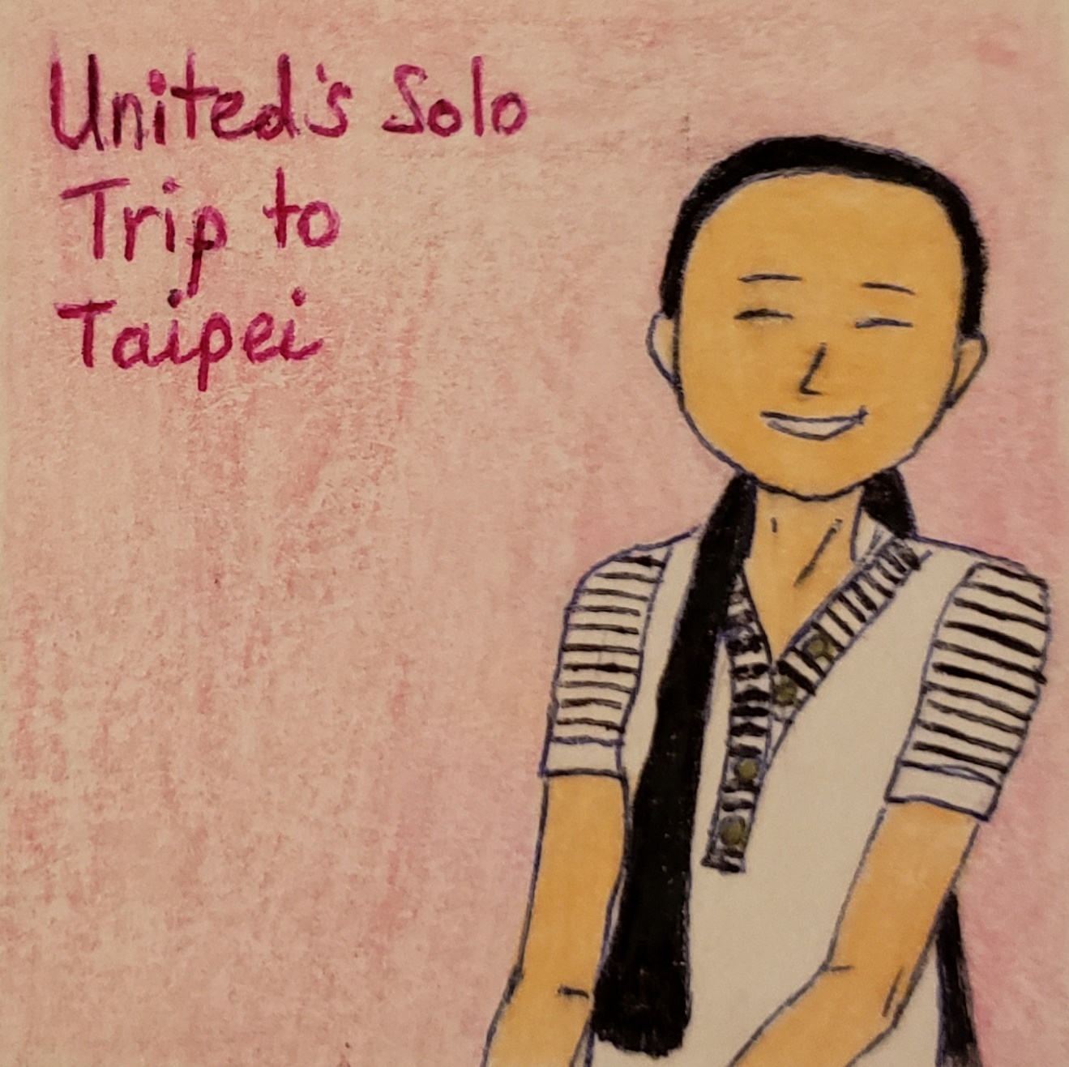

United’s Solo Trip to Taipei (Assume the COVID-19 pandemic did not happen)

United Acela Tse | Solo Travel Story | November 15, 2020

Her LinkedIn Profile

A story of a Temple Travel girl (aka. I-Powers Travel Innovator)
A 29-year old girl named United A. Tse (Real name Steph), who currently lives with her family together. A Temple University graduate is now working hard to get her a permanent job to earn money to live in dreams. She enjoys exploring new places, writing her travel blog, doing crafts, and working on an internship (at Estée Lauder) to move to a permanent job. Owning her personal brand name, “I-Powers Travel,” she has her generic interest in traveling, specializes in solo travel as her guidelines, tips, and stories.
She has her website she created: www.ipowerstravel.wordpress.com to learn more about the travel cycle: I-Powers Travel. She also has her travel blog for general travel, aka. I-Powers Travel – Tips, Tricks, and Stories at: www.ipowerstips.travel.blog/ and Funtastic Philadelphia Travel Guides at: www.funtasticphilly.travel.blog/.
Recently, she went abroad to Hong Kong to immersive her life-changing experience of herself. She has her goal to travel overseas annually and was glad that her ambition to bring her month-long trip to her educational experiences (e.g., traditional Chinese customs) landed her changing perspective. She called her travel “Cultural Tourism.”

Table of Contents
April 2020 3
May 2020 15
June 2020 48
July 2020 67
August 2020 79
Day 1 - Arrival in Taiwan 93
Day 2 - A whole new experience at Taipei 96
Day 3 - 1st day with a group of female solo travelers 100
Day 4 - 2nd day with a group of female solo travelers 109
Day 5 - Chiang Kai-Shek 113
Day 6 - Departure! See ya, Taipei 118
September 2020 and beyond 125
Acknowledgment 142

April 2020
It was time for her job search to earn more money for the living and her dream.
Searching for her jobs in Philadelphia, she founded a job: Estée Lauder – Part-time Intern (Trevose). She went on the website and applied it online.
Filling out the necessary information about her education, her qualifications, and her educational background, she checked everything before she hit submit.

Days later, she checked her email:
- Her job notification
- Her internship acceptance
- Her phone call to schedule an interview
- Finally, her internship interview

She had her job interview at the Estée Lauder – Part-time Intern at Trevose by studying its culture, skills needed, and the overall work environment (daily life). She took SEPTA to the interview with Eileen Meade (Bristol).
Dressed in her business casual, she was nervous but excited to work there.
Once she returned home, she immediately read the entire information about the internship and...
The internship contains comprehensive information, including vacation policies.
- Her orientation about the internship
- Her information about the internship program
- Her internship expectations
- Her probationary period of 4 months
- Her internship goals
- Her start date was in mid-April
She waited a few days to determine if the internship generally fit her internship.

Checking her email, she saw the message about the job offer and read the full information about the job offer.
Making her informed decisions about her prior job experience from the resume's latest work experience, she admiringly accepts the job in writing via email.
Accepting her internship, she happily plans to gain more work experience needed for real-world jobs. The job she applied for was suitable for her desirable career goal.

She sometimes gets a little emotional if her father was angry. Since she was a sensible person, she tried to walk away from the situation, ran to the room, washed her face in cold water, and ran in an outburst.
“My father was angry, but he loves me.” She cried painfully. “I need to calm down emotionally and don’t want my bad days to ruin my workdays. Working under pressure is the norm, but I need to calm myself before the next day. This time I am working under pressure to meet the demands and if I can’t meet that deadline. I will be stressed and will write a journal about why vacations are crucial for life. It gave me a mental/physical/emotional break from work and daily life. Vacation is not a luxury anymore. It is their rights for everyone.”

Once she landed her internship, she was excited but stressed. At the same time, she reviewed her bucket list for the year (2020):
- Climbing up the Taipei 101 to see the 360-degree view
- Try out more street food
- Experience with locals at hostels about Taiwan
- More to come…

Using the pen, she wrote on the bottom and showed her parents about her mental state.
Eating dinner...
“I rather go on vacation without my father or annoying events that cause me stress that impedes my mood and needs to function optimally. I understand the situation.”
“Vacation calming is my norm. I need my mental break, please. Dad, shut up and calm the (expletive) down. You don’t want anyone to look like a fool.”
Her mother can’t read English, so she translated it to Cantonese to explain to her.
She tried to read what she wrote and then said, “you don’t need to curse when writing to the letter. Just use plain language, so I am happy to read this.”
Her mother understands the situations why he overreacts over small problems. She guessed that she doesn’t have to go with him and said, “I bet that going with him sometimes overacts, and people don’t really like him simply because they believe he is immature.”
“United, I understand the situation. He is like that, but he is your daddy. There is only him he grew up with.”
“Mom, I knew that instead of confronting him, I guess that I need to take a break, go upstairs, and into my room. I just prayed.”
“That’s great. If he was angry, don’t say anything. You can step out of the situation, go to a quiet place, pray, and meditate, okay?”
“Okay, mommy. I knew that instead of having a great vacation, he was almost always like overacting impeded the quality of vacation time and going on a solo trip seems ideal for me.”
“United, listen...”
“Mom, I just want to know that going without stress situations helps me to relax. I just want to go on a solo trip.”
“Okay, United. Here is a deal. If you work hard and take responsibility, then we can talk about it. Focus and work hard. Mommy and daddy love you.”
“Love ya too!”
Minutes later, she felt calm and went off to sleep 2 hours later.

On the week of April 20,
Her 5 Factors that influence travelers to visit the place have made her public. Her blog has some crucial factors that travelers have motivated to visit places based on 5 factors or elements from the website: https://ipowerstravel.wordpress.com/2008/06/07/stamp-factors/.
“It is based on 5 factors.
- Social
- Text
- Article
- Media
- Picture
I came up with a way to connect 5 factors that influence travelers to visit Taipei, etc.”

Went on her own website...
...her 1st I-Powers Travel worksheet: Deciding Where you Want to Visit?
Then there are questions she will answer from the worksheet:
- List destinations/places you plan or you want to visit?
- Who will you travel with?
- Is the chosen place(s) suitable to travel alone?
- Based on any 5 STAMP factors, what makes you want to travel to [fill in the blank]?
- Do you want to request travel assistance?
Opening the Word Document, she pasted the questions from the website she created: www.ipowerstravel.wordpress.com. She was delighted that planning a trip wasn't easy, especially for frequent travelers.
“It comes in handy from the website, where upcoming travelers asked the question and the purpose of the trip. It was then evaluated by both questions: Safety and Health. It must be passed all 2 components before moving on. Otherwise, it is not safe or healthy, neither both. We are all about safety, health, financial, others that the traveler's individual needs and wants from the trip. It is just personalized trip planning.”
She told the public that trip planning is the biggest obstacle and complicated. It was then designed with her prior travel experience since she was in high school. Her final project was created from her gap year in Hong Kong/China, working with her senior high school project.

Working on an I-Powers Travel Cycle homework assignment, she was delighted to have a sense of goals of traveling to places. She came up with an itinerary, such as experience/climbing up the Taipei 101 Observatory from her bucket list she created once she came home from abroad.
Answering more questions in red font, she then asks her own question about the trip's purpose.
She researched what it is like to experience at Taipei 101 observatory and gets her a little nervous. She has not been to the Taipei 101 observatory but has been to observatories in Toronto (Skypod CN Tower), New York City (One World Observatory), and Philadelphia (One Liberty Observatory).
She spends around half-hour on some days (if time permits) answering the questions she created, not for herself but for other people’s travel preferences, history, culture, etc.
“It customizes people’s travel preferences, not just set their one itinerary. There is no itinerary fit all, so there are people’s preferences and interests. So, if travelers want to experience climbing up the building, a Taipei 101 Observatory is ideal; if travelers prefer to hike or see nature, they can include Elephant Mountain in the itinerary. Again, there is no itinerary fit all.”
Finally, she saves the document via USB drive needed for the future.

The next day, she continued to work on the questions she created herself before she went downstairs to cook for the family.
Working on the worksheet “Information/Survey about Chosen Places,” she has some knowledge about Taiwan (including Taipei).
She had not finished the 2nd worksheet last night because she had some obligations to get her room done (cleaning/organizing her room).
Fact: Back when she was in high school, she came up with lots of questions about the travel plan from the I-Powers Travel worksheets to help travelers to plan a dream trip according to the bucket lists. Her purpose from the website www.ipowerstravel.wordpress.com has contributed to her I-Powers Travel Worksheets, Tips, Facts, and Warnings. Still, she updated information from the website based on the research.

On April 25, she went to Temple University Center City in the morning, then Starbucks for lunch, and finally to Schuylkill Park for the afternoon stroll.
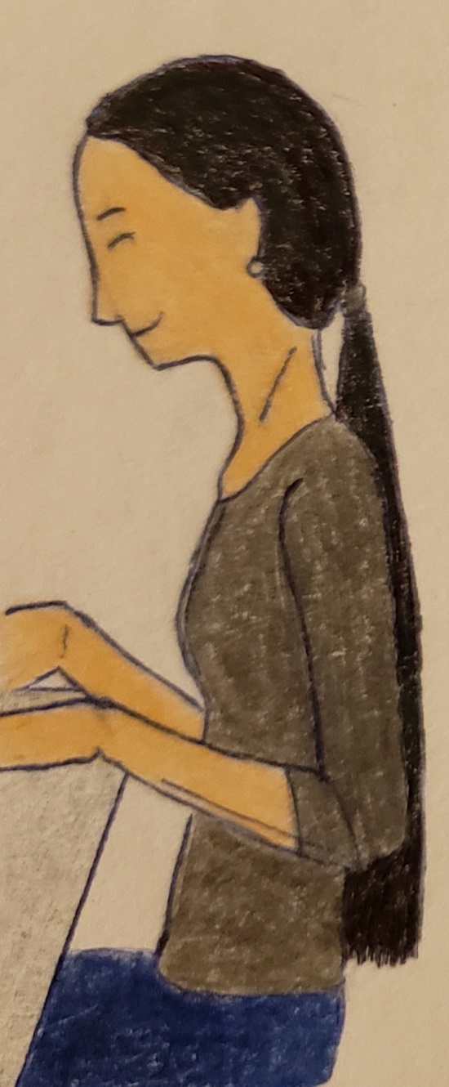
She researched the place, which includes history, culture, climate, and demographics. Answered some of the challenging questions about Taiwan, including Taipei. It took 3 days to finish the worksheet (Information/Survey on Chosen Places and Upcoming Trip Questionnaire).
At the same time...
She did the Trip Documentation (Travel Documentation and Currency) quickly before heading to bed (because she has to work the next day).
Taking her break from I-Powers Travel homework, she took her days off from the assignment.

5 days later, she reviewed the answers from the worksheets (Travel Documentation and Currency Declaration). She asked herself about travel requirements and answered that Taiwan travel for US citizens doesn’t require a visa for leisure travel. She responded that she needed an updated vaccine record for a trip to Taiwan.
Surprisingly, she has the up-to-date vaccination she needed to travel.
On the worksheet “Currency Declaration,” she answered on the currency restrictions; Declare cash amounts over 100,000 New Taiwan Dollars (TWD), foreign currencies over 10,000 USD, or over 20,000 Chinese Yuan (RMB) a few days ago. She pinned the website for the custom detail online before her departure.

A few days later, while she was free, she planned to do the part: Trip Evaluation by asking herself.
She started off with the answer to determine if Taipei is both safe and sanitation.
Thinking and researching about Taiwan’s safety and health on the website...
Both she answered sufficiently: Safe and Sanitation of the place.
“You must pass the 2 components: Safety and Health to consider “Ready to Visit” place; otherwise, you will have to start over from the beginning.”

It was a short answer to the 2 questions from the worksheet: Evaluation of Chosen Places.
- How safe the place/city is?
According to the previous research conclusion, this place is safer and more solo travel friendly. There is an exceptionally low crime, high in a tourist area where there is a live event, even at night. Be careful at night and don’t travel alone during the late evening. Stick to a public, well-lit area.
- How healthy and sanitation the place/city is? Do places/countries have adequate health care with trained medical staff?
Taiwan has excellent health infrastructure as well as an outstanding comprehensive health system.

Moving onto the next process; Plan. Plan Process takes lots of time, which includes an Activity Planner. The Plan Process is also included in the 4 components: Health/Wellness, Law/Safety, Travel Documents, and Finance. All of the 4 elements are critical for planning.
She answered Public Transportation and Hostel, respectively, based on the question she answered from both the Transportation/Lodging Questionnaire (2 pages - Word Document).
“The question from the trip questionnaire “What activity suits you?” is essential when planning a trip of your choice. Without trip planning, there is no purpose, and overall, the trip became boring. You don’t want to plan a trip with no purpose nor lack of planning. All trips will have some goals and a purpose.”
United kept the critical paperwork in the file. She will retrieve the information later when it's time to book her flight and accommodation. She used her folder to store essential materials and papers in the compartments.
Late in April, she worked on the Activity Planner she created by herself.
The most time-consuming thing was the Activity Planner; it requires a vast amount of time to fit into an ideal travel itinerary.
Looking at the webpage, she read the entire direction for the Activity Plan Workshop blog. It was published on February 29, 2008, and the one “Activity Plan Info” on May 9, 2008.
“I am making sure to read the direction before I began to do the worksheet. I have lots of plans to write as many activities as I can to fit into the itinerary. But be sure not to overplan nor underplan them, which sabotages the trip. I don’t want that to happen.”
In the Activity Plan Workshop, there are 4 worksheets to do.
- Activity Planner
- Your postponed activities
- Activities Budget
- Activities Worksheets

“Doing my homework makes me motivated to reach my goals for the outcome of something... Just like planning not only for the trip but for life goals. Suppose people don’t start planning with confidence. In that case, there is no focus or goal, so speaking of that, doing your homework enables people to discover something that empowers them. Doing homework will also calm yourself down.”

Since she will travel on a budget, she has a strategy of keeping her cost under control.
She began to research the budget by going on the website www.budgetyourtrip.com.
Typing the word “Taipei,” she hit search and then clicked the picture “Taipei.”
She then set the Travel Style to “Budget” and set the currency to “US Dollar.”
Using her phone’s calculator, she figured out using the airfare model she created using the GAS method. She followed the PEMDAS methods to get the suggested budget of an airfare.
“Well, it should cover the cost of airfare. The cost is $1,995 from Philly and $1,905 from Newark.”
She did the math for the hotel known as the 3H Method...
...and then multiplied the number of nights at a hostel.
“I budgeted the $240 for 5 nights. Budget accommodation is $48 a night.”
She then took notes on how much she planned to budget before putting numbers onto the Word Excel Worksheet.
“Hostel for female dorm only?” She wrote on the piece of paper.
“United, All Nippon, Asiana, Eva?”
She mentioned.
“You just can't guess how much it cost. You need to research how much it really costs to travel efficiently and effectively. It is important to research and ask for advice if you can't find the information. Without researching and finding evidence, there is no guarantee that you will have a fun trip. Better to research and find evidence like how you are to spend the entire duration of the trip. What about emergencies? What about food shortage or feminine products when you ran out of the item? Things you need to consider.”
As she continued her activity and plan phases, she finished her financial worksheet, including the entertainment and the Other Travel Needs (Emergency) funds.
“I was working on 4 phases of plan known as Plan 4. It is the most critical aspect of planning a trip, mostly for solo travelers. Without planning, I don't know how to maintain my healthy lifestyle, how to manage my finances, and so forth.”
Popping up on the blog: Why plan all 4 Phases, she showed the table of all 4 different reasons why planning is essential for any trips.
She concluded on the blog, “The 4 Phases are beneficial in creating your trip itinerary and the trip information with ease.”

Still, she worked part-time at Temple as the Faculty Monitor/Specialist while working on her job assignment at the Estée Lauder internship (probationary period).
She has landed her internship at the Estée Lauder – part-time a few weeks ago, including her personal and professional goals. Surprisingly, she got her paid time off after her 4-month probationary period. She also has paid holidays and an incentive mobility program, designed for all employees who want to land a dream job after successfully completing their probationary period. She will take her vacation right after completing her probationary period to improve her health (mental/physical/emotional).
In her blog (https://ipowerstips.travel.blog/2020/07/13/why-probationary-period-is-necessary/), she recently published (April 6) about her probationary period, stating that it is not for her vacation time until she completes her probationary period.

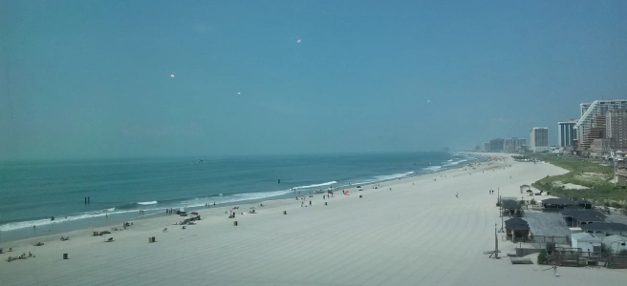
The picture took from Atlantic City Playground on July 8, 2016.

“In fact, taking a week-long vacation during the probationary period is not recommended because the probationary period is a training period on how to do the job, how to get along with the coworkers, manager, and others who work there, and determine if my job is right for me. I must fully complete my probationary period before taking off.”
Fact: In her LinkedIn, it stated that she landed her internship at the Estée Lauder in July 2020, not April 2020, so she could have landed an internship in April if the pandemic did not happen.
The blog was published on July 13, 2020, rather than April 6, 2020.

After working hard to gain her work experience needed for the permanent job she loves, she regretted herself to travel with her family on her last trip. Sometimes, her father got herself on the nerves. She understands that mental instability has affected her trip quality, so she came up with a solution about mindful traveling to focus on traveling peacefully and relaxing. Working a part-time job, she was so glad that her solo travel to Taipei was well planned by using her I-Powers Travel application. It was not the 1st time for her solo trip, yet she took several trips abroad. Reflecting on her last trip to Henan for 6 days, she wrote of her satisfying experience during the family vacation.
She enjoys visiting Henan but not enjoying herself with too much unnecessary stress.
She also read her book about “Mindful Travelling: Journeying the World, Discovering Yourself,” written by Sarah Samuel. After reading the book, she transitions her past, starting in childhood, up to the 2010s, including 4 years in Tucson and her undergraduate studies at both Community College of Philadelphia and Temple.
She was also discovering herself as a “traveler with confidence.”

In the last book she reads, it states about the book, “Travelling can be frustrating as well as wonderful, and the perfect opportunity to practice mindfulness in technicolor! Mindful Travelling explores why broadening our horizons is good for the heart and soul! Sarah Samuel shines a light on why Travelling offers the glorious opportunity to learn more about who we really are–outside of our daily routine and conditioned self. By embracing the sense of freedom of leaving everyday life and material possessions, facing fears and opening to trust, setting intentions, and connecting with our own wildness, she reveals how Travelling and mindfulness are natural companions. Through personal anecdotes and meditative insights, discover how to bring the joys of mindful Travelling back home in your suitcase–staying open, curious, and present wherever you are.”
She also believes in self-discovery that promotes both her personal and professional growth needed for long-term goals.
Speaking of herself, she prefers traveling solo or without her family. She wants her to have a good time to focus on her hard work in the long-term and boost her overall health for life.
Reviewing the overall 4 phases of the plan from the Word Document, she was delighted that she took responsibility for her personal finances, health, research, laws, and other important topic needed for further research about Taipei.

Relaxing from the I-Powers Travel assignment, she finally put off her solo Taipei vacation until May (to search for her flight and hostel) because she wanted to work hard for the internship and Temple job. Since she hasn’t finished part of the I-Powers Travel (finished Plan Process), she leaves it until later.

May 2020
Days later, when she was not previously scheduled to book a trip, she was on the bus, returning home from work. It was a beautiful afternoon, waiting for the bus, checking her I-Powers Travel worksheets she created.
Helping with dinner...
Eating dinner together...

Tonight, she started to search for an airline ticket to Taipei. She looked forward to traveling solo again soon.
“I will need to figure out how much I will be paying so that I don’t end up overspending according to the I-Powers Travel Budget I created. I will need to wait and see if it is the right time to book an airline ticket. I am just comparing the price from each gateway airport; Philly, Newark, and JFK.”
She recalled doing her budgeting a week ago. She was doing the Workshop Process that included budgeting.
On her phone, she was on Google.
Searching on Google flights, three different airports' price was $1,040, $941, and $933.
“It is just a sample airline ticket price, not just mention that of an average price, so there is a huge difference between these prices from the websites.”
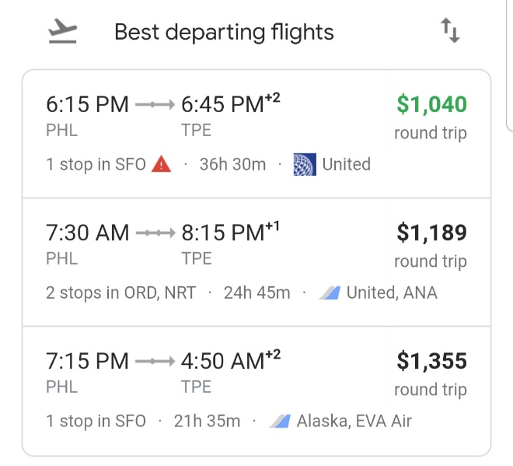
Photoshoot from Philadelphia to Taipei
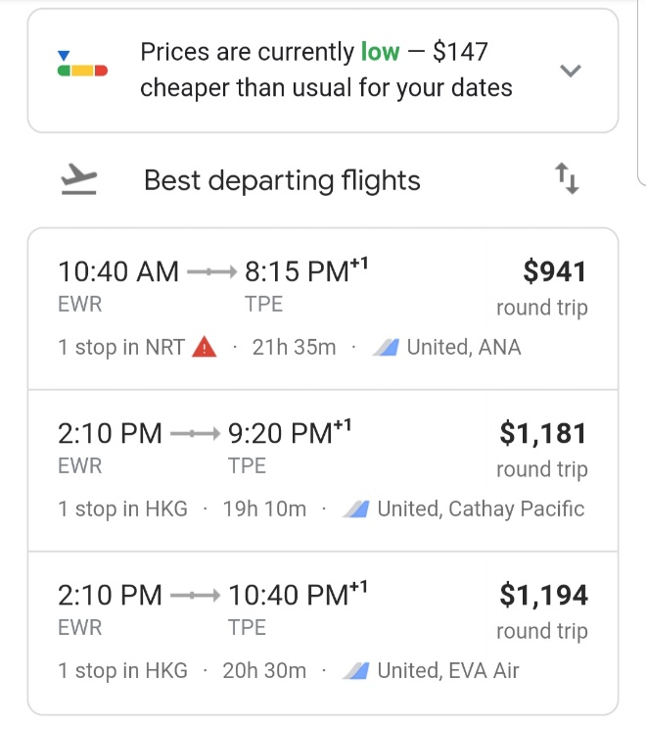
Photoshoot from Newark to Taipei

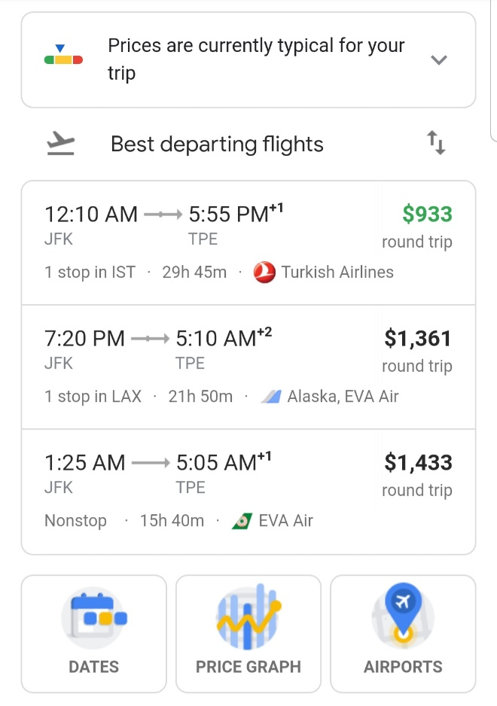
Photoshoot from New York (JFK) to Taipei

She compares the costs of all flights from these 3 cities by expenses.
“Turns out that the flights from JFK are cheaper, but that is not the case. I will need to wait when it comes to booking my flight. Since I am an active frequent flyer member of United Airlines, I am opting not just United but also Star Alliance partners. Since United is a Star Alliance Member, it is easier to thoroughly search, sign up for airfare alerts, and wait. The cheap airfare can wait.”
Can’t find the lowest price available from Philadelphia...
“There are still thousands of dollars available for the cheapest.”
She eliminated one of the getaway airports, Philadelphia, because Philadelphia’s airfare came out more expensive. Her goal was to save money for the trip (high season).
“Finding a good flight deal is hard work. It takes lots of patience because the prices change several times a day. It is called a yo-yo cost, a roller coaster cost, so to speak.”
Holding her United Airlines Polaris Bear while carrying on the phone...
Philadelphia is her primary airport with a hub of American Airlines (OneWorld Alliance). She is a United Airlines member. She only searches for Philadelphia (Domestic) flights or Newark (International) to get a better deal.

She witnessed.
“Just because I budget around $1,905 in plane tickets doesn’t mean that I should spend a thousand dollars. This is not how saving money works. Saving money requires lots of trial and error, including research and hypothesis for the performance, including the airfare. It is scientific. I believe that strategy works by opting for realistic expectations, including finding a good deal on flights, especially I am a frequent flyer. The flight I want is changing, just like the weather is frequently changing. Be sure if I have enough money for the airfare. Since flying to Taiwan from Philadelphia is expensive, I am opting for the affordable fare I can pay, preferably from Newark or JFK. My travel plan is a peak season because many people are traveling there for the summer vacation with their families before school.”

Since she will travel to Taipei in late August, it was time to search for her flight because she had her experience finding her cheap airfare abroad last time. It was around September for December travel.
“For domestic travel off-season, it is best to search 6 to 12 weeks before departure. High season, 9 to 16 weeks. For international travel off-season, 9 to 12 weeks and 15 to 20 weeks for high season. Since I will travel at the end of August, it is time to search for the ticket to get a good deal. The last time I went abroad with the 750, down from 900ish. I can’t remember the last purchase, and I think I confirmed my flight 16 weeks before my departure. Of course, searching for cheap airfare isn’t easy. Know the date of travel. Try flexible dates.”
Going on the website kayak.com, she logged her information into the account to update her information.
She checked her information: Her profile, her authorized senders, and other information.

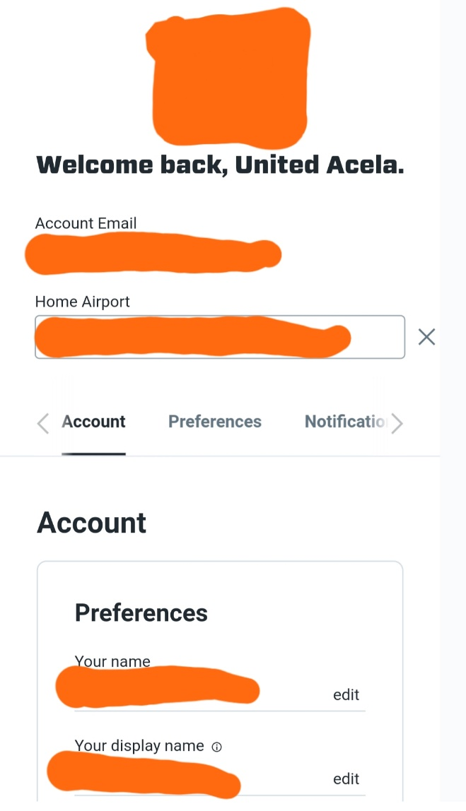
Her Kayak.com profile information
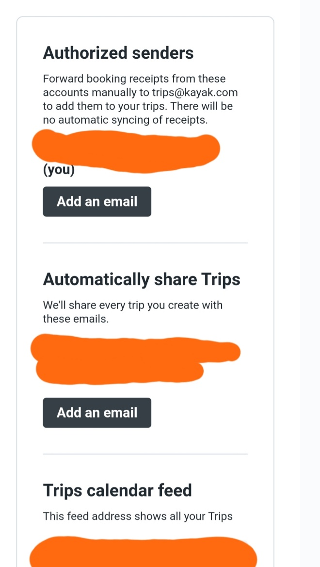
She updated her status including authorized senders, trip sharing, and trip calendar feed (just in case her flight includes in her calendar).
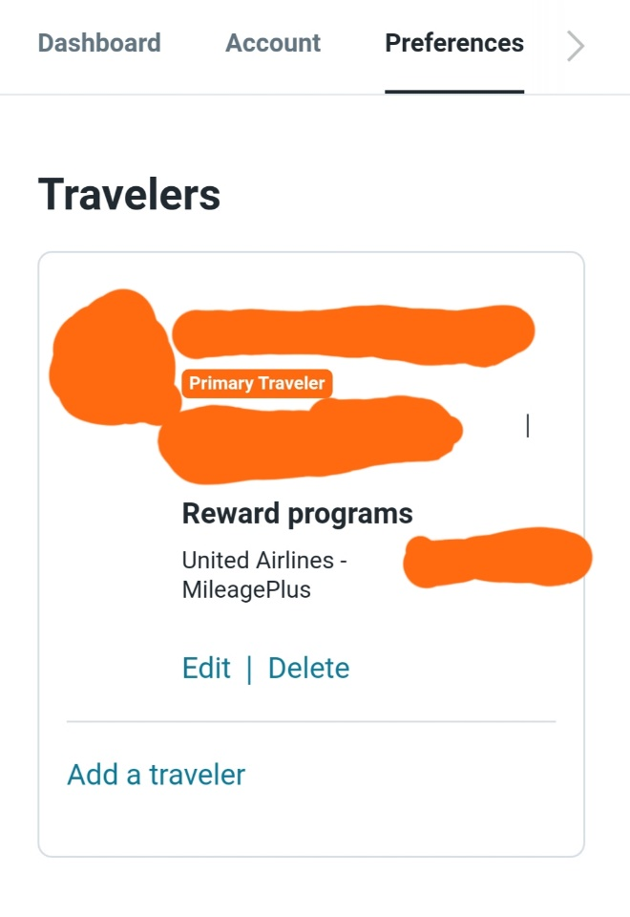
She updated her reward programs including her airline membership.

Clicking on the Notification button…
At the “Price Alerts” page, she signed up for the flight alerts (www.kayak.com/flight) for both Newark and JFK before going to bed. She went on the internet mobile instead of using the app to sign up for her personalized trip.

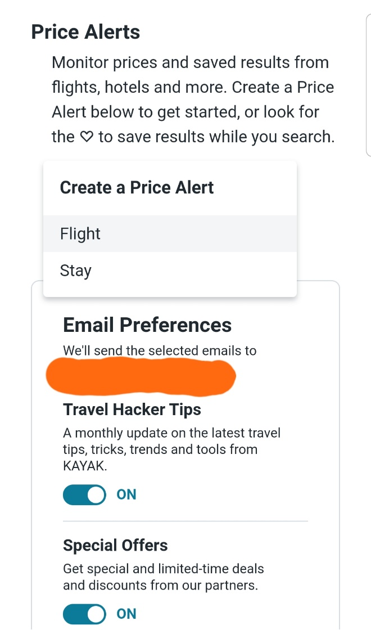
Signing up fare alerts gave her notifications about her total airfare costs.

“I highly recommend signing up to get the best deal, not just searching just one date, airline, or other time limits. Kayak took care of this. Kayak flights have saved some time and money over stressful times to search the flights daily. Save your stress. Serve your health.”

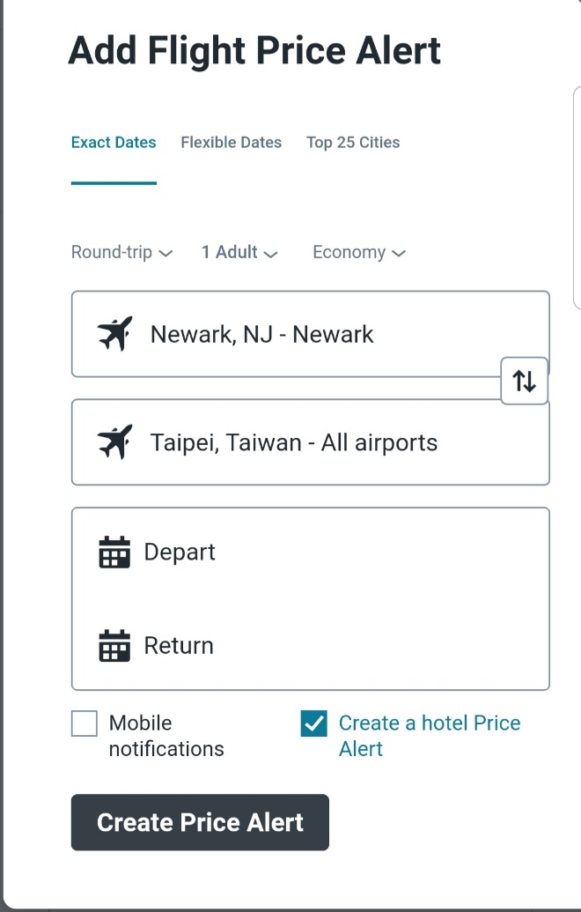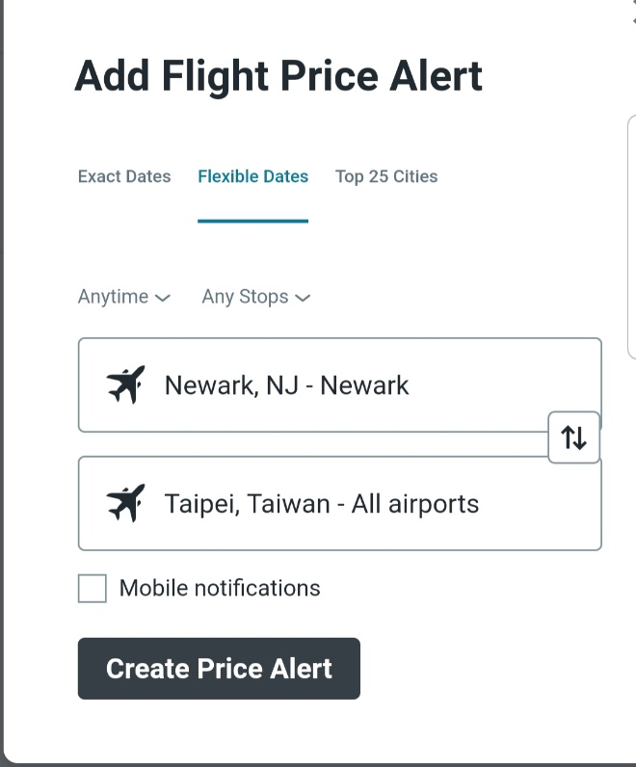
She signed for both exact and flexible dates to give her best airfare price.
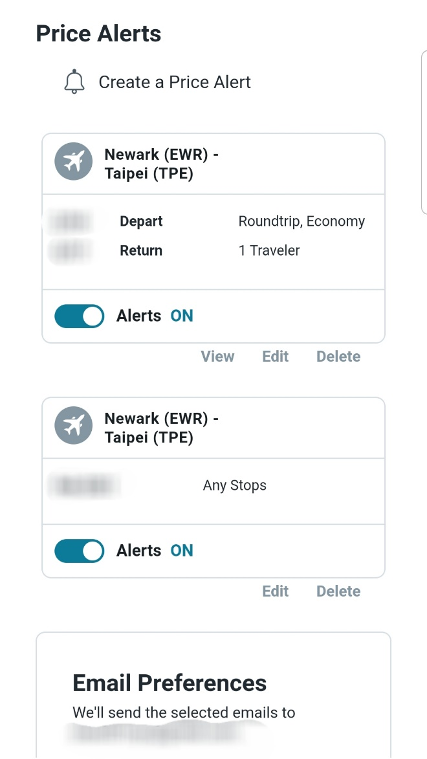
Her email alert for flight was completed.

She skipped “Create a Guide” because she already planned her ideal activities in Taipei.
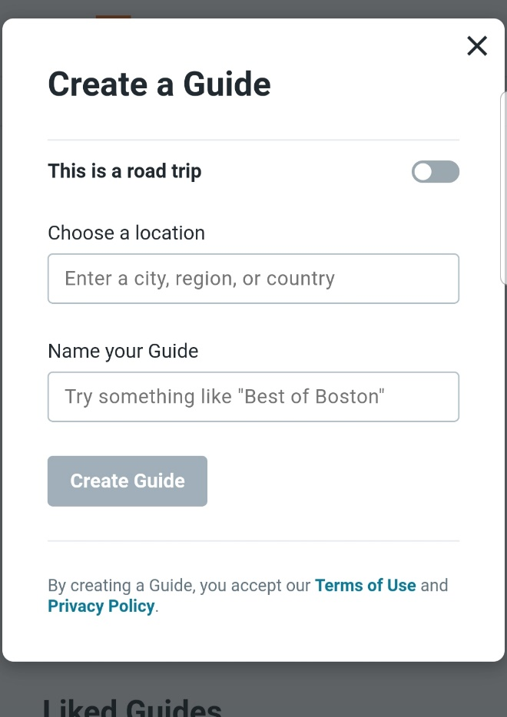
Her “Create a Guide” isn't needed when planning a trip with an answer, “What activities suit you?”

“I don't need to worry about what I must see or experience because I already have an idea now until my trip, so I probably don't need a guide. But will have 2 days of female solo travel groups. It is only for girls who are solo travelers to meet up together. Me too. The guide is free for those who only stayed at the hostel and are female who travel solo.”
She talked to herself while logging out at www.kayak.com mobile.
Sleeping 8 hours later...

The next day, she was off to work part-time with her neighbors, who worked at the Estée Lauder (Trevose), too but with a different job assignment. She was happy that she worked together on some days. This morning, they carpool together because the neighbor has a car to drive to the worksite. After work at 12:30, she took the SEPTA home while the neighbors were going to a social gathering.
She met a new girl named MacKenzie. She worked at the Estée Lauder for over a year during the break time.
She got paid weekly.

Days later, after working at Estee Lauder and Temple, she was at the SEPTA bus home.
Checking her email...
Her kayak price alert...
Today's deal...
She checked her email on some days for the total airfare, and the flight directly to Taipei was still a thousand and about $973 from other airlines from the same airport.
Click onto the inbox from yesterday...
She saw the airfare from JFK to Taipei went up from $967.
She puts off the airfare search until late May to book an airline ticket and book a hostel stay.

A week later, the airfare she checked on her email (JFK to Taipei) went up again to $995, a big jump from $973 because lots of travelers are traveling to Taiwan for a short break.
The fare she also checked was down (Newark) from $760 to $742 due to price fluctuation.
“You have to be patient because the airfare from both airports changes several times a day, and I schedule Tuesday to book a flight whenever possible. You must try different dates to get the best deals, not just one date you want. So, airfare is an expensive item to purchase. It requires financial commitment before making a purchase, just as you book a trip or make a large purchase.”

At the dinner table, she has a conversation at the table.
...in a family of 5.
She showed the trip itinerary and her I-Powers Travel work she created to her parents and was impressed.
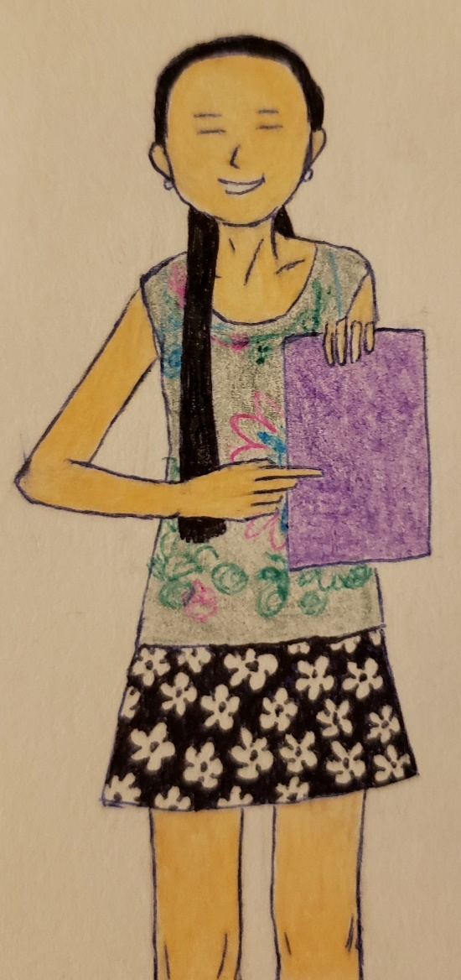
“Wow!”
Seconds later...
“Your work is so impressive.” Her parents showed appreciation for the work.
“I like it.”
Thumbs up.
A minute later, they asked her to specify their reasons for the trip.
“United, why did you take a solo trip to Taiwan?”
“I bet that the family trip was not going so well. I need that godd**m good time so that I can focus on stress management. I regret myself going without my family, including my dad. Look at you overacting in public? What do the people think of you when you travel, huh? People think that you are a freak. I don’t want you to shame other people or watch you being offensive. I would rather go solo traveling; I don’t care.”
“United, calm down. Your father is always like that, okay? Daddy still loves you. There is only one dad we choose from.” Her mother comforted her.
“Yeah, mom, I just don’t want to have a rough time vacation with all your arguing. My sister doesn’t want to go on a trip with him because of the outburst. People are watching you in public. They have weird thoughts about him.” She wailed in Cantonese.
“What did I do wrong?” Her father mimicked.
“Nothing!” She raised her voice.
“I understand the situation. Now you can calm yourself down with deep breathing.”
She closed her eyes and took her deep breath and...
Minutes later...
“I bet... that... um, don’t have to go with my daddy. I signed up for the women’s tour because it all makes me happier. It is all for solo women travelers.”
“Aha, that is a great idea. Maybe you will have a good time out there.” Her father comforted her.
“Thank, dad.”
“You go, and I am not going.”
“Hooray!” She felt excited.
“I don’t have to worry about too much stress when it comes to traveling. I just want to have a good time. Oh yeah, I am happier that I don’t have to worry about stress when traveling.”
Just then, after convincing their parents to let her travel solo to Taipei, they suggested taking increased precautions. While her parents are concerned about her upcoming solo trip to Taipei, they also took great care to ensure her to take responsibility for her safety, health, financial, and personally.

After dinner and her duties, she witnessed,
“I am so happy that even my parents are concerned about my solo trip, they have told me to be extra careful when traveling abroad since I am the only girl who takes pride in safety, security, health, and other personal obligations. I understand that solo travel has risks, and it is all about rewarding and confidence. It also builds the characters needed to build the values who I am.”

Working hard at the Estee Lauder during her probationary period...
...putting her flight and hostel reservation until the end of May.

Late in May,
After dinner, she helped her family with the dishes and sweeping the dining room, which kept the area clean. She concentrates on cleaning up the kitchen and the common area before she schedules to book her flight tonight.
Finishing her daily duties, she went upstairs to book her flight for 5 days because she had her money saved from her savings account.

Turning on her laptop computer...
Checking her email, she saw several messages from Kayak price alerts, “Prices going down for your Newark t...”
She clicked onto it, and it reads, “Prices going down for your Newark to Taipei Flight.”
Scrolled down on her email...

Newark, NJ - Taipei $712 (down $27).
Aug 2020, Round Trip
TODAY'S BEST FLIGHT DEALS
United Airlines $712
All Nippon Airways $719
Edit Delete

The other flights she signed up from JFK to Taipei have gone up from $995 to 1,036.

“Whew, that is not bad. I have been waiting for the fare to go down and save up.” She praised herself.
She checked it out that the airfare from Newark to Taipei was $739 and $995 yesterday.

New York, NY - Taipei $1,036 (up $41).
Aug 2020, Round Trip
TODAY’S BEST FLIGHT DEALS
Turkish Airlines $1,036
Edit Delete

Clicking onto the email and filter to Eva, she saw that JFK’s direct flight to Taipei was closer to $1,179, a significant spike from $1,104.
She remembered signing up for Newark’s fare alert to Taipei to get a better deal, not just JFK. Her goal was to save money because traveling requires a financial commitment to reach her travel goal.

“In conclusion, the nonstop from JFK to Taipei via Eva Air ($1,104) was more expensive than the flights included a layover to get a better deal. I checked the flight yesterday.”
“It is important for travelers to be flexible with the travel dates since the ticket prices are variable costs, meaning they will change several times a day. I was on Google flights and then compared to Kayak.com. I also compare the airline’s website if you are a frequent flyer member. Since I am a United Airlines MileagePlus member, a Star Alliance member. I am comparing airlines to airlines to get the best deals not just United but also Eva, Turkish, Lufthansa, and other Star Alliance partners to earn miles.”
The airfare (from expedia.com) was still high, with upper $900s and $800s from JFK and Newark.
Other aggregator websites to compare the cost of round trip…

Closing and clearing the internet cache, she searched for the airfare again for three different cities: Philadelphia, Newark, and New York (JFK).
Other aggregator websites to compare again for the cheaper fare...
Searching and loading...
The flight from Philadelphia, Newark, and JFK was still $1,152 (American), $1,030 (Turkish), and $775 (United), respectively. Still, Eva Air directly from JFK Airport to Taipei was over 11 hundred ($1,187).

Off to kayak.com...
The cheapest from JFK to Taipei was the Turkish Airlines with a layover at Istanbul (round trip) with $1,036.
She went on Google Chrome (incognito) to compare her flight again and selected her flight itinerary for the round-trip based on the price and airline preferences.
Signing into her email, she saw there are several emails regarding kayak airfare increasing from JFK. Another kayak airfare decreasing from Newark and…
She eliminated other airlines that don’t earn miles on United Airlines Account (Korean, Delta, American, etc.).
“If you are frequent flyer members, then you should eliminate the airlines that don’t agree with the airline’s frequent flyer program requirement.”
She realized that Newark’s flight was cheaper than JFK at $710 and $993, even though the flexible dates. She checked the email sent from Kayak, and it turned out Newark was the best deal.
“I compare with the getaway airport, and it turns out the cost is over 200 dollars less, which is cheaper when signing up for the fare alerts. I also used flexible dates.”
Observing the JFK flight search, it reads that it is only available at the cheapest flight with the $993 vis Turkish Airlines.
“I can’t pay this amount.” She said sarcastically. “Who else to pay me the $993?”
“Even though you budget your trip, it is important to compare the price and select not only the cheapest but also the best fit for your itinerary.”
Instead, she opted for the cheaper flight from Newark round trip because if she booked her flight from Newark and returned to JFK, the cost is much higher at $993.

Eliminating her flight from JFK, there was only one option: Newark.
There are only one or few flight selections left, Newark via All Nippon and United.


Selected the option that best fit for her itinerary, she felt confident about her flight selection.

Filtered by the “price” and “Best” flight selection, she found out the airfare fit for her itinerary.
She chose the flight option.
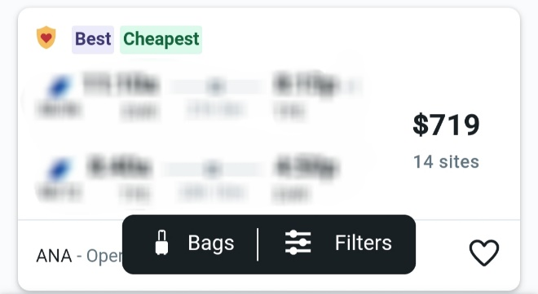
She selected this flight itinerary for only $719 (round-trip).

Based on her saving money experience, she did her math. Overall, she has saved up to $1,186 ($1,905 - $719). There is a huge savings of 62% decrease from the total cost ($719 – $1,905) / ($1,905).
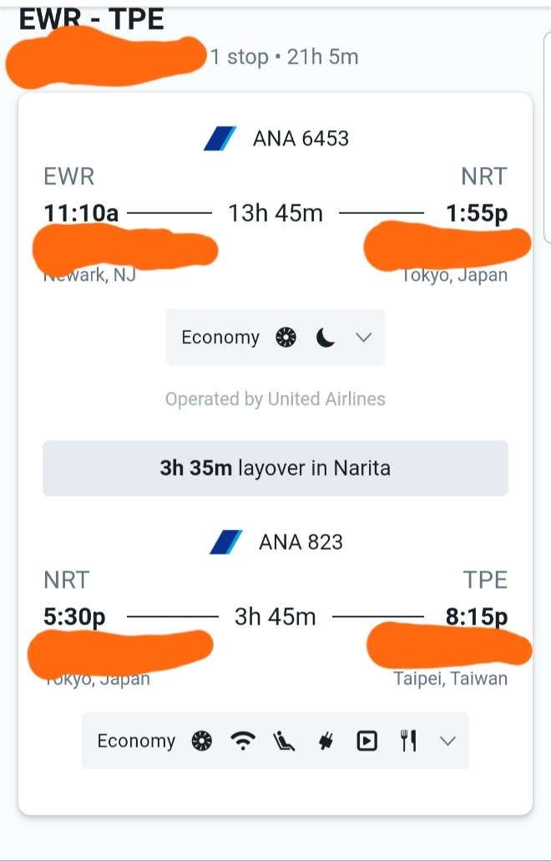
Her flight itinerary from Newark to Taipei.
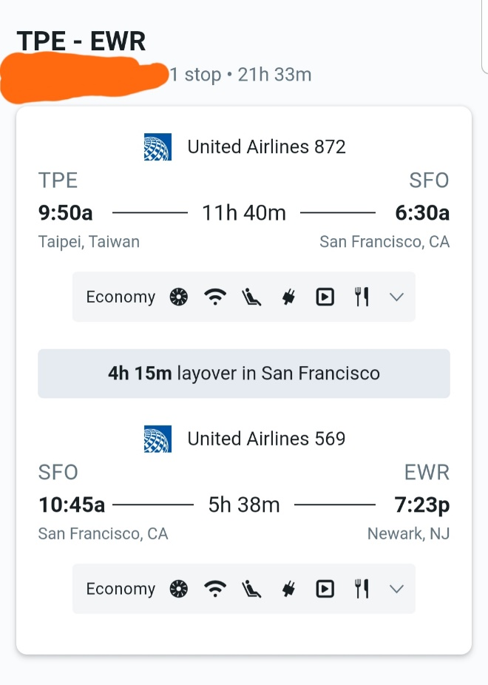
Her flight itinerary from Taipei to Newark.

Sending to the airline’s website, she pays the airfare by debit card.
“I better take my flight from Newark instead to get a better deal because I tried a flexible date on a kayak and other aggregator flights, and the cost was in the 800s round-trip for the last 7 to 10 days. And book a shuttle if Philly’s airline shuttle is not compatible with the airport or is not available for Philly passengers. Or my father won’t be available to drive me to the airport because he has to go to work.”
She added.
“Or I can book a shuttle that serves passengers to Newark airport to catch my flight after I purchase an airline ticket, depending on what airline I will be taking. I am going to ask my daddy if he can drive me to and from the airport. Will see what happens after he says about airport transfers.”
Thinking of booking an airport transfer, she compares the cost from service to service.
While some services are cheaper, it can cost about $110 each way, so it is costly to book these shuttles, such as economy one.
The only option is to get a shuttle to Newark airport from Philadelphia (her father doesn’t have to drive to Newark to catch the flight) is the airport shuttle she found online (Shuttle Fare), which is a shuttle service for the exclusive airport passengers (from Philly) to and from the Newark Airport. It costs around $75 one way, cheaper than the traditional ones, which costs around $110 to $120.
She has not yet confirmed her airport transfer because her father usually drives her to and from the airport based on his time allowance and availability. Since her airport getaway was Newark, she has figured it out by finding alternative transportation.

She remembered that her family took the flights to Hong Kong back in Summer 2015 via Asiana. They took their flights from JFK with a layover, spent a couple of days there, and vacationed in Hong Kong. Hence, there is a shuttle between Philly and JFK’s specialty for the airline they are taking.
Note: It is exclusive to the airline shuttle in which they are taking. For example, her family took Asiana Airlines from Philadelphia to JFK Airport and took the shuttle for all Asiana passengers directly to JFK for a discount. If other airlines, passengers must research the shuttle that fits within the budget, not necessarily the time.

Sign in on United Airlines’ website after its redirect to the website...
...www.united.com, her preference was on window seats.
Before she confirmed her flight, she chose the seats on all 4 flights. She saw the website page, with some of the window seats quickly sold out. She chose the window seats on all flights. 3 on the plane’s left side and one (flight to Newark) were on its right side.
Choosing the seat number, she confirmed the seat assignment.
Paying the airfare via credit card, she really knew how to pay it back in full since she saved more money once the bill came during the period until the due date.
“If you have outstanding debts or limited funds available to pay your credit bill, don’t pay your airline ticket by credit card because it can carry bills and interests from period to period. It is best to pay the full balance if you can if you want an excellent credit score. Otherwise, it carries a heavy balance on your bill, meaning your bill can be expensive to pay them back. Finally, you will more seriously affect your credit even if you miss your payment once. It is best to pay your airfare with a debit card. I don’t miss them.”
United knew how to manage her finances after her father taught the importance of finances, credit, and money since high school.

Once she confirmed her flight to Taipei, Taiwan, and entered her frequent flyer number on the airline’s website, she planned to figure out how she will get to the airport. Hence, she will take the airline partnered with the Star Alliance, All Nippon, from Tokyo to Taipei. She finally wrote the items down on the phone to remind her time of departure and return.

Off to airport shuttle search...
Compared to the shuttle to her father’s driving, she first went to shuttlefare.com for both Newark and JFK and came with the cost of $75 and $85 one-way, respectively. She has not tried to book it yet. She wanted to compare the shuttle’s price vs. her father driving to and from the airport to pick or drop her.

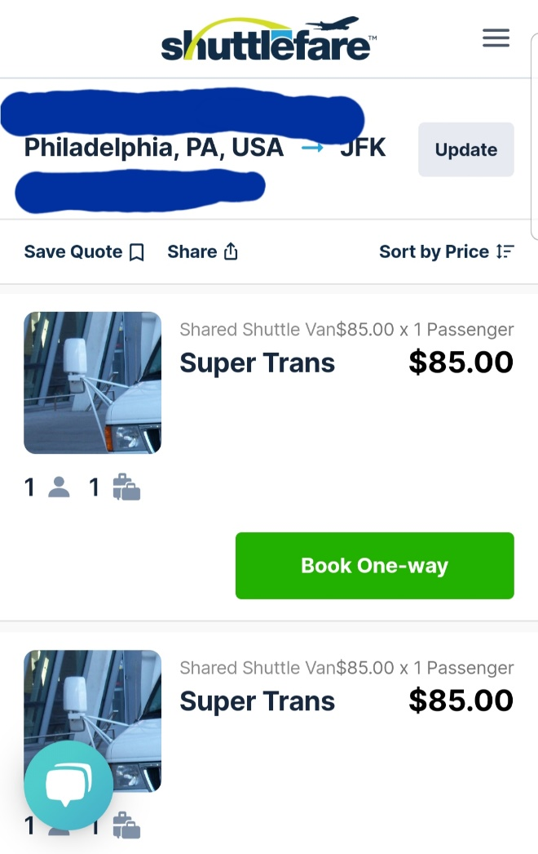
The shuttle from her home to Newark costs $85 (one-way).
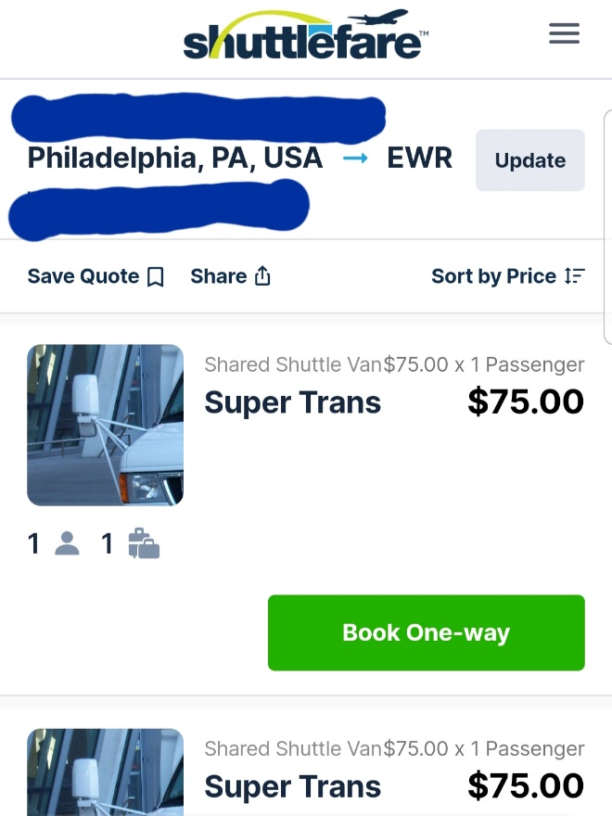
The shuttle from her home to Newark costs $75 (one-way).

“As I know, there is a fee for booking through shuttlefare.com to and from the airport, and it can be costly if you are not careful. Instead, do thorough research. If I tried to ask my father if he wanted to drive me to the airport, that would save about a hundred dollars.” She added.
Still, her father may drive to and from Newark’s airport if he was free based on his time allowance and schedule.
It was not the time to book an airport shuttle for now because it is far from the departure. She planned to wait approximately 1 month before her departure.
She closed the browser, turned off the laptop while looking at her I-Powers Travel budget worksheet, and signed out on a kayak and airline website.
Reviewing the I-Powers Travel worksheet, she stayed within the budget for airfare and hotel with the intended budget of $1,905 and $240, respectively.
“I realized that I budgeted 240 dollars from my budget sheet.”
Opening the app, she searched the hostels via the Hostelworld app to book a hostel stay. She typed the keyword on the top of the screen.
Where do you want to go?
Tap on the screen.
Typing “Taipei, Taiwan China,” she selected the date for arrival and departure and the number of guests. She chose 1 guest since she traveled alone and hit “search.”
Loading, she waited while loading the results.
She narrowed them out with “Female dorms.”
Loading them out, some of the hostels have been eliminated (where hostels don’t have any female dorm rooms).
She kept searching and preferred a 4-6 female bedroom.
“The less bed, the more protection and more convenient for me just to manage my time to use the bathroom to take showers, to use the bathroom, to brush teeth, and to change clothes. Most hostels have a shared bathroom, so there is only one bathroom to the number of beds.”
She made her suggestions based on how many beds are allowed based on the number of safety measures. She mentioned that staying 7 or more persons means more time to use the bathroom and are confused about which locker or bed to assign and are noisy. She suggests solo travelers book a single gender and 6 or fewer roommates for protection, convenience, and flexibility.
Finally, she selected “Dan hostel.”
She was selected for a hostel stay with a very high 9.2 Superb rating.

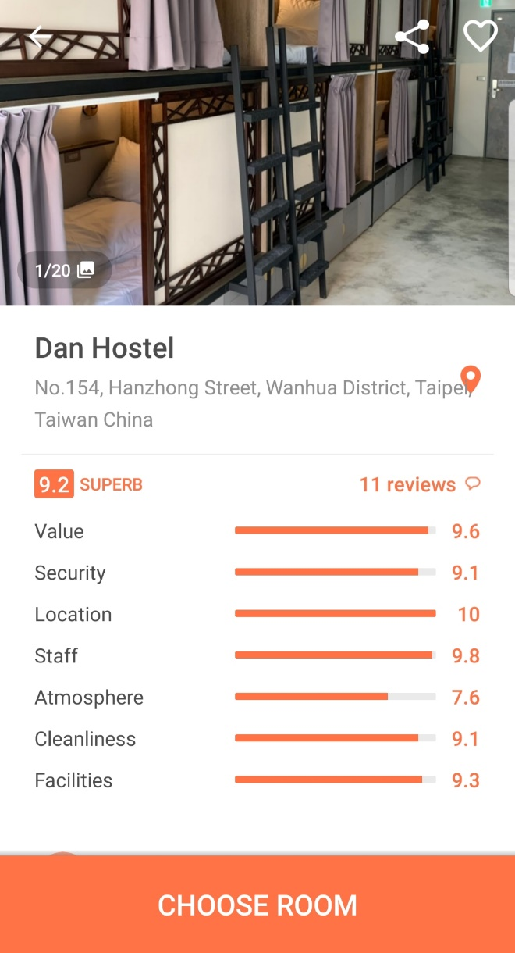

Scrolling down for the reviews, she was surprised that the hostelers have a wonderful time at the hostel experience from the incredibly good ratings from 8 to 10.
“I am glad that I founded a good place to stay for less.”
Scrolling down...
Tap on the word “See all facilities.”
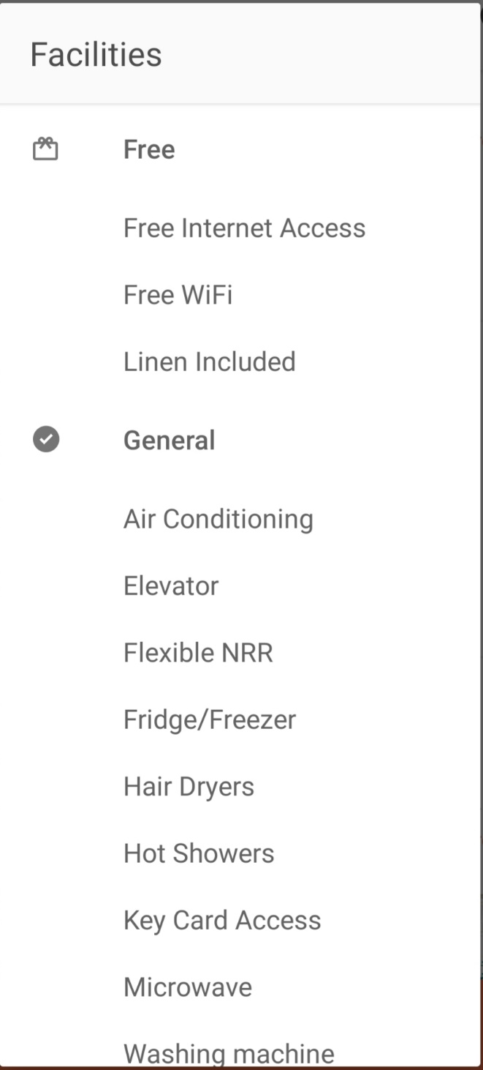
They included some additional facilities at the hostel.

“We have everything available for this hostel.”

Scrolling down...
Reading through the full information, including Property information...
- Policies
- Cancellation policy
- Things to note
...and took notes about the hostel she will stay in.
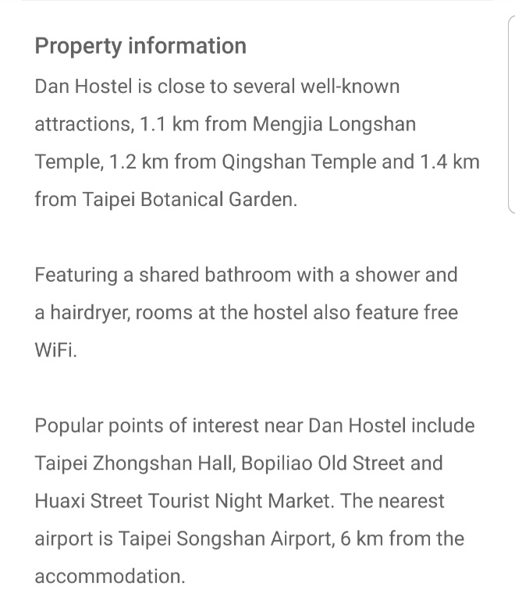

Tapped the orange button “CHOOSE ROOM,” there are choices; Standard 4 Bed Female Room, Standard 4 Bed Mixed Room, etc. All rooms have a shared bathroom.
“Before you can book a room, as shown in the example, it is important to observe any added facilities and information as well as the policies. I highly recommend looking up their reviews too. Make informed decisions before you finalized your booking.”
Observing the note, she witnessed.
Looking at the features, she observes the hostel policies, including “Things to note” on the bottom of the page app.
- Check-in from 15:00
- Check out before 11:00
- Reception time: 10:00 ~ 22:00
- Payment on arrival: cash and credit card
- Tax included in the room rate
- Breakfast not included."
She was excited to book a stay at Dan Hostel.

Scrolled up...
She finally selected the room with a Standard 4 Bed Female Room.
“For your safety, I do not recommend a mixed room just to protect yourself from unwanted attention or conversation. It is best to stay in a single-gender room as a precaution.”
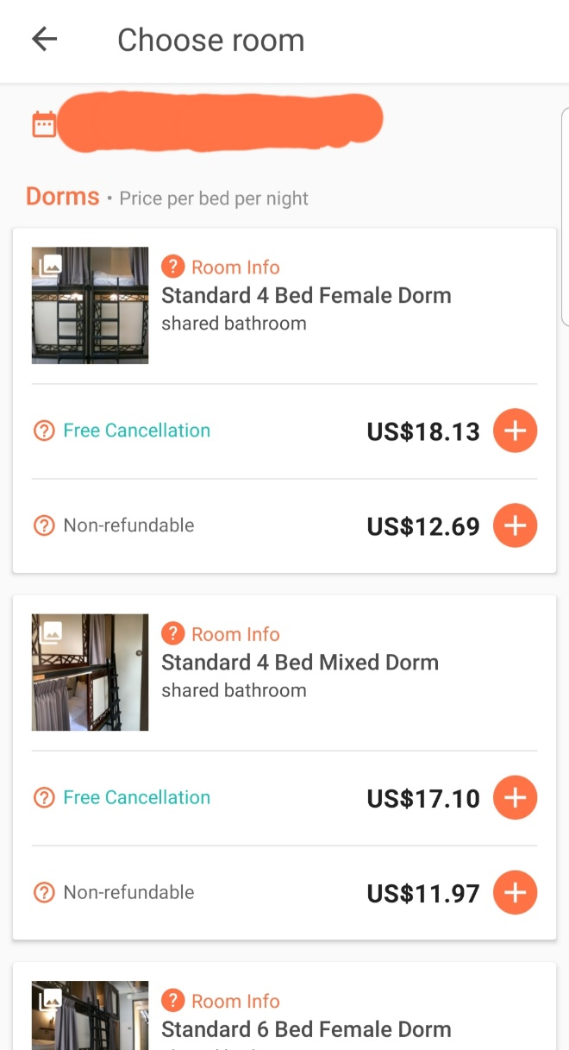

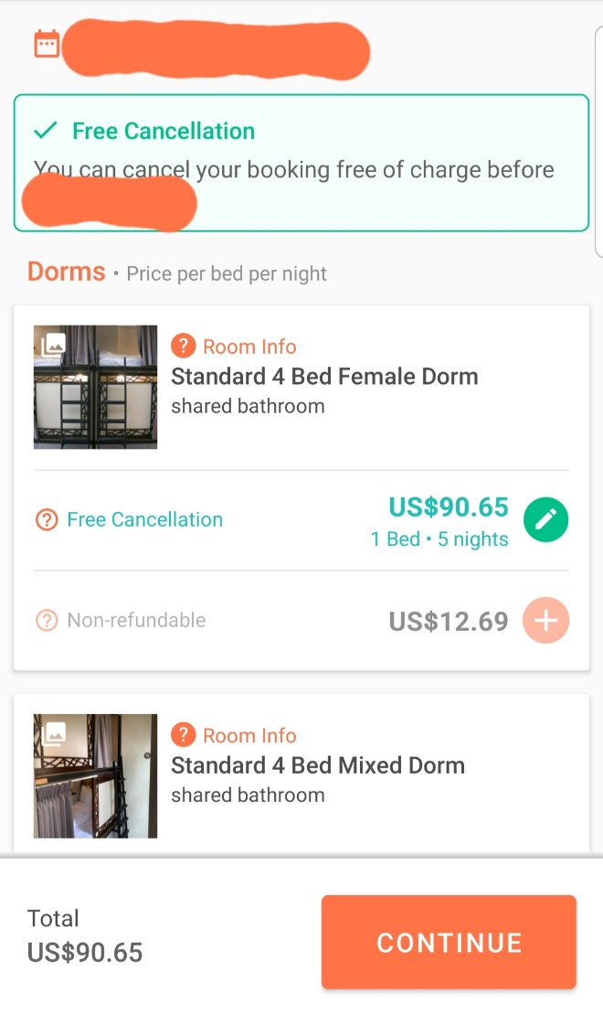

Here was the summary of each night's charge.
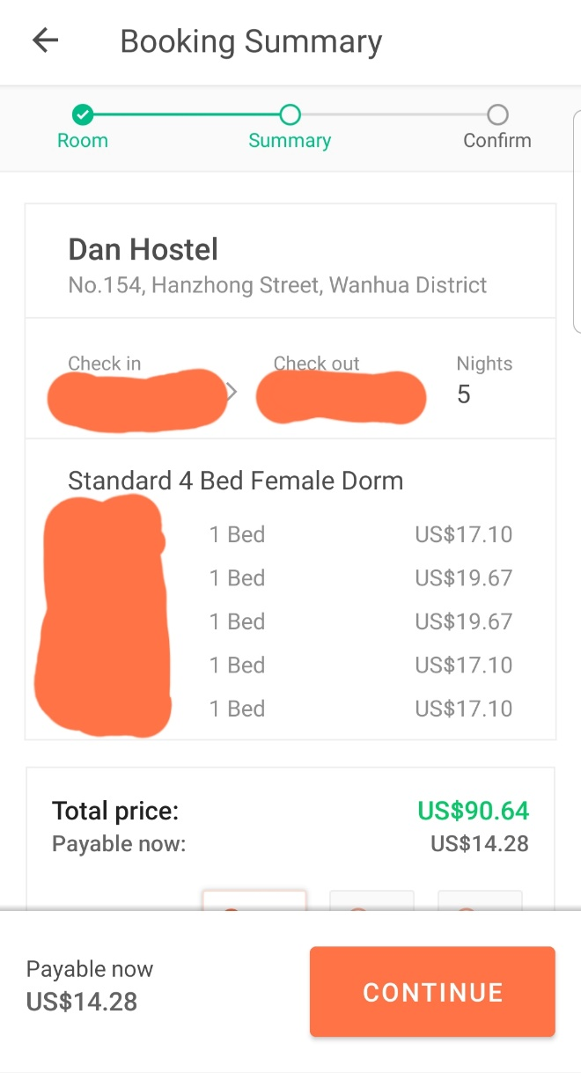

Total Price: $90.64
Payable now: $14.28
Pay in US$ Euro Pound, so she leaves the checked mark in US$...
She paid $14.28 (payable) via credit card.

After booking her trip and a hostel stay, she felt relieved that she got her best deal. She saves lots of money by opting out of Newark airport as the getaway via United and All Nippon to Taipei and United to Newark on the way home. She booked 5 nights for $18.13 a night.
It costs around $18.13 per night (Free-Cancellation) at Dan Hostel, so her total was $90.65.
“The reason why I chose the Free-Cancellation is that if my flight was delayed or canceled due to circumstances that imperil my hostel night cost included so just in case something happens. Overall, I can cancel my hostel reservation without penalty.”
She was very skeptical about the features, including the Fridge/Freezer to store the groceries. The facility also has a microwave. She likes to observe available facilities at the hostel before she books a night.
The Dan Hostel and her trip plan (with independent travel) generally fit her personality.

At her bedroom, the night before June 1st, she witnessed:
“I prefer to stay at the hostel in female dorms only. Because I will travel solo and a single female, staying in a female dorm room is a safe bet. With 6 other girls in the room, I feel safe. I remembered that I stayed with 6 other girls back when I was in NYC. I also safely landed a bunk bed with a safety staff in hand.”
She already has a handy Hostel app back where she stayed at a hostel in October 2018 for her NYC weekend trip, just before she finished her undergraduate studies. She gladly enjoyed the weekend off in NYC.
“Let’s put this trip off until 1 month and by learning more about Taiwan’s culture, not mentioning me going there obsessively. I am grateful to myself that my trip to Taipei is working out. Researching is not easy but rewarding to find cheap airfare. And so as finding a good place to stay.” She vowed to herself.
Organizing her folder, she kept her booking of both hostel and flight itinerary together along with the I-Powers Travel worksheets.
Off to bed to get a good night’s sleep, she stored her travel folder in a safe place.
Good night, United.

June 2020
Working hard on two jobs, she also has an excellent work-life balance, including visiting places during her free time.
She puts off her Taipei solo travel again while focusing on her job. She also focuses on gaining her work experience to put on her both LinkedIn and resume. She was excited but sometimes stressed.
She has experienced her travel experience, translating to her real-world travel blog to the public at www.ipowerstips.travel.blog.
Her travel experience has contributed to her another blog assignment, “Why I prefer Independent Vacation?”, which was due on June 11.
Writing the blog as part of her own assignment, she was eager to share information with the public once she published it.
On her Instagram (@ipowers.travelgirl), she vlogs about the upcoming blog about the exciting blog she created by saying, “Hello, this is United, and I will write the benefits of Independent Vacations. Yep!” She smiled. The post was posted on June 6.

On June 9 (2 days before the due date), she published her blog, https://ipowerstips.travel.blog/2020/06/09/why-i-prefer-independent-vacations/, with detailed information.
On her blog, she called an independent vacation “make-your-own (MYO)” vacation because she creates a picture of independent vacation with an itinerary in her research and imagination.
Highlighted on the blog, it explains MYO vacation’s meaning, which included detailed descriptions and examples.
Her business Instagram is @ipowers.travelgirl.
Embedded from her business Instagram pictures, she posted herself (smiling) with a location; Taipo. She also has her personal Instagram (private).
The picture was “taken at the Tai Po Tai Wo Road (Lam Tsuen River), Hong Kong on January 13, 2020.”
Below, Listed both pros and cons on her blog. She was eager to share information regarding if independent vacations are right for travelers. She organized them listed in a table.
She also included in the example of her weekend trip to NYC and a daycation in Wilmington, DE.
Her blog provides good examples of her independent vacation, which she shared what an independent vacation like for herself was.
The blog also included a picture of her, with a title, “My parents took me in front of DaPeng Fortress on January 18, 2020.”
She shared on the blog about the day trip to DaPeng Fortress, which she learns a lot by exploring and to take risks. But there is a downside.
She concluded beside her independent vacation by witnessing.
“It doesn’t mean that independent vacation is good. There are safety and security concerns regarding independent vacations, such as in Bhutan. Solo Travel to Bhutan is not something you planned because of reducing mass tourism in Bhutan and maintenance exclusively for the Bhutanese tour. It also gives them the preserve of Bhutan and to locals. Overall, you must get a Bhutanese visa to travel as part of the tour arrangements requirement. The Bhutanese visa is only available after you book a tour. Besides Bhutan, Israel, Turkey, Egypt, among others, will definitely need an escorted tour for safety and security.”
As the public was eager to read her post, they are impressed by how she translated from her travel experience into her fantastic blog.
“Without an escorted tour, I could be able to explore at my own pace. Depending on where I travel, I don’t have to stress out what time will be in because of the time limit which the tour guides assign for departure, so by the way, I may not be able to see them all. Of course, I am an explorer who likes to learn more about the place and culture.”
Her quotes have transparent in public.
“Remember that traveling doesn’t have to be stressful. No matter if you’re on a trip or a day trip, it is important to focus on unwinding and refresh from work so that you can work smarter once you come back from the trip.”
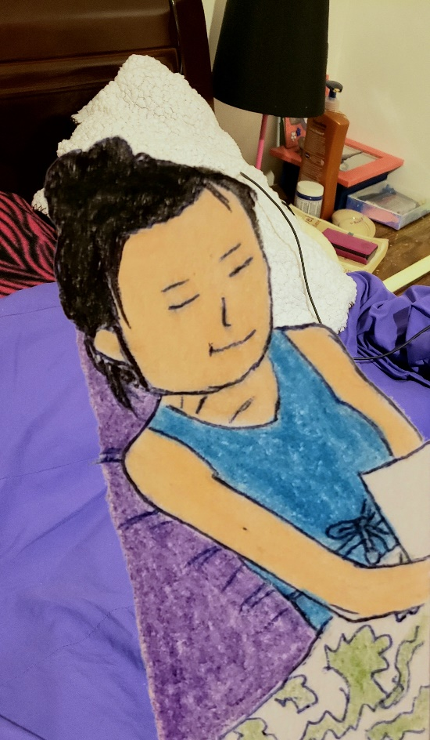
She likes the relaxed vacation, meaning that she also likes to take a picture, explore, and to travel as she pleased. She likes the relaxed-typed travel/tour, meaning that it is easier for her to relax and maintain her overall physical, mental, emotional, and spiritual health. So she took a quick nap before setting off to her good night's sleep.

A week later,
She slept 9 hours a night, getting ready for work in her beautiful face.
Dressed up for work, she was ready for the day.
Eating her quick breakfast (bran flakes cereal with protein shakes), she began to wash her dish and a cup of matcha green tea latte.
Taking the SEPTA bus, her neighbors were off for personal obligations. She received a text message last night. Today's work was stressful after the supervisor's responsibilities were to work on the inventory, working papers and calculate its production line of people working on each line during her 4-hour shift.
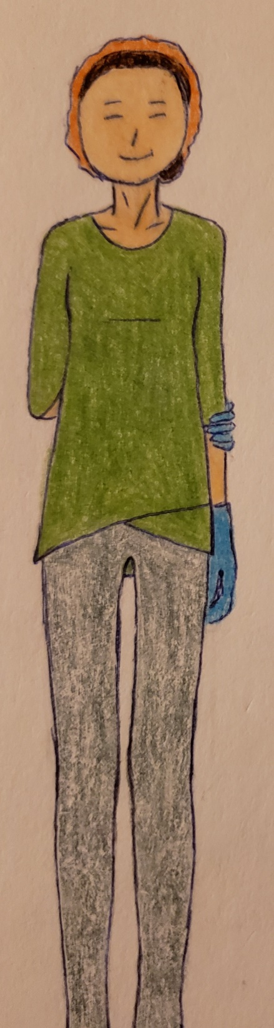
She works at the Supply Chain Management Department from 07:30 to 11:30.
During the break time at an internship, the supervisor has called, saying that she doesn't have to work at Temple on the day.
It was until she left the workplace at noon, walked toward the bus stop, about half a mile away.
The 14 bus comes...
...and paid her fare.

Sitting on the bus (left side), she said to herself while eating her packed lunch (veggie sandwich).
“It is like working well with pressure because it motivates me and makes me forget things that imperil my job assignment. Working under pressure is not naturally efficient but took a fun approach to reduce stress before working under pressure. It is like taking a break, relaxing. On some days, it is manageable for me to work well and like to take a relaxed approach when it comes to working long hours.”
She was scheduled to work at Temple from 14:00 to 16:30. During her break at work, her supervisor has called her, letting her know that she doesn't have to work on the day. Her co-workers were homesick.
At 12:50, she got off the bus and walked home, relaxed for her afternoon before reviewing the I-Powers Travel worksheets she did a month ago. She has the electronic copy she saved and downloads them onto her phone.
“I am making sure that all of the critical information needed for the references, like budgeting, information, personal info, etc.”
Reviewing the upcoming trip assignment she created, she studied her upcoming itinerary besides the financial and other necessary costs (emergency).
Shower time...
After cleaning both the bathroom and bedroom, she took her short nap. She thought a short rest helped with her face, beauty, and mind.

Her parents thought a vegetarian diet is not something they like. They prefer real meats to get the best nutrients.
She only cooks with the veggies while her mother cooks the meat.
She scheduled a reasonable date to talk about her upcoming trip since her parents were having a rough day amid other worker’s arguments. She has some bad days because of the co-worker’s inappropriate conversation about politics that she reported to the incident manager.
“Now, it is not the time to talk about my upcoming trip because they need a break from the bad days. Give them some time to cheer them up and me too. I need to wait a few days, and when is the best time to talk about my vacation plans.”
In the bedroom, she mentioned herself.
“It is okay not to be okay. Sometimes, I had a bad day and recently (last week). One of the workers, Jen, discussed the political topics and was uncomfortable. It happens at Temple University. I was supervising/monitoring other workers and coordinating activities with participants. At the same time, she talked about the sensitive topic that offended some of the participants. Finally, I have to notify the manager about inappropriate behavior at work. After their discussion, she got suspended from working at Temple without pay.”

A few days later, on her busy day, she worked hard for the job without worrying about her upcoming trip. She used her new skills and risks needed for her long-term job, ready to challenge herself.
Finishing her morning shift, she was off to take the bus to Temple for an afternoon shift as a specialist.
Her SEPTA travels to Temple...
Eating her lunch on the bus...
1 bus and the transfer to Broad Street Line to Temple...
Work from 14:00...
...and got off at 16:30.
Napping time on the bus...
Coming home from work at Temple, she helped her mother with the cooking because her parents are going the errands to exchange goods. She only cooks steamed veggies for the family to eat.

Helping with the dinner, her mother helped with her brother cooking vegetables and lean chicken. She gathered 4 bowls and napkins, 3 pairs of chopsticks, and 2 silver spoons.
“Today, we will have brown rice, but my sister only eats white rice with her friend.” She mentioned it to parents.
“Yep, she is probably not going to eat at home.”

At the dinner table,
She showed the pictures from Facebook she saved. It was an album about Taiwan’s vacation.
“Taiwan, here I come.” She smiled while showing them some beautiful pictures.
Her younger brother (Rich) told his parents, “Travel?”
“Yes!”
“Remembered, Taiwan, 2015! We went there” in Cantonese.
“Yeah yeah.” His father responded.
Her mother nodded and said, “Yes! We remembered.”
While her younger sister (Wawa) went to hang out with her friends, she sometimes went to dinner at the friend’s house.
Putting her phone down on the table, she focuses on mindful eating and practices eating slowly.
Eating a healthy diet, she eats mindfully while having a brief conversation with her parents about Taipei’s upcoming trip.
“Ooh, Lala, dad.”
Neutral smile...
“Guess what?”
“What?”
“I already confirmed my flight to Taipei because I have accumulated 6 vacation days from this internship. I understand the vacation policies, including taking 2 weeks of vacation during my internship annually.”
Her dad’s rolling eyes.
Her mother’s confused.
“Huh? Why, Taipei?” She asked.
“Why did you want to go there?” He asked.
“Well, it was 5 years ago when we went to Taipei but have not been to Taipei 101 observatory. I also make a bucket list so that I can have the goal for myself. I better check this out once I come back from Taipei. It is wee, and it is a life-changing experience for myself and for my life. It feels good about myself. Good vibes.”
“I understand the situation. Why did you decide to travel solo?”
“Why? Because on my last trip, I felt like solo travel empowers me and learns better so that there are no distractions. Didn’t I tell you last month? And I don’t want you guys to have a rough time anymore.”
“Oh, I forget. I am getting old.” He laughs.
“I believe that traveling without my parents gives me happier and more of a new person who changes myself into a confident person. On our last trip, I sometimes got on my nerves like arguing with my parents. I don’t like it. I like to challenge myself. I just want to have a good time. I just wanted myself to have a good time, too, so that I focus on meditation and mindfulness. I read about Mindful Travelling because I just want myself to feel good about myself and others. I like to enjoy life. Overall, blaming myself for mistakes I made puts me into stressful situations. I rather forgive myself and move on. I am an adult, and I can handle my stressful situations with confidence. I relax with the deep breaths.”
“Okay, but I am still concerned with you, traveling solo.” Her mother responded in Cantonese. “Listen to your daddy about it, okay?”
“Thank you, mom.”
She added...
“I researched the tips, honed my skills because I recently traveled solo abroad for over a month, and I felt safe in Hong Kong. I researched which places to visit so that I don’t end up in dangerous places. Protests. I tend to stay away after I researched, which is safer. I am a safety geek, ha. I learned, applied, and created my strategies from my experiences to achieve self-sufficiently, resilience, and self-confidence. I am a positive risk-taker to help me succeed in the long run. Overall, traveling solo actually builds my character.”
“Oh, gotta.” Her father mimicked.

Seconds later, her mother has told her that traveling solo can get lost due to the unfamiliarity of the places.
“Well, United, I am concerned about traveling solo because we might get worried about getting lost in unfamiliar places.” She then convinced her parents about her research by planning my activities according to the sheet’s list of activities.
“Mom, Dad, I did the research about the activities in Taipei and the places I want to visit.”
“How will you get around Taipei.”
“Ahh, I could say Google maps, or ask where? There are subways, buses, etc. It is easier to take a subway since I knew how to get there with the direction overhead. Google maps have set comprehensive information from the websites.”
“So?”
She then convinced them.
“Well then, public transportation is an easier way to get around and makes me challenge myself, and so, I am a navigator that is...”
“Aha.”
Seconds later, she added to the conversation.
“I also remembered when I was in Hong Kong when I was studying both at CCP and Temple, I navigated where I wanted to go there, for example, Kowloon park, I believe. I knew how to get there. I knew how to safely get back to my cousins’ home because I love to learn, take risks, and research what’s best for me. I knew how to read signs telling me where I want to go. I am smart, and it doesn’t mean I am smart.”
“Oh, yes. I do remember when you were spending some days in Hong Kong. You were smart, and I am having trouble getting there in unfamiliar places, for example, in Shenzhen, China, because we were in the Shenzhen metro and have trouble knowing where we want to go, remember?”
“Yeah, mommy. I remembered when we were going to... um, Splendid China Folk Village.”
“Right, we remembered when we were in Shenzhen Metro. We had difficulty finding a place to go, so we asked the people who worked there. Then at the movement, we learned that we headed this way to Splendid China Folk Village.”
“I think we were at the OCT Station, trying to find the best way to get to the Folk Village. I realized that this is how we were not sure if this is a way to Folk Village. Ideally, I knew how to get there, and it is all about patience, problem solver.”

She waited patiently to see what her parents have said to her about upcoming solo trips in the future.
“Maybe I can provide detailed information to us, showing how to get around Taipei, which I used google maps to navigate the places around. I am confident that researching which places is ideal because these trips will ideally fit me personally. Since I am an explorer, I just want to visit one of the places that satisfy me with the bucket list, for example, Taipei 101 observatory.”
She asked the question since she can’t remember if they did climb up the tower.
“Mom, did we climb up Taipei 101? I still can’t remember, and it was 5 years ago.”
“No. Since we have a limited amount of time spent on Taipei 101, we did not climb up. We also went on a tour.”
“That is the bucket list that I created months ago.”
A picture of Taipei 101 Observatory from Google search...
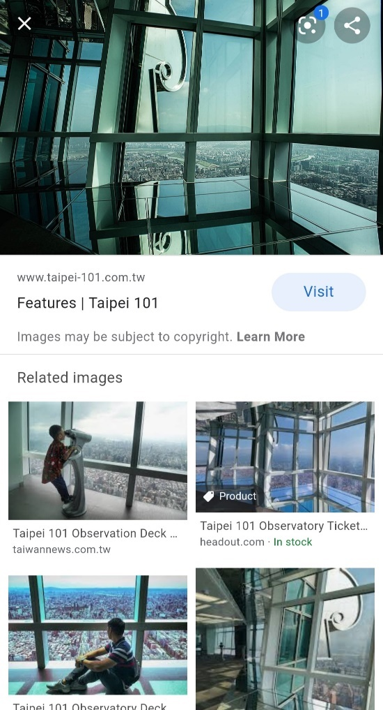
“Mommy, daddy. I budgeted 600 Taiwanese Dollars, which is around 21 US dollars. It is very cheap to visit Taipei 101 Observatory.”
“Wow, sounds like you are a money saver. We are impressed by this idea.”
“Thanks, dad.”
“Show us something that I wrote recently?”
“Go ahead!”
Showing the table of pros and cons of Independent Vacation...
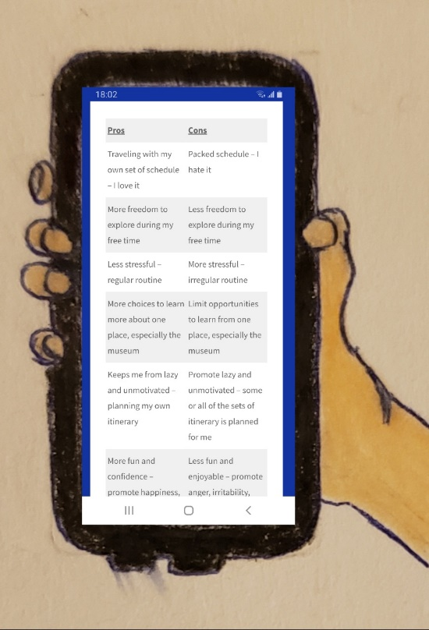
“Wow! did you do this all by yourself?”
“Yes. I did it all, pros and cons of independent vacation based on my experience. This is my opinion. Surprisingly, I have travel experience and can’t wait until it is shared with the public.”
“Good,” thumbs up.
Seconds later, she showed her blog to her parents.
“I wrote this blog about the pros and cons of independent travel, and some of the places are not safe for solo travel, such as Turkey, among others. I have also gained valuable information regarding how I gained self-sufficient skills I needed to live.”
She added her conversation from the blog she wrote.
“In my opinion, I hate to go on a tour, and like I mentioned that tours can be good and bad for me. I love to do my homework because this is what motivates me to desire to...”
Her father interrupts and mentions to her about the Tour back in China.
“Hey United, remembered when we are on tour back in China?”
“Aw, yes, dad. When we went on a tour at Zhengzhou and Chaozhou, China, we listed detailed information based on what they recommended. The itinerary was written in Chinese and barely read from traditional characters. I only read simplified characters, and some of them are not understood. A detailed itinerary helps with stress and relieve boredom. And we had a good time but can’t travel alone in China. I only rely on google and recommendations and put things on my itinerary.”
“Since you love to travel, why don’t you go on a tour where there are only females who are going with us.” Her parents recommended her.
“Intrepid Travel, female travel groups, G-Adventures, etc.” She added.
“Never heard of it. Was it a tour group?”
“Yes. Intrepid Travel is only a group for solo travelers, but some groups are just for girls.”
They nodded and suggested she finish her dinner before having a finished conversation.
“Got Cha!”
Her father mentioned.
“United, I understand the situation, but why don’t you book a tour instead? It gives you a gratifying experience.”
“Not a problem, mom. I knew how to get around Taipei, and I am confident that I enjoyed researching, partially on Google maps or Google. I typed it in “Things to do in Taipei.” I created this itinerary on my own. Yes, Taipei has Google, so it is easy to get around, especially because I can read signs (particularly in English) and know where I am going. Back when I was in Hong Kong, I took off to explore on my own and knew how to get back to my cousins’ place. Overall, I have no problems getting around, especially when I am confident about taking healthy risks.”
Her parents understand her perspective.
After finishing their dinner and helping with the cleaning, she talked about her upcoming trip relating to the ideal itinerary of her personality, Taipei.
“Hey guys, look at my paperwork. Homework is fun because I can explore things I need to achieve my life goals for myself. By the way, I answered the question from my interests, What Activities suit you? with a response based on my personality. And overall paperwork, there are listed emergency numbers included in the paper I download via phone.”
She convinced them.
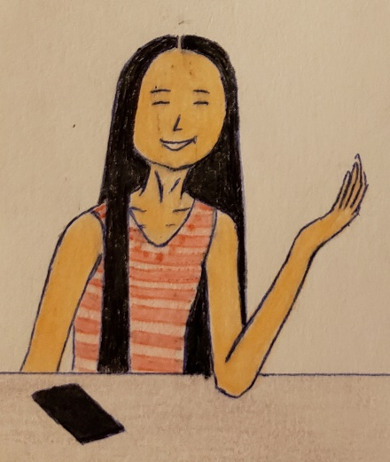
“I understand the worst-case scenario and know in case of an emergency. I realized that if difficult happens, for example, difficulty finding a place, go ask someone who works there for directions. I am trying my best to locate and solve problems not only for travel but also for real-life situations. In fact, solo travel can help me with the problem solver, not just for travel but needed for life, jobs, situations, etc.”
“United, I really understand the situation, but if you take your responsibility for yourself and are ready for it, then I will let you go but only in a safe place for solo travel. For example, traveling to Thailand may not be more suitable for solo travel than Taipei. You might need a travel guide or a tour and have someone to go with you.”
“Thank you, mommy, and daddy, for our conversation. I know that having this conversation about solo travel is a sensitive topic to discuss.”
“Not a problem.”

Minutes later, her parents left home to run errands from friends who exchange vegetables.
Finally, she was relieved when her parents suggested taking increased precautions when traveling solo to certain places safely. Her parents have advised her not to travel to other dangerous places solo due to safety concerns. Some places she researched require packed tours as part of her safety precautions.
“I am blessed that even though my parents are concerned about traveling solo abroad, they told me to take increased precautions because they love and take care of us. I am ready to move onto the next steps. Safety, health, and security are the top priority.”

Later in the evening, she went on a website that offers a tour for female solo travelers. She also planned to book a day trip exclusively for solo travelers.
Logging on the website, she searched Taipei’s tour, and there are only 44. Filtered out to 1 to 4 days, there are only 21 available tours, and some of the dates are out of range for her travel. There are tours from Taipei to Kaohsiung.
Filtered just “Taipei,” there are 15 choices, and most of them are 1 to 3 days. Some of the dates are out of range, so she filtered to “August 2020.”
Hence, there are limited available tours and...
...there are 6 available.
“I realized that I have only 5 days in Taiwan, and a 2-day tour is definitely the only option.”
She found the tour she wanted to join in.
The name of the tour was “2-day Taipei fun excursion of the dream comes true.”
She clicked on the 2-day tour. The available date was every Monday and Thursday. Hence, there are policies regarding the tour as well as the condition.

Looking at the 2-day tour, she saw that there are itinerary for Day 1 and Day 2:
Day 1:
- Tamsui Fisherman's Wharf
- Lunch at Din Tai Fung at Taipei 101 – Experience Taipei’s dining culture
- Taipei 101 Observatory (NT$600)
- National Palace Museum (Optional)
- Vigor Kobo Pineapple Cake Tour (suggest budget of NT$200 if you planned to buy a cake home)
- Raohe Night Market (suggest budget of NT$200)
Day 2:
- Jiufen Old Street and independent excursion (Suggested budget NT$150)
- Shifen Old Street for lunch together and Sky Lantern experience (NT$100-200 based on colors)
- Free afternoon at Shifen Old Street

**Free tour bus will be available to pick up/drop off at selected hostels and to/from the airport.
She wrote on the Samsung note, “Suggested budget: NT$1,400 (equivalent)”
Underneath, it said that the max people are 12 people who are over the age of 18 and are female solo travelers. Surprisingly, only 5 people booked on this tour for the date she selected: August 27 and August 28.
*Note: This tour is exclusively only for travelers who stayed at selected hostels in Taiwan.

Surprisingly, the hostel she will be staying in was available to pick her up for the solo travelers.

Reading the full information about the tour, she was surprised that the tour was covered with the basic emergencies, such as health coverage not covered overseas.
Clicked on the button, “Book now,” she prepared the debit card for the payment.
Finally, she booked a tour with a cost of $58.
After that, she sent off her email. Her email includes detailed information about the 2-day tour she booked.
Checking the email, she saw that her upcoming itinerary was in her email inbox...
...and off to bed.

It was a beautiful Sunday (June 28) as she was off for the weekend, preparing to go to the church with her father and brother.
Driving to Chinatown, they parked near the church.
Walking to the church sanctuary...
She also planned to take a Regional Rail to Malvern with her friends. They will eat lunch at Malvern Buttery and hang out for a bit.
“They texted me before breakfast.”
Just then, her family’s friends came to the church to sit together.
Stand up to sing...
...and then the church service.

During the service, she checked her email (Gmail). In the “updates” section, she found her upcoming itinerary (airfare) has changed via email. Her flight time to Taipei was changed from 11:10 to 10:10, and the plane’s fleet changed due to an increase in travel demand. It was sent via United with detailed information regarding the change in the plane fleet.
“It was the plane’s fleet to Tokyo, which will be a layover for about 4 hours.”
Smiled herself...
She already made her hostel arrangement last month after her parents have recommended; she stays safe when staying at the hostel after negotiating with their safety plan.
Off to the transportation app, she checked the time departing from Jefferson Station. It leaves at 11:35.

After the service, United joined with 2 girls to the train station to buy a ticket. United was the only girl with her Monthly pass with her weekend privilege.
Off to the Regional Rail to Malvern, she sat with two church friends, Sistine and Candy. The train was 5 minutes late and was at 30th street after her phone returned to the signal.
United had a conversation with the 2 girls about her upcoming Taipei trip and her upcoming trip in August. They were surprised by the fact that United planned to travel abroad in forthcoming months.
“Enjoy your trip, United. I have not been to Taiwan.” Candy complimented.
“Want to visit there someday.” She added.
“Thank you so much. We will pray for me.”
“Certainly,” Sistine added. “We will.”
She put her hands on her chest as more passengers boarded the train, heading westbound to Malvern. United felt relieved.
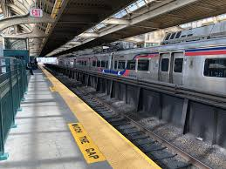
The train left the 30th street, heading westbound.
Laughing out loud, they enjoyed the ride on a new train set from Jefferson Station to Malvern.
Some passengers with luggage or carry-ons that just came back from the Amtrak or Airport line are going home. There are not many students from Villanova University because of the summer break.
“Looks like there aren’t too many kids out there,” United commented.
“Yep, I think that there are too many passengers going on a day trip, eh,” Sistine replied.
“Malvern! Ardmore! Hey Sistine, have you been to Ardmore?”
“I haven’t been there, and one day will invite me for...”
“It is a nice outdoor mall.”
“Yep! There are some boutique shops, Starbucks, etc.”
While Candy hasn’t been to Ardmore, United has a little time to plan until after her Solo Taiwan Trip.
Riding on the train to the next station (Overbrook), they waited for the next Amtrak train to come to the same route to Pittsburgh.
On the other side, United heard one passenger was acting up. Simultaneously, the train stopped for 6 minutes because another train emerged on the same route.

Arriving at Malvern (last stop), they got off the train and headed to lunch. They are all hungry.

Eating their lunch at Malvern Bakery, they chose the food they loved to enjoy, such as bread, all-you-can-eat food for a fee, and an abundance of drinks they decided. They sat together and chatted.
Excellent music overheard the customers. They enjoyed a lunch breeze.
...and then hang out at Malvern.

Pretty soon, at 15:30, they took the train back to Jefferson. Sistine drove the car to drop United and Candy at home in Northeast Philadelphia.

July 2020
A day at Temple, she really takes risks of helping the co-workers with all participants’ paperwork. She worked until 18:00 and headed home via SEPTA. After working all day at Temple, she was tired, coordinating the day trips, including hiking, city tours, etc., for the participants.
“The day was long, and I can’t work that no more. Hence, I was there from 8am for the participants’ day trip to Wissahickon Park. We need proper gear and fashionable outfits for a hike. I was a specialist, with instructors and a tour guide’s expectations. Also, we counted everyone in the group.”
At home, she was a bit tired. Showering, she washed her hair because she was sweating while her mother cooked a quick dinner: Bitter Gourd with eggs, Chicken breast, and wild rice. Finally, her mother cooked some sauté carrots and onions for the final preparation.

The next day, she was off to work 2 jobs and worked hard to gain her work incentives. She earned free makeup for her work recognition. She was blessed and can’t wait to go home to show it to her parents.
Her free makeup includes Estee Lauder and other cosmetics items together in the bag.
“I am proud of myself that I like to work hard and smarter.” She clapped when riding on the bus to Temple for her afternoon shift.
Her parents were very proud of her, recognize for her hardworking, and her dedication.
Working at Temple until 16:30, she took the SEPTA bus home, excited to show her parents’ work achievements.
Unfortunately, both parents weren’t home. They finally off work, commenting home just in time for dinner.
She started to cook a quick dinner with her brother and sister, an intern at the LaSalle Lab, working hard.
“Rich, let’s put off until it gets done.” United taught him to cook vegetables.
“Okay!”

It was 18:11 as the sun shines throughout Philadelphia and...
…United awaits her weekend to update her itinerary since she was busier with the work to earn her living.
Minutes later, her parents arrived home to eat dinner and...
...there were bok choy, sautéed chicken breast, and steamed veggies and baked spinach cheese.
Then, they ate together, discussing her exciting news.
“Mom, Dad, I earn a free bag for hard work.”
“Really, good job! God bless.”
“Bravo!” Her father complimented.
“Thank you.” She padded her hands into her chest.
Smiling at her parents, she ate slowly, while her father ate his dinner fast that he wanted more veggies.

Waiting for the first weekend in July, she planned to update by using her itinerary by creating her revised itinerary. She reviewed the itinerary back in April/May and wanted to revise her itinerary before departure. It was then she opened the Excel and created her new itinerary, using the preexisting Excel.
Heading to Atlantic City, United, and her family dreamed of the beach for the day.
She was then put off her assignment to play with the waves with a bunch of people (some in swimsuits) and others in old clothes.
United and others enjoyed the day off at the beach and...
...her church friends enjoyed it too.
Soon after she finished playing with the sand/water, she relaxed on the beach chair and took a nap in the shade. Feeling hot, she was sweating, with her mother and other church friends chatting.

The next day after church,
Her laptop computer...
She finished changing the itinerary, moved some of the activities before or after the day of the intended activity.
“I know that I-Powers Travel isn’t guaranteed that the trip is well planned. Some revisions are based on existing factors like budget, weather, duration of activities, and emergency. Things you need to think about it.”
Moments later, she finished her itinerary onto the revised itinerary and then the revised budget. Finally, she saved the new Excel document as “Taipei Revised Itinerary” and off to walk around downtown Philadelphia before heading home.

Sunday evening,
She reviewed the I-Powers Travel worksheets, including the climate. She did her homework about which items to pack on her solo trip during the humidity Taipei trip.
Checking the weather, Taipei's daytime weather is around 30 to 32 degrees Celsius (26 to 28 degrees Celsius at night) with exceedingly high humidity and storms (typhoons). She planned to bring her umbrella just in case it rains.
She made lists of things on her packing list, including umbrellas, rain gear, and flip flops as essentials for the summer trip to Taipei.
She already packs some summer clothes with some sweaters due to air conditioning in a hostel dorm room.

While her mother and her brother went out with their friends, she and her father at home. Her sister was out with her friends. Playing with the computer, she cooked dinner for two.
Preparing dinner...
She recreated her itinerary days earlier (due increase in Tour days) and showed it to her father.
Eating dinner, her father asked her about the trip again.
“United, why did you take a trip to Taiwan when you have a part-time internship?”
“Because I really like to travel, and when you travel together, I am feeling uncomfortable going on a vacation with tough times. Look at the people watching you? They will watch you overreact, and I felt extremely uncomfortable traveling with you. What do people think about you?”
Her father didn’t do anything literally.
“What is inappropriate when you act that way. People tend to stay away from you.”
She continued to convince her parents.
“I don’t feel like going on a vacation with stress. I just want to have a fun time. I just want to know that I only have only 2-3 paid weeks off because of the internship, and this is the only available internship I worked on. I understand the situation that needed to concentrate on the job instead of thinking about Taipei’s vacation. I worked hard on the internship that the manager has offered me 10 days of paid time off this time, so I am only taking 7 days. No penalty for that, but there is a penalty for taking more than 15 days without letting the manager know my vacation plan.”
“I understand the situation, and your priority is to work hard, earn money so you can travel. We love and care about you and us.”
Her father finally accepted her point of view but sometimes gets his nerves. He sometimes gets in his way, not her way.
Here is the emergency number she listed on the I-Powers Travel Paperwork.
For Taiwan, here is the number to include in the emergency kit:
- Emergency and non-emergency
- Police: 110
- Fire and Ambulance: 119
She also includes her doctor’s contact information into her phone and personal data in case of an emergency.
“No matter if you are going with your friends, family, etc., always have your emergency number, including your doctor and medical information. That way, in case of emergency and you need a call, the number is right here to call.”

After negotiation leading up to departure, her parents still reminded me to be extra careful, even though they were concerned about solo travel. She was delighted that her trip was worked out very well, and she was aware of the safety precautions.
“All you have to do is to research safety tips, apply them, and know in case of an emergency. I am telling you; solo travel can be rewarding if you take this seriously. No, kidding.”
Using her trip model called “I-Powers Travel,” she applied not only on her upcoming Singaporean trip but also on Taiwanese vacation. She holds onto her Singapore to 2021 or 2022 due to budget constraints and the time of the year. Since she has over a year left before her Singaporean travel, she worked hard for the job she loves.

Sunday afternoon, on July 12, she was excited to visit the library to borrow a book about Taipei. She also read some women's travel books, summarizing the trip's importance via the I-Powers Travel worksheet she was currently doing.
She studied dos and don'ts in Taipei on Dos and Don'ts worksheet.
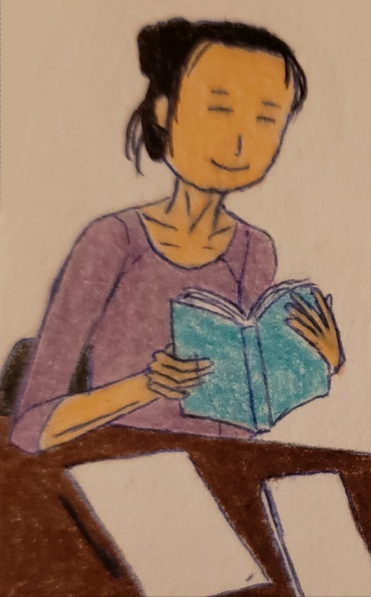
With the limited time at the library, she checked out one book. The due date was on August 2nd, 3 weeks before her departure.

She updated the dos and don’t worksheet to remind herself of what to expect or abstain from manners at home.

Toward the end of July, she had her informal conversation about how to get to the airport.
“Dad, I got a question? My flight time is 10:10 in the morning, and I’m not really sure if you can drive to the airport because you have work on this day. I booked a flight with the cheapest airfare of $719, which is the only cheapest on this day, Monday. And on my return flight, I will arrive at Newark at 7:25 evening. I am not certain if I want to book a shuttle and...”
“Okay!”
“I don’t think it’s work on Monday because you have work, and you understand that the time to drive me to the airport is not convenient because it’s early in the morning. And my flight time is 10:10 in the morning and... Sunday is work for you to pick me up at the airport.”
“United, don’t worry, daddy will pick you up at Newark, but I can’t drive you to the airport because I work on this day. Why don’t you find alternative transportation to the airport, okay?”
“Okay, dad.”
“United listen, mommy and daddy care for us. We want you to protect us, care for us, and nurture us. That is the reason why we were born to 3 beautiful kids, all grown up.”
“Thank you, mommy. That is a blessing to us.”
Smiling, her father did not know when was the last time to book an airport shuttle nor the name of the shuttle. It was almost 2 years ago.
“Guess what I found on the website?”
“What?”
“Shuttle Fare, the shuttle from my home to Newark Airport Term C costs $75.”
“Ah, that is not bad. It’s 75 dollars.”
“I think that you book for the three of us, and I think it’s $300ish, so I found this shuttle and found it’s cheaper.”
“Wow, looks like you are finding a cheaper shuttle, eh?”
“Yep, yep!”

After sweeping the floor, she finished a conversation and headed upstairs to book a one-way shuttle at shuttlefare.com.
Typing pick-up and drop-off locations, she entered the dates and the flight time. Loading up the available shuttle, the cheapest one was $75 (Shared Shuttle Van Super Trans).
Selected the cheapest shuttle with a click “Book One-Way,” it was notified with a booking fee of $5, which costs $80.
Entering the payment information, she clicked Book ride for $80.00.
They ask her to log onto the account to complete the reservation.
With her shuttlefare.com account, it makes checkout easier.

Seconds later, it stated on the laptop screen,
**** ******** **, Philadelphia, PA, USA to Newark Airport (EWR)
Order Summary

Pick-up: **** ******** **, Philadelphia, PA, USA
Drop-Off: Newark Airport (EWR), Terminal C
Passengers: 1
Luggage: 1 bag
Date: Mon, August 24, 2020
Flight Time: 09:30 (09:30 AM)

“Whew! My process is almost completed. I still have to book an airport shuttle in Taiwan and travel insurance because what if something happens like sickness or travel disruptions.”
She scheduled to book an airport transfer in Taiwan too.
Because a taxi to the hostel is expensive (NT$1,100 or $38), she successfully found a cheaper shuttle to the hostel: KKday.
On the website (KKday), she founded the ideal airport shuttle from the airport to the place she wants to drop her off. The shuttle will take her directly from the airport to the hostel.

Scroll down, it states on the webpage:
Product Info
*Booking time slots are just a rough estimation for reference, e.g., if your desired pick-up time is 12:15pm, please select the 12:00pm session. If the desired time is 11:40pm, please select the 11:00pm session and so on. The actual pick-up time is subject to your flight departure/arrival time.
－Highlights－
・Enjoy a private transfer between Taoyuan International Airport (TPE) and your chosen location within Taipei City and New Taipei City areas
・Avoid long taxi lines at the airport and crowds in mass transits
・Select from different types of vehicles according to your requests
－What You Can Expect－
Avoid hassles of public transportation and make the most of your time in Taipei and take advantage of a private transfer. Greet your friendly driver at the lobby upon your arrival.
Unwind in the backseat of the car while being driven to your destination. Once your trip is over, you can book this service again. Your driver will pick you up from your hotel or chosen location and take you to Taiwan’s Taoyuan International Airport (TPE).
Enjoy this convenient transfer service and improve the efficiency of your trip. Book now!
－Important Info－
・Service Hours: 7:00am - 9:59pm (an additional fee of NT$100 will be charged if you require transfer service beyond service hours)
・Meeting Point: Taipei City, New Taipei City, or Taoyuan International Airport
[Hotel to airport transfer]
・Pick-Up Time: your driver will arrive at the pick-up spot 3 hrs prior to the departure time of your flight. Driver's info and license plate number will be sent by "Messages" before 8:00pm (GMT+8) on the day prior to departure
・Waiting Time: A grace period of 30 mins will apply for hotel pick-up (i.e. for pick-up time of 2:00pm at the hotel, your driver will wait for you until 2:30pm). If you do not arrive within 30 mins, you will be considered a no-show and forfeit service without refund
*For travelers who requested specific pick-up time in the "Note" section when booking, a grace period of 30 mins applies
[Airport to hotel transfer]
・Pick-Up Time: the drivers will be waiting at your flight arrival time, holding a sign with your name
・Waiting Time: A grace period of 90 mins will apply for airport pick-up (i.e. for pick-up time of 2:00pm at the airport, your driver will wait for you until 3:30pm). If you do not arrive within 90 mins, you will be considered a no-show and forfeit service without refund
・Early arrivals: Driver will wait 90 minutes beginning from the updated time of landing
・Late arrivals: If within one hour of original arrival time, your driver will wait 90 minutes beginning from the updated time of landing
・If your flight delays over 1 hr, please contact KKday customer service to rearrange your transfer service. If no rearrangement can be made, we will provide you a full refund
－ Vehicle Info－
・5-Seater Car
- Capacity: Max. of 3 passengers and 3 pieces of 24-inch luggage
・9-Seater Car
- Capacity: Max. of 7 passengers and 8 pieces of 24-inch luggage
－Additional Info－
・No surcharge will be applied for the following districts:
- Taipei City: Zhongzheng District, Datong District, Zhongshan District, Songshan District, Daan District, Wanhua District, Xinyi District, Neihu District, Nangang District, Wenshan District (except for mountain area), Shilin District (except for mountain area), Beitou District (except for Yangmingshan area)
- New Taipei City: Banqiao District, Yonghe District, Zhonghe District, Tucheng District, Sanxia District (except for mountain area), Shulin District, Yingge District, Sanchong District, Xinzhuang District, Taishan District, Linkou District, Luzhou District, Wugu District, Bali District, Neighborhood of Xindian Interchange
・There will be additional charges for the following destinations:
- NT$300: Shilin District (mountain area), Tamsui (except for Shalun), Maokong, Xizhi. Shenkeng, Xindian, Bitan, Ankeng, Wenshan District (mountain area)
- NT$600: Yangmingshan, Wulai, Shalun, Wudu, Ruifang, Jiufeng, Keelung
- NT$1,200: Wanli, Jinshan (including Tien Lai Hotel on Yang Ming Mountain), Shiding, Pingxi, Sanzhi, Sanxia District (mountain area)
- NT$2,000: Shuangxi, Gonglia
・Children under the age of 4 are required by Taiwanese law to use child seats; failure to do so will result in the service being void, and refunds will not be granted
・Child seats for children under age 4 are available, please notify in the 'Notes' section if needed; an additional fee of NT$200 per seat will be charged on-site, directly to the driver
・For multiple stops within the same district, an additional fee of NT$100 per stop will be applied; for multiple stops in different districts, an additional fee of NT$200
- NT$1000 will be applied. Exact fees will be printed on the voucher
・Please note that 1 car seat occupies 1 seat
・For travelers with airport pick-up, in the event that 90 mins of waiting time is exceeded and the driver is still willing to proceed with pick-up service (30 mins for airport drop-off), additional fees of NT$300 - NT$500 will apply for additional waiting, to be paid on-site directly to the driver
・If you would like to include any specific information on the sign of the sign-holding service, please make requests in the "Note" section when booking
・The package should be booked at least 4 hours prior to departure or arrival of the flight
・If you book the service on the same day of using it, please place the booking at least 4 hours prior to flight departure no later than 6:00pm (GMT+8), and provide required personal info when booking
・Please select your flight arrival/departure time based on a 24-hour clock or notify us of your preferred pick-up time in the "Note" section when booking
・Booking time slots are for reference only. The actual pick-up time is subject to your flight departure/arrival time
・If you wish to be picked up at another terminal different from the designated arrival terminal of your flight, please notify in the "Note" section when booking. Surcharge of NT$100 applies if changes in pick-up point are made on-site. Fees are to be paid directly to the driver

First, she read the entire information (Product and Important Info) before booking the airport shuttle. When she read additional information, she was surprised that the hostel she will be staying in is located in Wanhua District. Hence, there is no additional surcharge between the hostel and the airport.
“Same as a hostel, airline, and other bookings, it is important to read full information, including additional information to give me a sense of what the product or service wants. It includes additional costs for the additional items onto the shuttle, including car seat policy for the little kids, accessible, etc. If I don’t read the information, I don’t know what the product or service is about, and I get confused. I will screw up if I don’t read this full information.”
Scroll down; there are two options: Taipei or New Taipei Airport (1-3 travelers) or (4-6 travelers). Since she traveled alone, she chose (1-3 travelers). Then it takes to the package options, which includes what time is her flight arrival and departure.
Underneath, it said:
Booking time slots are just a rough estimation for reference, e.g., if your desired pick-up time is 12:15pm, please select the 12:00pm session. If the expected time is 11:40pm, please select the 11:00pm session, and so on. The actual pick-up time is subject to your flight departure/arrival time.
Below, it said on the Package Details:
- Free cancellation 2 day(s) prior
- Instant Confirmation
- Voucher received within 1 working day(s) (Public holidays and weekends not included)

She selected August 25, 2020 at 21:00 (9pm) and August 30, 2020 at 06:00 (6am).
Since her flight arrival is late evening and departure is early in the morning, she decided to book a round trip with the cost of $57.88.
Sign up for the account, she completed her reservation.
“I can’t arrive in a new destination late in the evening because I will travel solo, a sole woman, and better to take an airport shuttle to get to the hotel or hostel. I don’t feel safe at night alone in secluded places. That’s my protection. If I arrive by daytime or early in the morning, then I can take public transportation there. Remember, arriving during the day is a safe bet.”
Just then, she has also scheduled to book travel insurance and prepare for the departure by observing dos and don’ts from the worksheet.

August 2020
Just then, she reviewed the trip itinerary and the customs where Taiwan's culture was traditional and conservative. While she was on the way to her afternoon shift, she relaxed on the bus, preparing for her Execution Process in the I-Powers Travel cycle.
From using traditional table manners to avoid talking about sensitive topics, she was preparing for the trip for 6 days. Since she was reviewing the expectations, she was aware of the situations where some residents and visitors get offended. People in Taiwan usually don't get offended or get upset. She also doesn't like others to get offended and learn the mistakes she learned.
In other words, Taiwanese people are generally polite yet save different feelings when one's upset or offended.
Reviewing dos and don'ts of traveling to Taiwan, she was doing the execution section, were practicing/preparing days before departure.
“Now, it's time for review days before departure.” She said while finishing the execution section (5th in the I-Powers Travel Process).
While she was at work at Temple, she put her travel preparation until the end of the shift, around 16:10 instead of 16:30, which her supervisor had requested for her early leave. She also planned to run errands at the grocery store to buy some vegetarian meats.

Several days later...
Before she left for abroad, she planned to register for the Smart Traveler Enrollment Program (STEP). Entering the travel information onto the database, she will remember the location and the contact information with the embassy just in case of emergency, e.g., a lost passport.
At step.state.gov/step/, she logged in, entered the information, including the destination for her vacation. She also fills out the detailed information and emergency contact, including her parent’s name and phone number.
“I am making sure you need to register with the embassy, which includes the governmental traveler program, such as the Smart Traveler Enrollment Program (STEP), every time I leave for the trip abroad. Emergency contacts are important for all travelers, even savvy travelers like me.”
Checking the weather for upcoming trips, Taipei will have a strong chance of rain and/or thunderstorm all week while traveling abroad for 6 days, including 2 days on tour for women solo travelers. She predicted her updated packing list, which items to bring, such as umbrellas, rain gear, just in case it rains.
“I realized it in Taipei, it rains most of the day of the week amid the Monsoon season. The weather will be hot and humid. Since I will travel in the upcoming days, I am making sure to check the weather before packing for the weather.”
She was also scheduled to buy travel insurance before departure by thinking of the different travel needs. Hence, there was more than one type of travel coverage for the needs depending on the travelers’ needs. Because she only visits the city, Taipei, she only purchases a lessor coverage, e.g., Medical Coverage, rather than the comprehensive coverage for the adventures/sport activities.
Googling “Travel Insurance,” she founded the website sevencorners.com and clicked on it. The trip insurance has a purpose.
Click!
On the website, they asked her about the purpose of the trip.
On the middle of the screen, it said;
- Need Help Selecting a Plan?
- Answer a few questions and we’ll guide you to the right travel insurance plan.
The arrow points to the right and...
She clicked on the word “Internationally” and “Travel Medical Plan” since she had some coverage to cover for her flight included in the airfare.
Selecting the state she lives in, “Pennsylvania,” she researched which coverage best fits her ideal itinerary.
She also has basic necessities for the 6-day city trip, which do not count as extreme sports or equipment loss. She will tour or explore the urban area with a minimum risk.
“If you are planning to go on extremely demanding activities such as rock climbing or skiing, then you will need additional coverage for that matter. For my upcoming trip, I don’t need that because it is costly to purchase items that I don’t need, and it wastes money.”
She added again.
“Since I purchase my flight and hostel with a total of $810, I do not need to purchase a Trip Protection Plan mainly because my flight to Taipei is less than $5,000 (flight, hotel, etc.) and I only tour in the urban areas with some solo groups guiding me. Here are the reasons:
My trip lasts 6 days and,
My trip to and from Taipei has covered some necessary costs relating to preexisting coverage from third parties such as Credit Cards with some essential trip protection and interruption.”
After the comparison, there are three options to choose from, ranging from $17.10 (Liaison Travel Basic), $17.40 (Liaison Travel Choice), and $28.40 (Liaison Travel Elite). Hence, she selected the coverage on the left.
- Medical Maximum: $100,000
- Deductible: $250 (after she checked her health coverage)
- Hazardous Activities as Declined (Her city trip doesn’t include hazardous activities for solo travel)
“From travel medical insurance, hazardous activities include SCUBA diving, rock climbing, extreme sports, etc. You will need this coverage if you participate in hazardous activities and will pay more for this kind of coverage.”

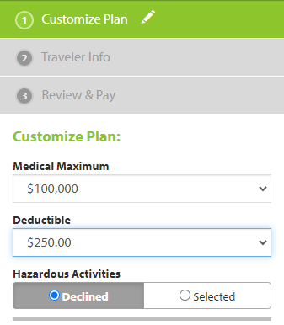
Reviewing all of the information needed for travel, she made her informed decisions if she wanted either Basic or Choice.
She selected the Liaison Travel Choice, entered personal information, and paid $15.24 via debit card, well below her intended budget of 10% out of $810 ($81) from the actual costs for both flight and hostel booking.
Checked everything out on the countdown to departure worksheet, she was relieved that she spent within the budget.
“Keep in mind that Medicare and Medicaid don’t cover costs overseas, so it is important to consider a Travel Medical Plan from the website so that in case of emergency. It can cover basic costs such as medical costs when you are abroad, emergency costs, and others that don’t cover the costs on Medicare and Medicaid entirely. That is the reason why I need to travel medical insurance abroad, especially for travelers with either Medicare or Medicaid and those for the immigration requirement, health insurance coverage for aboard.”

She was ready to travel for 5 days. She packs her passport, state ID, and other essential documents and the I-Powers Travel worksheet she answered while researching the activities she loves, stored in the red backpack. She remembered she answered briefly the question about “What Activities suits you?”
She answered previously.
“I am an explorer with the right purpose of seeing a beautiful scenic view of beautiful places and attractions. I am fascinated to explore areas or famous landmarks that benefit me to learn more about places such as “highly recommended places.” I am also enjoying shopping, exploring, and being a sense of adventurous. I am a good fit for this ideal itinerary. These activities, such as day tours, rides, museums, and things, help me to motivate me to learn more about the places, inside and outside of my comfort places.”
Reviewing her itinerary, along with the worksheet “Upcoming Trip Questionnaire,” She was able to review her intended trip as part of the trip preparation.
Indeed, her activities matched the question.
Organizing her travel materials into the folder and into the backpack, she was ready to go.

Working hard for the blog, she was ready to publish before her departure.
Her Singaporean blog was published on August 21 about the example of the trip planning with comprehensive details. She almost forgets to post her beautiful blog.

Sunday, August 24,
The day before, she checked in on her airline’s app at the service but forgot her passport. So she planned to check-in for her flight after she arrived home from both church and outings.
“Checking in my flight online saves me some time. Rather than standing in long lines, check-in online before the flight saves time. The check-in is available 24 hours before the flight time. Without checking in before arriving at the airport, it takes about an hour or longer if during peak travel times or 30 minutes during other times. Member or non-member of the airline, I am introducing other travelers to check-in online if you don’t like to wait longer with the long line of people at the check-in counter. Overall, it is also convenient for us and to save some travel time to wait in line.”
At the Starbucks café, she was ordered a green tea latte and a lunch (spinach, egg wrap sandwich). She sat down at the table, turned on public wi-fi, and kept it a secret (sensitive information) until she arrived home.
She will not go on her personal banking information nor enter any sensitive information until I get home to check how much money she has or log onto websites.
“I know that the ransomware happens not only in Philly but around the world where all of the sensitive and my files have gone unless you pay a lump-sum price to retrieve my files. So, I only use my portable charger rather than a public outlet just to protect myself and my data.”
Eating her lunch, she remembered when she was at Ardmore, PA, for her church friends’ lunch date. It was posted on her photos around Suburban Square and including the Ardmore Bridge (Main Street).
It was one year ago.

Eating and sipping a cup of matcha green tea latte...
…and took her paper about the weather.
Minutes later, she checked the weather (Google: Weather) for the 5-day trip to Taiwan, and it looks like they have a strong chance of rain and thunderstorm on some days.
- August 25: High 100, low 88, sun with some clouds
- August 26: High 100, low 85, partly cloudy
- August 27: High 95, low 80, cloudy, then periods of rain with thunderstorms
- August 28: High 96, low 82, sun, then cloudy with rain afternoon
- August 29: High 95, low 84, mostly cloudy with some sun, some light rain
- August 30: High 97, low 83, sun with some clouds
“It is important to check the weather a day before you leave to conform to the actual climate of the place you will visit so that my trip won’t end in disaster. Even though you checked the weather before, you may want to consider rechecking the weather a day before departure to confirm my last-minute pack-ups to not have to put on my stress related to my pre-trip preparation. I already pack my umbrella in my carry-on, along with my summer clothes suitable for the Taiwanese hot summer climate.”

Back at home late in the afternoon...
Showering and washing her long hair...
…and then helped with the cooking with her brother.
She ate dinner with the family together, chit-chat about daily life, and then helped with cleaning the tables, chairs, and floors.
After taking out the trash, she went upstairs and then opened the app and reviewed her I-Powers Travel working paper about tips she experienced.
“I am excited to travel alone for 6 days/5 nights instead of 4 nights because of the airfare flexibility. I also learned about the awareness of a young woman who traveled solo last month by providing testimonials to the solo travelers’ audience.”
She went on the United Airline’s app to check-in, scan her passport, and enter her checked bags onto the flight database. She checked no bags since she only brought one carry-on. Before going to bed, she has her flight information in the airline’s system.
She already finished packing her clothes for the trip 2 days before the departure.

Sleeping for 8 hours, she woke up with her excitement.
It was early in the morning, as she felt tired. Her pink luggage was downstairs while she chose her clothing for her flight. Today, she wore her denim shorts with a cute striped top. She also wore her long hair down.
Before not long, she already brushed her teeth, washed, and did her face, and the cleaning of her face.
Checking her room, she leaves after fixing her bedroom.
She went downstairs with her red backpack.
“Good morning, United!”
“Hey! Good morning dad.”
“How are you feeling?”
“Okay!” He danced in front of his desktop computer.
A 30-second YouTube commercial, he added.
“Listen, since I have to go to work, I can’t drive to the airport today but will pick you up at Newark.”
“No problem, daddy.”
“What time is your flight? I can’t remember.”
“My flight is around 10:10 since my flight time has changed. The shuttle will pick me up at 05:00.”

Eating her quick breakfast, she sent her flight itinerary to her father to remind her of flight times (departure and arrival). She drank a hot cup of matcha tea latte.
Her mother soon came downstairs, felt excited but prayed for her daughter to have a safe trip.
Mother’s blessing gave her a big hug while telling her to have a safe, enjoyable trip.

Her mother gave her a big hug while her phone rang.
It was a shuttle to Newark.
Picking up the phone, she answered it.
“Hello?”
“Is it a passenger United Acela Tse?”
“Yes, I am.”
“This is Jennifer speaking. Your airport shuttle is arriving at your address **** ******** **. is that correct?”
“Yes, it is my home address. I am coming.”
“See you shortly.”
Hanging up the phone, her mother and father gave her one big hug and a kiss before leaving the house.
“The shuttle arrived. Mom, Dad, I gotta go to the airport.”
“Okay sweetie, be careful. Mommy and daddy love you so much... God is with you, okay?”
“Okie, I love you.”
“I love you too, be careful when you are in Taipei. Send us some pictures so that we can share it with us.”
“Thank you, mom, and dad.”
“You got everything, including your passport, your state ID, your important travel documents with you?”
“Yes, mom, dad. See ya when I get home. Do you receive my email about my flight itinerary?”
“Yes, I did. See ya later.”
As she stepped on the shuttle bus, her mother and father waved and blew kisses.
The bus departed as her father was preparing to leave the house for work. He sometimes did not pray to himself.
Waiting for the bus/subway to work, he was still thinking about the 3 kids while focusing on his job duties.

While on the way to the airport, she was listening to music and playing on the phone. She sat on the left side of the seat, looking while the bus headed north via New Jersey Turnpike.
It was a bunch of cars and trucks, driving on the 4 2-3 lanes together. There were some Megabus double-deck buses and some travel buses on the outer driveway.
Approaching New Brunswick, New Jersey, she saw some buildings of Withum, hotels, and businesses.
Passing over the Raritan River via Basilone Bridge, she looked like the buildings passed, making them smaller.

At Newark Airport, she arrived safely just before 07:00, where there are some passengers at Terminal C who were waiting in line to check-in for flights. Since Newark Terminal C is primarily on United, most flights are operating, so she will take the airline abroad.
She texted her father that she arrived at the airport safely via WeChat.
“Dad, I arrive at the airport.”
“Okay... have a safe flight to Taipei. And I love to fly on planes, especially I am a United Frequent Flyer member."
"Okay."
"Love ya, (kissing emoji)."
"Love you too."
She checked online and did not check her bag, but only a carry-on (full of summer clothes) for 6 travel days.
Since she received her TSA Precheck, she was allowed to leave her shoes on while screening for passengers for suspicious behavior and/or items that aren’t allowed on the flights.
Showing her passport to the TSA officer, she was ready to scan her boarding pass on her United Airlines app.
“I am ready to go.”
Smiling.
She felt excited while passing through the security checkpoint. “Here!”
There are lots of passengers who got through the security checkpoint, compliance with the 3-1-1 rule. The passengers leave no doubt of bringing any forbidden items except empty, non-glass bottles onto carrying on.
United went through the security smoothly with her red bag, a sweater, and a pink carry-on.
Smile with a pretty face, she gathers her personal belongings.
Fortunately, her navy, empty collapsible water bottle was allowed in her carry-on. Heading to the gate, she looked at the flight information where the flight was located.
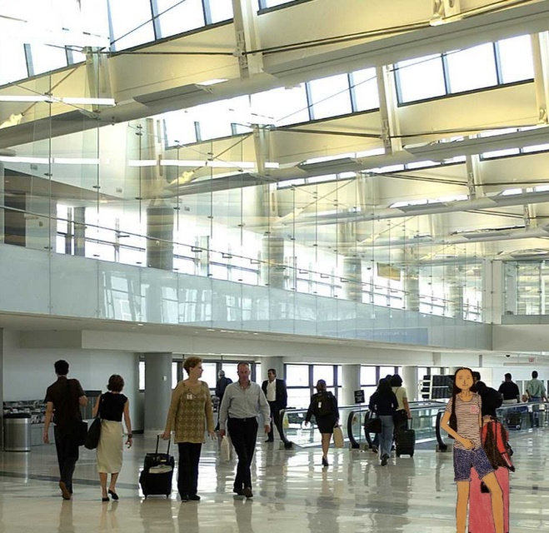
Heading to the Terminal C gates, she headed to the departure lounge, and some of the stores aren’t open. Since it was early in the day (Monday), she brought some snacks onto the plane.
She walked around the terminal to get enough exercise before her long flight to Taiwan.

Hours later, announcements have heard and…
Preparing to board the United Polaris passengers, she holds her phone ready to board the plane. She sat in the departure lounge and texted her parents.
“Hi, I am preparing to board the plane.”
“Okay. Be sure to text me once you safely arrive in Taipei.”
“Love ya!”
“Love you too (smiling emoji)”
Minutes later, the economy class passengers board as United lined up to scan with the boarding pass.
She also has her passport with her.
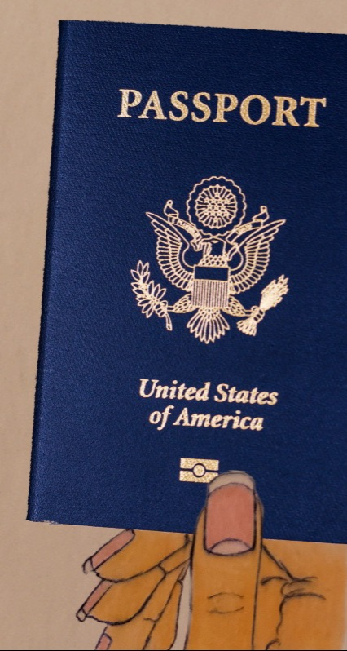
She was boarding the plane along with the passengers.
Scanning her boarding pass via phone, she walked down the jet bridge with her pink carry-on and...
...board the plane with a woman behind her, dressed in denim jeans.
It was then she waited until some passengers got to the seat.


She smiles as she finds the window seat selected after she confirmed her airline ticket earlier in May.
She felt confident about her solo trip again, and this time was Taipei for 5 days. A woman also sat next to United, who was even traveling solo to Japan. She was adorable yet charming.
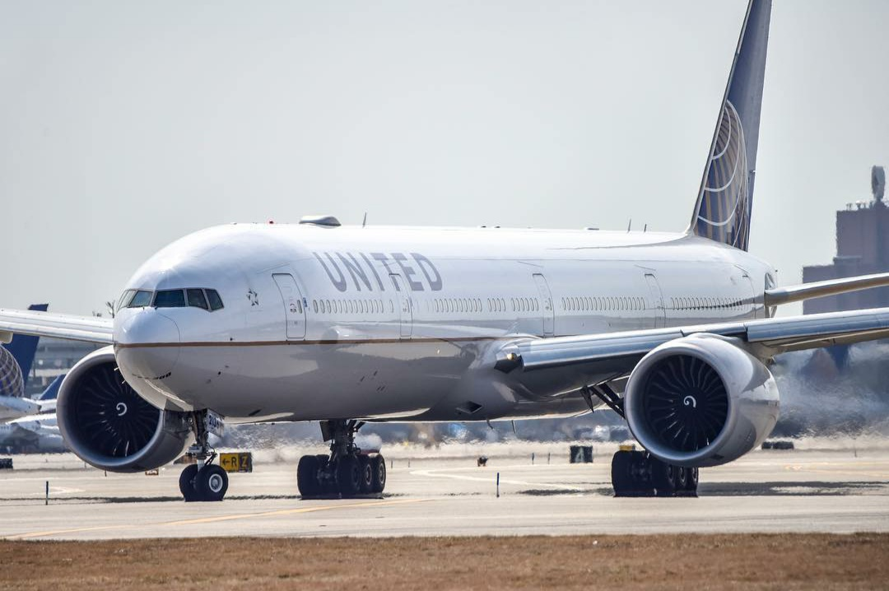
Preparing for the departure, the plane was taxiing to the main runway, heading south.
United seated in economy class as the plane took off from Newark.
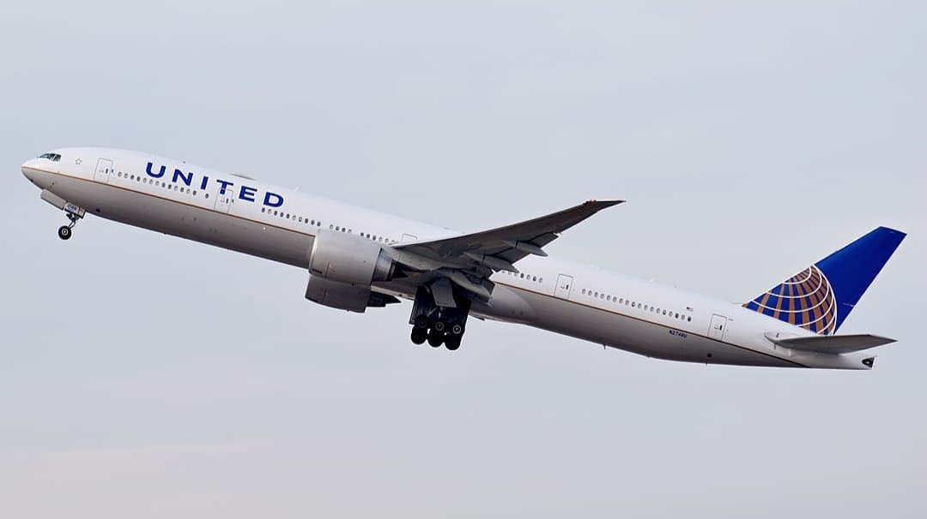

Hours later, after her 4-hour layover at Tokyo Narita...
On another flight to Taipei, she knew how to fill it out on the visitor card. She was very confident to ask for help for clarification relating to the visit.
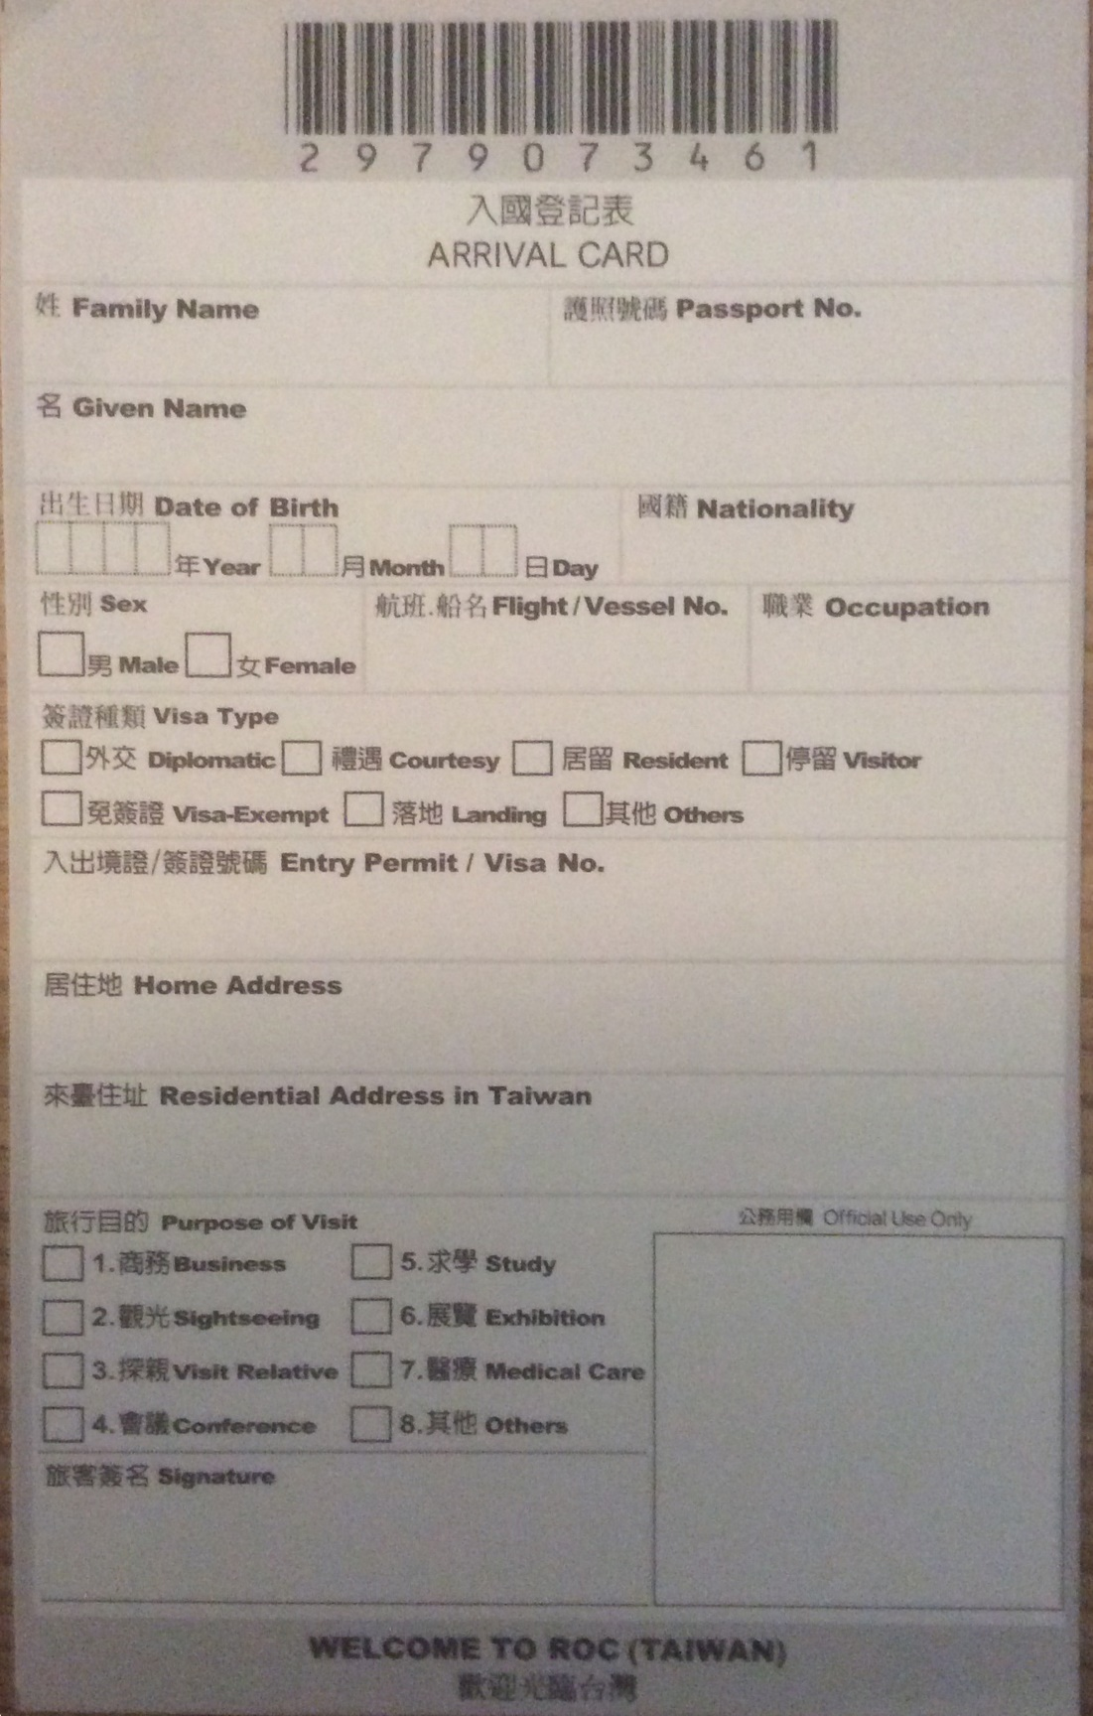
A typical Arrival Card when you are traveling abroad

Filling out her visitor card form in pen, she includes a hostel stay, and finally, her Chinese Signature, along with the English Signature.
- Name: United
- Passport No. ********
- Given Name: Tse
- Date of Birth: **** ** **
- Nationality: United States
- Sex: Female
- Flight/Vessel No.
- Occupation: Blogger/Specialist
- Visa Type:
- Entry Permit/Visa No.
- Home Address: **** ******** **
- Residential Address or Hotel Name in Taiwan: Dan Hostel, No 154, Hanzhong Street, Wanhua District, Taipei City, Taiwan 108
- Purpose of Visit: Checked Sightseeing
- Signature: United Acela Tse (Chinese name underneath)

She also knew how to pass the declaration custom before entering Taiwan for her 5-day visit.

Day 1 - Arrival in Taiwan
21:37 (Taiwan’s local time)
Once she got through the immigration process, the data roaming service received a text message that said:
“Welcome to Taiwan! Your T-Mobile plan gives you unlimited data at up to 2G speeds and texts at no extra cost. Calls at 25 cents/min. Want our fastest data and unlimited calls? Get an International Pass for just $5/day. ... Enjoy your stay!”
Her phone coverage has also given unlimited texts and unlimited data at 2G speeds abroad. Suppose she wants a call, for example, a voice call or a facetime. In that case, she needs wi-fi because it doesn’t cover the primary coverage for abroad but only works domestically.
“Roaming data costs a lot of money, so my phone coverage is covered by basic data needed, and if I want to text, for example, a friend or a family member, I can text at no cost. Calling from home costs money, e.g., long-distance calling, so I only call my family or friends via facetime only on wi-fi.”
She first stopped by exchanging some of the US Dollars for New Taiwanese Dollars. A woman spoke English.
“Hello, I would like to convert from USD to Taiwanese Dollars.”
“Sure, how much would you like to convert?”
“350 USD.”
Seconds later, a woman responded politely, “It’s 10,500 Taiwan Dollars.”
“Sure!”
Finally, she gave 10,500 Taiwanese Dollars in cash and put it into her money belt.
“Money close to my body and store it in the safest place is safer than to flash them out in public. Cash theft does not happen only in Taiwan but around the world. Be sure to bring what you only need and what you need to buy or wants, especially abroad.”
Seconds later...
Then stopped by to buy a Taipei 5-day Fun Pass, deciding which pass is right for her, and paid 700 Taiwanese dollars.

Toward the outside of the airport...
She saw several airport shuttles but hasn’t decided which one is her. It was the airport shuttle, waiting for her for the ride to the hostel.
Minutes later, a driver waved her, and United saw the driver with the hands waving.
It was then she got on the shuttle with just her pink carry-on.

Moments later, she arrived at the hostel safely.
She checked in at the hostel, signing the house rules, and paid the full amount for 5 nights.
Given the room key, she assigned the room and bed number on the 2nd floor.
Once she arrived at her room, she booked her ideal room; it was quiet with 2 other girls.
Observing the room, it was the fantastic view she ever had.
She was making sure to use the locker to store the red backpack.
Locked in her locker, she began to shower once the roommate got off the shower.
It was a female who got off from a 15-minute shower after she set her Wi-fi.
She took her shower with her own pink bath towel.

Relaxing in her room, she was assigned the lower bunk. The two other girls were on the bed. One solo traveler was sleeping while the other was reading a book with the reading light. It was a relaxing movement before going to get a good night’s sleep.
At the bed, she said softly while she was looking at the itinerary she created.
“For me, it is important to get a good night’s sleep, especially if I want to get beautiful on my face. It is also important for my body and health to clean myself during the sleep process. Once I wake up, I am ready for the day. Without enough sleep, I will feel tired during the day, especially when I am in the middle of nowhere. I also get bored at traveling, and I just want to have a fun time in Taiwan, especially I love to travel and explore places.”
Looking at her flight to both Tokyo Natira and Taipei,
“When I was on the flight, sleeping in planes can be difficult, especially when I was in economy class, where there is limited space I have available. Respecting other passengers can also be difficult because the space I have is available to take long naps or sleep. The neck is hurting after falling 4 to 6 hours later. I better use my travel pillow to sleep on my flight. It takes time to adjust my time from one another, passing several time zones. That is known as Jet Lag. Jet Lag is a common symptom for most frequent travelers, especially business travelers who traveled for work that flew through several time zones.”
While her tomorrow’s day itinerary did not happen until 11am, she already planned prior. It was Huashan 1914 Creative Park, where she would buy her street lunch and head to the National Revolutionary Martyrs Shrine. That is the plan for tomorrow she created weeks before.
Sleeping at 23:00, she tucked her blanket.
She slept with her money belt and her passport close together.

Day 2 - A whole new experience at Taipei
A beautiful early morning in Taipei...
Woke up at 08:30, feeling refreshed; she ate a half Special K protein bar (previously ate onboard the flight abroad).
Since Dan hostel doesn’t include breakfast, she brought some snacks and made a cup of coffee.
“Eating a good breakfast is essential not only for travelers but also for life. You must eat enough nutrients and calories to sustain your energy throughout the day. Without proper nutrients, you can’t have the energy to travel, to work, to live dreams, and to do what you want to achieve.”
It was her bag of snacks she brought from home too.
Once she finished her breakfast, she headed back to her room to bring the items she needed for the day.
Leaving the hostel, she said to herself.
“Today, I am heading to Huashan 1914 Creative Park, Central Art Park, National Revolutionary Martyr’s Shrine, and Ximending Walking District to do some shopping and groceries.”
Headed to the nearest subway station (Ximen Station), know how to get around before arriving in Taipei.
She got on the train from Ximen Station to Zhongxiao Station, an 11-minute subway ride.
While she was on the way, she kept quiet as she took the Bannan Line, saw more passengers get on the train at Shandao Station.
At the park, she was happy that she danced at the park, smiling in her hair bun.
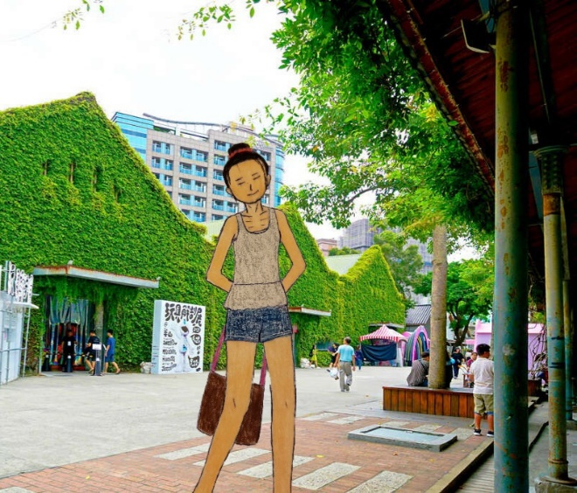
Walking around the park, the cluster of clouds floated around the Taipei area and took some noon breeze. It was time to eat her lunch by buying some street lunch, paying in New Taiwan Dollar.
Heading to the National Revolutionary Martyr’s Shrine via Neihu Line, she got off at the Beian Road, where the entrance was located. She saw that the garden’s scenic view makes her trip come true; remembered one day when she took her 1st Taiwan Trip back in 2015.
“I remembered on the day we went there together with my whole family and cousins.”
On the side of the Shrine, she took the picture. It was the wonderful day of the trip she had so far.

Later that day at around 16:30, she took the Neihu Line to the Ximending Walking district, where the tourist attractions are popular, similar to NYC’s Times Square.
She shopped at various stores. She finished off at the clothing store, buying some clothes as a gift. Suddenly, a store asked her, she spoke Mandarin Chinese and said in an informal, “I am just looking, thank you!” translated.
After she purchased some clothes, she was off to shop for the food she needed for the 5-day trip.
“Finally, I am off to the grocery to buy some food I need for the hostel and tour. Here I come.”
Shortly, she went grocery shopping at the JASONS Market Place to buy what she needed for her entire 6-day trip, including snacks she planned to bring home.
With her reusable bag, she paid NT$679 and carried them back to the hostel by crossing the Boulevard with the traffic light.

At the Hostel Tea & Coffee Facilities, the microwave and the fridge were located. She marked her bag as hers before putting them in the refrigerator. It was 3 packaged foods she brought since there is no stove to cook with.
“Before coming to the hostel, I called or emailed about the hostel’s available facilities, including the kitchen or dining area, and said that there is no stove. I just deal with it since I only am here until the 30th.”
Cooking her dinner in a microwave, she was hungry after her day trip.
“Overall, it is important to ask questions if you are confused or what you are asking, for example, a microwave or a fridge. You don’t really know what it looks like after you check-in at the hostel. The hostel is not a hotel, where there are some kitchen facilities, free soaps, etc. It is not like that in a hostel. You must rely on your own belongings you will pack.”

Then, some solo travelers came to the kitchen and wanted to chit-chat about their travel experiences. United was one of them who wanted to meet a girl. She was shy about meeting her. Thus, she was soft-spoken.
Grabbing her leftovers, she cooked it with a microwave and...
“Hello?”
Smiling neutrally, she greeted, “Hello!”
Feeling nervous, she accepted and responded, “Hey, what is your name?”
“My name is United. What is your name?”
“My name is Jess.”
“Nice name. Where are you from?”
“I am from the USA. You?”
“I am too. Actually, I am from Pennsylvania.”
“Ooo, I have never been there for an entire life. I am from Alaska, where the Eskimos live in the state. What is like in PA?”
“For me, PA is a fantastic county where Amish culture are originated and knew more about Amish?”
“Never heard about it. Who is Amish?”
“Aha, I think Amish is a group of Christians who believe in Anabaptists and are originally from European countries. They speak Penn German or Penn Dutch as the primary language. They are not a typical outsider world like us. It is a different living environment, where they only rely on self-sufficiency as daily life. In summary, they only live in rural areas, away from urban areas.”
“Ahh, gotcha.”
“Okie dokie, tell me more about the Eskimos?”
Talking more about Estimos, United learned more about the culture and rituals.
She was from Alaska and knew some of the Eskimos cultures.
Then, they share the story about their different hometowns: Pennsylvania and Alaska.
Having their conversation enables her to meet new travel friends, and she has a good sense of humor at times. For Jess, it was her overcoming her nerves socially, which helped her to overcome her nervousness.
“When you meet new people, don’t discuss personal information, including family, sensitive information that people do not like to talk about. Instead, talk about where you are from, the places, weather, and food.”

At around 21:35, their conversation ended as Jess’s mother had called her (via Facebook Messenger).
Returning to her room, she showered, brushed their teeth. Once she was out of the restroom, she took out the clothing for the next day. She also took relaxing yoga (to smoothie herself) and went to bed at 22:30.
Reviewing the tour’s booking stated that the 2-day tour starts at the Tamsui Fisherman’s Wharf. The tour picks them up at 08:00 and others (from hostels) at 08:10.
15 minutes later, Jess was back in the dorm room, taking turns using the bathroom.
Jess will go on a solo travel tour tomorrow with United and other 10 female travelers.
Before bed, she sent some of the pictures of Huashan 1914 Creative Park, National Revolutionary Shrine, and Walking district to the family. She posted some of the images on Facebook.
Her parents likened after she sent some pictures to the family group. Her sister went to work and did not look at the text via WeChat.

Day 3 - 1st day with a group of female solo travelers
It was around 06:30 as she woke up, feeling refreshed. Jess was in the same room, brushing her teeth and doing her hair. United packed her day bag and ate some breakfast she brought yesterday.
United received the text last night.
The text has sent all of the solo travel itineraries, including Tamsui Fisherman’s Wharf, Pineapple Cake tour, Taipei 101 observatory, Raohe Night Market, and the Jiufen/Shifen street.
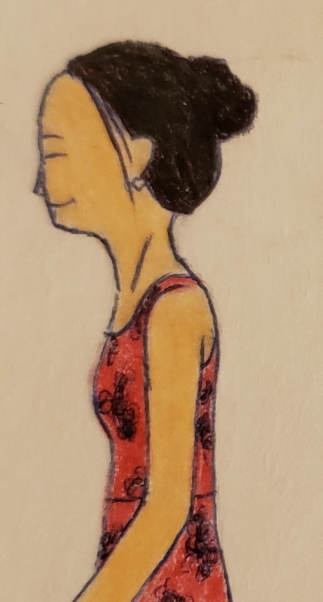
Getting ready for the day, she was excited as Jess was the only one who was slow to get ready.
It was 07:30, and United and 4 others had picked us up from the hostel for a day trip. Then headed to the hostel to pick the other 3 others and finally, to the hostel to pick up 4 others.
Driving to the Tamsui Fisherman’s Wharf, United was listening to the music while Jess fell asleep.
Arriving, they all got off the tour bus (for solo travelers) and headed to the lover Bridge. It was a wonderful experience for Jess.
The meeting time was 10:15 so that they could drive back to Taipei for lunch.
Jess is her 1st time in Taipei since she hasn’t traveled a lot because of her undergraduate studies.
Just then, they gathered together to cross the bridge and went to the other side of the bridge.
First, she took a picture of the bridge before crossing the bridge with 5 others.
Later at 10:19, they returned to the bus and drove back to Taipei for lunch and Taipei 101 observatory/optional shopping and was scheduled for an hour lunch. The plan was to climb up Taipei 101 for the observatory. Since the tour has covered the costs, 12 female travelers don’t have to worry about the admission fee to enter the tower observatory.
They have lunch together at Din Tai Fung together as a group with 2 English Speaking tour guides.
The thunderstorm began in the Taipei metro. The 12 travelers and tour guides planned to eat lunch indoors, eating lunch at the time of the rain and thunderstorm.
“Crack! Boom!” It was a loud thunderstorm outside.
It was raining hard.
Surprisingly, they did not hear the thunder nor saw the lightning because they are safely inside the mall.
United and others learned how to eat together with their table manners in Taiwan. She was the only girl who didn’t stick the chopsticks nor hold them directly into the bowl.
“Table manners in Taiwan is the norm,” United added as she demonstrated the proper use of the table manner in Taiwan.
“Thank you! What’s your name?”
“My name is United. What’s your name?
“My name is Connie.”
“Nice name!”
“Thanks.”
United, tour guides, and others felt offended as some females don’t know how to use the chopstick the right way; they stick the chopstick directly to someone or to the bowl.
Jess has not experienced her chopstick as United teaches her how to use them the correct way.
“Jess, try not to stick it to people, you know.”
“Yeppie.”
She smiled.
“Before coming to the country where its culture’s conservative, e.g., Taiwan, China, Hong Kong, Muslim Countries, it is important to practice manners according to the cultural norms. For example, in China, it is expected to use the chopsticks the right way, not sticking it toward the people or vertically into the bowl. Practice cultural manners before you travel.”

Later in the day, after lunch at 12:30, they entered the observatory. They climbed up the world’s fastest elevator with or without a group. It was United’s first time climbing up on the world’s fastest elevator.
“The ticket to the observatory deck costs 600 Taiwanese Dollars, which is around 21 dollars. It wasn’t so bad there, compared to NYC, the ticket costs $38.” She said while waiting for the group to enter the admission via ticket scanning.
She was super excited.
“Hello, I am on the way to Taipei’s Observatory and then have a glimpse at the overview of Taipei’s Metro Area. It will be a wonderful view. Ahhhh.” She voiced over the phone.
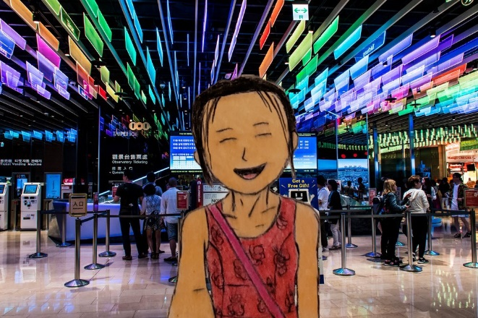
It will be the United’s first time visiting the Taipei 101 observatory.
As United and others took turns climbing up, Jess was behind the people entering the elevator.
As the elevator climbed up, United felt that her ears popped as the elevator ascended 1,010 meters a minute (around 37 miles per hour), making it one of the country’s fastest elevators.
“Aw, my ears popped out.” One woman said.
Shortly after their 37 seconds, they got off and then toward the observatory.
“It is like a wee ride.” United was among the people to process toward the observatory. It was her wonderful experience since her last visit to the One World observatory was in October 2018.
“It will be a touching experience.” She said while some of the local groups went first. There are only 4 girls who are together.
Jess and 3 local women from the tour were on the way up from the ground floor to the top of Taipei 101.
Because of the poor weather condition, the outdoor observatory deck (91st floor and 101st floor) was closed. The indoor observatory (88th and 89th floor) was open to the public, even though it rained with thunderstorms.
A girl (who was not part of the solo travel girl’s group) starred at the window.
It was still darker around the Taipei metropolitan area.
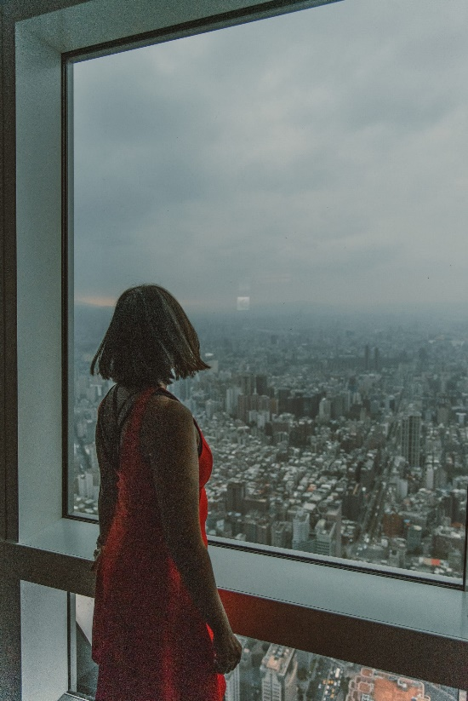
“Taiwan's summer is a monsoon season where there is rain, thunderstorm on some to most days. So glad that I am inside while the outside observatory is closed for the weather.” United kept her comment to herself.
The tour guides were also enjoying Taipei’s metro’s view as some of the participants already went down for the optional excursion to: National Palace Museum.
The meeting spot was around 13:45 to visit the National Palace Museum.
United took some photos of the view and planned to share once she arrived at the hostel.
They spent around 45 minutes to 1 hour on the observatory deck. Some of the local participants came down via the elevator whenever they wished. Jess was among the last people to come down on the elevator, and 6 out of 12 female travelers were on the private bus to the National Palace Museum for about 1 hour and 30 minutes.
According to her itinerary, the United chose to visit the optional activity National Palace Museum. Jess was not going and will remain in Taipei 101 shopping plaza to shop or to browse around.
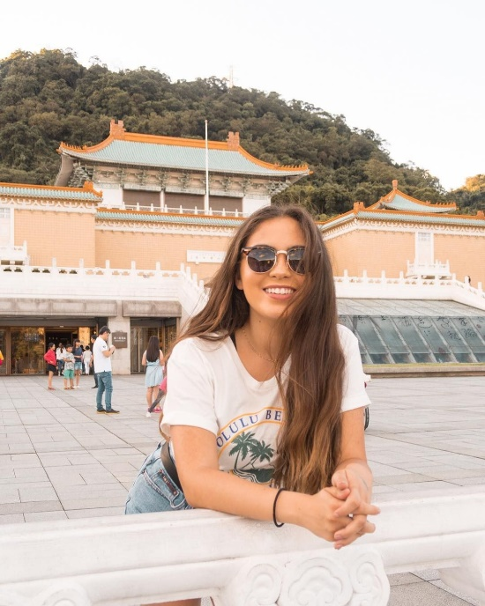
Francis Del Moore, a part of 12 travelers in the group, also went with 5 other girls.
Afterward, at around 16:20, they will pick the rest of the group at the meeting spot to drive to the Vigor Kobo Pineapple Tour.

At around 17:00, they arrived at the Vigor Kobo Pineapple Tour as a group and toured how the best pineapple cake is made.
United took a picture of the ceiling seconds before the group climbed up (escalator) to the show.
It was their satisfying experience of all female solo travelers, who gladly joined for the 2-day tour.
Finally, they tried the sample of the cake; some said it’s too sweet. United loves the Pineapple, so she brought 1 pack of cake to bring home.
Confused about what to bring in her carry-on...
She asked the tour guide if the cake is allowed for carry-on. Suddenly, the cake was allowed as long as it must be non-liquid or gel and must be less than 3 ounces in liquid or gel.
United was surprised after she asked for the tour guide. They are very knowledgeable and professional to help with the 12 solo female travelers.
It was a drizzling afternoon as all 12 travelers, as well as 2 tour guides, brought their own umbrella for the day because they will be going to the night market afterward.

Back in the private tour bus, a female tour operator announced via microphone:
“Ladies, we are going to Raohe Night Market, and we call it for the day. ... Tomorrow at 09:00, we will be going to Jiufen Old Street for Excursion, Shifen Old Street, for lunch. We will experience Sky lanterns and finally will spend a free afternoon at the Shifen Old Street. Any questions?”
Jess raised her hand to ask for her tour operator about airport transfer from the hostel to the airport (Taiwan Taoyuan) for tomorrow.
The tour operator gladly made her arrangement from the tour to the airport.
Her flight leaves tomorrow at 22:30.

It was soon cloudy as they headed to the final place for the day: Raohe Night Market for dinner. Jess and United (with a pineapple cake bag to bring home) were together and decided what they liked to eat. While some of the group were wandering around in the market, they also decided to buy a quick dinner (street food).
United and Jess each tried the fried Pork Blood and took pictures.

...conversation about food.
Then they went to the booth and ordered soup together.
...and paid in 25 Taiwanese dollars
Sipping with Jess, they started to have a conversation about food.
“It’s delicious, and I want to make it once I get home.”
“I haven’t tried for the very first time.” Jess recalled.
“Someday, I will make it for my family, back in Anchorage.”
“Does your hometown have Chinatown?” United asked.
“Nope, but they have some Chinese restaurants and supermarkets.”
As they ate together, they walked to the outlets together to buy something. While United was in the store, the store manager asked the two in mandarin Chinese and said, “I am just looking, thank you.”
“You speak Chinese?”
“Yeah but in Elementary Proficiently.”
“Ah. I speak a little Yupik.”
“Ooo, I never heard of this language. How to say hello?”
“Waqaa means hello; Quyana means Thank you...”
“Goodbye?”
“Piura means goodbye.”
“Aha! Sounds interesting.”
United and Jess had an informal conversation together as they walked together.
As time went by, some groups went back to the hostel by themselves or as a group in which they stayed in the same hostel.

At 20:32, Jess and United took the subway back to Dan Hostel. They got off at Ximen Station as the solo travel tours allowed under a safety umbrella.
“Just because other safer cities, for example, Taipei, doesn’t mean that you safely travel alone in the evening. During the evening after 8-9pm, traveling with someone is recommended, especially in the downtown area.”
The meeting spot is 21:00, and they felt tired. Left at 20:47, they drop off at the hostels. Only 4 females were getting dropped off at the hostel while the rest took the public transportation back to the hostel. The solo travel tour company has made arrangements for all travelers to better accommodate their schedules.
Jess is staying at the 6-bed female room on the 3rd floor and United, who remained with a 4-bed female dorm on the 2nd floor.
Showering in the bathroom, she brushed her teeth while unwinding her wonderful day.
Laying on the hostel bed...
Sharing some of the pictures via WeChat, she smiled as texting about her fun time in Taipei. She was happy about traveling on her own and with the female solo tours.
Having a conversation with her family over on WeChat, she was happy that the trip went very well.
She finally went to bed at 21:50.

Day 4 - 2nd day with a group of female solo travelers
Early in the morning at 07:15, United woke up, getting dressed and brushing her teeth. She finally did her long hair and face. It was around 08:05, and the tour started at 09:00.
Bringing items (including a navy collapse bottle) she needed for the day, she was ready to wait for other hostelers. Some checked out for the departure.
Bringing her own breakfast, the tour bus picked United and other female hostelers at 08:30. While Jess was checked out, United brought breakfast to eat to have enough energy for the day. She also has her bottle of coffee and water filled up.
“Hey, good morning Jess! What’s up?”
“Nothing much.”
“How’s a good night’s sleep?”
“My good night’s sleep is good, and 5 girls were sleeping with no distractions. You?”
“Mine is okay and wasn’t a distraction at all, per se. It is a smoother sound.”
“Good to hear,” Jess responded as the private bus arrived to pick the girls up.
It was 5 girls from Dan Hostel.

While on the private tour bus to the Shifen Old Street for execution, United ate her breakfast before starting a day tour.
They got off to explore, and the meeting time was 11:00 to drive to the Shifen Old Street, where they will eat lunch and experience the Sky lantern. They also have the excitement of experience in Taiwan on the 2 days of solo travel tours for females.

Suddenly, United brought something that will be brought as a gift. It was a wonderful memory, and Jess was with another girl who stayed in the same room. Her name was United Cecila Morris.
United has allowed exploring on her own until it was time to return to the meeting spot around 11:00.
Jess gives her some time alone too.
At around 11:06...
Driving to the Shifen Old Street, they took pictures from the beautiful view. It was the mountain and terrain.
Shortly, they got off from the private bus, and each ate lunch as a group. They each talked about Taiwan’s rich history of Shifen history and the Shifen Old Street train track.
United was curious about Shifen Old Street (Pingxi). The two English tour guides (operators) talked more about the history of the Shifen old street.
“Tell me more about Shifen Old Street?” United asked the tour guide, Susie.
“Shifen Old Street is a collection of railroad, transporting coals during the Japanese era from station to station throughout the village... Suddenly after the era, the train station and the station left, to the public, which the tourist can safely cross the tracks. It is a great town to grab some xiaochi snacks and souvenirs.”
“Wow, it is a historical place that my friends recommended Taiwan Trip.”
“United, you should invite your friends to go to the place. It is a cool place to learn more about the place.”
The group already finished their lunch, freely exploring and taking pictures before the Sky Lanterns.

At 13:00, the group of 12 gathered to experience the Sky Lanterns. It was once in a lifetime for travelers.
Ordered the pink, Jess was painting her wishes and luck on the red paper while liting up.
As they painted on one side for 4, United, Jess, and the other 2 chose the color and made their wishes.
United chose the red color, painted with the word in Chinese, “Luck” with fantastic pictures. Jess chose pink while the two girls did the same thing that matches the meaning of “luck” or “Wish.”
They then took a picture of them, holding the lantern, ready to lift off.
“Ready, set, bye-bye!”
Waving at the lantern, 4 girls waved with their hands, laughing.
Smiling...
Jess took a picture of the floating lantern.
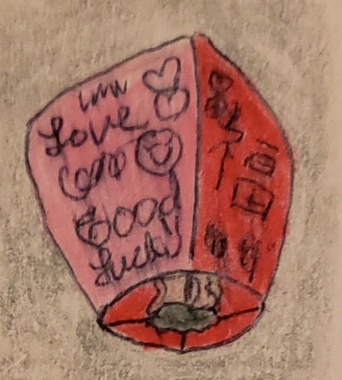
As the 8 others are doing the 2 lanterns, they each take turns floating up to the sky.
Some of the travelers took pictures of lanterns floating.
The only one did the yellow color with the polar bear drawing and useful symbols in black paint.

Confused, one woman (Afator) asked the tour operator about the meeting spot time and...” the meeting time is 4:00pm where we got off the bus. There is a bridge..., other shops, you can walk around, take pictures, be sure not to wander far because you may not be able to walk back in time for departure.”
“Thank you, Tammy Hughes.”
“You’re very welcome.”

They have free time to explore around Shifen Old Street until 16:00.
United and Jess went to cross the Jingan Suspension Bridge and walked back in time before 15:34.
Jess’s flight is 00:30 (August 29) via Tigerair to Tokyo, so they have to take her to the airport via a different bus.
Before she left for the airport, she took a selfie of Jess, traveling together. Then she asked her contacts, and she doesn’t have Instagram. She has both Facebook and Twitter.
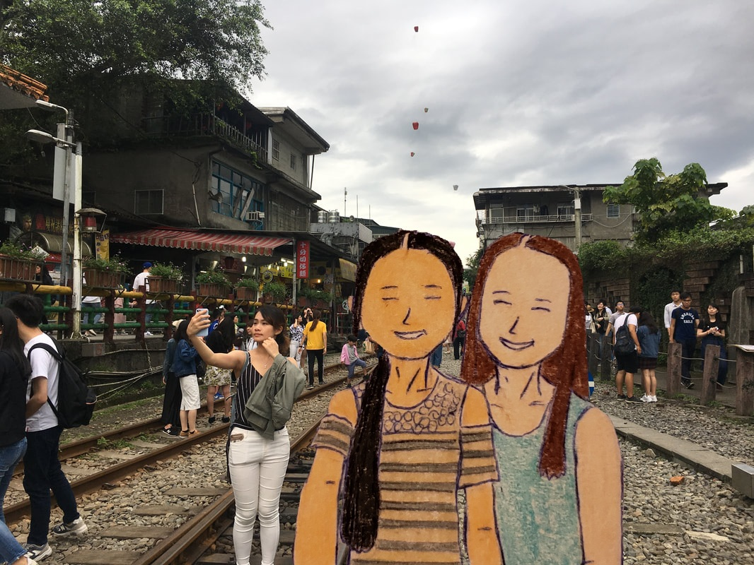
United was now a travel acquaintance with Jess.

7 were first headed back via a small tour bus back to Taipei to drop off at the hostel via Wanrui expressway and Sun Yat-sen Freeway.
Jess and 5 others were waiting for the bus’s departure after the passengers’ count from the booking tour website.
Also, she has a vacation to Tokyo for a few days.
She will also fly home on September 2 via All Nippon/United and work in the City of Anchorage.
Jess and the other 4 were on a different bus to the airport 15 minutes later to catch the flight.

It was then she planned to eat her dinner at a hostel. It is her groceries she brought for 3 days. It was a rainy evening as she was glad that she was safe at the hostel, eating her dinner.
It was a quick microwave food although she doesn’t like it very much.
“I know that I don’t like the taste, but I can’t do anything about it.”

Thus, United’s 2-day tour for solo travelers was relaxing yet gives them the flexibility to enjoy meeting new people in an atmospheric environment.

Day 5 - Chiang Kai-Shek
She woke up at 07:45, feeling ready for the day. She first did the hair, teeth, and face. She got dressed in a white dress as she made her breakfast.
Eating breakfast from the groceries 3 days later, she has a limited amount she has for tomorrow. She has not yet checked her flight via United, so she waited after she finished her breakfast.
She texted via WeChat, “Good morning! We had a wonderful time in Taipei. Today, we are going to Chiang Kai-Shek Memorial Hall, Shilin Residence, and maybe the night market.”
Seconds later, her mother texted with the sticker with thumb up and “United, okay ma?”
“Mom, I am okay. I had a wonderful time in Taipei.”
Then she sent out some pictures of fried pork blood, Tamsui Fisherman’s Wharf, Taipei 101 Observatory, and National Palace Museum. Finally, she also sent out the night photo of Raohe Night Market.
Minutes later, her father responded, “Very nice pictures in Taiwan.”
In Philadelphia, it was evening as her parents went to bed.
She then sent some pictures, including the Ximending Walking District she took 3 days ago.

Just then, United brought items she needed, with limited cash funds. She also had her collapse bottle filled with water to drink.
Heading to the subway Station (Ximen Station) to catch the train (Songshan-Xindian Line), she was eager to visit the Chiang Kai-Shek Memorial Hall. Since the visit to the hall is free, she doesn’t have to budget the money for an admission fee. It saves her some money for her future trips.
Got off at the Chiang Kai-Shek Station, she was looking at which way to the Memorial Hall. She rarely got lost.
“I don’t have to carry the map with me because people will think that I am a tourist. To emphasize this, I better off not to look at the phone while walking or pop up the map in the middle of the street.”
At the Memorial Hall, she looked at Chiang Kai-Shek’s facts, life, career, and personal biography. It was her 2nd visit to the hall since she remembered back in 2015.
Movements later, she took her selfie picture of herself, smiling with her teeth. It was her unique look.
2 hours later, still, no response since the parents are asleep. Taipei is 12 hours ahead of Philadelphia.
It was then close to 11:15 as she planned to take a walk to the Wistaria tea house.
Before she traveled to Taipei, she researched the new policies regarding bike rentals (YouBike) for foreigners and visitors.
“I remembered back in May or June, I researched the new policies regarding bike rentals such as YouBike. The policies are both confusing yet vague. It doesn’t explain the reasons and the purposes of why it changed. However, a one-time user must pay an upward of NT$2,000 liability to rent the bike. I know that, right.”
She continued to add.
“Not really. It is discrimination against the citizens, and it can impede the ability to rent a bike to visitors like me. It sounds isn’t fair. Finally, the coverage was covered only to Citizens of Taiwan just in case of an accident, and something needs to change.”
Walking south toward Wistaria Tea House, she remembered making a reservation (lunch) in advance before departure 4 days before departure.
It took a half-hour to walk from the National Chiang Kai-Shek Memorial Hall to the Wistaria Tea House.

Entered the Tea House...
...the greeter greeted her.
“Welcome!”
“Welcome!” United greeted to witness.
“Table for one.”
She was then assigned to the dinner table, where the host serves with a menu.
Her name was Tian, and she was charming and friendly. Although she speaks Mandarin, she also speaks English and has knowledge of the tea culture in Taiwan.
Talking more about tea’s history, they enjoyed learning more about tea and planned for her to bring the tea home.
United knew the restrictions regarding the items she could bring back home before coming to the tea lunch.
“I did not buy a bag of tea mainly because of the heavy load on what I carried nor what was inside upon entry at the Chiang Kai-Shek Shilin Residence.”
Had her quick lunch with tea culture, she let the waitress come to the table, and United paid the bill.
“Mai Dan!”
Waiting patiently, United pay the bill in cash and left the tea house. She did not leave a tip.

It was then after 13:05, she took the Tamsui-Xinyi Line from Daan Park Station to Shilin Station by using her Taipei 5-day fun pass. It was the last day of the past since the expiration date was 23:59.
30 Minutes, she arrived at the Shilin Residence, paid the ticket in cash, and entered the place.

It was then spending another hour and a half at the Shilin Residence and then headed to Shida Night Market for her final dinner. She planned to meet some travelers who experience much of Taipei’s culture but didn’t because of the time constraints.

Eating a quick dinner, another American woman with social anxiety/autism sat next to her, greeted her.
Sitting across from the table, she started to talk to whom.
United knew the social cue as she looked at the women with awkward moments.
“Hello! Are you a ...”
United did not say anything and focus on eating her dinner.
“Psst, hello! Are you there?”
“Ahh, yes.”
She spends less time socializing with her because she doesn’t sound engaging in the conversation.
“My name is... un, Andi, and I am m...married with an autistic husband. He doesn’t listen to me, and so...”
Because she was shy of social conversation, she sometimes asked about United’s marital status, and she responded briefly.
Andi was convinced about the dangers of traveling alone and...
“Hon, I got to tell you this, where is your husband?”
“Well, my husband is at the hotel, eating his own dinner.”
“Ooo, I think that you should get a husband then....”
While United felt uncomfortable talking more about the personal status, she proactively responded by telling her husband was at a hotel, traveling together (in reality, he was not).
“When someone or a stranger asks me about personal information, politely tell them that the topic is uncomfortable or too personal. You can say, “I am uncomfortable talking about this. Let’s talk about the weather, Taipei, travel experience, etc. that are easy to talk with.” A woman reactively talked about where my family or my husband is. I could say my husband is staying at a hotel, eating his own dinner, just to protect himself. You can also say that “My family is traveling together. I am waiting for my family to ride home.” Be wary of what you respond to. Finally, do not tell them that you are a single or solo traveler or traveling alone because they can take advantage of you and, in some cases, bully or spread rumors about you. Do not say then. Lie to defend yourself.”
Feeling uncomfortable, she learned how to protect herself from these situations.
United tried not to offend travelers with disabilities and tried to engage in conversation with Andi. The conversation has ended with a friendly, grateful conversation. She finally ended the conversation with a message, “I gotta go. My husband is picking me up in front of the night market. Thank you for inviting me to chat.”
“You know that discrimination happens just about everywhere. But there are laws to protect the people from harassment. It is just not how it works and why I-Powers Travel has the right to accommodate travelers with special needs. In 2010, I created the blog about “Travel Specialties,” which enable travelers to receive appropriate accommodations and assistance.”
She added, “Racial, Religion, Disabilities injustice isn’t that something of a circle of a community. This is still discrimination worldwide and must address with assistance, with a positive change of views, not to offend or make slurs. There is something that needs to change to strengthen diversity. Disability is a person’s identity, not disabled. Asian has an identity, simplified who the person is. Finally, it is important to identify yourself as a person, not an animal. It creates personal values, traits, and characters.”
Walking alone, she also has her fake wedding ring on her right finger.
“To protect yourself, it is recommended to wear a wedding ring (real or fake), married or unmarried, pretending that you get married. I also show my fake husband, saying that my real husband is on my phone, claiming my brother. I am telling you that women can be primarily targeted for unwanted attention or conversation. We don’t want that to happen.”

Pretty soon after walking around the night market, it was time for her to find the way back to the hostel.
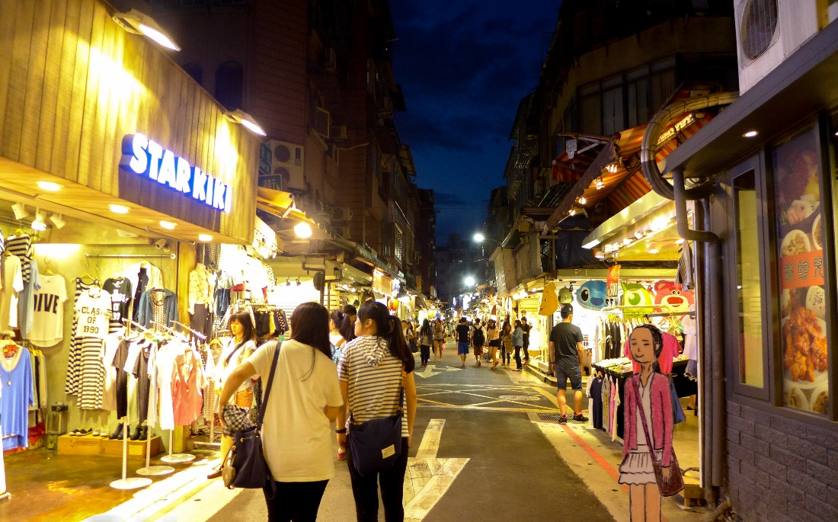
It was 20:35 as she headed back to the Hostel (Songshan-Xindian Line), packing home...
...and then she set the phone alarm to 05:00.

Day 6 - Departure! See ya, Taipei
Woke up, she dressed in a beautiful dress. She prefers a girly look with her beautiful face and decided to put on a low ponytail for her sleek look.
She checked the room before leaving to go to the receptionist to check out.
Checking out, she gave the card back to the receptionist and gave her a receipt.
As she checked out, the shuttle arrived 10 minutes, and she got on the shuttle to the airport.
At the airport...
She was at the security checkpoint. The cake she brought was allowed because it falls under an allowable TSA rule for carry-ons. She researched what’s permissible under the current TSA rule to be forbidden for carry-ons.
“Just want to know that any frostings, cakes with sauce are count as 3-1-1 rule for carrying on. It must be less than 3 ounces. The cake I brought from Pineapple Cake Factory is not liquid nor gel or sauce.”

As she was on the flight to San Francisco, she knew how to fill out the customs form, including the amount of merchandise she brought abroad. She estimated the cost of $110.

At San Francisco International Airport, she texted her father once she disembarked the plane, connecting back to the US data coverage.
On WeChat...
“Hey, Dad, just arrive at San Francisco. You can check my flight on www.flightaware.com, type in United 569 to see if my flight and status.”
Her mother texted with a thumb up and then texted her back, “Hey United, okay, ma?”
“I am okay. I am about to enter the immigration customs before checking in for my domestic flight.”
“Glad to hear that. Can’t wait to see you home, okay.”
“Me too, love ya.”
“Love ya too.”

Minutes later, at 07:45,
She successfully passed through the immigration custom before checking in for her domestic flight with only one carry-on and her personal bag. It was then morning as her flight to Newark was scheduled to depart at 10:00.

Sitting down, waiting for the announcement for departure to Newark, United texted to her friends, saying that she was still in San Francisco, waiting for the departure.
“We’re 3 hours behind Philly, so my parents aren’t home; they are at home, social gathering with friends.”
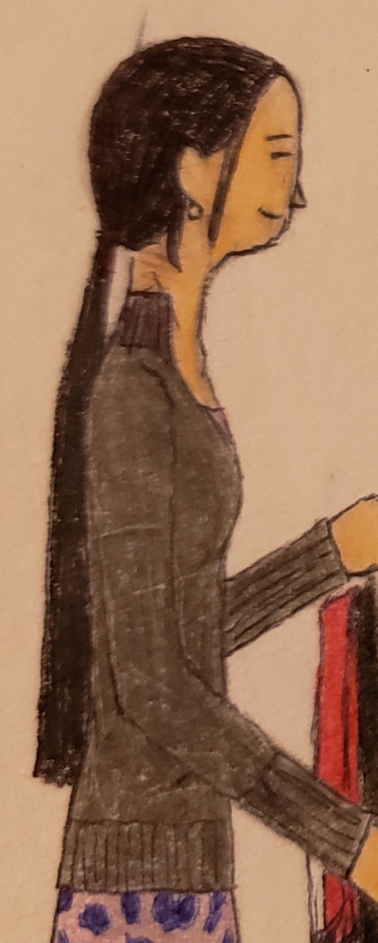
The announcement has heard that it was time to board the plane to Newark. United and other passengers lined up to scan the boarding pass. United has her electronic boarding pass from the United App.
“I hope my flight is going to be fun.” She recalled.
Smiling herself, she misses her family’s trip to San Francisco back in 2018 when they took the same airline.
She was initially planned to take a trip to San Francisco but decided not to explore for a few days because she has to go to work (internship and specialist).
“I know that flying home can be a difficult time for me. I really love to go on vacation, especially I am in love to explore places. I know that.” She smiles as she finds her seat selected during her booking process.
Sitting on the right side of the plane (window seat), she starred at other aircraft parked at the gate.
She texted her father.
“Hey! I am on the plane to Newark, ready to take off.”
“Hey. Enjoy your flight, United.”
“Dad, don’t forget. Come to pick me up at Newark Airport Terminal C. My flight will arrive at 7:30pm.”
Minutes later, as more passengers boarded the plane to Newark, he responded, “Okay, have a safe flight.”

As the plane took off from San Francisco, United was very tired, so she took a nap.
Daydreaming of her trip to Singapore, she walked around Gardens by the Bay, taking pictures. It was the moment when she was smiling and giggling back then.
She saw the beautiful lights blinking around Gardens by the Bay with some of the MileagePlus friends.
“Wow, it’s beautiful,” United commented.
“Yep! This is my 2nd time here since I had been there for solo travel back in 2016.” Rachael Hayden added.
“This is my first time.” United smiled.
At the same time...
United have initially plan to take another solo trip to Singapore in 2021 but move to 2022 due to budget constraints.
As the plane fly east, some passengers got up and walked around the cabin. Others were using the plane’s lavatory. The aircraft was cruising smoothly.

An hour later, she woke up, grabbing a snack.
Eating the snacks she brought from Taipei, she played with the phone, looking at the pictures of her 5-day Taipei trip. It was her wonderful memorable trip she has experience.
While the plane was halfway to Newark, United took another nap. She was experiencing jet lag on her 11-hour flight from Taipei to San Francisco. She knew how to handle her flight fatigue and planned to take a nap once she gets home.

In Philadelphia, just after her parents arrived home, they took some rest after the church gatherings.
At around 15:30, her father had a conversation about picking her daughter at the airport. United’s mother, Katherine, was happy that she was returning home.
“Hon, come on. I am going to pick my daughter up at Newark Airport.”
“Aha!”
“Well, she texted me during the church service.”
“Okay, hon, be safe. When my daughter arrives home, we will give her a big hug.”

Pretty soon, when the plane approaching Newark, an announcement heard that the plane was starting to descending toward the airport.
She felt as the plane turn left and right as the plane began to slow and descend as passengers returned to the seats, strapped in with seat belts, tray table stored, and set their seats in an upright position.
As her father drove to Newark to pick her up, he was still on the way via New Jersey Turnpike. It was then at 18:48. It was then there are some cars and trucks, all on the road together, heading northbound.
Just then, United felt the plane making the noise (landing gear) as the plane continues to descend to the airport. It was not until she and the other passengers felt a little bumpy as the plane touched down the runway.
As the plane landed, she smiled and cheered, “Whew, I just arrive safely. And I am at home.”
The plane slowed down on the runway, ready to the gate at Terminal C.
As the sunset at Newark (19:31), the plane parked at the tarmac for 5 minutes, waiting for the aircraft to pass by.
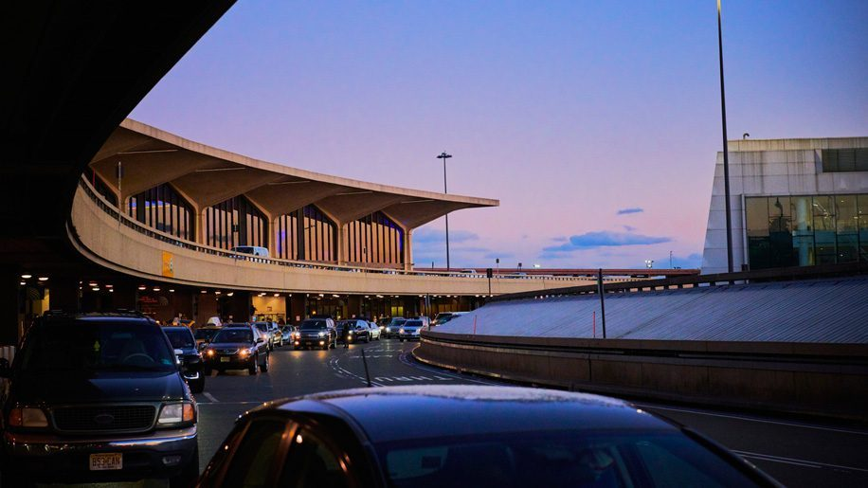

10 minutes later, the plane arrives at the gate, ready to exit.
As the passengers waited for the plane to disembark, they were excited but sad. Some travelers missed their vacation, even United. She felt sad too.
As the passenger in economy class waited to exit, they sat down, looking at the phone and chatting; others standing to see more passengers from the first-class already left the plane.
Turning off the phone’s plane mode, the clock changed from 16:34 to 19:34.
“Dang, the plane was 10 minutes late. And it is not that bad since I love United. Woo.” A male sat 1 row in front of her.
Laughing, they waited for the first-class passengers to disembark the plane through the jet bridge.
She texted her father, who was still on his way to the airport.
“Dad, I arrive at Newark Safely.”
“Okay, I am almost there.”
“Thanks.” She replied.

Minutes later, United and other passengers finally disembarked the plane and...
...and exited the security area, waiting at the baggage claim.
“I have no checked luggage, and I was traveling internationally with only d*mn carry-on. I will go to Singapore with just carry-on.” She laughed out loud.
Soon after, he texted her, “United, I am here.”

She gathered to leave the airport building.
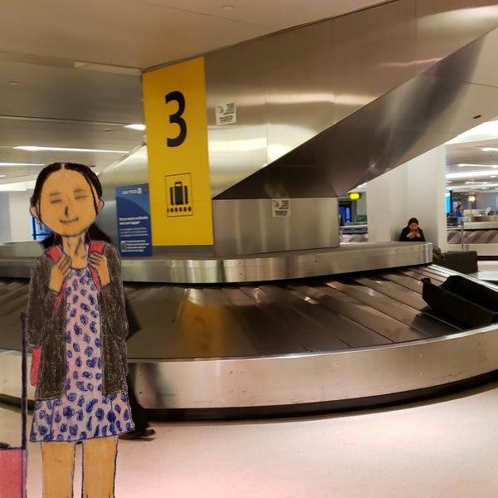
Going outside to find her father’s car, it was located behind a taxi car. He waved her.
“Hey, daddy!”
Smiling, “Hey, what’s up? How was your trip?”
“It was great. I enjoyed exploring places in Taipei.”
He got off the car to loading her pink and said, “United, what’s all this?”
“It is a pineapple cake.”
“Huh? Is it allowed to bring it to the USA?”
“That’s fine as long as I declare it to the US Custom and Borders Protection as food. I was in San Francisco to clear the immigration once I landed from Taipei.”
As she got in the Honda Odyssey, her father drove from the airport, heading home.
Playing with her phone and listening to the music for a bit, she started to take a nap on the way back to Philadelphia.

Pretty soon, at around 21:48, she arrived home safely. It was not as hot nor humid as in Taipei.
“Not that hot and humid,” as she exited the car.
“I know, right?”
“Taipei is hot and humid, just like Hong Kong and Singapore.”
She retrieved her pink luggage and...
...returned home with her father.

Seconds later, her mother and sister gave her a hug as her brother already took a shower, went downstairs to see her returning home.
“United, how was your trip?” her mother asked.
“My trip was fun. In Taipei, I tried different food, climb up the Taipei 101, although it’s rained. Still have a good time.”
“So glad that you enjoyed your trip.”
“Mom, did you like the pictures I sent?”
“Yes. I like the pictures you sent. It is beautiful, and I like it. It makes me wanted to go visit there.”
Smiling, she had a brief conversation about her trip before the shower.
...and she went to sleep promptly at around 23:00.

September 2020 and beyond
Her post-trip depression...
...and everything will be okay.
After returning from her solo trip last night, she was now in her room, sleeping but woke up at 03:45 to brush her teeth. She then went back to sleep because she felt so tired after her fun trip, jet lag, and wonderful experiences.

This day she was a bit tired but planned to unpack late afternoon and wash her clothes. Because of the paid leave, she did not go to work on the day due to Monday’s rest day. She expected to return to work tomorrow early in the morning and her afternoon work at Temple.
The sun was rising and shining. It was around 07:45 as the kids walked to school, dressed in uniforms.
She heard the kids were going to school, chatting, laughing, and screaming.
While she was sleeping, she was daydreaming about her plane ride to Taipei on August 25. It was her favorite thing, especially frequent flyers. She hoped to hop on a plane in the future.
She remembered sitting on the window seat on her flight from Newark to Tokyo Narita. Staring at the window, it was the bright white snow and ice built together on the ground.
It was not until around 10:00 when her dream became imagery. Although aircraft aren’t designed to fly above 38,000 feet in the air, the plane went to outer space.

3 hours later...
Yarning, she slowly woke up at 10:55, brushing her teeth, getting dressed, and eating brunch together.
“Good morning, mom!” She said while she went downstairs.
“Good morning, sweetie. How was your sleep?”
“It was okay.”
United added that the food smelled delicious.
“Mom, the food is yummy.”
“Yep, mommy made it.”
Her father was at work while her mother was at home, making a bow-tie pasta with some veggies and eggs. It was the chicken soup broth.
Her brother came back from Dave’s Buster for a work movement later.
Feeling a little down, she misses her vacation while she starts to eat her lunch.
“Any plans this afternoon?”
“I am going to buy some groceries. And then help you to make dinner and finally, unpack my clothes.”

Took the SEPTA to Fresh Grocer at Temple University. She was using her reusable shopping bag she used on her trip abroad. She likes to save the plastic bag from deposing and ends up in a landfill.
Buying only 1 pack of vegetarian meat, she went off to buy some healthy snacks and a box of whole-grain cereal.
Writing on her blog on the way home, she continued to brainstorm more.
She had a wonderful time in Taipei and wrote a journal, including a blog she wrote on WordPress. Working on her blog a bit, she felt tired after writing some more information about her trip.
The name was “My Taipei Vacation” and was scheduled to be published on September 28.
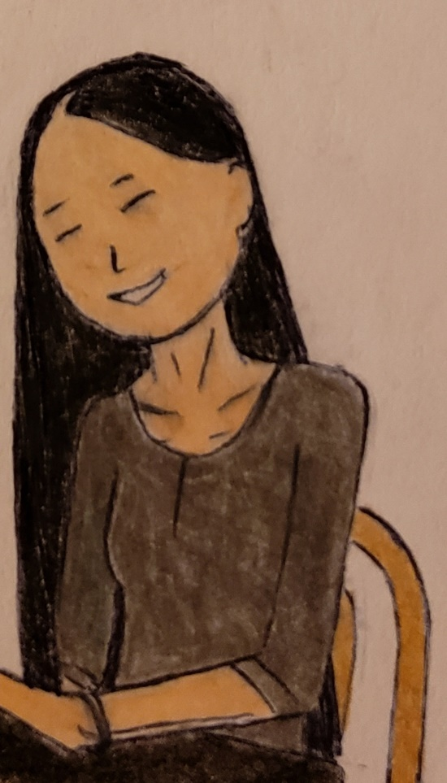
But there was work to be done. United’s trip has started with an itinerary, some pictures, and her experience during her trip.
Fact: On her blog “My Taipei Vacation,” it was stated that her trip had included examples of virtual vacation (5 senses), not her actual vacation. She went abroad if the pandemic did not happen. She safely traveled there for 5 days without problems.

The next day, she woke up at 5:45, ready for work as an internship, and this time, her friends texted her, “We will work this morning. I will pick you up at 6:45.”
“Okay, Lily. See ya shortly.”
Lily is working on an internship at Estee Lauder, too but started last week.
She met Lily last month, asking about her job interests, and said that she does have an interest in cosmetics and fashion.

Just then, she made her high protein breakfast; veggie sausages and eggs with cheese. Her father danced in front of the screen as he concentrated on his morning workout.
Looking at the pictures from her trip to Taiwan, she missed traveling and said, “I know that I have enough days for traveling. I only have 6 days to spare so I can travel more for health and step out of my comfort zone to learn myself.”
Feeling less irritable and stressed after her trip, she performed daily tasks without feeling tired or drained. She doesn’t have to deal with her solo trip’s problematic situation annually, even though it’s complicated.
Just then, she prepared for the work for the day.

She has the energy to survive her 4-hour shift, calculate how many people are working in the production line, updating its inventory, and managing its production schedule. This morning, she supervised other workers who broke the GMPs (Good Manufacturing Practices), e.g., the production line workers who hesitate to follow GMPs. Hence, there are fines for those who broke the rules of GMPs.
“It is important for your guys to follow all of the production regulations. Otherwise, there are citations and fines for those who broke the rules and regulations. We need to ensure production workers comply with the regulations at all times.” She said while observing the workers who intended to break the rules or regulations.
“I am telling all the workers, and this is no joke. There are also injuries, slips, trips, and falls relating to running around production lines. Remember the rule; walk don’t run.”
United tried hard to remind all workers who work in the production line.
As some production workers refused to take action, she notified the manager and wrote the incident around 09:30.
Investigating the incident relating to improper manufacturing practices, she was the only one who took charge of the actions.
“I believe that solo travel or any traveling can be a good sign of a “taking risks” because traveling abroad enables creativity, sharpened 21st-century skills, and collaborates with the situations. It is an ongoing learning process you will face for the rest of my life. I gave myself a mental, emotional break from daily life, I mean that stepping out of my comfort zone.”
Just then, at 10:15, her Temple supervisor called her, letting her know that she doesn’t have to work on the day. She went on vacation (Labor Day) for the rest of the week. She was expected to work on Tuesday after Labor Day.
While she missed her vacation, she focused on taking charge of the production line, from time to time until 11:35 and...
...left the worksite to return home to relax for the day.

Eating her lunch on the bus, one passenger complained about the sandwich that makes her sneeze.
Since she was once criticized for eating a sandwich on the bus, she learned not to offend other passengers.
“I tried not to say anything, and even though she said, “Put the sandwich away,” I tried not to get into an argument or get in bad situations. I need some space to spare myself.”
Finishing her sandwich, she got off the bus, heading home...
...and did the laundry later in the afternoon but felt tired after her day of work.

Later this month,
She opened United Airlines’ App and...
Her miles were credited into her United Airlines’ account. She saw her email about the airline’s credit card changes regarding the miles instead of cash.
It was then the news about United MileagePlus program updates regarding the changes in Credit Cards. The new Chase United Getaway Card replaced the existing United TravelBank Card, which earns cash instead of miles. United and other United Frequent Flyer members have complained both online and on Facebook/Twitter/Instagram about the product/service they received. They instead earn cash instead of miles on the airline’s account before the United MileagePlus program changes.

“I know that I have a Credit Card bill in which you must pay back the balance in full if you can. If you must pay with the Credit Card for a large purchase, please pay it back like I did by the due date. I paid around $778, along with the hostel and other purchases before June for airline/bookings/other purchases.”
United pointed out that using a credit card can be a risk if not careful. She stated that “Credit cards are not debit cards, which you can access to a checking account from the bank. On the other hand, credit card only access with the limited balance available paid with interest for borrowing.”
Just like loans, she learned how to manage her finance very well. With her excellent credit score, she applied for a United Getaway Credit Card by submitting her application online. Since she was busy with the blogging and other paperwork, she was offering an application online.
She was busier than before.

3 days later...
Waiting for the response, Chase asked her application for the income verification and sent out the paycheck award letter and the paycheck from the job.
She sent out the last paycheck online with the application and a signature.
She was delighted that her latest Credit Card can benefit her upcoming travel by using her miles to book her future flights in the future.

As then in October, she learned to overcome her personality, she gladly accepted her way she is. She never gives up doing things she enjoyed, although her internship doesn’t like: inventory and supply chain management. Her primary interests include visual arts, creative drawing and crafts, computer, traveling/tourism, and money.
“At the internship, it can be difficult to figure out my ideal career, although my interest is money and finance, with a creative/artistic career in arts and crafts. Even though I don’t really like this job, it can be rewarding if I take it seriously so that the job dreams come true.”
She takes her job seriously by applying her preexisting knowledge, math skills, and English skills. Speaking of that, her communication and business writing are her weaknesses and progressively improve her skills.
“I felt shy around people sometimes, and when I was on vacation to Taiwan, I wasn’t comfortable, and suddenly, I knew how to meet a girl named Jess, and she is from Anchorage. I realized that stepping out of my comfort zone gives me some skills and abilities needed to build my character and values needed for myself. It also gives me a sense of skills I have not encountered before.”
As she improved her weakness into her strengths, she was happy that she accepted herself, inside and outside.

At home, she thought of writing a letter, saying that her solo travels to Taiwan have helped with the lives and empowered women. She then thought of what she wants to write to the family and friends and church friends.
Working on the letter, she continued to write a letter and checked the grammar and punctuation.
She spent her entire afternoon writing her letter.
It said:

Dear Family and Friends,

We would like to thank you for all of the support and hard work I have given. The letter will include gratitude to the community, enabling travelers to change the era of travel tips and tricks. The story report contains helpful tips and information available to the public. Although solo travel can have risks, it can be rewarding too. Solo travel enables me to improve resilience, tolerance, sensitivity, flexibility, adaptability, and creativity. I also believe that solo travel also helps avoid personal conflicts and boredom during the trip and change myself into a better person. Fortunately, I, as a person, will change my perspective forever.

I also like to look forward to a happier, healthier life relating to mental, emotional, physical, and spiritual health.

Love,
United Acela Tse

October 29,
United worked hard to gain valuable skills needed for the permanent job while working on the blog about why solo travel enabled her changed personality. She explained that solo travel helps overcome nervousness and anxiety, even though the trip can be stressful. It also allows her to tolerate the environment.
While upstairs playing with the phone (Instagram), she looked at someone's Instagram, who went on a 9-day trip to Singapore and Malaysia. She was delighted that the upcoming trip to Singapore is valid, based on her adequate funding of the money needed to spend the 5-day trip.
"I guess that solo trip to Singapore is something of a miss but can be a fun, enjoyable experience I ever encountered. I am setting it until 2022, not 2021, due to financial restrictions and job aspects."
Looking at the photos she posted as Yassmine Lee (her childhood friend), she and her three friends selfie while filming, all having fun at the Singaporean Beach. It was taken on February 19, 2018 and posted on March 25, 2018.
There are 9 other photos; some were taken in Malaysia.
United wasn't planning a solo trip to Malaysia, including Kuala Lumper.
"It is something that I am really on the bucket list." She recalled publishing a blog back on August 21, 2020, 3 days before her departure to Taiwan.
On the blog, she gave an excellent example of her upcoming trip to Singapore but did not plan to travel for over a year. It includes detailed information regarding the steps of preparing a safer, more convenient trip/itinerary for the general public.
"Especially solo travelers, it gives comprehensive information about safety, health, and more thorough research because lots of travelers hesitate to plan a trip. They simply don't feel like doing enough homework. I know that, but using this example of this I-Powers Travel Cycle will help travelers plan and research trips."
After lunch, she spends her free afternoon working on her blog about her travel and then does her yoga. Although she had no plan for the day, she also spent some time with her friends and travel friends.
During her free time, she knocked on the door and her brother.
"Do you want to take a picture?"
"Yeah!"
Seconds later,
She held her United Polaris Bear, and her brother took her picture.
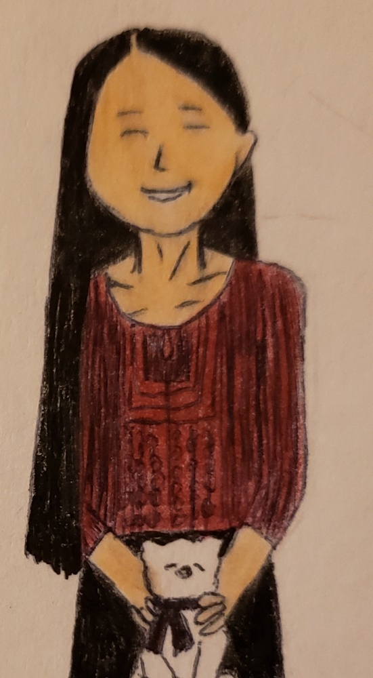
Selfie time…
…and shower time.
Then, nap time for a brief period...
...and feeling refreshed.

Pretty soon after 17:00, she planned to cook dinner. It was raining hard in Philadelphia amid the windy weather. She planned to eat fried rice with vegetarian meats, veggies, and some eggs.
“I am ready to cook because she claimed she was tired after all day at home.”
Cutting up the carrots and spinach/celery/red pepper, the white rice was almost finished.
Cooking 4 eggs, she learned how to multitask, including cooking and washing utensils at the same time.
Her parents are up, taking a quick nap, daydreaming of the trip to China. It was their moment when they were at Henan for 12 days, touring at Zhengzhou, China.
Her mother dreamed.
“What are you up to?” A Chinese man asked while she was crossing the street in a busy intersection. It was the moment when her mother’s eye began to move as she woke up.
Walking down on Zhengzhou streets, she was able to speak Mandarin, traveling with her husband.

Minutes later, she used the frying pan to fry the remaining vegetables, almost finished. She left the kitchen to wipe the table, washing the 5 bowls, 4 pairs of chopsticks, and 3 forks.
“Woohoo, I am almost finished,” clapped her hands.
Settling down in the kitchen, she turned off the stove, ready to eat while her parents woke up.

At dinner, she just talked about her upcoming trip to Singapore the other day. Her parents forget about the information because they are getting old.
“United, let me ask that question? Why do you plan a trip to Singapore?”
“Singapore is a beautiful city. And I am planning to travel solo, and they have told me it is safer than Hong Kong or NYC. It is the bucket list of the year in which I really want to see the dazzling lights, Gardens by the Bay.” She showed it to her parents.
“Beautiful!” Her father commented.
“Where is it?” Her sister asked.
“It is in Singapore.” She answered.
“United, by the way, why don’t you work hard so that you can earn money for your rent, to pay your bills, and your financial savings? It is your responsibility.”
“Ha, I am taking responsibility for my personal and professional goals. I am taking hard work of myself at work, having more responsibilities. I am grateful that having more responsibilities means I am taking the job seriously.”
“I know that you are a hard worker.” He smiled.
United recommended safer places for women solo travelers for their safety protection.

Just then, she ate her dinner while her brother said, “I wanna travel!” pointed at himself.
“Yep, we are going to Hong Kong for a 3-week vacation.”
“Okay, then.” She added. “I put it off from travel until 2022 to Singapore solo.”
Seconds later, United asked, “What airline will you be taking?”
“We are taking Cathay Pacific on December 22 and will return on January 15.”
“Never been on the airline. By the way, I mostly took United, All Nippon, Asiana. All are eligible for miles accrual, depending on the class of service.” She said, emphasizing her Frequent Flyer Membership.
“Interesting!”
“Where are you taking on the flight?”
“Newark!”
“Is your return flight to Newark?”
“Yes.”
“Okay! Ask my Godparents in New Jersey to drive there, or I am planning to book a Shuttlefare and...”
“Okay! But wait, United, for the shuttle, how much does it cost?”
“It’s $75 with a $5 booking fee for one person.”
“My wife, my son, and I are going.”
“3 passengers, so the cost is $225, and the total is $240.”
“Wow, you are a money saver and a researcher.”
“Thank you, dad.”

As she finished her dinner, her brother wanted to wash dishes, but she wanted to help too.
“Rich, wash dishes.” He pointed to himself.
“I am washing dishes,” United said.
“United, let him wash the dishes, and you can clean up the table and take out the garbage, okay? Since you already cook for us, let him do the job.”
“Okie Dokie.”
Taking turns doing the chores, United remains calm and confident while doing the chores.
“I felt like doing chores, making me more alert and ... um, not so tired.” She talked to herself while cleaning up the tables.
Sweeping the kitchen floor, her brother just doesn’t know how to wash the dishes and...
Her mother teaches him but to no avail.
“Look at me. First of all, scrub them in water with a soapy sponge, then you can use the washing cloth to rinse them with water.”
“Mom, go away.”
“Rich, I know that you don’t really want you to teach how to save water, don’t you? That is not how to wash the dishes. You are wasting the water.”
“Ahhhhhhh,” Rich screamed.
“Hey! Mommy is not happy.”
“Aww, mommy, good boy. Mommy’s happy.” He whined.
“If you want mommy to be happy, just follow my advice.”
Seconds later, United heard her brother whining and ignored him, finished sweeping the floor.
Minutes later, United was finished sweeping the floor. She was happy to wait until it cleaned up, including garbage.
“United, take out the garbage.” He said.
“Thank you, Rich.”

The next day while United stayed home while her supervisor was out sick due to flu, she was the only one who helped with the kitchen: cooking for her family for dinner while her sister was off at school. It was a cold morning as she woke up, the supervisor called her, and she didn’t have to work on the day.
“Ha, I will make some broccoli, onion, sweet potato, and carrots together. And chicken.”
Working hard, she made delicious food for lunch for herself while her brother was at home. Her parents went to work.
Eating lunch with him, she wrote about the importance of vacation coinciding with her work-life balance.
She then wrote a short journal about herself and the quality of life before and after vacation.
“Dear Family and friends,
I believe that work-life balance is essential for humans, so the quality of life is important too. Like taking a break, I spend about 5 days abroad solo and explore the senses and scenic attractions, Shifen Old Street remember? I got used to being moody before my solo trip to Taipei and now reported less irritable but more confident. My quality of life is improved too. I am considering another solo trip to Singapore in 2022. Finally, I spread the word, “Work-Life Balance” worldwide to improve human health and wellness. It is crucial.”
Just after one annual trip a year, she reported improvement in the quality of life and productivity.
On the back of the journal, she wrote,
“I found how to achieve a better work-life balance, just like most European Countries with 12-16 hours of leisure time a day. I like the way it works and promotes work-life balance to the public, not just in the USA, but around the world.”
“And so, working but not taking a break are the biggest regrets for most of you...
...and can lead to health problems. I don’t want my health to sabotage the quality of life. God Bless I made it a solo trip to Taipei successfully.”
She signed herself with a happy face at the bottom of the letter.

After the dishes, she waited for the welcome kit from Chase and...
...she checked her mailbox, and finally, she was glad that the white envelope, feeling that there were thick items inside.
Holding it, bending it, she felt that the card was in it too.
She opened it and saw the United Gateway Card finally arrived welcome kit and information including together.
She lay down on the bed and...
...took her picture. (Her personal information was crossed off for security and identification purposes).
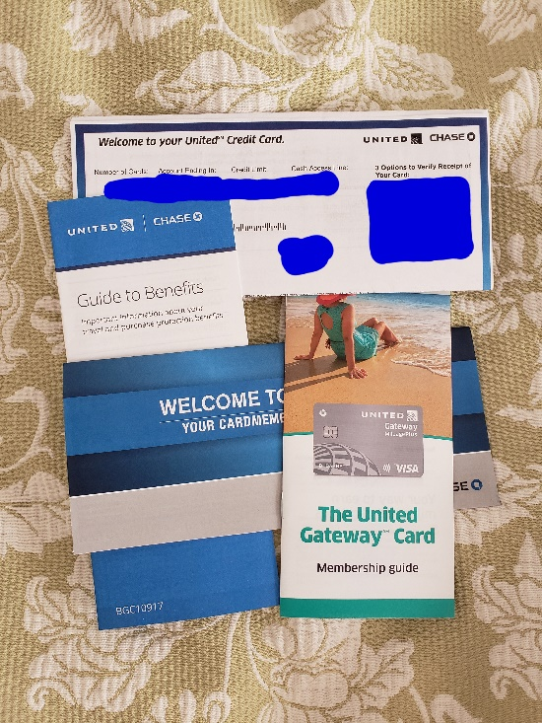
Unsure about the benefit, she wrote some questions down, including the MileagePlus and credit card agreements’ benefits and restrictions. She read that some are confusing and hard to explain, so she planned to write more questions and answers. She used different colored pens for questions and answers on paper.
Minutes, she took more risks by calling for the card’s verification and asking questions about the United Gateway Card’s benefits and restrictions.

Late in the afternoon, there is a Halloween Party at Church, and it ends at 20:00 (8pm). The Church Halloween Party starts at 17:00 (5pm) as she dresses up in a cute outfit. She was the only girl who liked to dress up when she was a child.
Telling more about her Halloween story to the friends,
She remembered when she was in middle school, she likes to get creative that suit her personality; Powerpuff girls, so she created her own costume with the paper mache. She recalled dressing up as a Powerpuff girl, Blossom with the bow tie on the head, dress in a pink dress.
“The Powerpuff girls have contributed to the cutest girl I have watched during my middle school, and so that flying is the term. Ha. Humans don’t have wings to fly... and so, Powerpuff girl as a fave had been the most childhood experience to develop. I decided to make a Powerpuff girl, Blossom.”
She likes the word “Powers” and “Girls” that fit her personality. That translates into the codeword: I-Powers Travel. The term “Travel” was also her favorite word since she regularly went to the library to learn more about its place.
Finally, the storytelling was over and…
Free time with treats, chocolate, cakes, and cookies, it was their wonderful Halloween experience.

Hours after her Halloween Party with her friends, they headed home just in time before 9pm.
Her mother and brother drove them home safely before 20:20.
She took her selfie of her 2020 Halloween Schoolgirl Costume: Her cute white button-down shirt, her plaid skirt, and her pigtail. She finished off with her red lip before she went to the Halloween Party at Church.

Feeling tired after eating some candy (after checking), she was showering, brushing, and flossing her teeth, unwinding herself an hour before going to sleep.
“I am just relaxing from the long day of work, play, and leisure.”
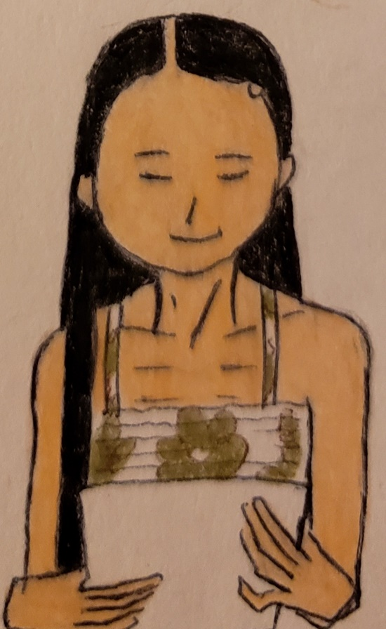
She finally reviews her trip itinerary again and felt happier after her trip went well. She sat on the bed, almost ready to go to bed, putting her both I-Powers Travel working papers and phone aside before turning off the lights.
***The End of the Story***

Acknowledgment
United was nicknamed “I-Powers Travel” after she created her personal name after her travel/life experience. Her bio is available on https://ipowerstips.travel.blog/meet-travel-writer/. She is currently a traveler specializing in solo and women’s travel information, including tips, tricks, and warnings. She listed creative ways to help travelers to plan a trip more efficiently and effectively and changed its traveler’s world in the era of the future.


