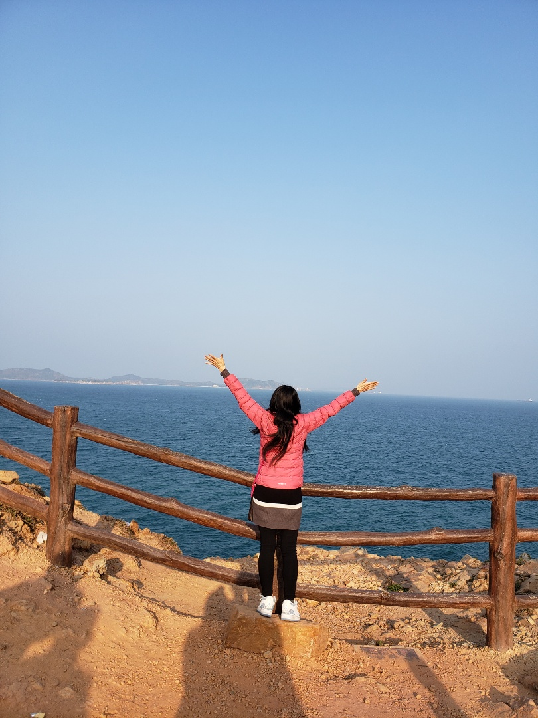

United’s Solo Trip to Singapore/Malaysia

United Acela Tse | Solo Travel Story (Part 2) | November 8, 2022

Her personal profile
A story of a Temple Travel girl (aka. I-Powers Travel Innovator)
A 31-year-old girl named United A. Tse (real name Steph) currently lives with her family. As a Temple University graduate, she has landed a dream job with abundant benefits. She is now working hard to get a permanent job to earn money to live in dreams. She enjoys exploring new places, writing her travel blog, doing crafts, and working on gaining her personal and practical skills to move to a permanent job. Owning her brand name, “I-Powers Travel,” she has a generic interest in travel, hospitality, and creativity. She specializes in solo travel as her guidelines, tips, and stories.

She has a website she innovates: www.ipowerstravel.wordpress.com; to learn more about the travel cycle: I-Powers Travel. She also has her travel blog for general travel, aka. I-Powers Travel – Tips, Tricks, and Stories at: www.ipowerstips.travel.blog/ and Funtastic Philadelphia Travel Guides at: www.funtasticphilly.travel.blog/.

She has her goal to travel overseas annually and was glad that her ambition to bring her month-long trip to her educational experiences landed her changing perspective. So she called her to travel “Experiential Traveler.”
Table of Contents
Preface 5
Introduction 21
In the Beginning 39
Trip Thoughts 49
Let’s Plan a Dream (Part 1) 73
Let’s Plan a Dream (Part 2) 95
Before You Go 102
Set Aside 113
Confirmation 117
Prep 154
PreTrip Orientation 173
Wanderful Life (Part 1) 184
Departure 190
Day 0 – Learn from Itinerary, the Basics 208
Solo Dining 214
Groceries 221
Day 1 – Singapore River Walk + Merlion Fun (Part 1) 224
Exchanging Money 225
Day 2 – Merlion Fun (Part 2), Sole Tour 235
Day 3 – Orchard Road + Speculator Garden Visit 245
Day 4 – Dreamy, Greeny Epic Places 255
Wanderful Life (Part 2) 264
Day 6 – Langkawi Day 272
Day 7 - Sailing to Penang 281
Day 8 – A Free Time in Penang + Cameron Highlands 289
Day 9 – Cameron Highlands Experience + Off to the Capital, the KL 293
Day 10 – Free Time in Kuala Lumpur + Batus Caves 299
Day 11 – A “Weeeeee,” Short Flight back to Singapore 309
Day 12 – Farewell + Little India + Specialized Gallery 314
Day 13 – Sentosa + Farewell Day Trip 319
Coming Home 326
Day 14 – Farewell + Return Home 326
Wrapping Up 341
Acknowledgment 356

Preface

The book is about a woman from Philadelphia who recently landed a dream job while balancing her family, social life, and leisure time. She enjoyed sharing some tips when traveling solo to the public.

Before you begin to read the article, ask yourself:

- Have you dreamed of traveling solo but have no idea where and when you like to go?

- Have you dreamed of traveling at your own pace?

If you answered yes but don’t know where to start? You are not alone. The article will guide you on how, when, where, what, and why you start thinking of solo travel.

Before you started to plan to travel solo, how did you ever wonder that one day you would rather travel alone for a day? For a few days? Or for a week or for a month?

If you haven’t traveled solo, that’s okay. However, it is time to read this book about a solo travel “bible.” It includes comprehensive tips, tricks, and warnings when considering a trip of a lifetime.

Make a dream trip a reality!

She came up with the definition of solo travel.

What is solo travel?

There is no clear definition of “Solo Travel.” Solo Travel for some people means:

- Explore the place as you please

- Self-Indulgent as you travel

- Enjoy their time alone

- Freely explore the area and reflect at your own pace

Benefits

According to her blog, “Plan a Solo Vacation Day,” she listed several benefits includes:

- You don’t want to wait for someone

  - You can go as you please

- You can able to manage your own time (downtime)

  - You can decide your time management

  - You can choose when it’s your mealtime and what and how you can eat

  - You can visit the place you want to see

  - You can set aside when, where, how, what, and why you travel solo

- You want to engage in healthy, positive risks

  - You will fly alone, know how to get into customs, and what and how you travel

  - You will ask questions or know when to seek help

  - You will meet new, interesting people

  - You will learn new skills, build characters, and foster the unique creativity needed for your future

  - You will adapt self-sufficiently skills you might need too

  - You will tell your story to your family/friends/others

- You want to gain independence

  - Make informed decisions and judgments

  - Gain responsibility

  - Learn from the mistakes

  - Personal/professional development

- You want to climb your career

  - Manage its multitasking better

  - Fosters creativity needed for life

  - More motivation

- You want to boost health and wellness

  - Confidence

  - Builds self-esteem

  - Reduce unnecessary stress and anxiety

What are the drawbacks if solo travel seems too good to be true? I listed a few of them.

- Safety

  - It can be complicated for solo travel in certain countries, especially women

  - More group escorted tours are intended for solo travelers for added safety

  - It can be complex to handle emergency situations

  - Solo Travelers can be a target for the attack, especially at night

- Loneliness

  - It can be hard to meet and maintain a travel buddy for short/long term

  - It can be boring (if you don’t plan a dream trip itinerary)

- Expensive

  - Handle all bookings and tickets/fees on your own

  - Some group tours’ single supplements aren’t available, so you have to pay the total price of a room

- Push yourself to the limits

  - Rely all of planning and budgeting on own

  - Use lots of energy to use the time to travel/explore on your own

What is another term for “Solo Travel?”

Solivagant

Solo Travel Facts:

- A quarter of women plan to travel solo.

- Women opted more for traveling solo. Why? Women are more likely to express confidence, a sense of identity, independence, and self-care. Men’sMen’s solo travel is on the rise too.

- Out of all solo travelers, about 84% are female.

- About 12.5% of all women have planned a solo trip in the USA.

- 25% of all solo travelers are millennials.

- Solo Traveling is also a growing trend.

- The first wave of “solo travel” began in 2010 and has exploded more rapidly than the family trips, honeymoons, and tours combined.

- Millennials are more financially independent in budgeting and planning a solo trip than other generations.

- The average cost for one traveler to travel the world is about $20,000.

- Australia is the expensive destination ($250 a day), while Laos is the cheapest destination ($30 a day).

- Many solo travelers prefer to stay at a hostel over a hotel to overcome loneliness.

- The average solo traveler is 47, but travelers can be as young as the 20s and old as the 80s.

- March 1 is a Plan a Solo Vacation Day and is not a federal holiday in the US. It is a special, fun day for solo travelers. It was established in March 2018. To celebrate, hashtag #PlanASoloVacationDay on social media with a picture of yourself traveling solo.

References:

https://modernadventure.com/magazine/march-2019/why-do-women-travel-solo-more-than-men/

https://www.thewanderingrv.com/solo-travel-statistics/

How to Travel Alone and Enjoy it Safely

As United dreamed of the vacation sharing on Friday’s social gathering, she researched suitable places for solo travel. She then researched and jogged down the specific countries and places appropriately. It was the moment when she brainstormed the information regarding the factors: Entry Requirements, language barrier, visa requirements, safety index, and other restrictive conditions. Then she shared some tips and advice with her friends (some don’t want to travel solo), which is absolutely okay.

Tip: Traveling solo requires lots of practice and patience, especially if you haven’t traveled solo for the first time. It is essential to start small, a giant leap. Start small and work the way through. Do not assume that solo travel happens overnight; it takes considerable time to achieve your “solo traveler.”

How to get started

Don’t know how you get started? You can start small and work it out. Don’t try to hurry to the next level. Solo Travel requires lots of practicing and learning. Take baby steps.

Steps

Step 1: Try it out with a day trip to the park, a big city, or a place. There are no fixed steps that fit all, so depending on skills, you will need to develop and grow to reach the goal you want to achieve.

Step 2: Write a journal about the event (whether good or bad news). Keep and recap your journal to learn more about your experiences.

Tip: Start your online journal, such as a blog. These will help you tell a story about your travels, whether good or bad things happened.

Advice: In the journal, list the lessons you learned as you travel independently, such as lying just to be safe, “My family will pick me up at the X place.” It is like a recap based on things you learned.

Step 3: Talk to your family members about the story. Try to convince them that you did show your responsibility. Examples will be taking care of your health and wellness or personal business, like showing that you are grown up.

Warning: Don’t argue over your parents, even though you don’t really like their options. It is essential to smile and say, “Thank you very much for having a discussion.” Don’t over-worry if your parents are reluctant to travel solo.

Step 4: Share your story about what you learned and praise your rewards. Show them your responsibility to yourself and others.

Step 5: Address your past mistakes. Learn from the mistakes that you have encountered. Review your journal and brainstorm your past travel experience. Use your critical judgment of yourself.

Step 6: Practice and be patient. You will learn better by enhancing your experience rather than just reading the solo travel tips or from the book. It is called Active Learning. Use the knowledge you learn and apply it.

Step 7: Repeat Steps 1 to 6 and develop the new skills that fulfill your survival skills, including critical safety lessons. Get used to the new skills you acquire. Then, journal your skills and share the tips you learned.

Tip: Don’t compare yourself to others. Instead, focus on yourself, your wellness, and your health. Be confident and enjoy.

Don’t get discouraged if your parents refuse you to go abroad alone. Show them your responsibility and take care of your health, wellness, and safety. Convince them that you did the research such as safety, budget, and the overall purpose of “traveling.”

Your practice of solo travel depends on individuals.

Advice: Try a day trip to local/nearby towns and come up with lists of things you want to visit. For example, plan a daycation to NYC. If you haven’t traveled solo that much, do not book your stay yet because you don’t know how to learn sufficiently from solo travel.

It takes time for you to adjust your safer travel as you progressive make your travels come true.

Recommended: After you get used to traveling alone, if you are very comfortable, plan a weekend getaway but only stay for 1-2 nights at a time. Don’t try to prepare for a week-long trip solo. You aren’t there yet to travel solo abroad.

Still, you need to keep practicing meeting new people, taking care of finances on your own, taking care of responsibilities and yourself.

Advice: Solo Traveling requires lots of energy and a safety net, so taking care of yourself and staying safe is the most priority.

Fact: Solo Travel is not for everyone. Don’t ask others to travel solo because of their opinions, characters, traits, and values. Be yourself, and don’t let the guard go down.

January 2021 in Philadelphia

It was a cold evening in Philadelphia as United checked her email at home. It stated that she had accepted a general position. Her next step was to take the job test required for all new employees. She was excited about the new job she had applied for.

Before she headed to social gatherings, she wrote a letter explaining to her family and friends. She developed when she traveled solo to Taipei last year.

The letter from the traveler (I-Powers Travel):

To the family and friends,

We would like to thank the loving family and friends who care for us. Although living with the parents while achieving independence isn’t easy, being myself and taking responsibility is the only one it needs. I knew that moving back home for the past 8 years had changed from living alone to living with my family. I know that it can be sad for me with no family/friends’ support, which gladly moved back home years before. Now, in Philadelphia, I have lots of social support from my family, family members, friends, church friends, family’s friends, and others who give me advice through prayers.

In Philadelphia, I felt happier and more enjoyable. I have more freedom to explore and get around more easily during my free time. There are subways, buses, trolleys in the community. There are much more traveling opportunities than in Tucson, where there is less of everything. Finally, it can be boring if I don’t travel locally and move sooner rather than later.

I am so glad that my hometown (Philadelphia) has more significant opportunities to travel and explore, take the regional rail to the nearby places, and visit NYC for a weekend trip. By exploring more places, I will feel much happier and more confident. In summary, traveling gives me more opportunities and freedom to learn about myself and my personal traits. I believe that learning new skills enables me to develop skills progressively. Last year was the start of my personal and professional development after I finally returned for my 5-day solo trip to overcome my shyness. I am blessed that my personality has changed to a more attractive, global citizenship needed. People will like me, and they will enjoy my confidence.

Love,

United Acela Tse

Then she was at the church, chatting with her friends while eating dinner, and planned to show them their favorite vacation spot for the year. After that, her friends talked more about their future plans since the airline ticket was getting outrageously expensive after the winter.

Meiji said the airline ticket to Hong Kong was around $1,000ish because of the peak Chinese New Year season. So she decided to wait for the springtime to travel with her husband for the week vacation.

Soon after, Sistine arrived at the church for bible study.

An hour later, they had already finished the bible study and then took their time to chat about their upcoming trip plan.

She approached her friends and greeted Sistine.

“Hello, Sistine?”

“Well, hello, United.”

“How are you?”

“I am good. You?”

“I am good, thank you.”

Discussing Sistine’s new job she landed, she worked a regular 8-hour shift during the first week of her new job at Chinese Christian Church + Center as a Bookkeeping and Supervisor, taking long, warm showers (to keep her warm) from the cold winter before coming to the church for Bible Study.

Just then, Kin and Sistine were there together, hanging out. They chatted more about the data mismanagement with Meiji. It was then Meiji had a bad day at work, saying the system went down in a significant amount of time. She then laughed while waiting for the personnel to fix the problem with Meiji and her friend Tracy.

Just then, after minutes passed by, Esther showed the picture of Osaka to her friends and,

“What is this picture?” her friend Meiji asked Esther.

“Oh, our picture of Osaka.” She laughed while remembering her last trip abroad.

“Mine is in Hong Kong,” Meiji added.

“That is nice. I was there last year and had so much fun,” Esther said graciously.

Showing her picture,

“United, where is this place?”

“Actually, it is Singapore. Is it beautiful?”

Esther replied, “United, you should definitely visit there. It is so beautiful.”

“Yeah! Can’t wait. I planned to travel to Singapore this year when I landed a job.”

“Sounds great. Will pray for you.” She added graciously.

“Thanks, Esther.”

As the conservation passed...

Esther finally mentioned, “Since we can’t travel due to the increase in airfares this winter, we can travel again soon this spring.”

Soon after, she realized the internet connection was slowed on the PowerPoint while Kin showed online, and then...

Loading onto the page, it was then displayed on the page, “The “website” can’t be loaded.” with the icon pixel (sad face).

“Un-oh,” United said to herself.

Then it displayed “no internet connection” with a pixel dinosaur.

Kin tried to fix the internet’s connection via the Wi-Fi connection issue and...

...disconnecting its Wi-Fi for the church.

“Hold on for a minute.” Kin said politely while waiting for the connection to be restored.

Then I clicked on the internet icon and reconnected the internet icon, but it said, “Can’t connect to the network.”

He left with no other choice.

And then there are no Wi-Fi options.

“Okay, now, we can emphasize how it’s connected to bible study, and if we have time, we can go on YouTube.” Kin continues to present their Bible Study while socializing his experiences.

30 minutes later, she and her mother returned home. United wrote her wish list for the year. She wanted to travel solo abroad, but she had lots of time to save money since she would start working at her new job.

The next day,

She focuses on her job and writes how solo travels will change her life forever. She recently landed a career as an associate in the hospitality industry. She demonstrates how traveling inspired her life and goals that changed the personality she experienced last year on her solo trip.

“Starting work will definitely bring new risks.” She said. “I don’t have to go back to the old life because I have memories of past events. I just want to move on.”

After she checked her email regarding the status of the job vacancy, she was very excited. She then emailed the job offer that she was interested in working in the hospitality industry. Therefore, she sincerely emails the human resources and the supervisor about the excitement that matches her benefits.

The benefits include:

- An excellent work-life balance

- Flexible work hours

- Friday is a fun workday

- 30 to 60 paid-time-off days annually but do carry forward

- Mandatory paid time off for holidays

- A maximum of 40 hours of work a week

- 6-month probationary period

- Excellent perks from travel discounts to shopping

- Free 401(k)

- Free saving accounts

- Excellent health coverage

- Etc.

She then emailed the job offer immediately after she carefully read the benefits the job offered.

February 17, 2021

It was the first day of work. She was both excited and stressed at the same time. She can’t wait to go to work.

It was a beautiful spring morning as United woke up excited and stressed. She had recently landed a dream job as an associate in the downtown area.

“Now is the time to learn while earning money,” she said while she was on the way to work via the Market-Frankford Line. “I started in the probationary period, which I wrote to let them know what to expect and how to survive on the first day of the dream job.”

On the subway to work, she said to herself,

“I know I have a probationary period of 6 months, so I will continue to work until it is time to travel solo. I know that it can be hard but worth it.”

Not Recommended: Schedule a fun, week-long vacation during the probationary period. The probationary period is a training period. It is a training period in which all employees must complete their era.

She witnessed, “The probationary period can wait and soon to be over.” As she looked at the blog she posted last July, she mentioned that everyone would get through it.

“You are not alone. Everyone, including travel addicts, has gotten through the probationary period at work. You will get through it, I promise.” She quoted on her blog.

As she was almost in the downtown area, she remembered some of the travelers (she followed them) on Instagram have 18 to 24-month probationary periods, and that’s okay.

“I recalled that to complete the introductory period, I learned how to pass the time to get through the period, like “do something fun or enjoyable while at work.” It is a training period to determine if the job is right. Of course, it’s right for me since I love the work culture I dream of.”

As she was almost in the downtown area, she remembered some of the travelers (she followed them) on Instagram have 18 to 24-month probationary periods, and that’s okay.

“I recalled that to complete the introductory period, I learned how to pass the time to get through the period, like “do something fun or enjoyable while at work.” It is a training period to determine if the job is right. Of course, it’s right for me since I love the work culture I dream of.”

As she got off at 2nd Street Station, she arrived at the worksite 20 minutes early to listen to music and relax while starting to work.

It wasn’t that stressful at the worksite, and she went to training class with a break in between.

While she was waiting for the class to begin, she remembered in May 2018 that she remembered working as a specialist at Temple. So, she wrote the letter explaining why she needed to change her personality relating to her mental state after her father burst into anger.

“I need to take a break from stress, and if I don’t have a soothing experience, life is gonna be hard. So, I wrote this journal to remind myself why I need to change negative thinking to positive. At work, it was time to save up for my dreams. Right now, it is class time.” She said to herself.

During the break at 10:15, she reviewed the places she wanted to go this year. It said on the white calendar,

“My bucket list for the year (2021):

- Climb up and experience theEdge (NYC)

- Visit Roosevelt Island via cable car?

- Try out the exciting places in both NYC and Singapore and write more travel blogs (I-Powers Travel and Funtastic Philly Travel Guides)

- Visit Gardens by the Bay

- Explore in the Haji Lane

- Langkawi

- Kuala Lumpur Visit

- More to come...

I can’t tell when I will be in NYC.”

She planned to show her parents her upcoming trips once she got off from work using the pen.

She ate dinner with her family and talked about her travel experiences at home. She shared her upcoming trips to NYC, Singapore, and Malaysia with the parents.

“Hey United, what is it?” Her mother didn’t know why she showed the paper about her upcoming trip this year.

“It is my New Year’s Resolution, including my dream jobs I landed. It includes paying bills, cooking vegetarian meals for my family, and taking care of my personal business independently.”

“Aha, you got this.” Her father said in an unfamiliar tone.

Seconds later, she said, relating to her last year’s solo trip abroad.

“Last year, I successfully went to Taipei on my own and took responsibility and passion for my dreams. I did it, took my healthy risk, learned how to overcome loneliness, and focused on the future. It is my next step to happiness and stress management. I knew that I had a 6-month probationary period and that it was time to save money. That was my most exciting thing to say last year.”

“You told me last Fall.” Her father said while listening to the conversation.

She continued.

“Vacation time is good for everyone, everything. I had a good time in Taipei for 2-3 days and then off to the beaten path with 11 other girls. We had a fun time performing the Lantern together. The tour guides took us to the dream world, Shifen street. I also met a girl named Jessei, who is from Anchorage. She is very nice, yet so friendly. She is now working with the city right after returning from her solo vacation. I still talk to her but not as much since she is less than an acquaintance.”

“Sounds like you are having a wonderful time and meeting new people,” her mother said in Cantonese.

“Yes, mama. I had a wonderful experience.”

“Impressive!” Her father exclaimed.

“Whew, thank you, daddy.”

“And here is the letter to you, mommy,”

She wrote,

“I really like to thank you for taking the time to relax and destress my life. I know that living with stress isn’t easy but manageable. I know that my daddy is like that, but unfortunately, I finally know how to deal with him no matter what. By taking myself away from the comfortable life, I come to work prepared after my 5-day trip and have already changed my perspective. It was a game-changer, thank God. Bless you and your family.”

Her mother couldn’t read English, so she translated it into Cantonese to explain to her.

She tried to read what she wrote and said, “Aww, how lovely, I am happy to read this.”

Her mother understands why he overreacts over minor problems. United accepts his anger by going up to the room and relaxing.

“Mom, I knew that instead of confronting him, I needed to take a break, go upstairs, and go into my room. I just prayed. Or I can ignore it.”

“That’s great. If your daddy was angry, don’t say anything. You can step out of the situation, go to a quiet place, pray, and meditate, okay?”

“Okay, mommy. I knew he was like that, and it finally helped me with the mood once the solo trip had concluded. I don’t need to stress myself or overact. I am finally accepting who he is. I am also accepting myself for who I am.”

“That’s great to hear.” She praised her.

“Thank you, mommy.”

Introduction

The day of the trip planning began as she successfully worked full-time as an associate.

She started saving money because she planned to travel there in the fall. First, she researched the airfare, which was expensive to travel during the summer. So she planned to mark the time to travel during October or November.

She has applied to real-life situations that benefit solo travelers as a whole. Then, she used her travel experience to put the information onto the website, starting with the Travel Cycle.

She already adopted a trip plan using the 7-step travel cycle called I-Powers Travel.

- I-Introduction

- P-Plan

- O-Observation

- W-Workshop

- E-Execution

- R-Results

- S-Survey

Before she started planning a dream trip, she read the blog on the first phase: Introduction.

Before you begin…

I am writing to inform travelers to effectively and efficiently use an “I-Powers” method to plan any trips regardless of romantic trips, vacationing with your friends, family, or solo travel. Planning a dream trip can be very stressful, especially for upcoming travelers who feel excited and are in a hurry in their planning process. These rushing trip planning assignments will affect the quality of the trip unless future travelers follow an “I-Powers” method when you actively plan any trips. We want to thank you for taking the time to create an innovative way to customize the trip itinerary with I-Powers by:

- Maintaining your travel budget.

- Gathering proper documents for country entry.

- Staying informed of your local family/friends while traveling.

- Knowing how to handle travel emergencies.

- Learning how to familiarize safety/laws abroad, even in your own country.

- Assessing local health facilities while traveling.

- Planning a customized trip itinerary of your choice.

- And much more benefits.

The above benefits will help travelers with struggles plan trips, plan a dream trip, and provide some tips and guidelines. So let’s get started.

She had already known how to plan a dream trip before heading to bed.

A few days later, she was still planning a dream trip for the year.

Tips: Before you begin to choose places to visit, the first theory is why travelers aspire to see specific locations based on 5 Factors or Elements.

Stamp Factors

Five factors influence travelers to visit or yearn to visit more places they love to explore. This blog will ask why people aspired to visit these places regardless of what they saw in pictures, discovered a spectacular place, shared on social media, what they read on a travel blog, or what they saw on travel channels. Instead, you will examine the five factors that affect your choice to visit the locations based on STAMP Factors. Of course, there is more than one factor that influences their visit.

- Social: Information shared through social interaction

- Text: Ads or words exaggerated through articles or books

- Article: Posts, articles, stories, blogs about travel or places an author wrote

- Media: Films or videos about particular places or cities

- Picture (Visual): Picture of famous landmarks or a familiarize texture or characteristics

“Before I start planning a trip, I only focus on the factors that I want to visit, not necessarily what I have to visit.”

Figuring out the factors, she opened her Facebook and Instagram and looked at her friend’s pictures of their dream trip for the Chinese New Year. It was her childhood friend Yassamine. It was posted on Facebook’s Album: March 2018 - Singapore and Malaysia.

She looked at the photos of both Singapore and Malaysia. She said, “I am super excited to plan my own itinerary and include a women’s tour in Malaysia. But first, I have to research ideal tours, including a dream visit to Langkawi. I already knew she posted of herself during the evening tour in Gardens by the Bay. She mentioned that Gardens by the Bay is stunning and encourages me to travel because it is very safe for solo travel.”

The Stamp Factors she wrote include:

“Social - Yassamine texted me that Singapore is a very safe city, and she encouraged me to go visit Chinatown and Haji Lane.

Picture - A woman posted a beautiful night at the Gardens by the Bay. Kinga shared a solo trip there and gave me advice on what I want to see. She went to the Merlion and took a picture there, then went to Singapore Flier the next day. She had a good time there, although she had traveled alone.

Article - I read a blog about Singapore and Malaysia, and my bucket was their experience of what the author wrote and see the glamping lights and touching experience day by day.”

Advice: Evaluating any 5 factors will inspire you to travel to specific destinations, but it is not guaranteed you will actually plan a trip and go there. You will have to earn and save money to afford it, as traveling requires financial goals and commitments.

Tip: Solo Travel requires trial and error and commitment to become a practical traveler. It takes the words “Patience and persistence” to achieve your desired goal, such as independently traveling solo.

Never give up your dreams.

She mentioned that solo travelers require considerable time to become successful travelers. Some travelers prefer to travel in groups or with friends, which is okay. However, it is crucial for you and those who want to achieve your dream of becoming a successful solo traveler.

She then reminds upcoming travelers of general tips when planning a dream trip.

General Tips when Introducing Places and Beyond

It is imperative to research and to do enough homework before you begin to plan a dream trip, whether you plan to travel alone, with your friends, with your family, or just a weekend trip. Without researching and doing enough homework, you will not effectively plan an efficient itinerary needed to travel and reach its goals and objectives. But, of course, you don’t want this to happen.

- Spend at least 15-30 minutes a day doing your homework if you anticipate traveling in the future.

- Manage your time to research and find evidence about safety and security, especially if you plan to travel solo. This time management enables which areas are safer than others, so you don’t end up in the ghetto.

- Do not procrastinate or put things off at the last minute, as you will miss these critical steps, such as spending time planning and observing places. You will need to make the necessary booking process (transportation and lodging accommodations). Make your time for yourself by creating to-do lists.

- Make realistic goals. If you plan to travel with your family or friends, try to make goals for them, not just for yourself.

- Research is required to obtain more countries and cities’ information about culture, places, demographics, geography, climate, etc., that needs to be included in the worksheet. These show that you did assignments about the places you will visit.

Remember the rule: Safety and security is the #1 top priority.

Days later, she thought of a weekend trip to NYC to spend a fun day at Roosevelt Island and ride the cable car.

Now, it was time for her to save some money while working through the first 6 months of work.

She only works on Mondays to Fridays from 8am to 3pm.

She was still planning a trip amid the probationary period. She has no big trip plan until the time comes until she finishes the period. Then, she starts off her weekend NYC trip, which she only travels on weekends.

Tip: If you only work Mondays to Fridays, you can still schedule a weekend trip to nearby towns such as Philadelphia to NYC while on a probationary period. You can still enjoy your weekend outings but be sure to let your supervisor and manager know the travel plans to extend your trip.

Just then, she made plans to visit the weekend Trip to NYC, such as seeing the Edge because she hadn’t had a chance to experience an outdoor observatory last year. But instead, she was focused on earning her living while planning a solo trip to Taipei last year.

Instead of planning a trip abroad, she only plans a trip to NYC by using her own website to plan a weekend trip.

“This time, I am going to experience what it is like to visit The Edge, which opened in March 2020. I was listed on the bucket list, but my brother wanted to visit NYC, and I don’t know when. My parents said May of 2021 is a good month to visit there because it will be a warm day to be outdoors.” She happily proactively saves money while working hard on the new job.

Coming downstairs to help with the cooking, she cooked roasted pork and then took turns boiling and steaming vegetables. It was then she took pride in helping others for dinner.

She had her document planned for a weekend NYC trip.

She mentioned when she was first traveling to NYC on her own when she was at high school to see her grandparent’s home. She gave some naïve solo travelers some advice, including restrictions when they started to practice solo traveling.

Not Recommended: Try not to plan a trip that involves an overnight stay if you are a naïve solo traveler. You don’t know how to protect yourself from these situations. In addition, your parents and friends will worry about you and don’t know how to handle the problem independently. Better to plan a day trip, write a journal, and be flexible based on what you learned as you travel solo.

Fact: Solo Traveling takes considerable time to be successful. Just like when you drive a car safely. It takes lots of practice, passing a test, and showing responsibility. The skills don’t happen overnight.

A few days later, she planned a trip to NYC by using her own trip application she created.

“I am focused on the 1st step of the travel cycle,” she said while taking a note onto the Microsoft Word Document.

I came up with a way to connect any 5 factors that influence travelers to visit NYC and Singapore, etc.”

She then answered the questions she created and saved via USB Drive.

A week later, she started a big trip by answering the questions on the website.

“I am grateful that information helps me and the public to plan a dream. I would like to thank you for taking the time to visit my website and was one of the amazing pieces of feedback I have seen. It is one step forward.” She said while texting the followers on Instagram.

It wrote on the message, “@i.powers.travelgirl, thank you.”

“Haha, thank you too.”

Minutes later, she introduced the trip by preparing for the worksheet she had created for herself.

Hence, many posts introduce the trip she created herself when she planned a dream trip.

She was doing the 1st worksheet.

Deciding Where you Want to Visit

- List destinations/places you planned or you want to visit. (List cities and/or countries only).

Singapore and Malaysia

- Who will you travel with? [1]

I will be traveling solo in Singapore but with an escorted tour in Malaysia.

- Is the chosen place(s) suitable to travel alone? Explain your answers.

Yes. I recently researched the data about crime and the place’s safety, and it was completely safe.

Singapore is a safe city. I saw on Facebook that some women traveled there and had no problems, especially at night. A local person I met online was Diane Ho. She mentioned Singapore is a safe place to visit, both alone or with your family, friends, etc., to spend a short vacation.

I am considering a girl’s tour of Malaysia as a fun experience.

- Based on any 5 STAMP factors, what makes you want to travel to Singapore and Malaysia?

I looked up on social media on Facebook and Instagram about their Singaporean trip (Gardens by the Bay). It was a very cool and vibrant place to see during the evening.

- Do you want to request travel assistance?

Yes. I am both a woman and a solo traveler.

If yes for number 5, see subtopic “Travel Specialties” for guidelines on the 7th Subprocess.

[1] If you travel with family, someone, tours, etc., you can skip 3. unless you will have some free time to explore on your own.

“I am going to read the script about “Women” and “Solo Travelers” after I finished planning a trip. It is too early to say I plan to read up the general information.” She said while reading the answers to 5 questions.

Opening the Word Document for each blog, she pasted the questions from her created website: www.ipowerstravel.wordpress.com. She was delighted that planning a trip wasn’t easy, especially for frequent travelers.

While answering the questions, she said,

“It comes in handy from the website, where upcoming travelers asked the question and the purpose of the trip. It was then evaluated by both questions: Safety and Health, which is on the next topic. Now, I am focusing on Introducing Places. For Trip Evaluation, It must pass all 2 components before moving on. Otherwise, it is not safe or healthy, neither is it. We are all about safety, health, finances, others that the traveler needs and wants from the trip. It is just personalized trip planning.”

Working on an I-Powers Travel Cycle homework assignment, she was delighted to have a sense of the goals of traveling to places. So she came up with an itinerary, such as experience/climbing up the Singapore Flyer from her bucket list.

Answering the questions with the highlighter, she then asks her own question about the trip’s purpose.

Reviewing the overall bucket list, she then researched what it was like when she saw the uniqueness of the place she endorsed to visit.

She spends around half-hour on some days (if time permits) answering the questions she created and figuring out her ideal activities based on personality and trip accommodations.

“It customizes people’s travel preferences, not just their one itinerary. No itinerary fits all, so there are people’s preferences and interests. So, if travelers like me want to experience a beautiful scenic view of an urban touching experience, Gardens by the Bay. I am planning an itinerary like no others.” She said while gathering information about her intended trip: Singapore and Malaysia.

Finally, she saves the document via the USB drivers needed for the future.

The next day, she continued to work on the questions she created herself, “Information/Survey about Chosen Places,” before she went downstairs to cook for the family.

Information/Survey about Chosen Places

Tips: Research is required to answer these questions. You can open a blank MS word, WordPad, or grab a blank piece of paper separately.

- Tell more about Singapore.

  - History

    - Year Founded

    - What inspire the influence of your planned visit?

    - Fun facts

  - Geography

    - Area

    - Country/City info.

  - Demographics

    - Population

    - Language

    - Main Religion

    - Ethnicity

  - Cultural

    - Food

    - Clothing

    - Daily life

    - Greetings

    - Others

  - Public Transport

    - Airport

    - Name of public transport

    - Cost of Fare

Information/Survey about Chosen Places

Tips: Research is required to answer these questions. You can open a blank MS word, WordPad, or grab a blank piece of paper separately.

    - Tell more about Singapore.

Singapore was founded as a kingdom of Singapura, where declared as "island" in 1299. Sang Nila Utama was named Singapore "Lion City" as he saw spotted Lion at the coast. A famous person Sir Stamford Raffles was a founder of Singapore afterward.

On August 9th, 1965, Singapore became an independent country, wholly separated from Malaysia as an independent country. The place was booming well into the 1980s and 1990s for economic growth.

  - History

    - 1299

    - Lion City “Lion”

    - Fun fact

  - Geography

    - 278.6 Square Miles

    - Singapore (City and a Country)

  - Demographics

    - 5.6 Million

    - English, Chinese (Mandarin), Malay, Tamil

    - Mostly Asian Descent

  - Cultural

    - Food

      - Hainanese Chicken over rice as the main dishes,

      - Noodles, rice, seafood are the 3 main pillars of favorite food,

      - Malay dishes.

      - Singapore Rice Noodles

    - Clothing

      - No traditional clothing here but hot, summer clothes (casual)

      - They typically wear light, summer clothes with sunglasses and hats to protect the sun. For footwear, you can wear any types of shoes, but I highly recommended wearing flip-flops or sandals or a comfortable pair of shoes for walking. Just to be sure there are no provocative clothing, where can seriously draw wrong attention and are unlawful.

    - Daily life

      - No traditional daily life but cleanliness in the city is both absolute and is the law in the city of Singapore.

    - Greetings

      - No formal greetings except saying “Hello.”

    - Others

  - Public Transport

    - Singapore Changi Airport – The international airport

    - MRT Mass Transit (Subway)

    - Cost of Fare

- What are your objectives for your trip? Give them more detailed information about your prior travel experience.

To see a famous landmark of Singapore, The Merlion. It named the mascot after Sang Nila Utama named the Merlion. I will have opportunities to see one of the actual mascots Merlion as a scenic view of it.

- What is Singapore’s weather like?

Ridiculously hot all year round as it located near the equator. It is almost like the tropical area. The humidity in Singapore is remarkably high with abundant rainfall. Bring your umbrella.

- Humidity Status:

Ridiculously hot with high humidity – high chance of rain

Mons | Jan | Feb | Mar | Apr | May | June | July | Aug | Sept | Oct | Nov | Dec
Avg High | 86 | 88 | 88 | 88 | 89 | 89 | 89 | 89 | 89 | 88 | 88 | 86
Avg Low | 73 | 74 | 75 | 75 | 77 | 77 | 76 | 76 | 76 | 75 | 75 | 74
Snow (mm) | - | - | - | - | - | - | - | - | - | - | - | -
Prep (mm) | 238 | 165 | 174 | 166 | 171 | 163 | 150 | 171 | 163 | 191 | 250 | 269

Source: https://www.holiday-weather.com/singapore/averages/

Additional questions to answer

- Can you handle this kind of climate? Yes.

  - If not, what are your limitation?

- What do locals wear? (You can draw picture of man/woman as an example).

Usually Summer, casual clothes (proper fashion).

- How safe is the place? (Give more detailed information as much as possible).

Very safe

- If you would take a trip again, would you recommend a someone to join you? [1]

Yes

- Refer to Travel Elevation after Travel Documentation to decide if the place is healthy/safe to visit. Then explain each place. [2]

[1] If yes, list the objectives of your intended trip.

[2] If you have any free time to explore on your own, refer to Travel Elevation for preliminary safety status. Research is required to find answers.

“It is the most daunting worksheet in which travelers are required to complete the worksheet before moving onto the next phases of the Travel Cycle.”

She finished the worksheet “Information/Survey about Chosen Places,” just in time for tomorrow’s important workday.

“Whew! I have finished the worksheet.”

Took a deep breath, went downstairs, and talked more about her upcoming trip, she wanted to talk to her parents, but there were busy. Hence, her mother was asleep, and her father watched TV on youtube. He was relaxing from his work.

Tip: Researching the place, including local customs, culture, climate, etc., is an integral part so you can learn more about the place you want to visit.

On Saturday morning (April 10), she went to Temple University Center City to do the “Upcoming Trip Questionnaire” worksheet.

A student saw her at the computer lab, typing and asking her, “Hello?”

“Oh, hi!” She greeted her.

“How are you?”

“I am good. Sounds like you are planning a trip, eh?”

“Sure do. This is my dream trip of my lifetime.”

“Where are you going?”

“Singapore!”

“Awesome! I have never been there before.”

Seconds later, a student quickly checked the time on the phone and said, “Sorry, I got to go to the meeting with some friends. Nice to meet you.”

“Nice to meet you too. Have a good one.”

25 minutes later, she was finished with the worksheet.

Upcoming Trip Questionnaire

- Based on STAMP Factors, why will you want to go to Singapore? (Give at least two reasons)

One factor is social media (Social). Some women from private Facebook Groups shared their travel experiences in Singapore. For example, she went to the Merlion and took a picture there, then went to Singapore Flyer the next day. She had a good time there, although she had traveled alone. Unfortunately, I did not have a photoshoot from the entire post because of privacy concerns.

Another factor is from the picture on the website, Gardens by the Bay. Gardens by the Bay is a beautiful place to see and more defined and more glowy at night. I did not have to wait until the last minute to get my ticket there because I still had my business to get it done before I took my dream off to travel.

- What are the goals of going to Singapore? (List the benefits)

To see the magical world of the Gardens by the Bay and the unique touching experience in the Haji Lane and Little Italy.

Indeed, Gardens by the Bay is a beautiful place to spend out at night because it is astounding. You can see vibrating colors you will imagine.

- When will you travel to Singapore? (Give specific seasons or months, not exact dates. e.g., May 2010 or Summer 2010)

Fall 2021

- How long is your trip?

4 to 5 days

- How will you get there? [1]

Plane!!!

- If your upcoming trip(s) is/are requiring a passport to travel internationally? [2]

Yes

- How will you get around places?

Bus, Subway, Tram (Public Transportation)

Singapore has an excellent transportation system, so I chose public transportation as more accessible to get around.

- Which types of lodging will you stay in? [3]

Hostels (My preference)

- Where will you stay? [4]

Somewhere in the Chinatown or nearby (safer and touristic area)

- How will you stay safe? (Novice knowledge at local destination are included)

I learned in my previous travel experience by sticking to most tourist areas and staying rooms reserved only for females as protection if traveling alone. I am also maintaining my low profile by keeping expensive items at home. I only carry things I need, not as I want to, because taking more items may experience pickpocketing and may lose items. I don’t want this to happen.

Essential Question: What activities suit you? (Needed to build customize itinerary on Activity Plan under Plan Process.)

I am an explorer with the right purpose of seeing a beautiful scenic view of beautiful places and attractions. I am fascinated by exploring areas or famous landmarks that benefit me to learn more about places such as “highly recommended places.” I am also enjoying shopping, exploring, and being adventurous. Therefore, I am a good fit for this ideal itinerary. These activities, such as day tours, rides, museums, and things, help motivate me to learn more about the places inside and outside my comfort zone.

[1] Questions is based on Gas Method. See the page.

[2] If yes, please enclose information on Travel Documentation Worksheet.

[3] The answer is based on 3Hs Method. See the page.

[4] Unsafe lodging locations do count as an answer. Research only lodging in the safer/tourist areas.

She then finished the 1st part of the trip planning.

Then, she went to Starbucks for lunch and Schuylkill Park for the afternoon stroll.

Warning: When planning a trip, not all countries allow US citizens to travel for safety and security reasons. Afghanistan, or Venezuela, for example, is listed by the US Department of State as Level 4 - Do not Travel.

In the Beginning

A week later, she quickly did the Trip Documentation (Travel Documentation and Currency) before heading to bed for some critical work event. She has spent some time doing her homework while planning a big trip.

Advice: If you plan to travel abroad, check your passport for expiration. If you have a passport less than 6 months from the expiration date, it is time to renew. The Real ID Act complies with any domestic trips via air travel.

Tip: No matter the trip, be sure to bring your Government-issued ID and your passport in case many hostels/hotels need verification.

“Since I already have a passport, I am good to go.” She said while reading through the blog.

Trip Documentation Info

Traveling domestically or Internationally requires specific documents such as your photo ID with you. The second form of photo ID, e.g., student ID or other identification, is recommended to travel alone. Carrying these photo IDs is essential because it identifies the person seeking assistance or requesting help in case of an emergency.

- If you are flying domestically, make sure you research the state you live in ~ your RealID requirement what identification to bring to the airport.

- If you are driving, make sure you carry your current driver’s license with you. Do not drive without your Driver’s License with you nor with your expired or suspended driver’s license. You will get yourself in trouble.

- A passport book is required if you are traveling internationally via air travel.

- In some countries, you visit or have a layover in a visa country. A visa is required, and in developing countries, a vaccine certification (e.g., WHO Certification) is required for entry. You will learn how to research the countries entry requirements for further assistance at http://www.travel.state.gov or similar (for other citizens).

For US Citizens or Others:

- A US Passport Card is not valid for international travel; better switch to the passport book. A Passport Card is only valid to enter Mexico, Canada, Bermuda, and other Caribbean Countries by sea or land.

- A US Passport Book is valid to enter all countries by sea, land, or air.

- For cruise passengers, I highly recommend a passport book. Emergency emergencies such as cruise disasters or personal illness require air transport to the hospital or a home for evaluation.

First, she has read the worksheet she created not for herself but for the general public.

Travel Documentation

Hint: Go on www.travel.state.gov (for US Citizens) and/or other third-party websites to answer these questions. (Some questions may not be applicable, so it is better to ask than know all the answers).

  - What country(s) will you plan to visit? List them.

Singapore and Malaysia

- What are the policies for expired passports and the passport validly?

6 months from the last travel date

- How many blank pages are needed?

A total 3 pages

- Do country(s) require a visa? [1]

Visa is not required for leisure travel.

- Do country(s) require legal entry/exit/other documents? [2]

No.

- If the country planned to visit requires doctor’s check-ups? [3]

Not necessary unless for long-term travel (30 days or longer)

- Are vaccines necessary or required to travel to the country(s)? [4]

None

- Do countries have currency restrictions for both entry/exit? [5]

Yes

If you answered “yes” to questions 4-7, you would need to enclose information on the next page.

If you answered “yes” to question 8, you would need to enclose currency restrictions here.

And...

Current Declaration

Info to know here.

  - Currency restriction for entry:

For Singapore: 20,000 Singaporean Dollars or equivalent for both enter/exit. Visit www.xe.com for your currency. For US Citizens, it’s 14,761 USD in cash.

For Malaysia: USD 10,000.

  - Currency restriction for exit:

For Singapore: 20,000 Singaporean Dollars or equivalent for both enter/exit. Visit www.xe.com for your currency. For US Citizens, it’s 14,761 USD in cash.

For Malaysia: USD 10,000.

She took days off from the assignment to finish her obligations, including planning an overnight trip to NYC to climb up the Edge and visit Roosevelt Island via Cable Car.

On May 15, 2021, her father drove to NYC. It was then she was listening to music and taking a nap.

Upon arrival, her father asked her, “United, where are you heading to?”

“Dad, I am going to climb up the Edge.”

“Whoa. What is the Edge?”

“It is an outdoor observatory. I have never been to this observatory before.”

“Aha, I gotcha.”

“I wanna go there.” Her brother Rich wanted to spend her time.

“Remember, Rich, perhaps when you can save some money for our two, we can book this ticket together. Sounds good? You are going with your daddy.”

“Next time.” He then pointed to himself.

“Dad, next time!” He repeated.

“Rich, okay. You don’t have to repeat.”

“United, one more thing, where are you staying?”

“Dad, I am staying at the Q4 hostel. And I will pick up the red bag when I return to Brooklyn.”

“Okay, stay safe. I will text you where we parked to grab a key to pick up the bag. Do not come to the hostel late, okay?”

“Okay, daddy.”

As United took off from Chinatown with her mother, hanging out with her friends in NYC, her father tried to find a parking spot.

Hence, there is nowhere to find a single parking spot near Chinatown.

“Parking?” Rich has no patience in finding a parking spot.

“Okay, Rich. We will try to find a parking spot. But, unfortunately, it has been a while since we arrived 30 minutes ago, and parking in NYC is the worst.” He then ran out of patience.

“Ahhhhh, I hate NYC.” He whined to himself, feeling agitated.

Tip: When driving to the destination alone and not knowing how to figure it out, it is essential to be patient when handling difficult situations. It is necessary to remain calm, practice meditation, and look for alternatives. This is something all solo travelers must learn how to overcome complex problems. Try to ask for help if needed. Give advice. Use resources.

Warning: Complaining with yourself and being impatient make situations worse and make you feel immature. Better to meditate and find ways to cope with difficult situations, especially when facing stressful situations. Also, patience is another skill all adults must handle, especially solo travelers.

As United took the subway to 42nd street, she then walked to the west to locate its entrance to the Edge. It was scheduled for 11:00, and she planned to eat lunch after the observatory.

After about 15 minutes, her father was relieved when he found an ideal parking spot near the public housing apartments. But, unfortunately, it was near Chinatown when he didn’t feel good about himself.

United and others entered the entrance, scanned the ticket, passed the security checkpoint, and processed to the elevator.

As they climbed up to the 100th floor, United smiled and stepped off the elevator. Some visitors felt their ears popping.

She took a picture of the outside, looking down while enjoying her snack.

An hour later, she then decided to visit Roosevelt Island. She then waited for the cable car to come. It departed at 12:54 and felt like a “vacation.”

United and the passengers have safely boarded the cable car, ready to depart.

As they departed, United and the riders took a picture while going to the island to browse around.

Pretty soon, at 15:30, she planned to return to Manhattan to retrieve her red bag.

Her mother and father hugged her and said, “United, stay safe. I am a little worried about staying in a hostel.”

“Mom, I understand the concerns. I did the extensive research and project about an NYC weekend while you were away...”

“I know that. Your project is impressive.”

“Thank you.”

As United was ready to check in for the night, she settled in at the 4-bed female room.

And the next day, she had breakfast at the Dunkin Doughnut. Then she checked out and caught her at 12pm via MegaBus to Philadelphia.

5 days later, she reviewed the answers from the worksheets (Travel Documentation and Currency Declaration). She asked herself about travel requirements and answered that Singapore and Malaysia travel for US citizens doesn’t require a visa for leisure travel. However, she said she needed an updated vaccine record for a trip.

Surprisingly, she had an up-to-date vaccination but needed a flu shot before traveling.

A few days later, while she was a free evening, she planned to do a Trip Evaluation by asking herself.

On the blog:

Trip Evaluation Info

Choosing which places to travel, explore, or visit might be an easy task. Still, the trip evaluation can be a time-consuming and challenging task. The trip evaluation is mainly based on the safety level and health infrastructure. The trip evaluation is primarily depending on which countries you will travel to. You will evaluate the safety basics, including up-to-date, unbiased travel resources such as recent safety/crime reports stored in the crime database. You will also assess the health information, including the database based on sanitation and the quality of health care. These large tasks are to research the destination you intend to visit or explore. Here is some guideline/website you will recommend to visit.

Website: www.cdc.gov/travel

Fact: The trip evaluation is the SaHe Acronym model, which evaluates a place’s “Safety” and “Health.” SaHe acronym is an application in which travelers assess safety and health by determining the questions they want to visit. It is unlike the trip evaluation of security per se; however, health is part of the trip evaluation whenever travelers need necessary vaccines.

Why Trip Evaluation is Important as part of Trip Introduction?

- Monitor the latest safety news of the place you will visit

- Assess comprehensive embassy/police/fire/other emergency services

- Know which areas are considered safe/dangerous

- Know the country’s health infrastructure

- Research the latest travel advisory/warnings about countries you will visit (If the trip is international)

Info to know: You must familiarize both the safety and health of a place you would like to visit so you can move on to Health/Wellness and Safety/Laws on the following process (4 Phases).

If you are traveling or planning to travel internationally, here is the website you should check out:

- Go to www.travel.state.gov for American citizens or American residents or national

For other residents or national, you can go to:

- Australian Residents: www.smarttraveler.gov.au

- Canadian Residents: www.travel.gc.ca

- Irish Residents: www.dfa.ie

- New Zealander Residents: www.safetraveler.govt.nz

- British Residents: www.gov.uk

For other residents, you can google or search the local state (similar to travel government or ministry) in which you are living.

And next blog page:

Evaluation of Chosen Places

Before moving into the Observation process, 2 parts of trip evaluation must be passed and satisfied to consider a “ready to visit” place. I-Powers Travel had mentioned earlier to carefully evaluate places and make informed decisions before you start booking and reserving tickets, so you don’t end up wasting money and commitment, not knowing when illness or dangers has experienced. Your goal for this process is to evaluate both the safety and health of the places by asking questions:

- How safe is the place/city?

- How healthy and sanitation is the place/city? Do places/countries have adequate health care with trained medical staff?

These questions should evaluate on your own by researching clues and find evidence on both traveler’s experiences and unbiased websites such as governmental agencies (CDC – Center for Disease Control) or a local government website to learn more about the country you are visiting on the following process – Plan for These Four.

Tip: To consider “ready to visit” places, both safety and health assessment must be passed to the question above. Additionally, you may be required to disclose information from either safety or health you answered from your overall research.

She started to determine if Singapore/Malaysia is safe and has sanitation.

Thinking and researching Singapore’s and Malaysia’s safety and health on this website, she studied the resources to answer the question.

Both she answered sufficiently: Safe and Sanitation of the place.

It was a short answer to the 2 questions from the worksheet:

Evaluation of Chosen Places

- How safe is the place/city?

According to the previous research, this place is safer and more solo travel friendly. There is an exceptionally low crime, high in a tourist area where there is a live event, even at night. Be careful at night and don’t travel alone during the late evening. Stick to a public, well-lit area.

- How healthy and sanitation is the place/city? Do places/countries have adequate health care with trained medical staff?

Singapore has an excellent health infrastructure and a unique, comprehensive health system.

According to the U.S. Department of State:

Good medical care is widely available in Singapore. Doctors and hospitals:

- Expect immediate, up-front payment for health services by credit card or cash.

- Generally do not accept U.S. health insurance.

- May require a substantial deposit before admitting you for any major medical treatment.

On the other hand, Malaysia may have standard procedures in some areas below the western standards.

According to the U.S. Department of State:

Ambulance services are:

- Widely available, but training and availability of emergency responders may be below U.S. standards.

- Not equipped with state-of-the-art medical equipment.

- Injured or seriously ill travelers may prefer to take a taxi or private vehicle to the nearest major hospital rather than wait for an ambulance.

Advice: Without either Safety and Health of the place, there is no way you are going on a trip without a safety and health plan. Both are a must when considering a trip plan as part of the package.

After finishing both the Safety and Health of the place she intended to visit, she moved to the Observation Process, which focuses on the learning and training process, starting in June.

Trip Thoughts

The plan is one of the challenging assignments to plan a dream trip since she has to brainstorm the activities that fit into the itinerary.

The plan is one of the challenging assignments to plan a dream trip since she has to brainstorm the activities that fit into the itinerary.

“I am working on Transportation and Accommodation arrangements before moving on to 4 Phases. I am doing all of the trip planning step-by-step. Before I start, I will read through the script to understand what I will do. This time is the word “Plan.” Planning is the big component of trip planning.” She said while reading through the lines on her blog.

Tip: Planning a trip must be around 40-50% of the time if you exclusively travel solo. Mark your calendar to plan your trip by researching.

The “Y” Version of Plan

Real Travel Stories

People have experienced a lousy trip once they came back from prison simply because they broke their local laws in Hong Kong and Singapore. Some randomly visited a dangerous neighborhood because they thought “nowhere else to go” in Philadelphia and got scared. Other travelers’ bank account has fallen (even down to negatives) simply because they compulsively spend more than the budget for their trip. Even savvy travelers had experienced severe illness on their journey to Thailand. They forgot to plan to pack their health essentials. As a result, they did not know what to do when they got sick and had to incur staying in a hotel for days to get better.

Consequently, most travelers have fallen their prey into the hot water, which causes them to ruin their trip, leaving their sad memories. Because of the lack of trip planning, they are also skimping on preparing all 4 phases of “Plan:” Health/Wellness, Safety/Laws, Documents, and Finance. From this perspective, some savvy travelers regret deciding to visit a country only because of the visa requirements to enter a country. Some travelers have experienced unhealthy weight gain and have experienced less energy once they come back from vacation. These are unfortunate news for travelers, and I hope completing a plan (4 Phases) will change your trip perspective.

Here is the reason why plan, according to I-Powers’ “Y” Plan:

- Narrows down the importance of trip information.

- Estimates the anticipated total trip cost for each person.

- Knows your health signals just in case if you get sick or ill.

- Familiars with the local laws (local states’ laws).

- Addresses the safety of the places by using unbiased information.

- Important: Sets your boundaries/Limits by

- Time

- Money

- Value

In conclusion, you can enjoy your trip without neglecting your fun time in the sun.

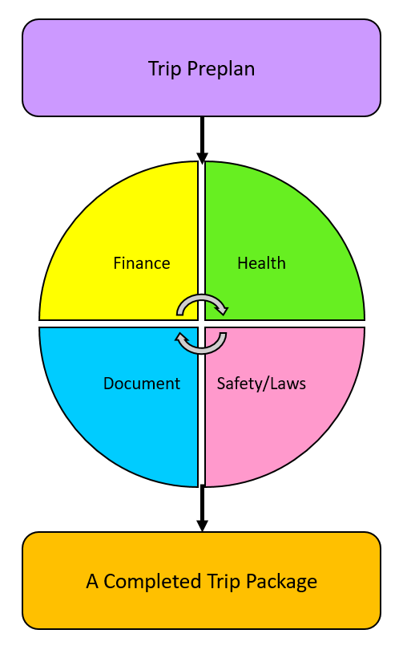
A visual graph of a “Plan” process

Preparing to do the assignment, she opened the Word document with the questions she created. She was also beginning to write on the white index card.

She then wrote essential things.

While deciding her options to take public transportation while in Malaysia, she said, “Plan Process takes lots of time, which includes an Activity Planner. The Plan Process is also included in the 4 phases: Health/Wellness, Law/Safety, Travel Documents, and Finance. All of the 4 phases or elements are critical for any trip planning.”

Fact: Planning a solo trip requires all 4 Phases. First, you plan for your health. Second, you prepare for your safety/Laws. Third, you plan for Documents needed for the entry, especially if you will need your governmental ID to travel in case of emergency. Finally, you prepare for your finances and the required budget for the trip.

Warning: Skimming on all 4 Phases, it is almost impossible to enjoy your trip. To avoid trip obstacles, you must plan carefully and work step-by-step, and double-check your work before you agree on your trip conclusion, known as the “Finished trip package.”

Advice: An overnight or more extended vacation requires Transportation and Accommodation arrangements.

She then looked at the website, paid attention to the step process.

First, she was at the post said, Transportation/Lodging Arrangement Info for the overall how to plan a trip goal and the purpose.

On the blog page, it said,

Transportation/Lodging Arrangement Info

Deciding on transportation and lodging arrangements can be complicated, especially if you plan to travel without escorted tours. However, you need to know the options of both transportation and lodging because you will narrow down the future travel possibilities.

Planning a transportation and lodging arrangement is important because you will:

- Know how to get around with your preferred transportation method.

- Help you to plan several activities each day depending on three factors:

- How far is the place

- How long will it take to commute to and from each place

- How long is each activity

You can opt more or less of each activity each day if allowed after completing your Activity Plan.

It is essential to mention your preferred transportation and your preferred lodging accommodations so you can move on to the activity plan. Activity Plan will conduct after you figure out both Transportation and Lodging Options. So grab a piece of paper/notebook or pop out of your MS Word or Wordpad to get planning.

Next, she moved on to 2 worksheets and asked about Transportation Arrangements and Accommodations.

She answered Public Transportation and Hostel, respectively, based on the question she answered from the Transportation/Lodging Questionnaire (2 pages - Word Document).

Transportation Questionnaire

Based on your chosen destination and the availability of transportation on both guided tours and/or independent travel, will you decide to take:

- Plan 1: Public Transportation [1]

- Plan 2: Private Transportation [2]

- Plan 3: Both Public/Private Transportation

Result: Plan 1.

Results:

- Plan 1: Plan 2-3 activities a day

- Plan 2: Plan 4-6 activities a day

- Plan 3: Plan 3-6 activities a day

[1] Public transportation includes buses, trains, and subways operated by the city government.

[2] Private transportation includes personal car, car rental, private bus, or transport not operated by the city government and is private, independent.

“I am considering only 2-3 ideal activities a day just for starters.” She said while she had already looked at the ideal activities from the list.

She has also worked on both worksheets since she asked herself which transportation and lodging methods she prefers.

Lodging Questionnaire

Tips on using this worksheet:

- It may help look at the 3Hs Method in the Workshop Process.

- Before you plan any activities and/or attractions, you will evaluate the mode of transportation and lodging based on how far the places and the time limit you can spend each activity.

Based on your preferred accommodation, you want to stay at a hostel.

- Hotel

- Hostel

- Homestay

**Still deciding? You can look at the 3Hs Method with examples for reference.

“Since I have experience staying at a hostel, it is a great opportunity to meet new people such as Jessie from Anchorage. She is a charming yet nice girl.” She remembered when she met with a girl at Dan Hostel on the 1st day of her trip.

Tips: If you are lonely and want to meet new people when traveling, I highly recommend staying in a hostel so you can meet new people.

Then suddenly, she moved on to an “Activity plan,” which counted as the majority of the time, planning activities suitable based on the answer she responded to from the question, “What activity suits you,” in that she answered earlier.

She mentioned, “Without trip planning, there is no purpose, and overall, the trip becomes boring. So you don’t want to plan a trip with no purpose nor lack of planning. All trips will have some goals and a purpose.”

United kept the critical paperwork in the file via USB. She will retrieve the information later when it’s time to book her flight and accommodation. She used her folder to store essential materials and papers in the compartments.

“I might need it for the trip.” Finally, she organized the paperwork from her trip assignment into the folder.

On May 30, after taking a long walk to the University City, she had lunch at Starbucks. Then, she worked on the Activity Planner she created for herself on her Acer Laptop.

“The most time-consuming thing was the Activity Planner; it requires a vast amount of time to fit into an ideal travel itinerary.” She mentioned.

Looking at the webpage, she read the entire direction for the Activity Plan Workshop blog.

Activity Plan Info

Now, the Introduction Process is complete. Let’s review your answer, “What activities suit you?” and think of your activities for a minute. Ask yourself. Know your travel style. There is no one size fits for trip itineraries. It is your responsibility to write down lists of activities or places you like or wish to visit. After reviewing your answer previously, you should know how to get around in a city.

Activities are other essential elements when planning a trip because you want to have fun when visiting places. The journey you plan has no goals or functions without any scheduled events. Therefore, it is imperative to plan these activities according to your response based on your preferred activities. Instinctively, visiting an unfamiliar place is an expense, and you will have to take your commitments and dedication to execute activities that fit into your personality. It is also critical for you to review the answer from the Upcoming Trip Questionnaire and review” What activities suit you?” Take a few minutes to think of your interest before you start to jog down Activity Plan Worksheets. You don’t want to end up in the wrong, dull, or disinteresting activities.

After reviewing an important question, you can now process the Activity Plan and download all three files.

Advice: It is essential to know your ideal activities based on your interests so that you don’t have to worry about boredom when trying to enjoy your dream trip.

She then said, “I am making sure to read the directions before I begin to do the worksheet. I plan to write as many activities as possible to fit into the itinerary. But be sure not to overplan nor underplan them, which sabotages the trip. I don’t want that to happen.”

Activity Plan Workshop

After you have done with your transportation arrangement, let’s do this activity: Travel Plan for Activities. Download these worksheets at the end of the page (activity-plan-worksheet) that I-Powers Travel provided you to plan your activities that customize your personality.

There are 4 separate worksheets to include in the travel plan.

- Activity Planner

- Your Postponed Activities

- Activities Budget

- Activities Worksheets

Activities Planner

Direction: List as many activities (excluding eating out) you will brainstorm — research required to think of activities that fit your custom itinerary.

After you plan out the activities or events you execute, you can highlight or put a checkmark on each activity you want to visit as your bucket list.

She first did the “Activity Planner” and the “Your Postponed Activities.”

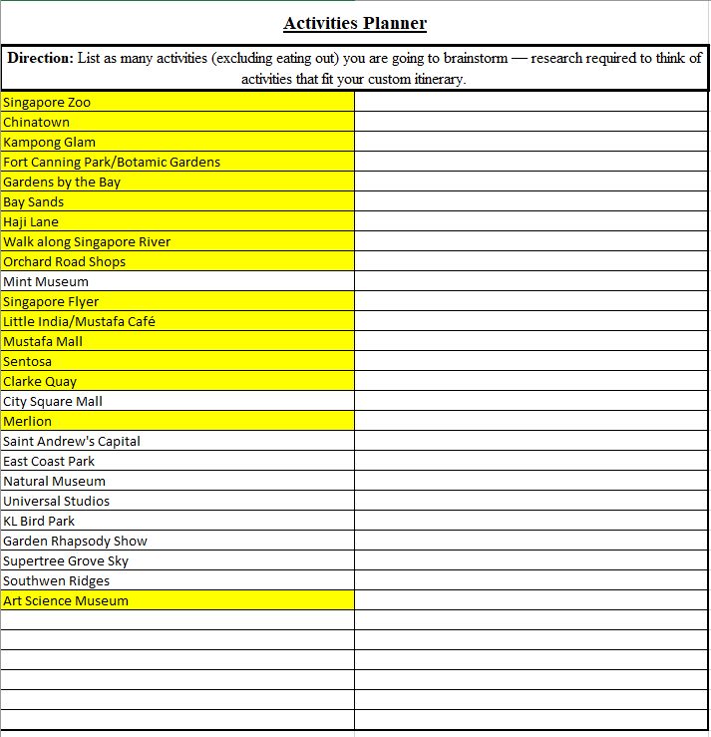

Remember that highlighted activities or activities you put in don’t mean you can visit all places or engage in all activities in one trip. After you confirmed both transportation (Gas) and lodging (3Hs), there are some changes to the plan.

Note: Planning an original itinerary takes lots of time, dedication, and hard work. Therefore, it doesn’t happen overnight; it takes lots of planning, evaluation, and commitment to ask yourself if this activity suits your personality.

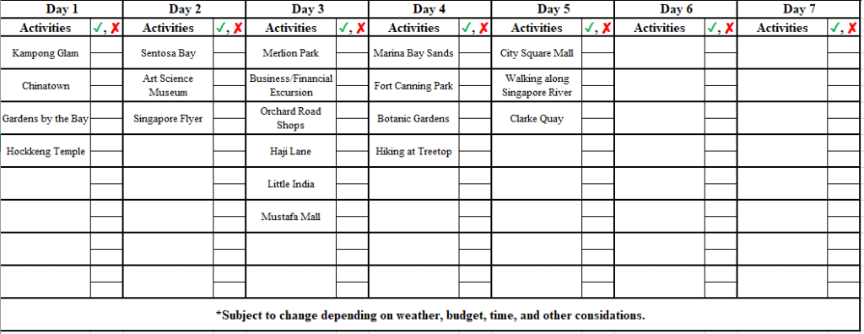

She said while doing 2 out of 4 worksheets for each of 4 nights, “Doing my homework makes me motivated to reach my goals for the outcome of something... Just like planning not only for the trip but for life goals. Suppose people don’t start planning with confidence. In that case, there is no focus or goal, so speaking of that, doing your homework enables people to discover something that empowers them. Doing homework will also calm you down, especially if I have a busy evening.”

She then reminded the travelers when planning activities while traveling.

“Planning an original itinerary takes lots of time, dedication, and hard work. Therefore, it doesn’t happen overnight; it takes lots of planning, evaluation, and commitment by asking yourself if this activity is suitable for your personality.”

2 days later after getting off from work early, she finished her entire Activities Plan Workshop. She was grateful that she took her time to do the assignment related to the itinerary planning of her choice and her bucket list.

She has done her “Your Intended Trip Itinerary.”

Here is what you will need to follow (2 steps):

Step 1

- Make the best guess for each day and activity but not evaluate them yet. Try to maximize days of travel. For example, if you prefer public transportation, you should plan 3-5 activities each day. There is some modification as needed.

- Do not plan a meal and eat out yet. You will get through it after reviewing the reasons for the 4 areas of the Plan (aka 4 Plan or Plan for These Four).

- After narrowing each activity each day, you can still add some events or activities to the worksheet if needed.

Step 2

- Once you finish with the obligations, you can look at each activity (such as looking at the activities’ info or event on behalf) to determine if each activity is suitable for your travel personality.

- Mark each “Checkmark,” “Question mark,” or “Cross mark” to each box next to the activity. If you prefer to use Excel or computer, you can substitute the 3 characteristics:

  - V = Check Mark

  - ? = Question Mark

  - X = Cross Mark

- Not sure what the three characteristics mean? You can take a look at the information below (Keys)

- Once you finish the two-step process, you can change, modify, alter, or omit activities that don’t fit your personality.

Keys:

- Check mark – Approved for the day or itinerary

- Question mark – To be considered

- Cross mark – Rejected, move to days before/after, or omit

Acceptable combinations (Sometimes there is confusing or hard to decide whether or now you will visit or engage in each activity).

- Check and Question mark – Possibility of approving activities/events for a day or an itinerary

- Cross and Question mark – Possibility of rejecting or changing activities/events for a day or an itinerary

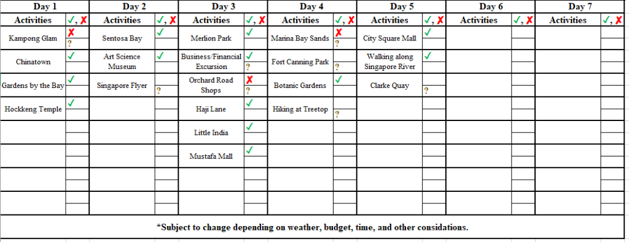

“Just because the intended trip itinerary doesn't mean my trip goes well. This trip itinerary is subject to change depending on circumstances.” She said, figuring the activities that suit her personality.

*This itinerary is subject to change

**Keep in mind that this completion of planned activities is not finalized. You will need to modify some changes after booking transportation and lodging arrangements.**

And she finally did the “Activities Planner Budget Sheet," which is the final steps of the Activity Plan Worksheet.”

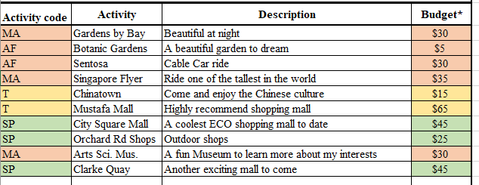
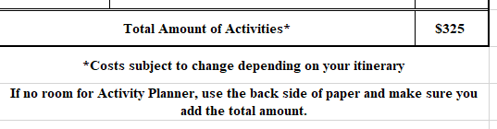

Keys:

- Green fill – Optional Fees

- Yellow fill – Recommended Fees

- Red fill – Required Fees

Hint: If any activities and admission are free, leave them blank.

Note that shopping is an optional fee and can be used within entertainment parameters.

After she finished the activities, she read the blog about trip changes. She said, “There is something that all travelers must deal with the trip changes or situations, especially for solo travelers.”

Advice: You must be patient and flexible when your trip changes.

Warning: Complaining and/or blaming for the trip changes to make situations worse and make your health and situations worse. Travelers must deal with and adapt to the trip changes. They also must have a backup plan.

The “Y” Version of Trip Changes

Sometimes, trips or itineraries can change for numerous reasons. For example, flight delays or cancellations, terrorist attacks near the tourist areas, unpredictable weather conditions such as typhoons, lack of available funds to gain admission to an art museum or other personal circumstances may cause your itinerary to change without your reasonable notices. However, it happens to most travelers, and here you can investigate the cause and the specific reasons.

Think of the RES Method. RES Methods broke into three words to apply the cause of the trip itinerary change.

- Reason

- Explanation

- Solution

Sometimes, you must deal with the change of your intended trip plan, no matter how fun or boring the situation is. Often, travelers may feel frustrated or angry when their trips do not turn out the way they want to present or simply because the flight has been canceled without reasonable notice, or they don’t have enough money to spend their day. Take John, for instance, who yearned to take a nonstop from Newark to Honolulu on a hot summer day to see the beautiful Hawaiian culture. However, when he approached the departure gate, his flight to Honolulu was canceled. “Cancelled – You must be kidding me.”

Consequently, he threw temper tantrums or worse because he did not identify the cause travelers have missed a day or two that could ruin his nice Hawaiian trip. However, he may repetitively find an airline agent if he can book their earliest flight at the earliest convenience. Overall, he complained and blamed himself that the situation could be changed. Still, unfortunately, the flight cancellation can’t be changed but is manageable.

Likewise, John got angry when his flight to Honolulu got canceled because of the engine problem. He did not know how to distinguish between the two categories: internal and external situations.

Since flight delay or cancellation is an external situation, travelers are not their problem, so they can’t control the flight status. The airline can control the flight status. John should have dealt with his situation by approaching an airline counter for his available flights to Honolulu at its earliest convenience. He should have to calm himself down before getting out of his control. We will learn how to handle unexpected events, like flight cancellations. Besides flight delays or cancellations, you should understand the different situations: what can and can’t control.

There are two types of changes: Internal and External

- Internal: Things you can control

- External: Things you can’t control

Two differences in the “Y” Version of Trip Changes:

Internal | External
Time Management | Transportation Cancellations
Budget Constraints | Crime/Terrorist Incidents
Personal Situations | Weather

It is essential to familiarize the cause of a trip change, and you should deal with your trip change no matter how small, or big the problems are. On the next blog page, you will list 6 reasons.

Remember: Don’t become “John” above because he did not know how he reacted when his plans changed.

And she then learn why some trips have changed based on 6 reasons.

Reasons Why your Itinerary Changed ~ aka. Six Causes

There are six reasons why itinerary or trip plan can change according to the 6 factors below. It is essential to know the 6 factors, cause, and classification. Think RES Strategy.

Weather – Some activities such as touring, going on a beach, or going out late at night might be changed to a day(s) based on weather permitting. Check the weather the day or two before planning any weather permitting activities.

Budget – Some activities and attractions might cost additional dollars to gain access to the entrance, so you might check the price of each ticketed person. Check the actual and estimate budget sheet before you begin to make a reservation.

Distance – Some distance to attractions/landmarks may be evident. It is crucial to calculate tie time-correlated with the distance, whether driving or taking public transportation. In reality, public transit or regional rail may be an excellent source to get around. Still, the time may be consumed because of the long wait to transfer to another bus route or train delays. Check local transportation to see if buses/subway/trains ran late, suspended, or detoured.

Time – Some attractions may have a time limit to spend a specific time in one location. Follow the set schedule of activities.

Location – Some activities and attractions may be inconvenient to visitors and travelers because of the terrorist area, crime zone, or dangerous neighborhood. Research or visit information about the safe place before planning any activities.

Emergency – Car Breakdown, running to buy emergency kits, volcano eruption, broken arms, and other unforeseen events will significantly affect the trip itinerary. Plan any backup so you have enough time to address the problem if possible.

If changes occur because of weather, budget, distance, time, location, and emergency, make sure you give sufficient reasons on the next page.

After downloading the worksheet, “Reasons why your Itinerary Changed.” She then moved on to the “References” needed to budget for her dream trip.

Travel Costs

Travel costs are travel-related costs you will need to budget. Hence, according to the I-Powers Travel Innovator, these categories of items you should budget.

The Travel Costs included:

- Transportation to the destination (Gas method)

- Lodging (3Hs method)

- Food/Groceries

- Entertainment/Tips/Activities

- Needs/Emergency

- Others

The above categories included the total amount of money you will budget to plan a trip.

Note: Travel Costs vary depending on these factors:

- Destination

- Season

- Time of the day

- Day of travel

- Duration of travel

- Travel Style

Before she planned to do the “Travel Cost,” she looked at her deposit, and her job was put into her account. She then calculated her annual salary since she only worked 4 and half months.

“I bet that I am traveling on a budget because I have time to save up for long-term savings. The job I earned from the internship and a job I worked at Temple.” She whispered to herself while figuring out her budget style.

Your Travel Style (Finance)

Based on your spending style and money personally, what is your travel style for travel?

- Budget

- Average

- High End

Your Travel Style: Budget

Since she will travel on a budget, she has a strategy of keeping her cost under control.

Working on the worksheet, “Estimated Travel Costs,” she began to research the budget by going on www.budgetyourtrip.com.

Typing the word “Singapore,” she hit search and clicked the “Singapore.”

She then set the Travel Style to “Budget” and selected the currency to “US Dollar.”

Estimated Travel Costs

Tip: Go on the website www.budgetyourtrip.com or search for the average cost and search the places you would like to visit. Next, default to the current currency and your ideal travel style. Finally, remember that 3 Travel Classes is the travel style.

Your Travel Style: Budget.

Average Travel Cost

- Daily: $46

- Weekly: $322

- Bi-Weekly: $645

- Monthly: $1,382

Here is the breakdown of items you should budget

- Accommodation (hotels or hostels): $50

- Food [1]: $9

- Water [2]: $1

- Local Transportation: $4

- Entertainment: $10

- Tips/Handouts: $3

- Intercity: $11

- Scam/Robberies:

- Alcohol [3]:

**Leave it blank if these do not apply to you**

[1] You will need the amount to solve the total food and groceries cost.

[2] If you are traveling with clean water facilities, you don’t need to budget the cost of buying a water bottle. Bring your own reusable water bottle to save money.

[3] Drinking alcohol makes you drunk (and illegal in most countries). If you prefer solo travel, don’t try to budget alcohol as it will make you unaware of your surroundings. I highly do not recommend it.

Not Recommended: Drinking alcoholic drinks from an unknown person who just met. You don't know the person well. It is best to avoid any alcohol when you travel solo.

Moving to the “Equations” article, she read through the lines.

Equations

The equation for predicting the anticipated total costs for the Gas Method and other travel-related expenses can be complicated because these prices change frequently depending on circumstances. It can vary based on these factors on the previous subpage. I-Powers Travel sets your equations for transportation (Gas Method) and the estimations for food, groceries, eating out for a day, etc., that you need to budget, so you don’t end up running out of money needed for the remaining for the trip. There are equations I-Powers Travel innovator had created on the following three pages:

- Gas Method Equation

- Eating Out Equation

- XYZ Equation

Keep in mind that social class doesn’t discriminate against the overall travel style, so everyone has an opportunity to travel on a budget, whether you are earning more or less money for a living.

Moving to the GAS method Equations, she only does the equations, International Airfare.

Gas Method Equations
This Gas Method Equations will determine the anticipated cost of figuring out the cost of airfare, bus, train, and cruise. These are variable costs, meaning that the price of all three modes (Gas Method) is changing at any time.

Airfare Equations (Based on US Dollars):

Economy:

- Domestic Airfare: [ (Total Mileage – Round Trip) * 4.5% ] + 350 = Average Domestic Fare

- International Airfare: [ (Total Mileage – Round Trip) * 8% ] + 250 = Average International Fare

Peak Travel:

- Average Domestic Fare + 350 = Peak Domestic Fare

- Average International Fare + 450 = Peak International Fare

Since she has no plan to book a premium class, she only budgeted the original cost of an airline ticket.

Using her phone’s calculator, she figured out using the airfare model she created using the GAS method. Then, she followed the PEMDAS methods to get the suggested budget for an airfare.

Fact: The distance between Philadelphia to Singapore is 9,593 miles. Newark to Singapore is 9,520 miles.

“The round trip from Philadelphia to Singapore is 19,186 miles while Newark to Singapore is 19,040 miles.” She said while calculating the roundtrip.

- International Airfare: [ (Total Mileage – Round Trip) * 8% ] + 250 = Average International Fare

- International Airfare from Philly: [ (19,186) * 8% ] + 250 = $1,784

- International Airfare from Newark: [ (19,040) * 8% ] + 250 = $1,773.20

“Since I will be traveling off-season, this is how much I should budget.”

Minutes later, she added, “Well, it should cover the cost of airfare. The cost is $1,784 from Philly and $1,773.20 from Newark.”

On the worksheet, she wrote, “flight from Philly to Singapore is $1,784, and flight from Newark is $1,773.20” onto the worksheet. Since she put it onto the worksheet, she put the maximum airfare amount.

Then, she did the math for the hotel, known as the 3H Method...

...and then multiplied the number of nights at a hostel.

“I budgeted $350 for 7 nights. So with $50 per night, I am staying in Singapore for 5 nights before the fun tour and an additional 2 nights before departure.”

She then took notes on how much she planned to budget before putting numbers onto the Word Excel Worksheet.

“Hostel for female dorm only?” She wrote on the piece of paper.

“Please book Star Alliance airlines only because I plan to earn more miles. Thank you.”

Food Equations

Food/Groceries Equation based on how many days of travel

- Eating Out: [( Food Cost) * Max travel days ] * [(# of person traveling) – .5* or .75*)]/1.25 = Totals * (x/y) = Total Eating Out

- Eating at 3Hs: [( Food Cost) * Average travel days ] * [(# of person traveling) – .5* or .75*)] / 1.25 = Total Eating at 3Hs

- If eating out is included in the trip, you can calculate (number of days traveling/number of total days traveling) to get the final percentage of traveling independently, known as (x/y).

- Total Cost of Food and Groceries: Total Eating Out + Total Eating at 3Hs

Deductions

- .5* deduction is only intended if you are traveling with 2-4 people

- .75* deduction is only intended if you are traveling with 5+ people

What is (x/y)?

- X is the allocated days of travel without meals includes, whether or not you are on the tour that you will need to spend your meals for yourself or others for an entire day.

- Y is the total days you spend on vacation.

- So, therefore, this is a percentage of food deduction of (x/y) that is only applied to Eating Out.

Not Recommended: Guess the cost when you plan a trip. Instead, try your best to estimate your trip cost and figure out the final trip cost so you don’t overspend on your budget.

She remembered when doing the presentation about saving money while traveling solo last year,

“You just can’t guess how much it cost. You need to research how much it costs to travel efficiently and effectively. It is important to research and ask for advice if you can’t find the information. Without researching and finding evidence, there is no guarantee that you will have a fun trip. Better to research and find evidence like how you are to spend the entire trip duration. What about emergencies? What about food shortages or feminine products when you ran out of the item? Things you need to consider.” She was standing alone, making a quick presentation on money smarts.

Here she figured out from the costs from budgetyourtrip website.

Food/Groceries Equation based on how many days of travel

- Eating Out: [($9) * 7] * [(1)]/1.25 = Totals * (7/7) = $50.40

- Eating at 3Hs: [($9) * 7] * [(1)]/1.25 = $50.40

- If eating out is included in the trip, you can calculate (number of days traveling/number of total days traveling) to get the final percentage of traveling independently, known as (x/y).

- Total Cost of Food and Groceries: Total Eating Out + Total Eating at 3Hs

As she continued her activity and plan phases, she finished her financial worksheet, including the entertainment and the Other Travel Needs (Emergency) funds of $100.

Recommended: Planning an emergency fund is highly recommended and is a must.

She was excited that she had taken responsibility for the trip independently.

“It is going part of a grown-up. I knew how difficult the thing is when I first didn’t know how I budget until I created this guide on what I must budget.” She happily said.

“Whew!”

She was done for the night, taking a week off before moving on to the activity plan.

And she skipped the “XYZ Equation” after she finished booking her trip – Gas and 3H Methods.

Let’s Plan a Dream (Part 1)

A week later, she started to read the article “Why Plan all 4 Phases.” Then she opened a word document and typed in to answer the questions.

Why Plan all 4 Phases

These 4 Phases will help you plan four different components: Health/Wellness, Safety/Laws, Travel Documents, and Finance. They will not only plan just the reasons but the completed trip package as the trip prep requirements to achieve a fun trip without ruining out of money, ambition, and freedom. There are reasons to Plan all 4 Phases:

Health/Wellness | Safety/Laws
-Know your health conditions, your preferred diet, and your health care emergency contacts  -Easier to maintain a healthy lifestyle while traveling | -Familiarize overall safety status  -Know the law system and how its works  -Familiarize different places in term of State and Local laws
Travel Documents | Finance
-Familiarize travel document requirements to enter the country you are visiting  -Assess documents if needed and emergency information (Embassy) | -Know your travel style and your spending limits  -Calculate leftovers to spend or to save for the upcoming days of travel

Keep in mind if you only plan a domestic trip, please make sure you do some 1-2 phases of planning because local laws and culture may be different. The 4 Phases are beneficial in creating your trip itinerary and information with ease.

After reading the necessary information regarding the 4 phases of the plan, she planned to do the most daunting assignment: Plan 4 because she had to plan in 4 phases.

- Health/Wellness

- Safety/Laws

- Travel Documents

- Finance

“I am working on 4 phases of a plan known as Plan 4. It is the most critical aspect of planning a trip, especially for solo travelers. Without planning, I don’t know how to maintain my healthy lifestyle, how to manage my finances, and so forth.” She said while working on the worksheets.

Not Recommended: Forego trip plan mainly because the trip plan is too complicated. No matter the trip’s purpose, always plan a trip carefully by using all 4 phases of the plan.

Popping up on the trip planning website (I-Powers Travel), she started on phase 1: Health/Wellness.

How Healthy/Sanitary is the Place

Researching about health status when planning a trip abroad is complicated because it requires lots of time and commitment to do the work. It also requires lots of patience to decide if the country you will be visiting has good health care and sanitize their environment.
These questions don't trick you but determine the status of the country you are visiting on the next page.
And she moved on to the next page.

Now, it is your turn to ask about health Infrastructure.

Direction: To meet the criteria for adequate health care abroad, you must pass the green down arrow to all 4 questions. If you responded no or need evidence, you will need to disclose information on the next page correlated with the question you asked yourself. If you can’t find available data or the government states that “there is limited health information, or health infrastructure breakdown,” you will need to choose another place to visit. I-Powers Travel cares about health and wellness to protect you, your family, loved ones, friends, and the public. We are committed to protecting ourselves from getting sick, ill, or injured while traveling.

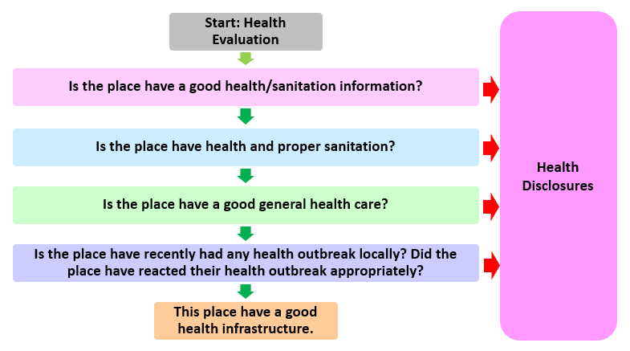
Health Assessment Flow Model (Visual)

Questions based on scoring to pass the health status:

- Does the place have good health/sanitation information?

  - Yes is 1 point

  - No is no point

- Does the place have health and proper sanitation?

  - Yes is 1 point

  - No is no point

- If the place has good general health care?

  - Yes is 1 point

  - No is no point

- If the place has recently had any health outbreak locally? Did the place react to their health outbreak appropriately?

  - Yes is 2 points

  - Some is 1 point

  - No is no point

Scoring of Health Status:

- 5 is Satisfactory (pass)

- 4 is Substantial

- 0 to 3 is Unsatisfactory (fail)

Solving the Singapore and Malaysia health status, she answered all 4 questions.

“It looks like the Singapore health system meets with western standards. Although, compared to Malaysia, it doesn’t meet Western standards in some places...” She reviewed the results.

“It looks like Malaysia has an unsatisfactory rating because of the inadequate health system in some parts of the country.”

She next moved into the article about the health assessment.

Health Assessment

- Tell more about Singapore and Malaysia’s health?

- Based on the intended place you chose, do you check the website at www.cdc.gov and other relevant websites for general health status for a certain countr(ies) you are visiting?

- Did any people refer to health recommendations on doctor’s visits or your friends, family, or relatives? What did they say about them?

- If applicable, do you schedule a doctor’s visit related to travel?

For final verdict: Only use Satisfactory, Substantial, or Unsatisfactory as the answer below.

Final Result: Singapore: Satisfactory; Malaysia: Unsatisfactory

If you answer either Substantial or Unsatisfactory, you will need to enclose additional health information below:

- What makes the places either Substantial or Unsatisfactory health care?

- How can you stay healthy and protected from these conditions?

Tips: If the place’s health care isn’t available or hard to explain, it is time to choose another location to travel to, where you can start over from the beginning (Introduction).

After doing the health enclosure for Malaysia, she moved into the article about general health.

Your General Health

Taking care of your health is the most important for traveling and your life. In addition, your health is the more indicator of specific disorders and/or diseases later in life.

First, let’s take a quick question to decide if you are in good health before you travel, no matter if you are going to places either domestically or internationally. Traveling in poor health can lead to specific illnesses and/or disorders such as depression, anxiety, fatigue, and in some cases, traveler’s diarrhea or diseases. It is important to note that health is more important to stay healthy, develop your habits for life, and maintain proper hygiene before you travel. I-Powers Travel innovator mentions that traveler’s sickness is neck and neck for many healthy travelers in some cases. Therefore, it is crucial to have your health and wellness in hand and schedule a doctor’s visit and/or have a travel vaccine before you travel abroad, especially to places where yellow fever is sensible.

Let’s take a quick look at the meaning “Travel Health” on the next page.

Ahead, she then read the article more about health.

Advice: It is essential to be medically, physically, and mentally stable to travel solo. That is what your parents said: they take good care of you and grow up with you. And so, you are fully responsible for taking care of yourself before achieving your dreams.

Fact: Traveling requires many calories to use up, so eating more and being physically, emotionally, and mentally active before you travel is essential. It can be exhausting if travelers don’t eat enough calories. Try to incorporate a minimum of 1,600 to 2,500 calories a day. Aim for 2,500 to 3,000 calories if you are physically active.

Travel Health

Travel Health is a specific phrase for the topics for “health-related travel.” Travel Health is more of a public health topic because “Travel Health” is a relatively new, innovative term to describe “how healthy you are when you are preparing for the trip?” or “How well you will be able to tolerate it if you are going abroad to third world countries?” These questions should be noted if a traveler has any travel-related health concerns during the doctor’s visit. Also, this expression “Travel Health” includes additional pre-departure doctor’s appointments, necessary vaccines, medical evaluations, health insurance, etc., that a traveler might need to travel. Therefore, it is not generally talking about “health” itself but also a specialty called “Travel Health.”

She later skipped “Your Health Status” and “Questions to Consider” and moved to food/Groceries.

“Not everyone will have the same conditions; however, it is important to be unique to each traveler. For example, I am a traveler who likes to travel but with a girly face. Many travelers look at me and say that I was not that age. I look like a teenager, even though I am 30. And some travelers with down syndrome. And others who use a wheelchair to travel. Everyone is different, and there is no need to compare to themselves. It represents unique personalities.” She made me aware of the situation when she traveled abroad soon.

Tip: If you have certain medical, mental, or physical conditions that hinder traveling, you must see a doctor for advice and to prescribe the proper medication.

Warning: You should have someone traveling with you if you believe your mental health is unstable, especially if your trip is coming soon.

Food/Groceries

Food and Groceries are the most crucial topic to budget because you don’t want to travel without food/meals/dining. In addition, spending a vacation requires lots of energy and proper nutrients to have a fun-filled holiday. That is why I-Powers Travel has implemented food/groceries as part of the Trip Plan – Health/Wellness.

Info to know: I-Powers Travel has discussed earlier that skipping meals and eating fast food/convenience stores (to save money) is a big no-no for travelers. By skipping meals and skimping on eating a balanced diet, a traveler may feel tired, drained, and even fatigued when on vacation. Don’t do these! Also, it is relatively easy to indulge in junk food and fast food that comforts travelers’ burden. In reality, travelers must focus on a meal plan to overcome excessive caloric and junk-food spending. By managing both food/groceries budget plans, travelers will find it easier to eat a healthy, balanced diet while traveling within a framework to control unnecessary spending to save some money to achieve their financial goals – Plan 4 – Finance.

Tip: Spending on junk food to save money might be a good idea, but taking care of your health is wrong. Instead, use the I-Powers Travel Meal Planner to plan your meal, which includes all 5 groups of food. These include protein, dairy, fruits, veggies, and grains.

She was glad that she was doing the general food questionnaire.

Your Food Preferences and Lifestyle

Based on your typical diet and lifestyle, what is your ideal diet: Vegetarian

Are you allergic to:

- Peanuts

- Milk

- Eggs

- Tree nuts

- Shellfish/Fish

- Soy

- Yeast

- Preservatives

- Wheat/Gluten

- Others

If you have no allergies, you can leave it blank.

What is your ideal lifestyle? (Select that apply to you):

- Brisk Walk

- Run

- Jog

- Bike/Scooter

- Leisure walk

- Yoga/Meditation

- Stretch

- Weight Lift

- Swim

- Sport Clubs

- Others

Info to know: Many travelers have mistaken that physical fitness isn’t needed when traveling, so skimping on walking, running, biking, etc., will make them feel good and energetic. Physical fitness is essential to stay healthy and maintain an active lifestyle, especially while traveling or vacationing. You will need at least 30-60 minutes of physical fitness/activities daily to maintain a healthy lifestyle.

Do you have a tight travel itinerary? Aim at least 30 or more minutes of Physical fitness/lifestyle a day to maintain a healthy lifestyle.

Warning: Being sedentary to focus on other personal business is also not an excellent way to “take care of yourself” when trying to be responsible for your general health. Again, traveling solo requires good health to fully travel without any health problems.

And she was off to the following article.

Meal Plans Worksheets

Meal Plans is an upcoming planning worksheet in which each meal is set aside for each day. Your job includes a healthy balanced diet with plenty of nutrients when you travel. Try to include fruits, veggies, whole grains, proteins, dairy, and essential fats. It is important to stay nourished and healthy when you travel. I-Powers Travel mentioned in the last article that traveling/vacationing requires lots of energy to stay physically, mentally, and emotionally stable.

Directions of using the “A Planned Meal Plan” worksheet:

- Incorporate a healthy, balanced diet with your meal plan.

- Leave it blank if not applicable.

- If you eat small meals multiple times a day, replace breakfast with meal 1.

Tips on using Meal Plan Worksheets:

- EO is Eating out; EH is eating at the hotel, hostel, home, etc.

- Remember: Do not skip meals as you will require significant energy to use and to enjoy a dream vacation.

Tips on using “A Planned Meal Plan” Worksheet:

- Try to guess by potting each one on each rectangular spot, such as EO or EH.

- Do not list specific places you eat after completing only primary booking in the workshop process (Transportation and Lodging arrangements).

Tips on using “An Intended Meal Plan” Worksheet:

- Try not to list specific food you will eat. You will list the name of the restaurant/places instead to make your own decisions about what I can eat, not what I must eat. Eating and meal plans require flexibility.

- This worksheet is only intended to use after you actually book your trips (primary booking process), such as transportation and lodging.

Here are 2 worksheets you can use when planning your mealtimes, including snack times.

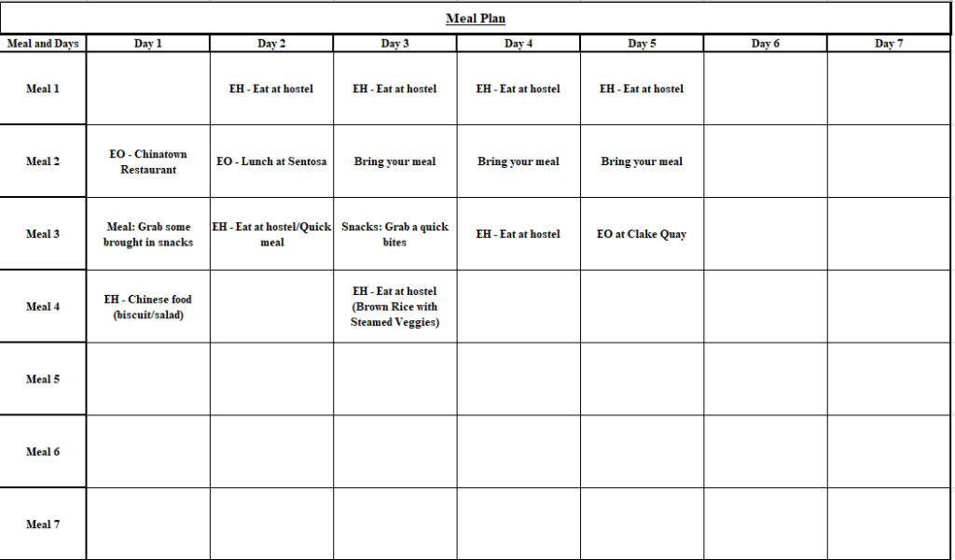

She then moved into health.

Staying Healthy Tips

Like staying healthy tips, maintaining a healthy lifestyle is just as important as staying fit. These two phrases, “maintaining a healthy lifestyle” and “staying healthy,” are related because they refer to achieving mental, physical, and emotional wellness.

Why should you not eat out too often?

I-Powers Travel Innovator recommended you should not eat out too often. Why?

- Health: Some restaurants have added artificial ingredients such as MSG, artificial coloring, and food additives to make meals tasty and cheaper. In reality, these added components may cause harm to your health because you are putting something into the body, leading to cancer, health problems, etc.

- Cost: Eating out 3 meals a day can cost upward of $40 or more a day, compared to eating meals at home or a hotel can save money 2 to 3 days’ worth of groceries. Note that the portion sizes are much bigger than one serving, so do not assume eating out is the best option. Try to eat at home or bring your meals to reduce travel costs.

Other Health Emergencies

Other health emergencies are critical because travel accidents, cancellations, and injuries happen, exceptionally experienced, savvy travelers. Therefore, you will need specific preparation to prepare for your dream trip, no matter how long or safe the journey is.

I-Powers Travel Innovator has recommended you to “Always prepare your health emergency as well as your health and wellness well in advance before departure. Then, create a backup plan just in case something happens.”

Knowing your insurance policies when you plan to travel is essential as some health coverage isn’t covered, especially emergency evacuation. In addition, some underlying health coverage (Medicaid and Medicare) does not cover the cost overseas, so it is crucial to purchase supplemental insurance before you travel. The good news is the majority of the trip comes in medical evaluations and health coverage just in case travelers get sick or injured, not trip cancellations unless the trip is precious, e.g., over 5,000 in US dollars or equivalent.

For this topic, the categories primarily focus on health per se. This topic will include medical information (medical, dental, family doctors, health insurance, etc.) as well as the first aid kit you will need before you travel. Accidents happen, and no one can travel without these emergency kits and preparation.

Finally, she read what she needed to include a first Aid Kit just in case.

First Aid Kit

These things you should include just in case minor cuts, bruises, and blisters happen.

Things to include in the First Aid Kit:

- 8-12 Bandages (4-6 small and large bandages)

- 4 packs of Grazes

- Instant Ice pack

- 2 Pack of tissues

- OTC Medications*

- Cough Drops

- 1-3 oz hand sanitizer

- 3-6 antibacterial medical wet wipes

- Sunscreen – SPF 30+ (3 or less ounces if carry-on)

- 12-15 cotton swabs

- 5-10 cotton balls

- Itch cream

- Small bottle of antiseptic cream

- Scissors (4 or more inches in length) are generally prohibited on-board the plane as the carry-on. Please, store them in the check-in luggage. Info here. Subject to change.

Things to include in your Medical Health Record:

- A Copy of Health Insurance (Required)

- Medical Record

- Prescription Medication (with Doctor’s note)*

Applicable (Optional, otherwise required)

- Medical Alert bracelet

- Medical Supplies (make sure you need enough items for your entire trip)

- Others

Note that First Aid Kit items vary depending on the activity plan and the nature of the traveling environment.
﻿
*Keep in mind that bringing medications (inducing OTC) may be illegal in some countries, so go on the website at www.cdc.gov for advice.

Advice: Be sure to include a First Aid Kit every time for your trip. A First Aid Kit is essential. Only pack the First Aid Kit in the carry-on or a personal bag, not in the checked baggage, so it is impossible to retrieve them when you are waiting for the flight or on the plane.

Just then, she was moving on to the Safety/Laws.

Tell more about Local Laws/Government System

Law System completely differs every time you travel, especially state laws. Therefore, it is essential to familiarize local laws and how it’s compared to local laws when you are vacationing. This worksheet will learn more about their 3 types of form of government:

- Republic

- Monarchical

- Others

Hence, there are different types of systems of governments:

- Presidential Republic

- Semi-Presidential Republic

- Parliamentary Republic

- Other Republic

- Constitutional Monarchy

- Semi-constitutional Monarchy

- Absolute Monarchy

- One-Party State

- Military

- Provisional

The law system is entirely different from where you live when you are abroad. Therefore, learning more about laws, including government systems, how they work, and their function, is vital. You will ask these questions.

- Government system:

Singapore is the Parliamentary Republic, while Malaysia is a Constitutional Monarchy.

- How they work:

Singapore’s Parliamentary Republic works when the head of state relies on the head of the state with the prime minister. On the other hand, Malaysia’s Constitutional Monarchy works when the government relies between the king and the queen with limited power of the country’s constitution.

- Functions:

Singapore’s Parliamentary Republic functions as a kind of government-managed (to make laws) by the overall countries’ management system (managing people). The people get to choose the legislature and then decide who to become a leader, known as Prime Minister. The Prime Minister will become the leader of the country.

Malaysia’s Constitutional monarchy is one country that can use its constitutional manner based on what the monarch (the king) can/can’t do. Also, it has both federal and state parliamentary democracies and works with the parliament to rule one country.

Now, you learn how you learn about the government system. Next, it’s time to learn more about the legal system.

- Legal System:

- History:

- Purpose:

There is more than one kind of law not in America but around the world, where rules about religions. Keep in mind that Saudi Arabia and some Islamic countries have strict religious laws regardless of your practices. Therefore, it is vital to research religion and different directions you should be familiar with when you travel.

- Common-Law System:

- Civil Law System:

- Customary Law System:

- Mixed Law System:

- Religious Law System:

Then, she moved on to Local Laws 101.

Local Laws 101

Laws differ every time you travel out of the country (or even out of state). It is vital to research how laws are structured regardless of the travel purpose. Laws, in general, are governmental bodies not only to protect their citizens but also to serve as a nation of the country or society to keep their communities in operation. We will want to know that laws can benefit not only one in the place where you live but also benefits from social and economic benefits as a whole.

As mentioned earlier in the previous blog about Federal, State, and Local Laws, these government systems serve different purposes. Every state’s laws have their own laws and characteristics. For example, Colorado and Pennsylvania laws are other differential environmental characteristics.

“Colorado laws deal with its own skiing laws while Pennsylvania laws permit deals with its own local tourism community, such as the Amish community. In contrast, there is no Amish community in Colorado, so no local tourism community exists. There are different state laws in terms of tourism attractions, criminal, custody, gun laws, motor carrier, business, and so forth.”

I-Powers Travel Innovator

It is essential to research these laws, too, if you are heading to out-of-state travel.

I-Powers Travel Tips: Research the government system that includes how the laws work and the functions. Take notes, think about its structure and importance, and compare it to your hometown.

Sometimes, laws can make the communities safer and more reliable in some countries.

Some government systems have enabled their society functionally more than the various government systems, for example, under republican rules. For instance, the American government system is the Presidential Republic. In contrast, the Saudi government system is Absolute Monarchy under a totalitarian dictatorship.

And she did the worksheet when she researched dos and don'ts when traveling to Singapore as part of her solo trip project.

Dos and Don’ts Worksheets

Here is the worksheet to list dos and don’ts when you travel as your reminders. Travelers, please bring this worksheet or saved files with you when you travel. Or you can take this picture from your screen or even screenshot and save it for your personal use.

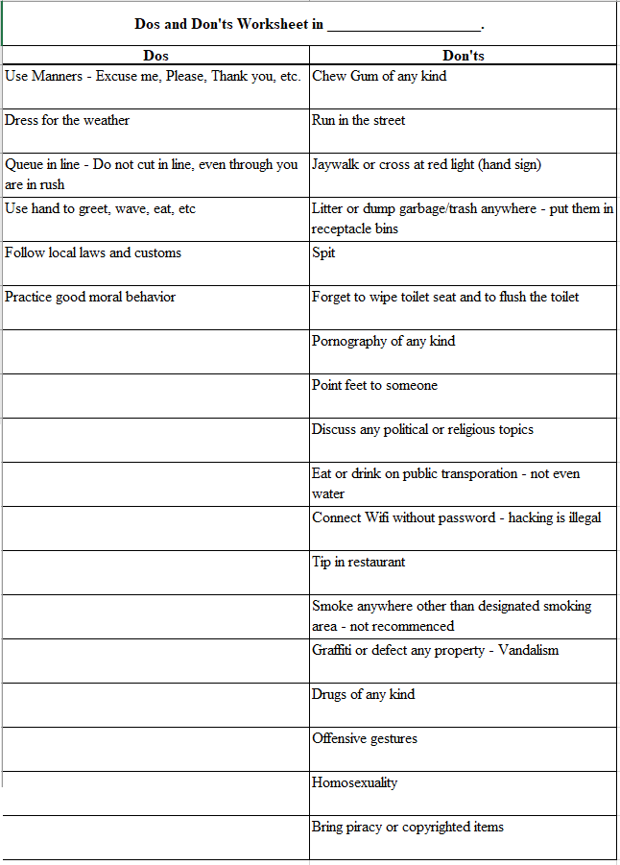

She then mentioned the stories of other solo travelers who recently traveled to Singapore. She said, “Respect others in public because Singapore is a good reputation for kindness and a fun, greeny place to explore. She mentioned that it is also an ideal place to travel solo because of a very safe place. Security and police were in place, ensuring all public places were free from criminal activities. Another woman said hygiene is a priority in Singapore. That is the #1 reason why gum is not allowed in Singapore. Gum can easily get dirty and can ruin public places. I believe she was right; Singapore has a good place for earth’s day every day.”

And she was moved to safety...

How Safe is the Place

Researching safety status when planning a trip abroad or locally is complicated because it requires lots of time and commitment to do the work. It also requires patience to decide if the country or places you will be visiting have a good safety record. Remember that safety and security is top priority.

These Questions don’t trick you but determine the safety status of the country you are visiting on the next page.

And move onto the next page.

Now, it is your turn to ask about safety.

Direction: To meet the criteria for the safe place you want to visit, you must pass the green down arrow to all 5 questions. If you responded no or need evidence, you will need to disclose information on the next page correlated with the question you asked yourself. If you can’t find available data or the government states that “there is limited safety information,” you will need to choose another place to visit. I-Powers Travel cares about safety and security to protect you, your family, loved ones, friends, and the public. We want to protect from visiting disastrous places.

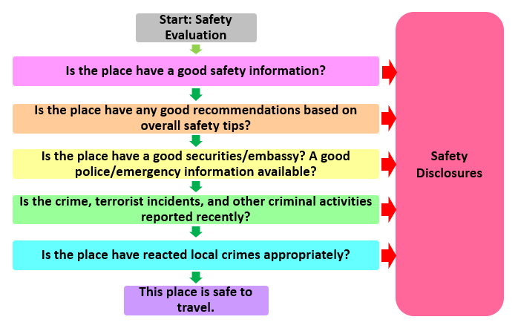
Safety Assessment Process Flow Model (Visual)

Questions based on scoring to pass the health status:

- Does the place have good safety information?

  - Yes is 1 point

  - No is no point

- Does the place have any good recommendations based on general safety tips?

  - Yes is 1 point

  - No is no point

- Does the place have good security/embassy? Is there good police/emergency information available?

  - Yes is 1 point

  - No is no point

- Has the place reported the crime, terrorist incidents, and other criminal activities recently reported?

  - Yes is 1 point

  - No is no point

- If the place has reacted to local crimes appropriately?

  - Yes is 1 point

  - No is no point

Scoring of Safety Status:

- 5 is Safe (Pass)

- 4 is Conditionally Safe (Conditionally Pass)

- 3 is Conditionally Dangerous (Conditionally Fail)

- 0 to 2 is Dangerous (Fail)

She first answered the questions based on the results.

Safety Assessment

- Tell more about Singapore and Malaysia’s safety?

- Based on the intended place you chose, do you check on the travelers’ social groups to evaluate if places are safe? (Please, connect to traveler’s groups on Facebook or social media or talk to your friends, family, and others about the safety information).

- Did any people refer to travel recommendations on social media or your friends, family, or relatives? What did they say about them?

- Do you look up which neighbors are safer/more dangerous than others?

        - Visualize or list any neighborhoods you don’t want to visit.

For final verdict: Only use Safe, Conditionally Safe, Conditionally Dangerous, or Dangerous as the answer below.

Final Result: Singapore: Safe; Malaysia: Conditionally Dangerous

If you answer Conditionally Safe or Conditionally Dangerous, you will need to enclose additional safety information below:

- What makes the places Conditionally Safe, Conditionally Dangerous, or Dangerous places?

- How can you stay safe from these conditions?

Tips: If the place is Dangerous, it is time to choose another location to travel to, where you can start over from the beginning (Introduction).

“It sounded like only Singapore has an excellent safety reputation for solo travel. Malaysia, on the other hand, has a substantial safety record. Unfortunately, it has a poor reputation for safety for women, especially for solo travelers. I planned to travel with the girls instead.” She reviewed the results for both of the countries she planned to visit.

She showed the table of all 4 different reasons why planning is essential for any trip to her parents the importance of “trip planning.”

“Dad, I recalled the trip experience that I planned a solo trip to Taipei by spending more time planning a dream trip, just like last year. So now, it goes the same planning procedures for my sole Singapore trip.”

“Hum-um.” Daddy hummed.

“Okay then. I guess I left off for a couple of days of free time between the trip planning.”

Let’s Plan a Dream (Part 2)

At home on the warm June evening, just after helping the family with the dishes, she spent some time with the parents to watch a Chinese drama.

“Hey, dad. I am currently planning for my dream trip. Take a look. It is in progress, and I will show you guys when I am done.”

“Wow, nice. Did you create this?”

“Yes, I did.”

“Impressive.” Her father smiled.

“I have to ask you something. Why did you plan for a solo trip abroad?”

“It is just a new opportunity like I said last year.”

An hour later, United was first to read the 2 remaining of 4 phases. Her mother and father were very impressed she took full responsibility for the trip she created.

Before you Travel Abroad

Traveling outside of the country, especially US Citizens crossing the country border requires a passport. In addition, it is essential to note that some countries you are visiting may require a visa, and some require health certifications well in advance before you travel to satisfy a travel requirement. You will learn more in the following four blogs for general information about passports, visas, and other required documents.

Your assignment:

If you are a US citizen, national, or resident, you can go on the website and the country information here. You can type the count(ies) you visit, including traveling requirements.

If you are a Canadian citizen, national, or resident, you can visit the website.

You can either refer to the local foreign ministry or Google “Foreign ministry” here for other citizens.

“I am going to skip the article “Passport” because I have my current, unexpired passport. I still have several years until my expiration date.” She took out her current passport and saw it was undamaged.

And she put it back into the safe container.

Tip: If you are traveling soon, be sure that your passport hasn’t expired 6 months from the last day of the trip.

Advice: To fly on planes domestically, a current, valid passport is sufficient to meet a “real ID” compliance.

“Sounds like I have everything I need except I still have trip insurance, which is on the “Workshop” Process.” She was reading an article called “Travel Folder.”

Travel Folder

Some travelers have regretted packing their essential documents and storing them into the travel folder or separate files just in case they need them to gain entry into the country. Instead, they were making an excuse themselves by skimming their virtual folder. This mistake can cause travelers to forget their necessary documents, e.g., a visa to enter a country, which wastes their fun during the vacation. This information (Travel Folder) could have reduced their travel mistakes by organizing their travel documents and marking them as completed. This information also made travel easier to locate all the travel documents needed to enter a country without spending more time unstuffing your bags for essential items needed for various purposes.

Note: You don’t have to buy an expensive travel folder to store all travel documents. You can buy the plastic folder in most stores, retail stores, office stores, online, etc.

Here are the items you will bring (in the folder) if you are traveling with you here.

“The next page is important,” she added. “I am going to save this page.”

Items included in the Travel Folder

These items should include in the Travel Folder:

- Your Gov Issued Photo ID

- Other Photo ID

- Your current passport

- A copy of passport (front and back)

- Visa Documents (if applicable)

- Yellow Fever or health certificate Card (if applicable)

- Other authorized travel documents for country entry

- Embassy Contact Info

- A copy of your itinerary and bookings (all from the Workshop process)

- A copy of health insurance

- A copy of Travel Insurance (Workshop process)

Moving onto the last phase of the plan, Finance, she first read the article.

Fact about Travel Finance

Travel Finance is the most critical part of travel planning because it requires money management and careful planning for the trip.

What are the Facts?

- About 68% of all Americans overspend on vacation. Here’s why over 2/3 of Americans attempt to spend more than their ideal budget.

  - Millennials are more likely to use Credit Cards while on vacation, including booking flights and hotels. This Credit Cards overuse can lead to accumulated debt plus interests.

  - Credit Card charges for young people have more debt than Millennials due to having some knowledge or novelty of money management than the latest generations who have general financial knowledge, including currency conversation.

  - About 35% of all travelers actually don’t plan to budget their trip by saving money to travel. About 37% of travelers had attempted to cancel their trip due to a lack of funds needed for vacation. This lack of funds has contributed to a lack of money management (Meyer, 2015).

- For an average American, spending money on vacation was easy to splurge non-essential items such as a pricey restaurant, a luxurious hotel stay, or wants instead of essential needs (Dizik, 2017). It is crucial to know your travel style to overcome overspending on vacation expenses.

  - The Average Vacation Overspending for all Generations was about $206 due to a lack of budgeting, planning, and financing, with an average of about $2,242 vs. $2,036 per vacation for a single traveler for 5 days of travel (Travelex). This amount can add up to $11,210 for my family of 5 than those who plan their budget and control their spending ($10,180).

  - Guzman (2018) stated that Americans only receive zero to 10 paid vacation days with an average of just 5 days annually, compared to other countries around the world with mandated holidays and paid leave.

- The latest generation (Gen Z) are more likely than other Generations to have vacation overspending on their intended trip budget. The I-Powers Travel Budget Worksheets can help Gen Z, and all generations control spending.

  - The most unexpected charges were Credit Cards, following International Calls, which resulted from almost 20% vs. 17% of total travel costs (Christoff, 2019).

“Now, I am pretty confident about the budgeting for the trip to both Singapore and Malaysia. Right now, I am reading about it with worksheets. I first knew what I was doing. I knew the money I needed to put into the travel budget worksheets.” She was happy while reading through the lines.

Travel Budget Worksheets

Here is the overall travel budget worksheet you will need to budget and rebudget your overall dream trip.

Hint: Before you budget your transportation (Gas), you will need to figure out how much you are willing to spend before starting Travel Budget Worksheets. See the Gas Method equation here.

6 Worksheets:

- General Travel

- Food + Groceries

- Entertainment

- Documents

- Other Travel Needs

- Total Travel Budget

You can download this worksheet and use it as your future travel budget plans.

She downloaded the worksheet, opened it, and started putting the numbers.

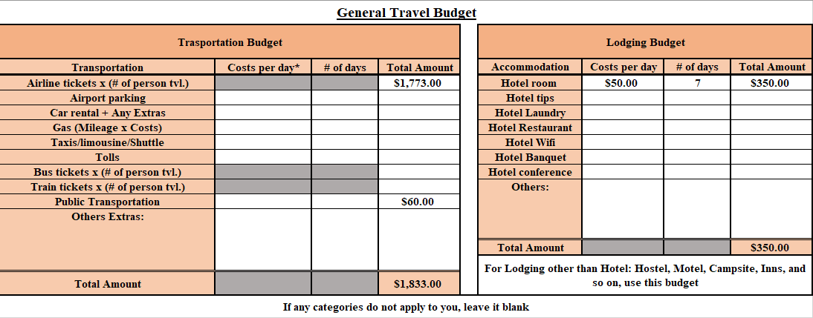

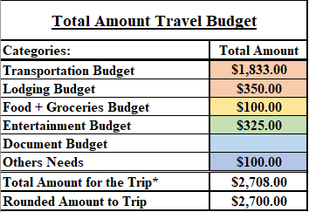

She said, “This trip budget is just an estimate for the 5 to a 7-day solo trip to Singapore. If I want to go to Malaysia, which I really wanted to go, then I need to modify this budget.”

She then waited until her Malaysia solo tour confirmation. So she leaves this budget for now.

Once she was done, she showed the table of all 4 different reasons planning is essential for any trip.

She concluded on the blog, “The 4 Phases are beneficial in creating my trip itinerary and the trip information with ease.”

She went downstairs to show her parents the overall all-trip plan project, and then they smiled.

“Wow, nice job.”

“Thank you.”

Just then, United was proud that the trip had worked very well. “The trip plan is officially done, and now, I am going to work on Observation Process.”

Reviewing the overall 4 phases of the Word Document, she was delighted to take responsibility for her personal finances, health, research, laws, and other essential topics needed for further research about her solo trip to Singapore.

Relaxing from the I-Powers Travel assignment, she finally put off her solo Singapore/Malaysia vacation until the week of June 13 (to search for her flight and hostel) because she wanted to work hard during her probationary period. Instead, she left it until later since she planned to move on to 3rd Process - Observation.

Before You Go

The chapter is more than just the basic skills needed for solo travel. This chapter discusses general information and warnings regarding traveling with special needs, females, and other special considerations.

Note: It is prohibited to discriminate against solo travelers based on age, race, religion, gender, marital status, social class, disabilities, etc. Solo Travelers have an opportunity to travel safely, reliability, and realistically.

The blog she created listed the essential concepts of solo travel from the blog: Travel Specialties.

Learn more about the I-Powers Travel purpose for the travel needs based on who you are.

https://ipowerstravel.wordpress.com/2010/01/06/travel-specialties-info/

Tip: Be sure to look for additional information. If you are a:

- Students

- Solo Travelers

- Women

- Seniors

- Travelers with Disabilities

- Faith-Based Travelers

- LGBTI Travelers

For example, since she will be both Solo Travel and Women, she will read between the lines for more information.

Solo Travelers

Solo travel means you freely explore places on your own, whether it is a day trip or a whole week trip. Here are tips and warnings, whether you are male or female, young or old, married or single, or just anyone.

Tips:

- If you plan a first solo travel trip, create a detailed itinerary.

- If traveling abroad, enroll in Smart Traveler Enrollment Program (STEP) program.

- Always have family or friends know where you are and regularly contact them.

- Visit the visitor’s center on the first day of your trip or ask the hotel counter for places to see is highly recommended.

- Wear fake wedding rings and carry a fake boyfriend or a male (can be imaginary).

- Lie as you will defend yourself from dangerous and unwanted situations.

- Don’t be afraid to say no. If you experience uncomfortable or feel irritated yourself, say something such as “Sorry, I have to meet with a friend.”

- Create personal boundaries.

- Be proactive rather than reactive. Proactive means taking responsibility for your safety/security rather than not engaging in steps to protect yourself.

Warnings:

- Do not say you are traveling alone. Say that you are waiting for your family to pick you up or your business workers.

- Don’t travel to dangerous or isolated places at night.

- Without a doubt, try to come back to the hostel, hotel, or home by 8:30 pm. An exemption is traveling as a group.

- Always stick to the travel plan you just created. Better not to wander away from the local tourist area.

- Whether young or old, male or female, married or single, always stay at hostels with single-gender only (Female stay in other female room; male stay in other male room) for personal safety. Booking a mixed room is safely forbidden and is not recommended.

Note:

- Solo travel is NOT for everyone, so it is best not to ask someone to travel because it is their choice.

And she read about “Women.”

Women

- Most women safely travel solo without incidents, either locally or abroad.

Women have traveled more than men simply because women are the main target to draw wrong attention, especially abroad. Women, especially traveling solo, can be vulnerable and face more enormous obstacles to religious and cultural beliefs in foreign countries. Therefore, women must take extra preparation and be cautious when they plan a trip. It is imperative to provide tips and warnings when traveling, young or old. You can learn these resources to help women share travel experiences and challenges.

Tips:

- Visit travel.state.gov for more information. It is better to have a piece of paper and a pen/pencil to write information info to retrieve the information later if something happens. Use Observatory Notes.

- Same as traveling alone, always visit the visitor’s center or ask the tourist counter for any travel information/officials on the 1st day of arrival of a place. Within doubt, ask them which particular neighborhoods are safe/dangerous.

- Do not flash expensive items in public. Leave them at home.

- Only carry items you need. Do not carry large bills with you. Have only debit cards with you for large purchases (with liability protection in case the card gets stolen). A credit card is an easy target for thieves.

- When heading out, use a money belt and keep your stored items close as you are. Make sure your bags are closed (and locked).

- Married, widowed, single, or whatever a marital status, state a someone you are married, pretend to yourself that you have a husband to defend yourself from unwanted attention.

- Always wear a fake wedding ring (notice above) whenever you travel locally or abroad.

- Lie as you will defend yourself from dangerous and unwanted situations.

- Don’t be afraid to say no. If you experience feeling uncomfortable or irritated, say something such as “Sorry, I have to meet with a friend.”

- Reminder: Be proactive rather than reactive. Proactive means taking responsibility for your safety/security rather than not engaging in steps to protect yourself.

Warnings:

- Never go out alone at night, especially if the hotel/hostels aren’t the safest places at night. Have someone go with you.

- Always stick to the safest places/neighborhoods (where more visitors and people are around, no matter the day or night), e.g., tourist areas. Avoid wandering off the area where the ghetto is located. Stick only places with well-lit places.

- Avoid drawing attention to yourself. Some women have experienced unwanted attention related to someone they don’t know, especially abroad. It is best not to engage in a conversation with those who make themselves uncomfortable or irritate themselves. Just say something to defend yourself and walk away.

- Never stay at hostels in a mixed room (male living with females unless you are traveling for a honeymoon or romantic travel). It is always advised to book female-only rooms. Date rape, romantic kidnapping, and sexual activities are common in hostels and hotels. That is why males actively look for females for an engagement without consent.

- In Islamic countries, be aware that wearing certain clothes can draw the wrong attention, especially when traveling with other women or groups in public places. For instance, what you wear (short dress) in the USA or Europe may not be appropriate in Islamic countries (Qatar). Wear a headscarf, a long dress/skirt, and a long-sleeved shirt if you visit these countries (shoulder covered).

Info to Know:

- Some countries may require a male escort before you legally leave a country. Further research about the country’s information is mandatory to plan a trip.

Traveling with Disabilities?

Just then, she was aware of discrimination against travelers with disabilities. She pointed out that the types of discrimination are not tolerated but can happen. She took a quick look at the travelers with disabilities specialty.

Traveling with disabilities can face unique challenges, especially when traveling solo. In addition, they can face obsolete challenges, especially when dealing with communication challenges, health emergencies, meeting people, seeking help, etc. It is essential to address challenges so that they can work on barriers at a time.

It is essential to note your doctor’s mental/physical/emotional health to get evaluated before you travel solo. Make sure to give your doctors in writing, stating your health has dramatically improved.

Note: No one shall be discriminated against by solo travelers with disabilities. Every solo traveler deserves to include a variety of people from all backgrounds.

Warnings: Don’t travel solo if your emotional/physical/mental health hasn’t improved. You can’t get help once you have problems, such as getting sick or injured or needing immediate attention. I highly recommend getting health insurance that covers abroad and traveling with someone.

They can travel solo with assistance or accommodations, depending on their medical conditions.

Receiving public assistance?

She pointed out some restrictions regarding traveling, especially long-term travel.

It is essential to know the policies regarding the travel restrictions and where you are heading so that you don’t lose the benefits.

Hence, that is good news. You can travel abroad as long as it does not exceed a certain time when you are abroad outside the country of residence.

Under its current rule, the public assistance receipts usually come with comprehensive health insurance called Medicaid and Medicare.

Remember that Medicaid and Medicare do not cover costs overseas. She recommends purchasing supplemental travel insurance covering overseas.

For Supplemental Security Income receipts, the limit time you can travel abroad (except in sanctioned countries) is 30 days.

For Social Security Disability Insurance, the limit you can travel (except imposed sanctioned countries) is 6 months.

No matter the circumstances, if you plan to study abroad, let the social service know the trip plan since study abroad duration is usually has a semester or a year-long program. That way, you don’t lose the preexisting public assistance.

Travel with disabilities

Traveling with disabilities can face unique challenges, especially abroad. Some countries do not legally require reasonable accommodations, so it is imperative to research information and references before you travel. Here are some essential tips and warnings, especially for those who receive public assistance because of disabilities.

Traveling with disabilities can face unique challenges, especially abroad. Some countries do not legally require reasonable accommodations, so it is imperative to research information and references before you travel. Here are some essential tips and warnings, especially for those who receive public assistance because of disabilities.

Tips:

- Please, visit travel.state.gov for guidelines, and be sure to have a paper and a pen/pencil with you to take notes from Observatory Notes.

- Research places and countries’ information. Look specifically for travelers with disabilities.

- Schedule a doctor’s appointment if you have specific health issues.

- If possible, have a psychiatric evaluation if you are treating any mental disorders.

- Travel with a group or someone if possible.

- Request mental/physical/medical assistance.

- Obtain supplemental travel insurance with mental/physical/medical evaluations.

- If you are carrying/bringing special equipment, e.g., oxygen tank for medical health reasons, see Others -> Other Items Abroad.

Warnings:

- Traveling with mental illness can be risky, especially for those who couldn’t travel on specific types of transportation. If applicable, have a chaperone (siblings, parents, friends) with you.

- You can still travel unaccompanied only if your mental health has improved and only tell if your doctors tell you are okay.

- Suppose you are traveling with your medications (abroad) for medical/mental reasons, e.g., an anxiety disorder. In that case, it is essential to visit the website for important advice, so you don’t end up confiscating medications when entering the country.

Note for those who receive public assistance (SSDI or SSI) or have Medicare/Medicaid insurance:

- Keep in mind that Medicare/Medicaid doesn’t cover costs overseas. It is essential to purchase travel insurance that covers the costs of medical evaluations abroad just in case things happen.

For those who receive Supplemental Security Income (SSI):

There are restrictions for travelers who receive monthly public assistance in which you can travel abroad outside the US.

Note:

- You can still be able to travel abroad to most countries, but there are certain restrictions:

  - Check the SSA policies for specific countries in which you are visiting.

- You can travel abroad for up to 30 consecutive days (full calendar month) without losing the benefits.

- You can still be able to receive benefits abroad as long as you are not in these countries (due to US Treasury Sanctions):

  - Georgia (Country)

  - Iran

  - Belarus

  - Tajikistan

  - Turkmenistan

  - Moldova

  - Vietnam

  - Azerbaijan

  - North Korea

  - Kyrgyzstan

  - Kazakhstan

  - Ukraine

  - Uzbekistan

  - Cuba

- In advance, you must notify the local Social Security Administration (Social Services) if you are traveling abroad for more than 30 consecutive days (full calendar month). These include a study-abroad program, student exchange, or an internship abroad.

  - Your payment will be suspended if you do not notify the local SSA (Social Services).

- You usually don’t need to notify SSA if you are going on vacation out of state as long as it is in 50 states, even though your vacation lasts more than 30 days.

- It is essential to notify the Medicaid/Medicare insurance about travel plans if you are traveling out of state.

  - The policies of this insurance are entirely different than where you live.

For those who receive Supplemental Security Disability Income (SSDI):

You can travel as long as you are notified by SSA and only if you have a limited work history.

- You can still be able to travel and live abroad in most countries, but there are certain restrictions:

  - Check the SSA policies and report the change of home address.

- You can still be able to receive benefits abroad as long as you are not in these countries (due to US Treasury Sanctions):

  - Georgia (Country)

  - Iran

  - Belarus

  - Tajikistan

  - Turkmenistan

  - Moldova

  - Vietnam

  - Azerbaijan

  - North Korea

  - Kyrgyzstan

  - Kazakhstan

  - Ukraine

  - Uzbekistan

  - Cuba

- In advance, you must notify the local Social Security Administration (Social Services) if you are moving abroad.

  - Your payment will be suspended if you do not notify the local SSA (Social Services) about a change in home address to move abroad.

- Same as SSI, you usually don’t need to notify SSA if you are going on vacation out of state as long as it is in 50 states.

- It is essential to notify the Medicaid/Medicare insurance about travel plans if traveling out of state.

  - The policies of this insurance are entirely different than where you live.

You can use this online tool to determine if you are eligible for the Social Security payment abroad if you leave or travel outside of the USA.

Example:

A 26-year-old Rich*, currently receiving public assistance in the USA, has an upcoming trip to Hong Kong. His trip dates were from December 25 to January 21. He also received a Supplemental Security Income (public assistance) while working part-time as the cleaning crew/janitor. He worked hard to earn his living while continuing his job.

Info: He was diagnosed with Asperger’s syndrome and moderate developmental delays that hinder the solo travel essentials (self-sufficient skills). His parents accompany him while abroad, claiming that he’s incapable of achieving self-sufficiency and self-care to some extent.

Based on Social Security Administration travel restrictions, he is allowed to travel abroad for up to 30 consecutive days. He can receive a monthly payment in Hong Kong and will travel for 28 days.

Without a proper notification from social services, his public assistance will be discontinued until he returns to the country’s residence for a number of days before being eligible for public assistance. Moreover, unless he plans to travel to sanctioned countries, he won’t be eligible for the benefits because the country has been prohibited from sending the payments abroad.

Also, he needed help in finding directions, especially in unfamiliar surroundings. He also needed much assistance in getting around and functions such as transportation in which language may be an issue.

*United changed to a general name of a character to protect his identity.

Just then, she was allowed to travel solo if her health did not compromise the health and wellness of the travelers.

Set Aside

Just then, she was reviewing how to get the best airfare. She has accumulated 17 vacation days and has over $2,000 saved up during her 3 months of her full-time job. She was eager to save more until she was ready to purchase for the trip, including the group's tour.

Before you Start Booking…

It is essential to know your upcoming vacation plan and where you want to go. You will figure out the right time of the season to get the best travel deals when you book and reserve. Once you purchase something, for example, the most restricted airfare (cheapest), these are non-refundable. So review your intended itinerary before you click to purchase.

Tips:

Before you begin to move on to Workshop Process, it is essential to know your job’s time and vacation policies (whether it’s a part or full-time job). It is imperative to accumulate vacation days (Paid Time Off) well in advance and give notice to the supervisor and manager before you start booking your transportation arrangements (Gas Method) and lodging arrangements (3Hs Method). You don’t want to book a trip without letting your job manager and supervisor know your travel plans well, as you will waste your time and money. You don’t want to waste your vacation plans, do you?

She learned the tips how to fall into the traps when she planned to book a trip.

Gas Method

Before you shop for airfare, here are my handy tips you should lookout.

- Are you living in a city where 2 or more major airports are located in nearby cities 100 miles from your home?

  - If so, it’s time to compare and contrast the two cities. Let’s assume I live in Philadelphia, and my getaway airports are in Philadelphia, Newark, and NYC. There are 3 major airports and one regional airport in my area. JFK is a little far, so I only searched two airports: Newark and Philadelphia.

- I highly recommend signing up for daily fare alerts.

- If you are a frequent flyer member, you should search an airline website or an airline alliance partners website to find a better deal. I searched my flight on my United’s app to find a deal because I am a member of United MileagePlus. Whew, it wasn’t that expensive.

- Be patient. It is essential to check any email + flight data daily to find a better deal.

- If you are flexible with your travel plans, try to fly 2-3 days earlier or later.

- I highly advise you to book 60-90 days before your departure, but this is not the case. Ask me why?

  - There is a trend in airfare in which flights are sold on factors:

    - Flight time,

    - Day of the week,

    - Airline,

    - Airports, the

    - Booking gap before the departure,

    - Airport taxes

    - Contract of carriage

There is a massive demand for travelers, and business and leisure travelers are expanding. Therefore, the cost of airfare and lodging (including hostels) is increasing per night on a pro-rata basis.

The first thing is to check the price of the airfare, which you should look at the date of the cheapest flights available.

She haven’t started to book the trip yet.

Keep in Mind:

Google flights only indicate an average cost of airfare, not guarantee a lower price for a round trip ticket. However, finding a better one has not been easier, especially if you are a frequent flyer member of an airline, so there is a better alternative.

You can search an airfare on:

- www.kayak.com

- www.priceline.com

- www.hotwire.com

- www.orbitz.com

- www.momondo.com

- www.skyscanner.com

- Google flights

- Airline’s website

Warning: When looking for a good flight deal, don’t sneak on the Skiplagged website because it is not worth it. It is best to stay away from this website that sells Skiplagged flights. It is highly recommended to book flights that don’t sell Skiplagged flights, especially if you are a frequent flyer member.

Fact: Skiplagged flights mean you initially book your flight to the final destination of Los Angeles at a higher price but cheaper when you get off in Phoenix. For example, you get off at Phoenix instead of Los Angeles from Philadelphia for $100 less. This translates to Philadelphia to Los Angeles with a layover in Phoenix for $400. Finally, the skiplagged flight is from Philadelphia to Phoenix for $300.

Then, she reviewed the 3H Methods

Tips:

- Before you book hostels per night, make sure you should read descriptions, available facilities, and house rules on http://www.hostelworld.com or hotel descriptions.

- Look for customer ratings and any complaints provided and make informed judgments about whether or not to book a hostel.

- Make a final informed decision on how to get to the hostel.

Then she puts off again.

Confirmation

Several days later, the workshop wasn’t done yet. Except for primarily booking Gas Methods and 3H Methods, she hasn’t purchased tickets yet.

“Before booking a ticket to attractions, it is important that the attractions I will go to will be included in the Malaysian Tour Group. So I don’t need to book this again. I also make enough money to purchase an entrance to Gardens by the Bay, and so forth.”

Working hard as an associate, she also has an excellent work-life balance, including visiting places during her free time.

She puts off her Singaporean solo travel again while focusing on her job. She also focuses on gaining work experience before her trip.

A few days later, in her room,

“I am ensuring all the critical information needed for the references, like budgeting, information, personal info, etc.” She added while gathering the information needed to book her flight.

Reviewing the upcoming trip assignment she created, she studied her upcoming itinerary besides the financial and other necessary costs (emergency).

Then she went downstairs and cooked a vegetarian meal for the family. She cooked the entire dinner while her mother came home from work.

Her father thought a vegetarian diet was not something they liked. Instead, they prefer meats to get the best nutrients.

She called to her brother, “Rich, it’s dinner time. We will have brown rice with some veggies and chicken breast.”

Downstairs, she asked again.

“Yo, dad, is my sister coming home for dinner?”

“Nope, she will probably not eat dinner at home.”

At the dinner table,

She practiced mindful eating while her mother discussed the life events of some of her church friends. They discussed where they wanted to hang out on Saturday, located at Tyler State Park. United wanted to go and have a good time.

Eating a healthy diet, she eats mindfully while conversing briefly with her parents about an upcoming trip.

“Hooray!”

“United. Why are you excited about it?”

“Why are you asking that for?”

“I’m just saying.”

She then whispered, “A solo trip to Singapore!”

“Why Singapore?”

“It is a beautiful place. Plus, many solo travelers went there and felt safer than in Hong Kong. Plus, a visa to Singapore and Malaysia isn’t required, nor is a language barrier needed. And it is safer for women too.”

Neutral smile...

“I couldn’t believe that either. No wonder many female solo travelers have a good time traveling alone and still enjoy it.”

“Oh. I gotta.”

She added.

“Guess what?”

“What?”

“I already thinking about my dream trip to Singapore because I have accumulated 18 personal days from my job. I have only 11 days left for this year, and maybe it will be carried over to 2022. I understand the vacation policies, and I don’t regret taking my 18 personal days off the job. It is allowed by law to take a lot of personal time off to improve their health and wellness.”

Her dad’s rolling eyes.

Her mother’s confused.

“Oh, okay!” He said sarcastically. “But, why are you thinking of traveling to Singapore?”

“Well, it has been a while since I traveled solo to Taipei, Hong Kong, Shenzhen, etc. I dare to learn how to take risks and not be a badass person who fell on the wrong wagon. I just want to travel to learn more about the world of touching experiences.”

“Can you show me your trip itinerary for me, please?”

Smiling at them, she gave the flight itinerary.

“Mom, I will show you after dinner so we can talk.”

“Sure. After dinner, can you look at the budget worksheet you just did?”

“Certainly.”

Then Rich said, “Rich’s washing dishes today,” he pointed at his chest.

30 minutes later, “I believe that traveling without my parents makes me happier and more of a new person who changes me into a confident person. On my last trip, my personality changed, and I enjoyed learning a lot of new stuff and experience. I like to challenge myself. So I just wanted to have a good time focusing on meditation and mindfulness, which I did when I returned for a 5-day trip.”

“Okay, but I am still concerned with you, traveling solo.” Her mother responded in Cantonese.

Then, she showed me all the paperwork she had done for over 3 months.

“Listen to your daddy about it, okay?”

“Thank you, mom.”

She added...

“I researched the tips and honed my skills. Last year, I traveled solo abroad to Taipei for 5 days without any incidents. I researched which places to visit, so I don’t end up in dangerous places...”

“Oh, gotta.” Her father mimicked.

Seconds later, her mother told her that traveling solo could get lost due to the unfamiliarity of the places.

“Well, United, I am concerned about traveling solo because we might get worried about getting lost in unfamiliar places. Singapore is so far away.” She then convinced her parents about her research by planning my activities according to the sheet’s list of activities.

“Mom, Dad, I researched the activities in Singapore and the places I want to visit.”

“How will you get around Singapore.”

“Ahh, I could say Google maps or ask where? There are subways, buses, etc. It is easier to take a subway since I know how to get there with the direction overhead. Google maps have comprehensive information from the websites. The subway is called Mass Rail Transit.”

“So?”

She then convinced them.

“Well then, public transportation is an easier way to get around and makes me challenge myself, so I am a navigator, that is...”

“Aha.”

She waited patiently to see what her parents had said to her about upcoming solo trips in the future.

“Here, I can provide detailed information, showing you how to get around Singapore. I used Google maps to navigate the places around. I am confident that researching which places is ideal because these trips will fit me personally. Since I am an explorer, I just want to visit one of the places that satisfy me with the bucket list, for example, Gardens by the Bay.”

She asked the question about Gardens by the Bay.

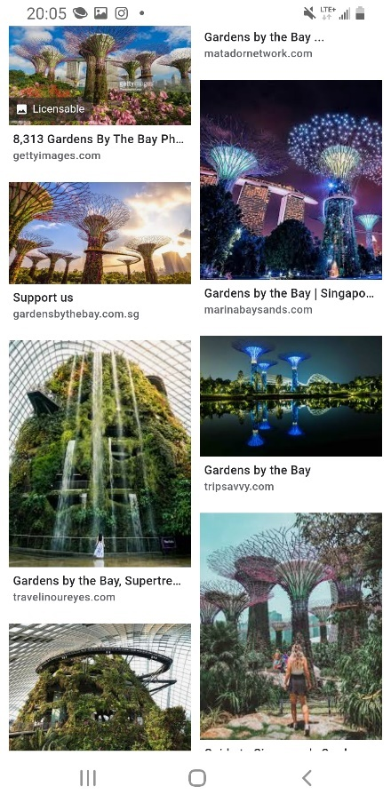

“Dad, what do you think of visiting Gardens by the Bay? It looks pretty at night, doesn’t it?”

“Um, I could say it is beautiful, especially at night. But, for you, since you are traveling solo, I highly don’t recommend going out alone past 8, even though Singapore is a safe city.”

“I know that many solo female travelers usually don’t go out late at night.”

She added seconds later,

“That is the bucket list I created months ago and took full responsibility for.”

“So?”

“Mommy, daddy. I budgeted 28 Singapore Dollars, which is around 21 US dollars. So it is very cheap to visit Gardens by the Bay. I also fit through this kind of savings because I want to save more money in the long run.”

“Wow, sounds like you are a money saver. We are impressed by this idea relating to your spending preferences.”

“Thanks, dad.”

United recalled figuring out how to get to the place by reading the maps electronically or reading the signs she shared with her parents. She knew how to get to where her parents planned to visit back in Shenzhen.

Minutes later, her parents will ask her to travel again,

“United, have you thought of traveling to Malaysia too?”

“Um, yes. I am considering a trip to Malaysia and carefully researched since I saved over 4 grand during the probationary period.”

“Wow, sounds like you have been saving more money since then. By the way, are you considering traveling on a women’s tour?”

“Yes, there are solo travel groups such as Intrepid Travel, female travel groups, G-Adventures, etc. I will check it out, and let me know after booking a tour.” She added.

“Okie Dokie.”

Her parents understand her perspective.

Seconds later, she added.

“Hey guys, look at my paperwork. Homework is fun because I can explore the things I need to achieve my life goals. By the way, I answered the question from my interests, “What Activities suit you?” with a response based on my personality. And overall paperwork, there are listed emergency numbers included in the paper I download via phone.”

She convinced them.

“I understand the worst-case scenario and know in case of an emergency. I realized that if something difficult happens, such as difficulty finding a place, ask someone who works there for directions. I am trying my best to locate and solve problems for travel and real-life situations. In fact, solo travel can help me with the problem solver, not just for travel but for life, jobs, situations, etc.”

“United, I really understand the situation, but if you take responsibility for yourself and are ready for it, I will let you go but only in a safe place for solo travel. For example, traveling to Malaysia may not be more suitable for solo travel than Singapore. You might need a travel guide or a tour and have someone go with you.”

“Thank you, mommy, and daddy, for our conversation. I know that having this conversation about solo travel is a sensitive topic to discuss.”

“Not a problem.”

Tip: It is essential to talk with the parents or loved ones about your upcoming trip to know how to contact them in case of an emergency.

Emergency Info

For Singapore, here is the number to include in the emergency kit:
Emergency: 999
Police: 999
Fire and Ambulance: 995
Non-emergency:
Ambulance: 1777
Police Hotline: 1-800-225-0000
NEA Hotline: 1-800-225-5632

While her parents let her travel solo to Singapore and other safer places, they suggested taking increased precautions. As a result, United took care of safety, security, and health at home and abroad.

She witnessed,

“I am so happy that even though my parents are concerned about my solo trip, they have told me to be extra careful when traveling abroad since I am the only girl who takes pride in safety, security, health, and other personal obligations. I understand that solo travel has risks and is all about rewarding and confidence. It also builds the characters needed to build the values of who I am. And I am mature enough to handle this kind of emergency.”

Later in the evening, she turned on the computer.

While waiting for the computer’s loading, she also sells some old clothes online to make more money in her free time and boost earnings for the escorted trip to Malaysia.

“I have earned more than $2,000 from my side job, an odd job that raises my money well.”

After spending some time with her parents, she went on a website that offered a tour for female solo travelers. She also planned to book a day trip exclusively for solo travelers.

Logging onto the website “Tourradar,” she then typed “Malaysia,” clicked October 2021, and “All Adventures.”

It said, “25 Malaysia holiday packages for *** reviews.”

Then she filtered to “Min 3 days - Max 8 days,” and only 9 available holiday packages.

Scrolling down, she chose the ideal tour she listed on her Bucket List, “Langkawi and Kuala Lumpur.”

It said “Malaysia and Singapore Highlights (8 Days)” from Pulau Langkawi to Singapore.

Click to view the tour. A green oval with white print, “Book with flexibility.”

“Hence, there is an easy group in which this tour is ideal for me.” She founded the tour in which she planned to book a tour later.

Scrolled down to read all of the information, it said,

Itinerary

Start in Pulau Langkawi and end in Singapore! With the Explorer tour Malaysia and Singapore Highlights (8 Days), you have an 8 days tour package taking you through Pulau Langkawi, Malaysia, and 4 other destinations in Asia. Malaysia and Singapore Highlights (8 Days) include accommodation in a hotel and flights, an expert guide, meals, transport, and more.

About this trip

Starting on the beautiful island of Langkawi, you’ll uncover the best of Malaysia, from island life in paradise to the vibrant street art of Georgetown, the tea plantations of the Cameron Highlands & cave temples of Kuala Lumpur, plus a night in Singapore to round it all off.

Day 1: Start Langkawi

Langkawi

Welcome to Langkawi, a place of postcards and dreams and a paradise for us lucky wanderlusters to uncover. After checking into our hotel, you’ll have a free afternoon to settle in and explore.

Stay: Fave Hotel or similar

Day 2: Langkawi

Langkawi

We’ve found the Earth’s prettiest spot. Perfect turquoise ocean, slanted palm trees swaying in the breeze, mountain backdrops - Langkawi may fast become your favorite travel destination. The day is yours to soak up the sunshine and saltwater as you see fit, with an optional sunset dinner cruise topping off the day like an umbrella on a strawberry cocktail.

Optional: Sail the islands of Langkawi on a luxury catamaran with a BBQ buffet dinner (MYR 280)

Stay: Fave Hotel or similar

Day 3: Langkawi to Penang - Laters Langkawi!

Langkawi

Us hungry travelers must kick on and see what the rest of Malaysia offers - the next stop, Penang.

Penang

Check-in and throw down the bags, but no time to stop. Today, we’re heading to the vibrant suburb and UNESCO-listed Georgetown, where we’ll be whisked into a world of temples and street art. Then, we’ll head back to Penang for spicy street eats and exploration this evening when we’re done with Georgetown.

Stay: Neo+ Hotel or similar

Day 4: Penang to Cameron Highlands

Penang

This morning, you can hit the streets of Penang for some free time. Penang is a haven for the senses, with street food and bright lights seasoning our evening to perfection. This town is known for its plethora of delicious street eats, blending Malaysian and Indian influences. Be sure to ask your Trip Manager where to head, and make sure you’re hungry and have a wallet bursting with ringgits.

Cameron Highlands

This afternoon we head to the hills to see a different side of Malaysia: the lush and fragrant Cameron Highlands, where we’ll be bunkering down for a night of mountain-bound bliss. Malaysia’s most extensive hillside area spanning 712 square kilometers, this place is LUSH. So settle into our hotel for the night. We’ll be resting easy, knowing a full day of exploring lies ahead. After that, we’ll get together for a typical Steamboat dinner like the locals do tonight. A steaming pot of broth and any ingredients you like are on offer to create your own tastebud adventure.

Included Tour: Taste a selection of traditionally steamed dishes at a ‘Steamboat’ dinner in the Cameron Highlands, Malaysia

Stay: Nova Highlands Resort Hotel or similar

Day 5: Cameron Island to Kuala Lumpur

Cameron

We’ll be frolicking about this morning with a tea plantation tour and sightseeing in the local area. Then, breathing in our final gulps of fresh highland air, it’s then onto the city vibes of Kuala Lumpur, where we’ll spend our afternoon exploring the city.

Kuala Lumpur

We arrive at a complete change of scene as we head to the Malaysian capital city for some big city vibes and epic sights.

Included Tours:

1) Take a tour of Malaysia’s lush tea plantations in the Cameron Highlands

2) See Kuala Lumpur’s hotspots, including the Petronas Towers, on a guided city tour

Stay: Swiss Inn Hotel or similar

Day 6: Kuala Lumpur

Kuala Lumpur

Today is a full free day in KL. Here you can decide to check out the Batu Caves, a series of colorful gilded cave temples just out from the city.

Free Time Add-ons: Guided Tour of Batu Caves ($27.00)

Stay: Swiss Inn Hotel or similar

Day 7: Kuala Lumpur to Singapore

Kuala Lumpur

We came, saw, and did it all. KL, you’ve been a dream, but we’ve got one last big city in our sights, this time, Singapore! We’ll hop on a quick flight, and before we know it, we have arrived.

Singapore

After landing at our final destination, spirits will be at an all-time high over the last few days of seeing and doing it all. So, team, let’s go out with a bang.

Included flight from Kuala Lumpur to Singapore on Tigerair

Stay: Aqueen Hotel or similar

Day 8: End Singapore

Singapore

That’s a wrap on our week-long adventure. Malaysia & Singapore are under our belts. We’ll say our sad goodbyes before going our separate ways - with big plans to reunite somewhere special soon.

She continues to read through the lines about what’s included in the selected tour.

What’s Included

Accommodation

7 nights in the hotel

Flights

Included flight from Kuala Lumpur to Singapore

*** International flights to and from the tours are not included.

Guide

Expert Trip Manager and Local Guides

Meals

8 meals: 7 breakfasts and 1 dinner

Additional Services

Take a tour of Malaysia’s lush tea plantations in the Cameron Highlands

Included flight from Kuala Lumpur to Singapore

Transport

Private Coach + Internal Flights

Insurance

Insurance is not included.

Optional

Sail the islands of Langkawi on a luxury catamaran with a BBQ buffet dinner
MYR 280

Guided Tour of Batu Caves
$ 27.00

Additional Services

Other activities and services are not included.

Where You’ll Stay

Hotel

“Since this tour doesn’t cover travel insurance, I ensure I have supplemental insurance before the girls’ tour.” She said while scheduling to book insurance.

On the 2021 calendar, she turned to the page to September and wrote, “*Suggested budget: $100 needed for the dream Malaysia tour. Please book insurance 4 to 6 weeks before my departure. Very Important.”

Underneath, it said that the max people are 35 people over 18 to 35 and are solo travelers.

Reading the full information about the tour, she was surprised that the tour didn’t cover medical insurance. Still, she knows what she needs to do.

She then selected October 31, 2021, as the best day to start the tour.

Clicked on the button, “Book now,” she prepared the debit card for the payment.

Finally, she paid $1,080 with a discount of 10% off.

After that, she sent off her email. Her email includes detailed information about the 7-day tour, “Malaysia and Singapore Highlights (8 days).”

She checked the email and saw that her upcoming itinerary was in her email inbox and…

“OMG, my upcoming Malaysia Trip itinerary is there. I don’t worry about missing the itinerary because it is handy on email.”

And she was off to bed, ready for the next workday.

A week later,

United awaits her weekend to update her itinerary since she was busier working as an associate. Now, she was at home, relaxing and napping while her brother cooked dinner independently.

Minutes later, her parents arrived home to eat dinner and...

...there was bok choy, sautéed chicken breast, steamed veggies, and baked spinach cheese.

Then, they ate together, discussing her exciting news.

“Mom, Dad, I earned a free travel bag for hard work.”

“Really, good job! God bless.”

“Bravo!” Her father complimented.

“Thank you.” She padded her hands into her chest.

Smiling at her parents, she ate slowly, while her father ate his dinner fast because he wanted more veggies.

The next day, after she got off from work, she was excited to search for a flight and hostel. It was a beautiful afternoon, waiting for the bus and checking the I-Powers Travel worksheets she had created.

Sitting on the bus...

“It is looked like I am on the right track to a dream trip planning.” She said while reviewing her trip plan on the worksheet.

After showering quickly, she went downstairs and helped her mother with a quick dinner.

Then, her parents went out to join the church friends for dinner. United was at home, waiting for her sister.

Brandson came over for a fun, relaxed dinner with her sister Wawa. United joined with them, having a fun conversation. Just then, United was super excited to talk more about her upcoming solo travel and, this time, why she planned to travel.

“United, why Singapore?” Brandson asked.

“Well, it is so beautiful, and so, I yearned to go again and, this time, solo travel and meet new girls abroad. And to take more pictures of Gardens by the Bay.” She laughed.

“Aha, okay. Have a safe trip.”

“Thank you so much!”

After helping with the dishes, she searched for an airline ticket to Singapore. She looked forward to traveling solo again soon.

“I will need to figure out how much I will be paying so that I don’t overspend. Then, I will need to wait and see if it is the right time to book an airline ticket. I am just comparing the price from each gateway airport; Philly, Newark, and JFK.”

She recalled doing her budgeting weeks ago. Then, she did the Workshop Process, which included budgeting from the Plan Process.

She compares the costs of all flights from these 3 cities in her room by expenses.

She was on her phone on Google for the flights to Singapore: Philly, Newark, and JFK.

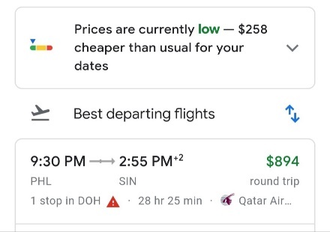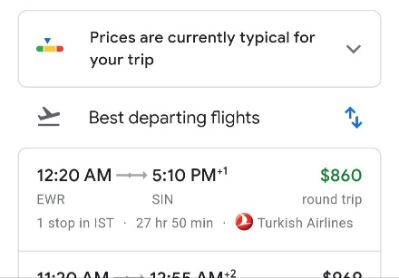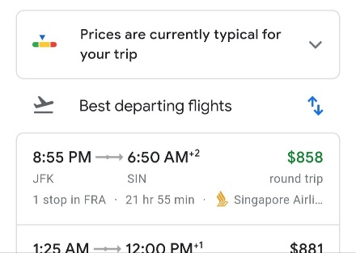

Loading on three different flight prices to Singapore were $894, $860, and $858.

“It is just a sample airline ticket price, not just an average price, so there is a huge difference between these prices from the websites.”

“The flights from Newark are cheaper, but that is not the case. I will need to wait when it comes to booking my flight. Since I am an active frequent flyer member of United Airlines, I am opting not just for United but also for Star Alliance partners. Since United and Turkish Airlines are Star Alliance Members, it is easier to thoroughly search, sign up for airfare alerts, and wait. The cheap airfare can wait.”

Can’t find the lowest price available from Philadelphia...

“There are still more expensive options available for the cheapest.” She groaned. “There is only one chance, but we must find alternative airports like Newark or JFK.”

Tips: When searching for an airline ticket, booking alternative airports for the best deals is essential. For example, if you live in Philadelphia, try to shop for bargains in Newark or JFK. Or you can try Trenton.

She planned to eliminate one of Philadelphia’s getaway airports because the airfare became more expensive. Her goal was to save money for the trip for the low season.

A minute later, she added, “Finding a good flight deal is hard work. It takes lots of patience because the prices change several times a day. It is called a yo-yo cost, a roller coaster cost, so to speak.”

Warning: Budgeting around $1,784 on plane tickets doesn’t mean you should spend a thousand dollars. This is not how saving money works. Saving money requires trial and error, patience and time to find the best, lowest available airfare. I-Powers Travel believes that strategy works by opting for realistic expectations, including finding a good deal on flights, especially since you are a frequent flyer. The flight you want is changing, just like the weather frequently changes. Be sure you have enough money for the airfare.

Since she will travel to Singapore in October, it was time to search for her flight because she had experience finding cheap airfare abroad. She practiced the “solo traveler” and researched information based on solo travelers’ experiences and travel lectures and seminars.

Tips: It is best to search 6 to 12 weeks before departure for domestic travel off-season. High season, 9 to 16 weeks. For international travel off-season, 9 to 12 weeks and 15 to 20 weeks for high season. Of course, searching for cheap airfare isn’t easy. Know the date of travel. Try flexible dates.

Fact: The airfare changes based on external factors:
- Time
- Days of the week
- Season
- Place of origin and destination
- Distance
- Class cabin

Flexibility is imperative since airfare isn’t guaranteed to get the best deals.

She logged her information into Google flights to sign up for flight alerts.

Then she clicked on the toggle that said, “Track prices” for Oct 23 – Nov 9, 2021.

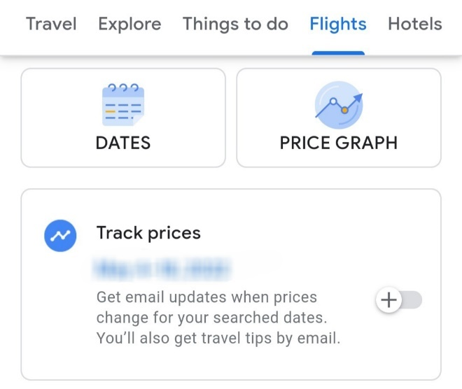

Recommend: I-Powers Travel recommends signing up for airfare alerts to get the best deal, not just searching just one date, airline, or other time limits. The flight alerts took care of this. The flight alerts have saved time and money in searching the flights daily during stressful times. Save your stress. Serve your health.

“I don’t need to worry about what I must see or experience. I already have an idea for my trip, so I probably don’t need a guide. But will have 7 days of female solo travel groups and an additional 2 days of recap. It is only for girls who are solo travelers to meet up together. The guide is free for those who only stayed at the hostel and are females who travel solo.”

She talked to herself while closing the browser on Google Flights.

Sleeping 8 hours later...

The next day, she was off to work full-time with her new people, who also worked at the hospitality company but with a different job assignment. She did the presentation and administrative duties by educating the customers about the “I-Powers Travel Cycle” and the importance of trip planning. She was happy that they worked together on some days. This morning, she met a new girl named Donna. She worked at the hospitality company for over a year during lunch break.

Days later, she was at the SEPTA bus home after working on the trip planning assignment for customers.

Checking her email...

It was then she saw the upcoming flight deals were changed and…

It was updated on June 20th.

“Google Flights” on her email updates showed that it posted fare changes relative to price fluctuation.

“Your tracked flight to Singapore is now $855 (was $860).”

Clicked on it, it said,

Hello,

There’s been a price change on the following destinations and dates:

Newark, New York, Philadelphia to Singapore
[Dates redacted]
Round trip - 1 adult
$855

“This is the cheapest relatively from Newark, but I prefer to wait a week and see.” She added.

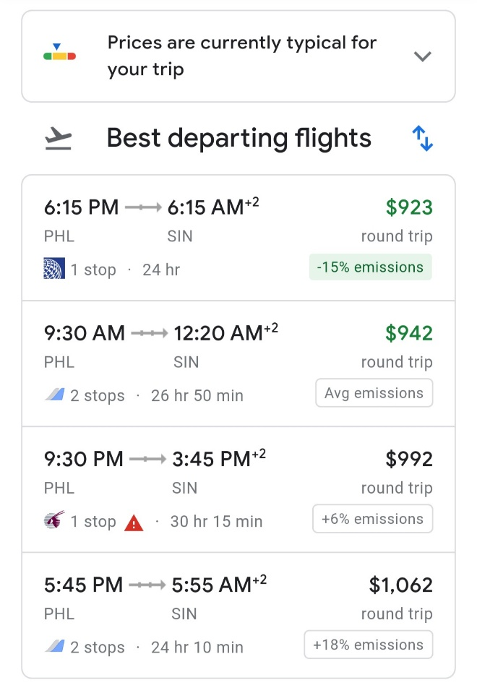
The flight was expensive from Philadelphia to Singapore at around $923.
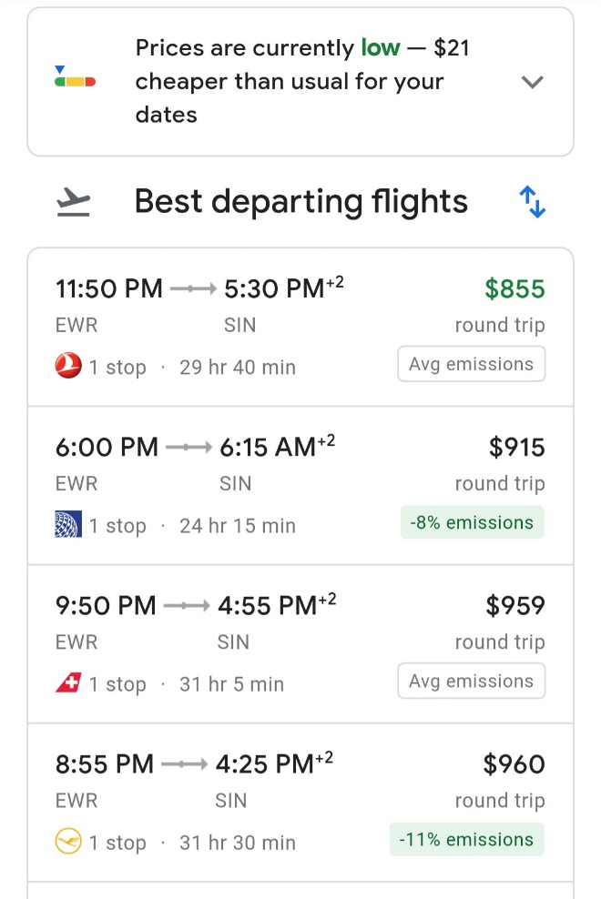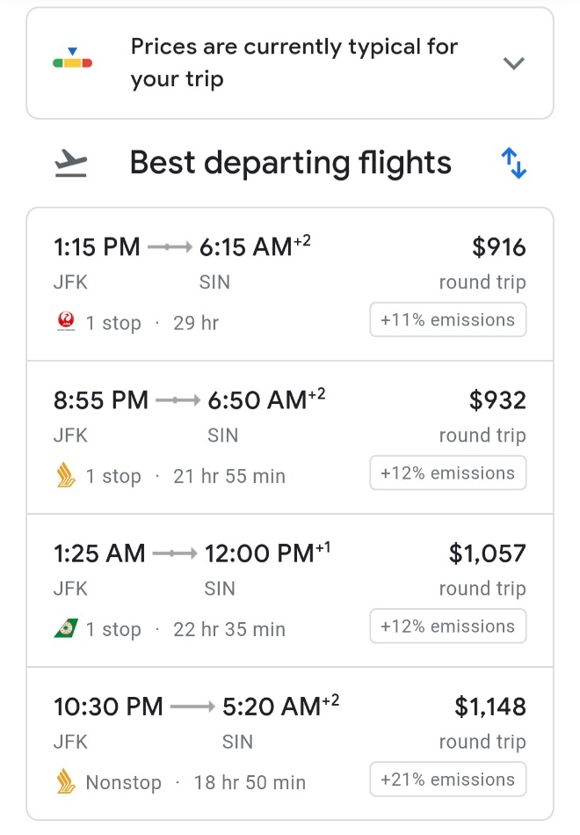

The price is relatively lower than Newark and JFK, at around $855 and $916.

“The good news is that Turkish Airlines from Newark to Singapore is $855. Since I want that flight, I will wait and see because airfare search is a searching period, so patience is the key to getting the cheapest fare. Now, I am filtering to a “nonstop” and see what happens.”

Filtering to “Nonstop,” it has only one option (Newark to Singapore) via Singapore Airlines was worth $1,479.

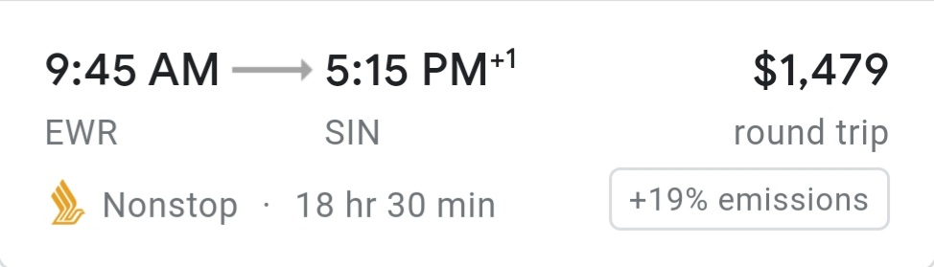
The nonstop from JFK to Singapore was expensive at $1,479 with the Singapore Airlines Economy Plus Class. Hence, there is no nonstop basic economy class airfare.

“Turns out the nonstop is a lot expensive, so I am not considering a nonstop. I am not taking a Singapore Airlines. This is not how saving money works. So now, I will not book my flight yet because I need to wait and see the price.” She added while planning to mark the calendar when to book her trip.

She puts off the airfare search for another week to book an airline ticket and a hostel stay.

On June 27, 2021, after she returned from church, she checked her airfare on her email (JFK to Singapore). It went up again to $1,033, increased by $30 because the ticket for the selected flights sold out fast.

The fare she also checked was down (Newark) from $910 to $900 due to price fluctuation.

Not Recommended: Being impatient when searching for the best airfare deals. Because the airfare from both airports will change several times a day, try to schedule Tuesday to book a flight whenever possible. We highly recommend trying different dates to get the best deals, not just the date you want. So, airfare is an expensive item to purchase. Before making a purchase requires a financial commitment, just as you book a trip or make a large purchase.

Late in the evening, she helped her family with the dishes and cleaned the dining room, which kept the area clean. Next, she concentrates on cleaning up the kitchen and the common area before she schedules to book her flight tonight.

After finishing her daily duties, she went upstairs to book her flight for 14 days because she had her money saved from her savings account and flexible vacation plans.

Turning on her laptop computer, she checked her email and saw several messages from Google Flights alerts, “Your tracked flight to Singapore is now $900 (was $855) – Google Flights….”

She clicked on it, and it read,

Hello,

There’s been a price change on the following destinations and dates:

Newark, New York, Philadelphia to Singapore
[Dates redacted]
Round trip - 1 adult
$900

Scrolling down on her email, she clicked to search for the flights again for any changes.

“One of the flights she signed up for from JFK to Singapore. With a layover in Tokyo, it has gone up from $1,033 to $1,134. But, I prefer to spend less.”

“Whew, that is not bad. I have been waiting for the fare to go down and save up.” She praised herself.

Filtering to “Nonstop,” she saw that a direct flight to Singapore was closer to $3,124, a significant spike from $2,240.

She remembered signing up for Newark’s fare alert to Singapore to get a better deal, not just JFK. Her goal was to save money because traveling requires a financial commitment to reach her travel goal.

“In conclusion, the nonstop from JFK to Singapore via All Nippon Airways ($1,134) was more expensive than the flights, including a layover to get a better deal. I checked the flight yesterday and will eliminate JFK.” She tried to hunt for the best airfare.

Recommended: Travelers need to be flexible with the travel dates since airline tickets are variable costs, meaning they will change several times a day. If you are a frequent flyer member, google flights are the best. It is an all-in-one flight search, making it easier to eliminate one of the alliances or a specific airline you want to take. Hence, there is a lot of selection of flights available.

Days later, she said, while compared to the getaway airport,

“I am on Google flights and then compared to exclusive. I also compare the airline alliance if I am a frequent flyer member. For example, since I am a United Airlines MileagePlus member and a Star Alliance member, I accumulate miles only on partnered airlines. Also, I am comparing airlines to airlines to get the best deals, not just United but also ANA, Lufthansa, SAS, Air Canada, and other Star Alliance partners to earn miles.”

The airfare went low for a limited period, with an upper $1,000s and $730s from JFK and Newark.

Rechecking the airfare, she was shocked, “Woah! The departure from JFK was costly...”

Despite the flexible dates, she realized that flights from Newark were cheaper than JFK at $730s and $1,220. So she checked the email sent from Google Flights, and it turned out Newark was the best deal.

“I compare it with the getaway airport, and the cost is over 500 dollars less, which is cheaper when signing up for the fare alerts. I also used flexible dates. For example, I could leave on Monday, but the airfare deals have assigned me to Sunday, October 24.”

Observing the Newark flight search, it reads that it is only available on the cheapest flight with the $1,845 via Singapore Airlines from Newark.

“I can’t pay this amount.” She said sarcastically. “Who else will pay me the $1,845?”

“The departure from JFK will be eliminated, so the final option is from Newark.”

Tip: If you are a frequent flyer member, you should eliminate the airlines that don’t codeshare with the airline’s frequent flyer program requirement. Instead, try alternative dates, times, and airport locations for the best deals.

Recommended: Even though you budget your trip, it is essential to compare the price and select the cheapest and the best fit for your itinerary. Spending too much is not recommended because you will have sufficient funds for other costs, e.g., emergencies, savings, etc.

Eliminating her flight from JFK, there was only one option: Newark.

Instead, she opted for the cheaper flight from Newark round trip as the final option.

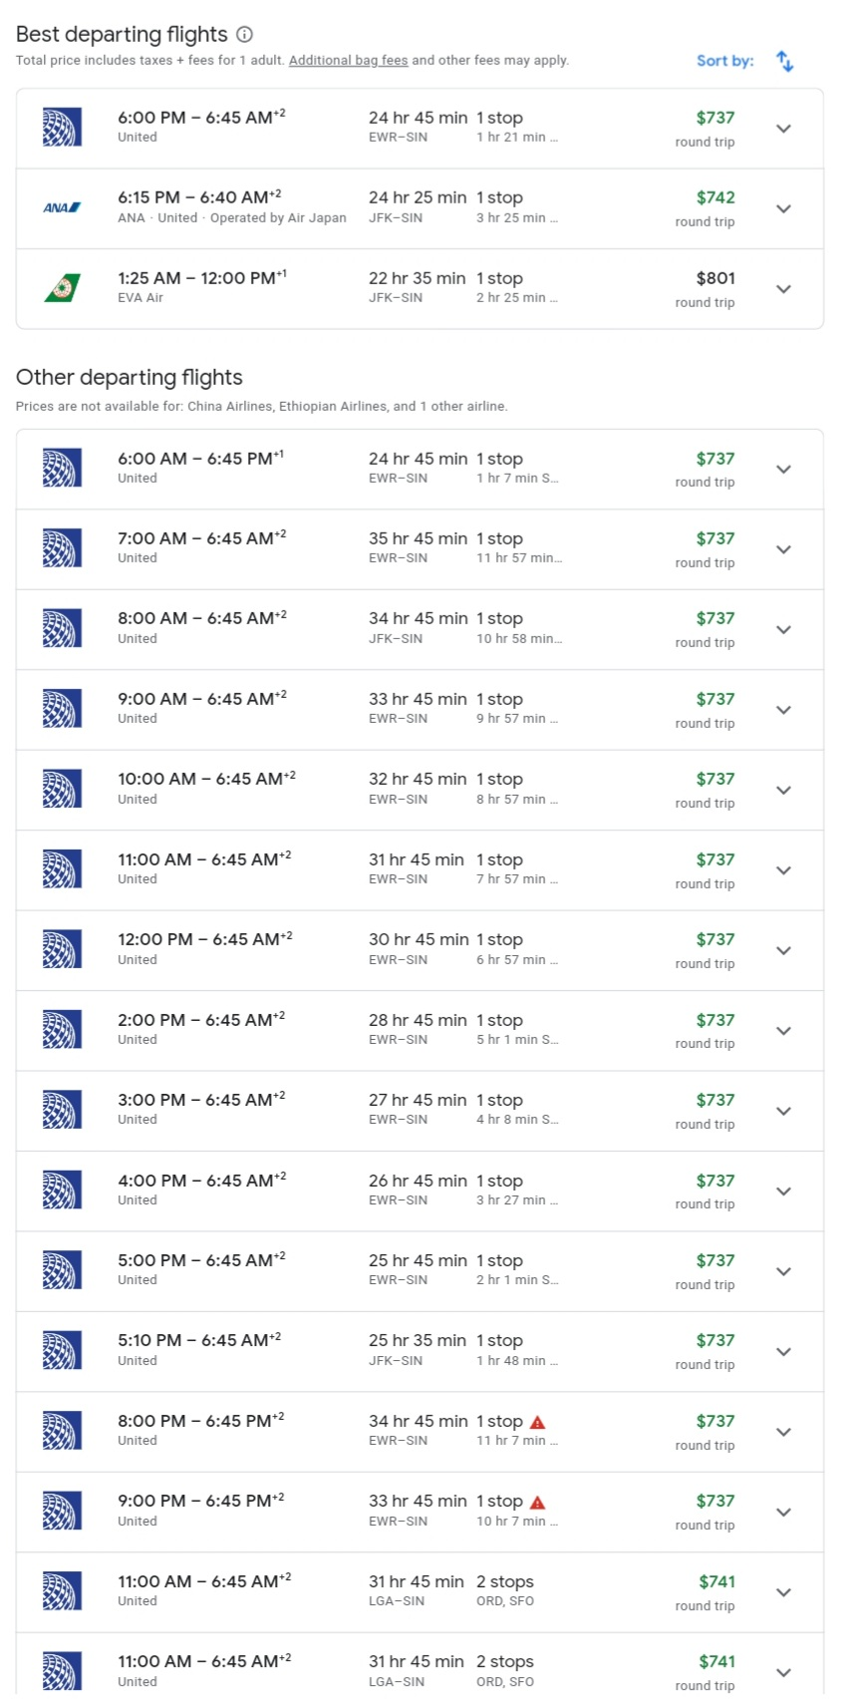

“It looks like that flight from Newark to Singapore is the cheapest. So I am going to select the flight at 2pm.” She praised while redirecting to the airline’s website.

She added, “I have enough time for the long flight via United Club in my layover.” She selected the flight for $737.

Based on her saving money experience, she did her math. Overall, she has saved up to $1,047 ($1,784 - $737). There is a huge savings of 58.7% decrease from the total cost ($737 – $1,784) / ($1,784). And she decided to select and purchase the flight.

Sending to the airline’s website, she paid the airfare by credit card because her credit limit increased due to her full-time work and annual income.

“I am ensuring that the credit debt ratio shouldn’t exceed 20 to 30 percent. The lower the credit ratio, the better. For example, I have a credit limit of $5,500. Overall, I can’t spend more than $1,100 to $1,650. So I have to be very careful not to overindulge this spending and must pay in full if I can.” She said while holding her airline credit card.

The flight itinerary was sent via email.

Minutes later, it said:

Your Flight Itinerary to Singapore

Confirmation Number: ******

October 24 - Depart Newark

United Airlines Flight 1665
2:00pm Newark to 5:29pm San Francisco
Class/Seat Assignment: Economy
Flight Time: 6h 29m
Meals: Food for Purchase

5h 16m Layover in San Francisco

United Airlines Flight 1
10:45pm San Francisco to 6:45am Singapore (October 26)
Class/Seat Assignment: Economy
Flight Time: 17h
Meals: Dinner/Breakfast

November 9 - Depart Singapore

United Airlines Flight 2
9:00am Singapore to 8:55am San Francisco
Class/Seat Assignment: Economy
Flight Time: 14h 50m
Meals: Dinner/Breakfast

4h 45m layover in San Francisco

United Airlines Flight 1428
1:35pm San Francisco to 10:00pm Newark
Class/Seat Assignment: Economy
Flight Time: 5h 25m
Meals: Food for Purchase

Total: 737.00 USD

Observing her intended flight itinerary, she mentioned,

“I will take my flight from Newark instead to get a better deal because I tried flexible dates on these flights. However, the cost was the lowest at 700s round-trip for a limited time. Then my father will drive me to and from the airport because he’s very flexible.”

She added.

“Or I can book a shuttle that serves passengers to Newark airport to catch my flight after purchasing an airline ticket. Then, I will ask my daddy if he can drive me to and from the airport. Will see what happens after he says about airport transfers. Since he is no longer working at BNY Mellon, he is free to drive and pick me up.”

She signed in on United Airlines’ website (www.united.com) and chose the window seats as her preference.

Before she confirmed her seat, she chose the window seats on all 4 flights. Unfortunately, some of the window seats on rows 22 to 32 were quickly sold out.

Choosing the seat number, she confirmed the seat assignment included on her chosen seat assignment.

Paying the airfare via her airline credit card, she knew how to pay it back in full since she saved more money once the bill came during the statement period.

Tips: If you have outstanding debts or limited funds available to pay your credit bill, don’t pay your airline ticket or expensive purchase by credit card because it can carry bills and interests from period to period. It is best to pay the entire balance if you want an excellent credit score. Otherwise, it carries a heavy balance and late fees on your bill, meaning your bill can be expensive to pay them back. Finally, you will more seriously affect your credit even if you miss your payment once. It is best to pay for your airfare with a debit card.

Once she confirmed her flight to Singapore and entered her frequent flyer number on the airline’s website, she planned to figure out how she would get to the airport.

“I am also planning how to get to and from the airport. My dad has retired because of his personal circumstances, so he is free to drive and drop and pick me up from the airport.”

She finally wrote the items on the phone to remind her of the departure and return times.

Then, she decided not to purchase a shuttle because her father was flexible in picking up and dropping her off at the airport.

She added, “It was not the time to book an airport shuttle because it was far from the departure. United planned to wait approximately 1 month before her departure. My father is available now, so I don’t need to book a shuttle, which costs some $200ish.”

She closed the browser, turned off the laptop while looking at her I-Powers Travel budget worksheet, and signed out on a kayak and airline website.

Reviewing the I-Powers Travel worksheet, she stayed within the budget for airfare and hotel with the intended allocation of $1,784 and $350, respectively.

“I realized that I budgeted $350 from my budget sheet. So next, I am booking a stay.”

Opening the Hostelworld app, she searched the hostel’s app to book a hostel stay. Then, she typed the keyword at the top of the screen.

Where do you want to go?

Tap on the screen.

Typing “Singapore,” she selected the arrival and departure dates and the number of guests. Finally, she chose 1 guest since she traveled alone and hit “search.”

She waited while loading the results.

She narrowed them out with “Female dorms.”

Loading them out, some of the hostels have been eliminated (where hostels don’t have any female dorm rooms).

She kept searching and preferred a 4-6 female bedroom.

Advice: If time management is the primary factor, try to book a room with fewer beds. The less bed, the more suitable for you to manage your time to use the bathroom to take showers, use the bathroom, brush your teeth, and change clothes. Most hostels have shared bathrooms, so there is only one bathroom for the number of beds.

She made her suggestions based on how many beds are allowed based on the number of safety measures. She mentioned that staying with 7 or more people means more time to use the bathroom and are confused about which locker or bed to assign and are noisy. She suggests solo travelers book a single gender and 6 or fewer roommates for protection, convenience, and flexibility.

After several attempts, she found a 4-6 female dorm.

Finally, she selected “Dream Lodge.”

She was selected for a hostel stay with a high 9.7 Superb rating.

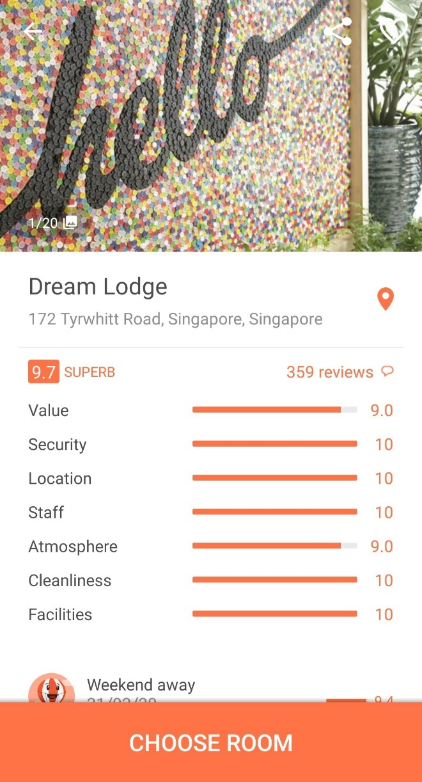

Scrolling down for the reviews, she was surprised that the hostelers had a wonderful time at the hostel experience from the outstanding ratings from 8 to 10.

“I am glad I found a good place to stay for less.”

Next, she looked at the location of the hostel she would be staying…
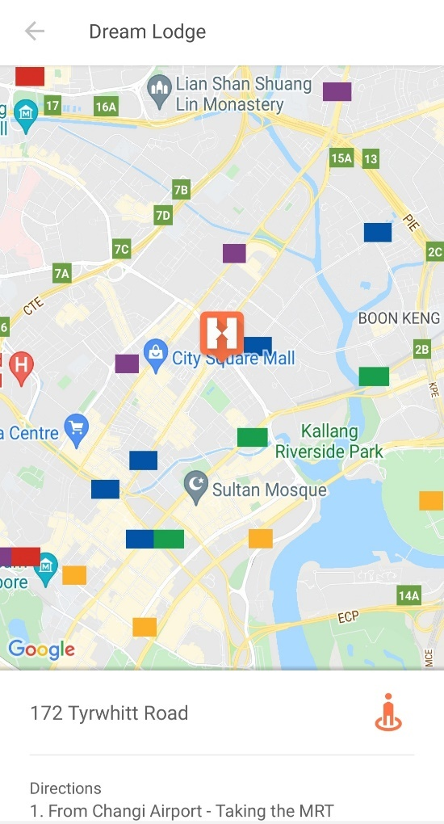

Scrolling down...

Tap on the word “See all facilities.”

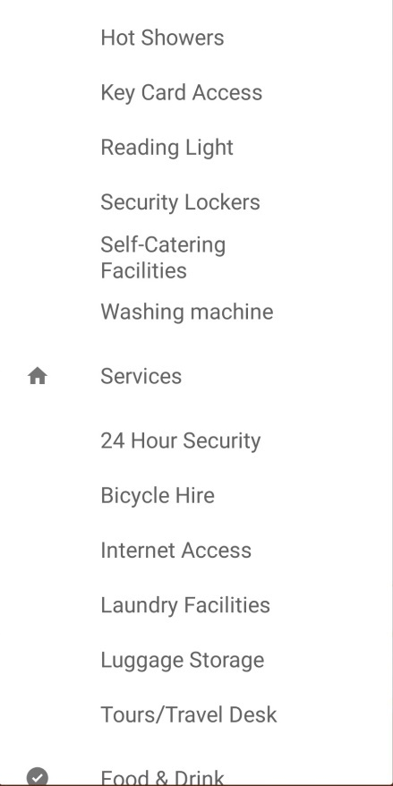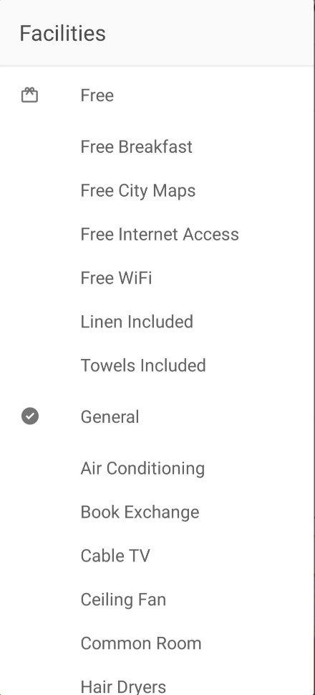

They included some additional facilities at the hostel.

“We have everything available for this hostel but no kitchen to store food.”

Reading through the full information about the hostel…

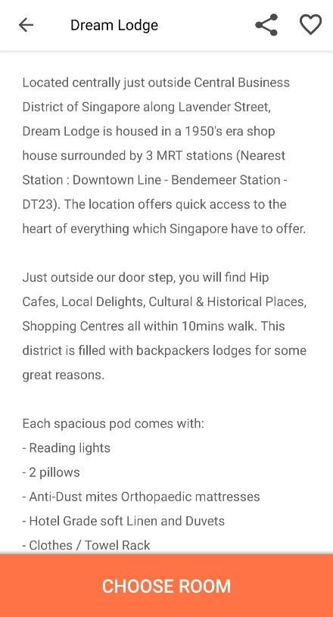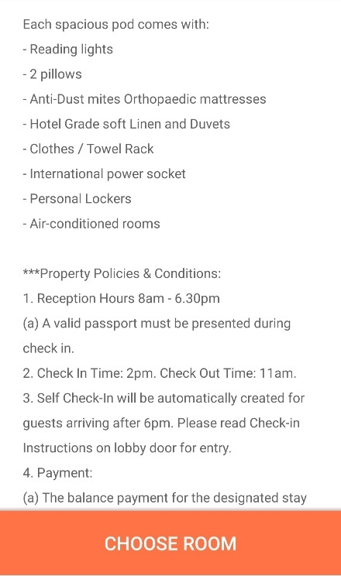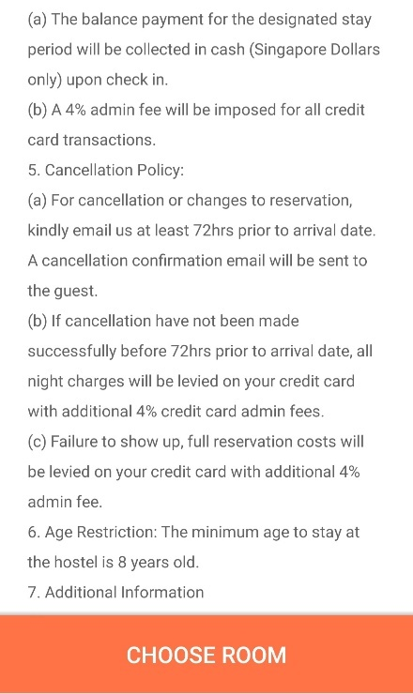

Tap the orange button “CHOOSE ROOM,” there are choices; Standard 6 Bed Female Room, Standard 6 Bed Mixed Room, etc. All rooms have a shared bathroom.

Advice: Before booking a room, as shown in the example, it is essential to observe any added facilities, information, and policies. I highly recommend looking up their reviews too. Make informed decisions before you finalize your booking. Hotel locations also matter, so you don’t have to stay in shabby neighborhoods. Know how to get to the hotel too.

Observing the note, she witnessed,

Looking at the features, she observes the hostel policies, including “Things to note” on the bottom of the page app.

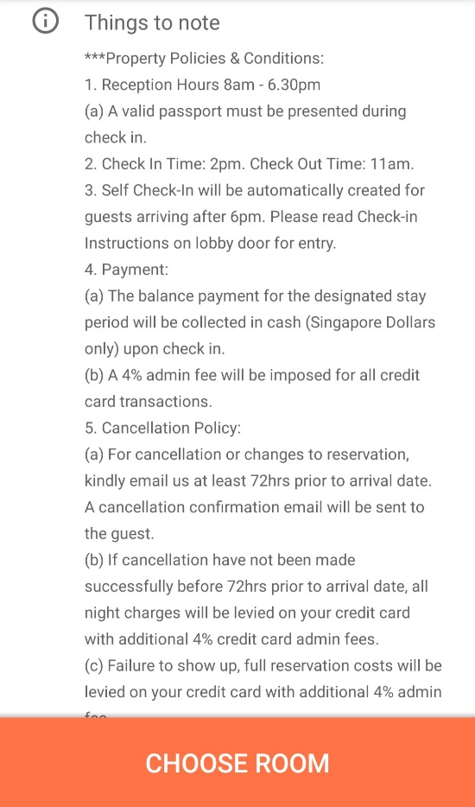

She was excited to book a stay at Dream Lodge.

Scrolled up...

She finally selected the room with a Standard 6 Bed Female Room.

Warning: I do not recommend a mixed room for female solo travelers. Sometimes, males can get unwanted attention or take advantage of you. Your goal is to protect yourself from unwanted attention or conversation. As a precaution, it is best to stay in a single-gender room.

Here is the summary of each night’s charge.

Calendar Icon: Tue, 26 Oct – Sun, 31 Oct

Free Cancellation

You can cancel your booking free of charge before 23 Oct 2021

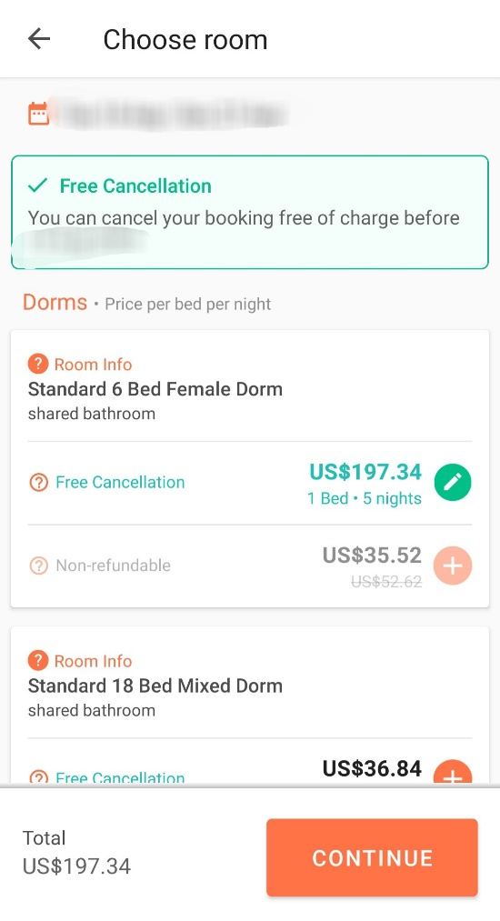

Total Price: $197.34

She hit “CONTINUE,” and the screen popped to the next page.

Dream Lodge
172 Tyrwhitt Road

Check in  Tue, 26 Oct | Check out  Sun, 31 Oct | Nights  5

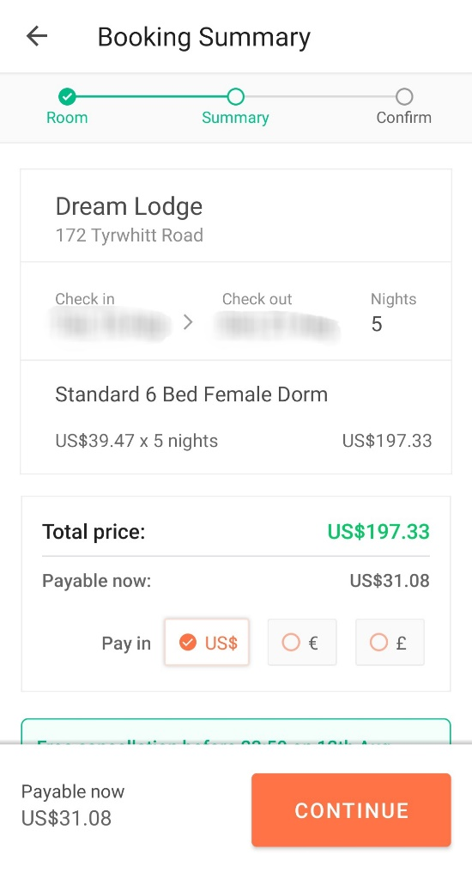

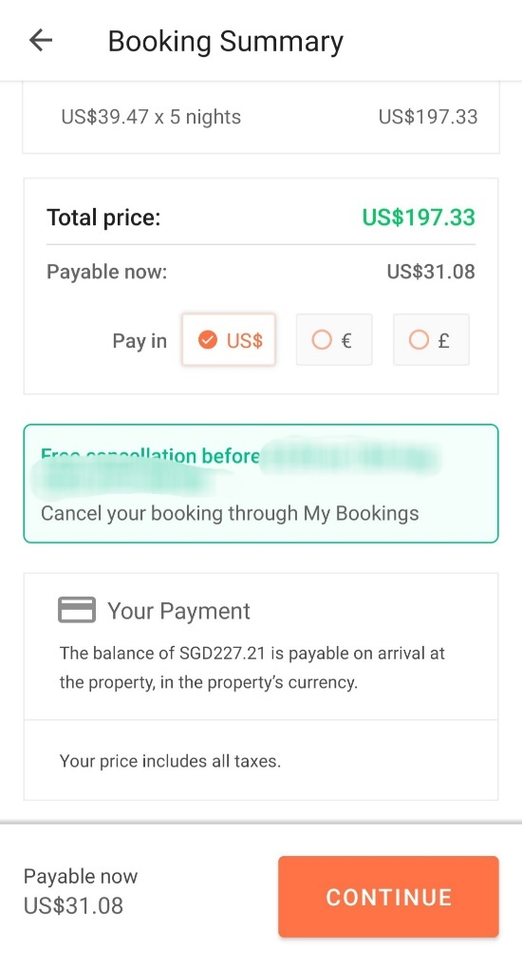

She paid $31.08 via credit card.

After booking her trip and a hostel stay, she felt relieved that she had found the best deal. She saves lots of money by opting out of Newark airport as the getaway via United roundtrip. She booked 5 nights for $39.47 a night before her Contiki Tour.

It costs around $39.47 per night (Free-Cancellation) at Dream Lodge, so her total was $197.33.

Advice: I highly recommend selecting the Free-Cancellation just in case your flight was delayed or canceled due to circumstances that imperil your trip plan. Night cost is included, just in case something (emergency) happens. Overall, you can cancel your hostel reservation without penalty.

She was very skeptical about the features, including laundry facilities. However, she likes to observe available facilities at the hostel before she books a night.

The Dream Lodge and her trip plan (with independent travel) generally fit her personality.

“In conclusion, I budgeted airfare and hotel combined of $2,134 but only spent $934.33. That is impressive savings.” She smiled and said while doing her calculations that and turned out to be $1,199.67, about $1,200. Wow!”

In her bedroom, the night of June 27th, she witnessed:

“I prefer to stay at the hostel in female dorms only. Because I will travel solo and single females, staying in a female dorm room is a safe bet. With 6 other girls in the room, I feel safe. I remembered that I stayed with 6 other girls back when I was in NYC. I also safely landed on a bunk bed with a safety staff.” She looked upon her Facebook and saw a Q4 Hotel room with a 6-bed female dorm.

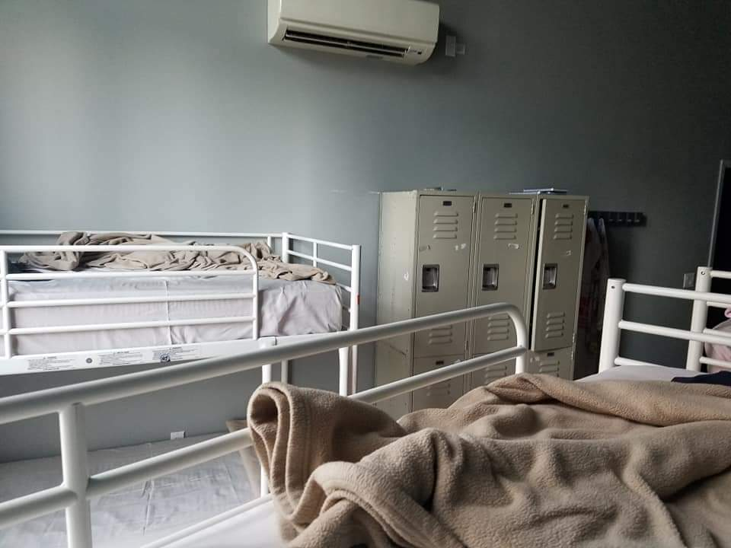

“Let’s put this trip off until 1 month and learn more about Singapore and Malaysian culture, not to mention me going there obsessively. I am grateful to myself that my trip to Taipei is working out. Researching is not easy, but rewarding to find cheap airfare. And to find a good place to stay.” She vowed to herself.

Organizing her folder, she kept her hostel and flight itinerary booking together with the I-Powers Travel worksheets.

Off to bed to get a good night’s sleep, she stored her travel folder in a safe place so that she needed it for the last minute before she traveled.

Prep

It was a warm July morning when she was on the way to work via public transportation.

On the Subway, she reviewed the trip itinerary and the customs where Singapore culture was traditional and conservative. Then, she took her note, preparing for her Execution Process in the I-Powers Travel cycle.

“I am ready for both Passive and Active Execution, which are necessary for the trip preparation.” Then, taking some notes on the white 2021 calendar, she marked down when she scheduled to perform “Pre-trip” tasks.

Evaluation vs. Execution

Many people confused these two E words: Evaluation vs. Execution means the same thing with the same different word. In reality, both evaluation and execution are two different meanings; it includes two various courses of action when planning a dream trip. Therefore, they required two E words to meet together.

Evaluation: To make a judgment on a plan of action, especially in the Plan Process. It sometimes refers to both Pretrip and 4 components of Plan: Health, Safety/Laws, Documents, and Finance.

Execution: To carry out a course on a trip or a plan, especially in the Observation Process. It sometimes refers to both prior trip experiences and 4 components of Observation: Languages, Customs, Traditions, and Communities.

Evaluation vs. Execution Theory

Think of this theory as a balance scale. Both evaluation and execution must meet together, so I-Powers Travel came up with two inequalities of outcomes of trip results. A plan without Preparation and Preparation without Plan.

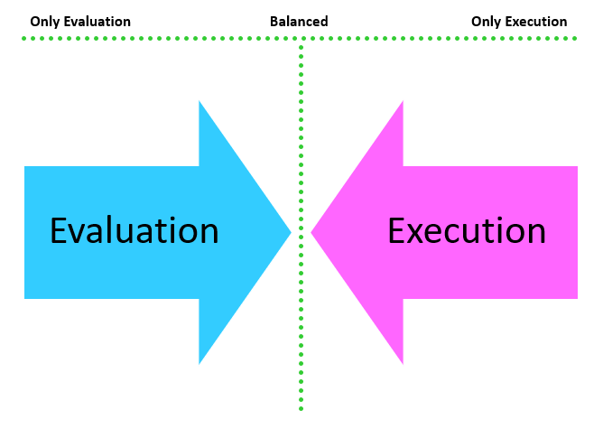

Evaluation vs. Execution Theory Model

Result 1: Plan without Preparation

A Plan without Preparation is the “Only Evaluation” Strategy.

Outcome: You will travel with no intention of the basis of local laws, cultural awareness/influences, and without adequate preparation, end up in miserable vacation time. You may have some kinds of cultural influences that you might need to adapt and execute when you plan a trip, especially locally and abroad, to familiarize its laws and communities. Consequently, if you have limited knowledge of cultural knowledge and 4L’s components, you may have to review these materials about the place well before your departure. This lack of cultural awareness lacks knowledge of laws and social and cultural connections to locals. It may offend you if you don’t research the cultural influences and trip preparation. That is why you should plan to achieve Observation and Execution Processes to enjoy your trip with fun and ease.

Result 2: Preparation without Plan

A Preparation without a Plan is the “Only Execution” Strategy.

Outcome: You will travel with some knowledge of cultural influences. Perhaps you will have already prepared for your dream trip. However, you may not be aware of the safety and health of an environment or place you intend to travel to, especially third-world countries, where safety and health planning are a must-have. Also, your financial travel budget will eat up your wallet simply because you lack financial trip planning, including your daily spending, meals, activities fees, etc. Another concern for the lack of planning includes the activity plan; you have limited to no idea where and what you want to do abroad or even in your town.

Result 3: Plan within Preparation

A Plan within Preparation is “A Balance Approach between Evaluation and Execution where two Es meets in the middle.”

Outcome: You have equally prepared for your dream trip with your 4L’s and 4 Plan knowledge. This outcome is what both Evaluation and Execution meet when you plan a trip. You spent some time evaluating these places, learning more about them, and executing your trip plan. This outcome is supposed to be like when you plan your trips.

Congratulations that you balance your time, commitment, dedication, and preservation of your trip plan and goals. Happy Travel.

Arrived at the worksite, and after greeting some workers and supervisors, she said,

“From putting litter into the public trash can to avoiding talking about sensitive topics, I prepared for the trip for 17 days. However, I knew that some residents and visitors were offended since I reviewed the expectations. But, overall, Singapore is all more than just being kind, and cleanliness is expected.”

She added,

“These people are exceptionally environmentally conscious of keeping the city clean and beautiful.”

Before her 9am shift, she reviewed the dos and don’ts of traveling to Singapore solo. She was doing the execution section and practicing/preparing days before departure.

“Now, it’s time to review the days before my dream trip after I get off from work.” She said while planning the execution section (5th in the I-Powers Travel Process).

Working in the hospitality company, she put off her travel preparation until the end of the shift because she had other tasks and planned to deal with her boredom and focus on the present.

At around 4pm, she was off from work, catching up with the Execution Process while taking the subway home.

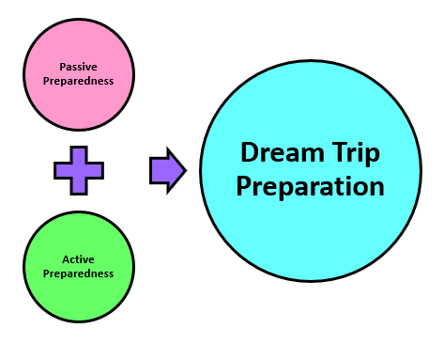

Looking at the picture, she said, “It looked like both Passive and Active Prep go together, a Trip Preparation. Just like we need a balanced evaluation and Execution to make the trip fun and reality.”

She emphasized in the blog:

Note: To have a successful dream trip preparation, you must engage in Passive (Evaluation) and Active (Execution) Preparedness in the Execution Process.

At home, she was reviewing the Passive Execution. She was making a list she planned to do before her departure.

“First, I am reading through the article about Passive Execution. Then, I am excited about the countdown.” She said while working on the trip countdown.

Passive Execution Info

Passive Execution refers to:

- Not actively engaging in particular places’ cultural, social, and economic aspects.

- Relates to the 4 Components of the Plan Process (4 Phases). This includes:

  - Health

  - Safety/Laws

  - Travel Documents

  - Finance

It is closely related to what you are thinking about what travelers need to pack, their clothes, documents, home care, contacts, etc.

...and

“Since I will be traveling solo, I don’t have to worry about cleaning up the whole house since my parents will be here for my trip. So I am just cleaning my room.”

Trip Countdown:

4-6 weeks before departure
- Purchase travel insurance (important)
- Make a list of what to pack for the 16-day trip.

2-4 weeks before departure:
- Develop a habit needed for travel.
- Take actions I learned from research.
- Evaluate the weakness and habits.

2 weeks before departure:
- Notify any bank’s debit and credit cards.
- Make a copy of my flight itinerary, passport, and itinerary of the tour from Contiki and my own itinerary to my parents.
- Update my emergency contact for the hostel’s front desk, tour operator, and hotel’s front desk.
- Start thinking about which clothes/items you will pack/need for the trip.

2-3 days before departure:
- Clean my room.
- Exchange currency you will need.
- Finalize my packing.
- Photocopy essential documents, including passport, Gov ID, Flight itinerary, your own itinerary, emergency contact information, etc., to your family/friends.

Days later, she did the Active Execution after she did the passive.

Active Execution Info

Active Execution refers to:

- Actively engaging in particular places’ cultural, social, and economic aspects.

- Related to the 4 Components from the Observation Process (4L’s). This includes:

  - Languages

  - Customs

  - Traditions

  - Communities

It is closely related to what travelers ask from their previous travel experiences, influences, values, knowledge of the place through immersion, social and cultural aspects, etc.

She was ready to review based on her prior research over the several weeks researching Singapore and Malaysia. In addition, she was eager to apply her knowledge once she arrived at the destination.

Several days later

At the dinner table,

She showed the itinerary she had created weeks before. It was a picture of places she wanted to visit.

“Singapore, here I come.” She smiled while showing them some beautiful pictures.

Her younger brother (Rich) told his parents, “Singapore?”

“Yes!”

While her younger sister (Wawa) hung out with her friends, she sometimes went to dinner at her friend’s house.

Putting her phone down on the table, she focuses on mindful eating.

Eating a healthy diet, she eats mindfully while conversing briefly with her parents about her upcoming trip.

“Hey, dad. I got a surprise for you.”

Neutral smile...

“Guess what?”

“What?”

“I already booked my flight to Singapore because I have accumulated 14 vacation days from my dream job. I understand the vacation policies, including taking 5 to 6 weeks of vacation during my job, but I have only 14 days left.”

Her dad’s rolling eyes.

Her mother’s confused.

“Huh? Why did you buy an airline ticket to Singapore?” She asked.

“Why did you want to go there?” He asked again.

“Well, Singapore is a beautiful city, but consider visiting the Gardens by the Bay. I also make a bucket list to have a goal for myself. It is wee and vibes and a life-changing experience for myself and my life. It feels good.”

“I understand the situation. Who are you going with?”

“I am traveling solo.”

“Why did you decide to travel solo?”

“Well! Because on my last trip to Taiwan, I felt like solo travel empowered me and helped me learn better there. I don’t have to worry about being in a confirmative argument between immature travelers like my daddy. I also don’t have to worry about waiting times for someone reluctant to see the senses. Didn’t I tell you last month? And I don’t want you guys to have a rough time anymore.”

“Oh, I forgot. I am getting old.” He laughs.

Then her mother was concerned about traveling solo and made suggestions,

“Okay, but I am still concerned with you, traveling solo.” Her mother responded in Cantonese. “Listen to your daddy about it, okay?”

“Thank you, mom.”

She added...

“I researched the tips and honed my skills because I recently traveled solo abroad for over a month and felt safe in Hong Kong. I researched which places to visit, so I don’t end up in dangerous places. I remembered that I did the project about NYC back in 2018 when you were away during my last semester at Temple. I am strong and brave. I also tend to stay away from shabby neighborhoods, which I did. But I am not overprotective but need safety guidelines. I am a safety geek. I learned, applied, and create strategies from my experiences to achieve self-sufficiently, resilience, and self-confidence. I am a positive risk-taker to help me succeed in the long run. Overall, traveling solo actually builds my character. Finally, other people have described me as brave, confident, and strong.”

“Oh, gotta.” Her father mimicked.

After finishing their dinner and helping with the cleaning, she talked about her upcoming trip relating to the ideal itinerary of her personality, Singapore.

“Hey guys, look at the paperwork I did weeks earlier. Homework is fun because I can explore the things I need to achieve my life goals for myself. By the way, I answered the question from my interests, “What Activities suit you?” with a response based on my personality. And overall paperwork, there are listed emergency numbers included in the paper I download via phone.”

“Wow! Did you do this all by yourself?”

“Yes. I did it all. I did the research based on a holistic approach like things I enlisted on my bucket list.”

“Good,” thumbs up.

Then her mother took turns talking about safety in Malaysia after she found her trip booked via Tourradar.

“United, how will you get around Malaysia?.”

“Well, I already booked a tour for solo travelers, including experts, tour guides who speak English, and a group of 35 solo travelers. It is from Contiki. We will get around Malaysia by the Contiki Bus, the coolest ride, with 34 other travelers. It will be a fun trip, I promise.”

“Wow, it sounded like a dream trip. Where do you meet for a tour?”

“My solo travel tours will start at Langkawi Airport, which will be on October 31st.”

“Okay, then. Daddy will purchase a one-way ticket from Singapore, okay?”

“Okay, dad, you sent me an email.”

“United, I will.”

“Thank you, dad. You are the best.”

Minutes later, she convinced her parents.

“I understand the worst-case scenario and know in case of an emergency. I realized that if something difficult happens, such as difficulty finding a place, ask someone who works there for directions. I am trying my best to locate and solve problems for travel and real-life situations. In fact, solo travel can help me with the problem solver, not just for travel but needed for life, jobs, situations, etc.”

“United, I understand the situation, but if you take responsibility for yourself and are ready for it, I will let you go but only in a safe place for solo travel. For example, traveling to Malaysia may not be more suitable for solo travel than Singapore. You might need a travel guide or a tour and have someone go with you.”

“Thank you, mommy, and daddy, for our conversation. I know that having this conversation about solo travel is a sensitive topic to discuss.”

“Not a problem.”

It was a beautiful Sunday (July 11) as she was off for the weekend, preparing to travel to Jefferson to meet with some travelers waiting to catch the 9:15 train to Conshohocken together.

She was waiting for Rachael and Drake at the Jefferson on the way from the Marriott Hotel on Market Street. Afterward, they planned to eat lunch at Nudy’s Cafe Conshohocken and hang out.

“They texted me, saying that if I want to travel to Conshohocken today. I replied, “Sure, I’ll come and join you.””

And by 9am, the two female travelers arrived and waved to United, who was sitting solo, waiting, and replied, “Good morning.”

“Good morning, Rachael and Drake; what’s up?”

“Nothing much. What’s up?”

“Nothing much!”

As they were waiting for the announcement, she checked her email. In the “Updates” section, she found her upcoming flight time has changed. Her flight time to San Francisco was changed from 2:00 to 2:15pm, and the plane’s fleet changed due to increased travel demand. It was sent via United with detailed information regarding the change in the plane fleet.

“It was my flight to San Francisco, which will be a layover for about 5 hours.”

Smiled at herself...

…she already made her hostel arrangement last month after her parents had recommended; that she stays safe when staying at the hostel after negotiating their safety plan.

Off to the transportation app, she checked the time of departing from Jefferson Station. It leaves at 9:10.

Off to the Regional Rail to Conshohocken, she sat with 2 travel friends, Rachael and Drake. The train was 11 minutes late and roared down the tunnel to Temple University Station.

United had a conversation with the 2 girls about her upcoming Singapore trip in October. They were surprised that United planned to travel abroad to Singapore and Malaysia in the forthcoming months.

“Enjoy your trip, United.”

“Thank you, Drake.” Drake complimented. “I have not been to Singapore.”

“Thank you so much. We will pray for me.”

“Certainly,” she added. “We will.”

She put her hands on her chest as more passengers boarded the train, heading westbound to Conshohocken. United felt relieved.

The train left Temple University Station, heading northbound.

Laughing out loud, they enjoyed the ride.

Arriving at Conshohocken Station, they got off the train and headed for a morning walk to Spring Mills. But, first, they need sunshine on the trail.

They ate their lunch at Nudy’s Cafe Conshohocken and chose the food based on their favorites. United ordered Classic Salad with a choice of croutons and dressings.

They enjoyed the lunch breeze after their 3-hour walk and the morning breeze at the trail and downtown Conshohocken.

...and then decided to retake a walk to Norristown.

Pretty soon, at 15:30, they took the train back to Jefferson and returned to the Marriott hotel. Since United had some personal obligations, she decided to take the subway to Frankford Transportation Center home.

On July 24, just before heading to Atlantic City, she planned to update by using her itinerary by creating her revised itinerary. She reviewed the itinerary from March to May and wanted to revise her itinerary before her trip. Then, she opened the Excel and made her new itinerary using the preexisting Excel spreadsheet for a quick before heading for a day trip.

At around 09:30,

She and her family were headed to the beach for the day when heading to Atlantic City.

She was then put off her assignment to play with the waves with many people (some in swimsuits) and others in old clothes.

United and others enjoyed the day off at the beach and...

...her church friends enjoyed it too.

Soon after she finished playing with the sand/water, she relaxed on the beach chair and took a nap in the shade. She was sweating with her mother and other church friends chatting.

The next day after church,

Her laptop computer...

She finished changing the itinerary and moved some of the activities before or after the intended activities and experiences.

“I know that I-Powers Travel isn’t guaranteed that the trip is well planned. Some revisions are based on budget, weather, duration of activities, and emergency. Things you need to think about.”

Moments later, she changed her itinerary to the revised itinerary and then the revised budget. Finally, she saved the new Excel document as “Singapore Revised Itinerary.” Then, she went off to walk around downtown Philadelphia before heading home.

In the evening,

She reviewed the I-Powers Travel worksheets, including the climate. Then, she did her homework about which items to pack on her solo trip during the humid Singaporean trip.

Checking the weather, Singapore’s daytime weather is around 30 to 32 degrees Celsius (26 to 28 degrees Celsius at night) with exceedingly high humidity and storms (typhoons). So she planned to bring her umbrella just in case it rained.

She made lists of things on her packing list, including umbrellas, rain gear, and flip-flops as essentials for the summer trip to Singapore.

Due to the air conditioning in a hostel dorm room, she had already packed some summer clothes with sweaters.

While her mother and her brother went out with their friends, she and her father were home. Her sister was out with her friends. Playing with the computer, she cooked dinner for two.

Preparing dinner...

She recreated her itinerary days earlier (due increase in Tour days) and showed it to her father.

While eating dinner, her father randomly asked her about the trip again to ensure the family event may change.

“United, why did you take a trip to Singapore when you have a probationary period?”

“Dad, my probationary period is 6 months and will be completed on August 23. Now, my company recommends employees take some days off to relax before returning to work. This is because the nature of a company’s culture is a relaxed work-life balance.”

“Really? I thought your probationary period lasted a year.”

“Well, my probationary period ends on August 23, but I decided to work to save money and reward myself. So after that, everyone who works there must have a 6-month probationary period, and my travel dates are from October 24 to November 10.”

“Can you send me your flight details, please?”

“Sure, daddy.”

Flight Itinerary to Singapore

Confirmation Number: ******

October 24 - Depart Newark

United Airlines Flight 1665
2:15pm Newark to 5:40pm San Francisco
Class/Seat Assignment: Economy
Flight Time: 6h 25m
Meals: Food for Purchase

5h 5m Layover in San Francisco

United Airlines Flight 1
10:45pm San Francisco to 6:45am Singapore (October 26)
Class/Seat Assignment: Economy
Flight Time: 17h
Meals: Dinner/Breakfast

November 9 - Depart Singapore

United Airlines Flight 2
9:00am Singapore to 8:55am San Francisco
Class/Seat Assignment: Economy
Flight Time: 14h 50m
Meals: Dinner/Breakfast

4h 45m layover in San Francisco

United Airlines Flight 1428
1:35pm San Francisco to 10:00pm Newark
Class/Seat Assignment: Economy
Flight Time: 5h 25m
Meals: Food for Purchase

Total: 737.00 USD

“I like to travel, and when you travel together, I feel uncomfortable going on a vacation with tough times. Look at the people watching you? They will watch you overreact, and I felt extremely awkward traveling with you. What do people think about you?”

Her father didn’t do anything literally.

“What is inappropriate when you act that way? People tend to stay away from you.”

Warning: No one will travel with someone immaturely if you misbehave in public. Not even kids will enjoy the trip. No one wants to be aggressive in solving problems. Instead, try to avoid or modify trips to enjoy your time without stressing yourself out.

“I don’t feel like going on a vacation with stress. I just want to have a fun time. I just want to know that I accumulated 14 days of personal leave because of the nature of my company’s culture. This is the only available dream job I worked on. I understood the situation and needed to concentrate on the job instead of considering the solo trip. I worked hard on the job. I love that the company has offered me 30 days of paid time off this time, so I am only taking 14 days. There is no penalty for that, but there is a penalty for taking more than 35 days without letting the company know my vacation plan.”

“I understand the situation, and your priority is to work hard and earn money so you can travel. We love and care about you and us.”

Her father finally accepts her point of view but sometimes gets on his nerves. He sometimes gets in his way, not her way.

Here is the emergency number she listed on the I-Powers Travel Paperwork.

She wrote in the Word Document:

Emergency Info

For Singapore, here is the number to include in the emergency kit:
Emergency: 999
Police: 999
Fire and Ambulance: 995
Non-emergency:
Ambulance: 1777
Police Hotline: 1-800-225-0000
NEA Hotline: 1-800-225-5632

She also includes her doctor’s contact information on her phone and personal data in an emergency.

Tip: No matter if you are going with your friends, family, etc., always have your emergency number, including your doctor and medical information. If you need an emergency, the number is on your emergency list.

After negotiation leading up to departure, her parents, friends, and relatives still reminded her to be extra careful, even though they were concerned about solo travel. Nevertheless, she was delighted that her trip worked out very well. She was aware of the safety precautions, just like last year’s solo trip.

“All you have to do is research safety tips, apply them, and know in case of an emergency. I am telling you; that solo travel can be rewarding if you take this seriously.”

Using her “I-Powers Travel” trip model, she applied not only on her upcoming Singaporean trip but also on the Taiwanese vacation she applied for last year. Also, she has other plans for her family trip abroad for the 2022 Chinese New Year.

On August 1, she was excited to visit the library to borrow a book about Singapore and Malaysia on Sunday afternoon. Hence, she will have free time in Kuala Lumpur. She also read some women’s travel books, summarizing the trip’s importance via the I-Powers Travel worksheet she was currently doing.

She studied dos and don’ts in Singapore on a Dos and Don’ts worksheet.

“I will recap these dos and don’ts for traveling abroad.” She smiled while reviewing the worksheet. “I am happy to add if I might forget.”

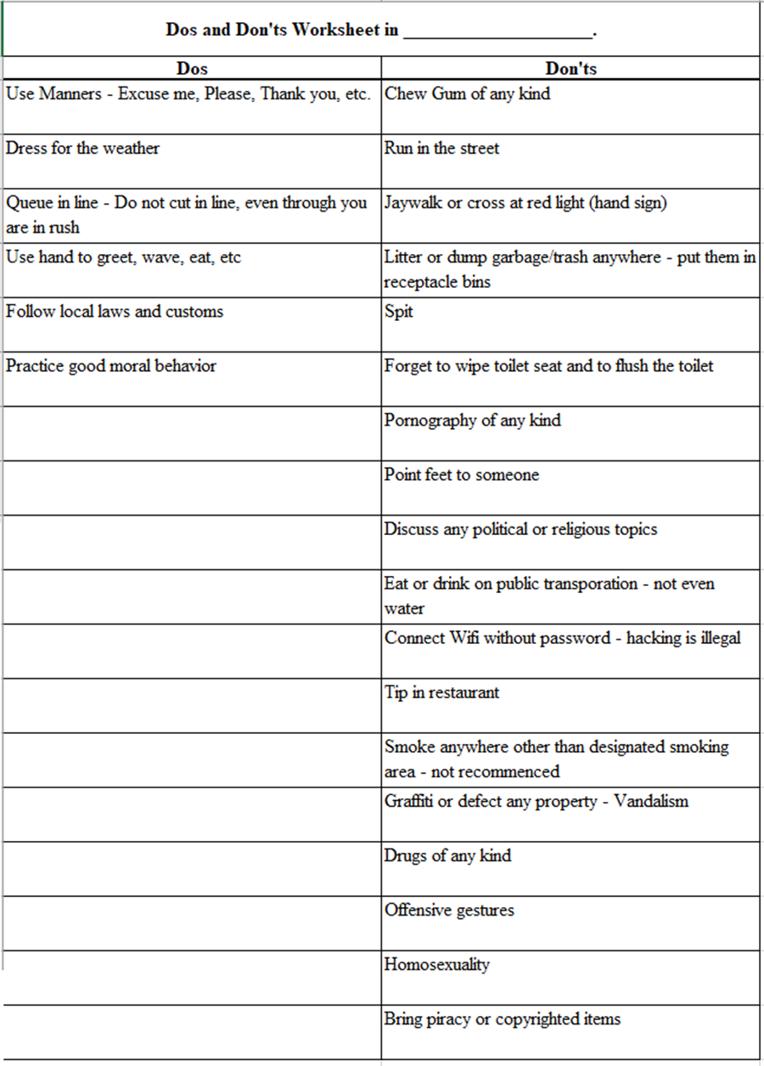

With the limited time at the library, she checked out 2 books. The due date was on August 22, 3 weeks from today.

She updated the dos and don’t worksheet to remind herself what to expect or avoid manners at home.

During family dinner time,

She had her informal conversation about getting to the airport.

“Dad, I have a question? My flight changed last month. My flight to San Francisco has changed to 2:15 in the afternoon, and I’m not sure if you can drive to the airport because you have church on this day. So I booked a flight with the cheapest airfare of $737, the only cheapest on this day, Sunday, for a limited time. And on my return flight, I will arrive in Newark at 10:00 in the evening. I am not certain if I want to book a shuttle and...”

“Okay, so?”

“Since you have a church service every Sunday, I don’t think you will be driving me to the airport to drop me off and pick me up.”

“United, don’t worry. Daddy will drive you to and from Newark Airport, okay? So don’t book a shuttle because it costs money.”

“Okay, dad.”

“United listen, mommy and daddy care for us. We want you to protect, care for, and nurture us. We were born to 3 beautiful kids, all grown up.”

“Thank you, mommy. That is a blessing to us.”

“Whew! My Execution process is almost completed. However, I still have to book travel insurance. What if something happens like sickness or travel disruptions.”

While reviewing her flight itinerary, she said, “Sounds like I don’t need an airport transfer in Singapore because I will be arriving at the destination in the morning. Arriving in a new place during the day is safer than arriving at night.”

Advice: Same as with a hostel, airline, and other bookings, it is important to read full information, including additional information, to give me a sense of what the product or service wants. It includes additional costs for the additional items onto the shuttle, including car seat policy for the little kids, accessibility, etc. If you don’t read the information, you don’t know what the product or service is about, and you get confused. You will screw up if you don’t read this full information.

She mentioned,

“I can’t arrive at a new destination late in the evening because I will travel solo, a sole woman. I don’t feel safe at night alone. It is better to take an airport shuttle to the hotel or hostel. That’s my protection. I can take public transportation if I arrive in the daytime or early in the morning. Remember, arriving during the day is a safe bet. I expect to arrive in Singapore during the day, so I will be okay to take public transportation.”

Thinking of packing for the trip, she figured out which clothes would fit into the 16-day trip. She then grabbed her pink carry-on luggage, opened the bags, and took the picture.

Tip: Whether carry-on, checked luggage, or bag, take a picture of your bags (inside or outside) to remember your baggage and whether you need it.

Immediately, she packed some summer clothes, folded them into smaller pieces, and placed them.

“Okay, I haven’t decided what clothes I want to pack since it is too early to finish packing. I have 2 months to depart. I tried not to pack too early. I will finish packing by October 21 or 22.”

She decided to store her pink luggage in her closet.

Just then, she has also scheduled to book travel insurance on October 4 and prepare for the departure by observing the dos and don’ts from the worksheet and executing.

Using her white planner, she wrote, “packing week – October 18 to October 22. Bring a passport, I-Powers Travel worksheets, summer clothes, an umbrella, and essential items. Etc.”

PreTrip Orientation

“The Secondary booking (from Workshop) should happen approximately 2-6 weeks before departure, so you don’t have to procrastinate and don’t have to wait at the last minute.” She added when she was booking insurance.

Soon after she booked the airline ticket and the hostel room months ago, she listed things to do, including registering with the embassy (Smart Traveler Enrollment Program) if she plans to travel abroad.

Not Recommended: “I don’t need to register for the Smart Traveler Enrollment Program because I will be going to New Zealand for 5 days. I will be safe. I am good and smart enough.” Every time you travel abroad, no matter what, you must register for the STEP just in case of an emergency, including embassy assistance. Accidents happen, so why don’t you register before you travel?

On September 15, 2021, she registered for the Smart Traveler Enrollment Program (STEP). Logging in, she enters the travel information into the database. She will remember the location and the contact information with the embassy in case of emergency, e.g., a lost passport.

She also fills out the detailed information and emergency contact, including her parents’ names and phone numbers. She plans to leave a copy of her parents.

On September 19, just after the church service, she planned to check Singapore and Malaysia’s weather a month apart at Starbucks.

Marking the two dates: September 19 and October 20, she was using the pencil, “Check the Singapore and Malaysia weather.”

Then on October 20, she wrote, “Check the Singapore and Malaysia’s Weather before packing.”

Tips: Be sure to check the weather on two different dates: A month before and a day before departure. You don’t need to confuse the temperature when you pack the clothes you need for the trip.

Checking the weather for upcoming trips, Singapore has a strong chance of rain and/or thunderstorms on selected days while traveling abroad for 6 days, including 7 days on tour for women solo travelers. If it rains, she predicted her updated packing lists and which items to bring, such as umbrellas and rain gear.

“I realized it in Singapore; it rains most of the day of the week during the Monsoon season. So the weather will be hot and humid. Since I will travel in the upcoming days, I check the weather before packing.”

A week later, she was working hard for the job she loved. She has saved the money she earned, including her leftovers from last year’s trip.

She planned to buy insurance needed for travel at home right after dinner.

After helping her family clean up after dinner and family time, she planned to purchase travel insurance.
.

Recommended: For solo travelers, purchase health coverage if you exclude traveling on your own. In case of an emergency, travel insurance may incur costs that may be covered for certain expenses.

While she was online, she said, “Hence, there was more than one type of travel coverage depending on the travelers’ needs. Because I only visit Singapore, I only purchase a lesser coverage, e.g., Medical Coverage, rather than the comprehensive coverage for the adventures/sports activities. My credit card has some necessary benefits from the trip and travel interruptions coverage.”

She went on the travel insurance website sevencorners.com and clicked on it. Then it asked if she was living in the US.

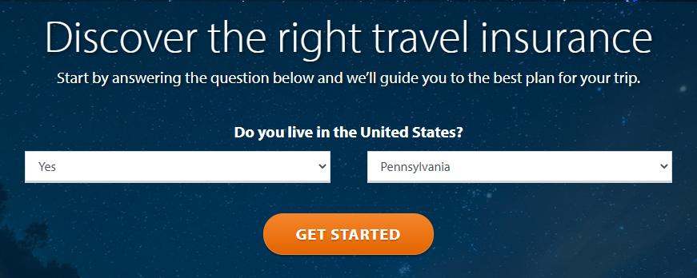

She responded before clicking on the orange button.

Click!

On the website, it asked, “Where are you traveling?”

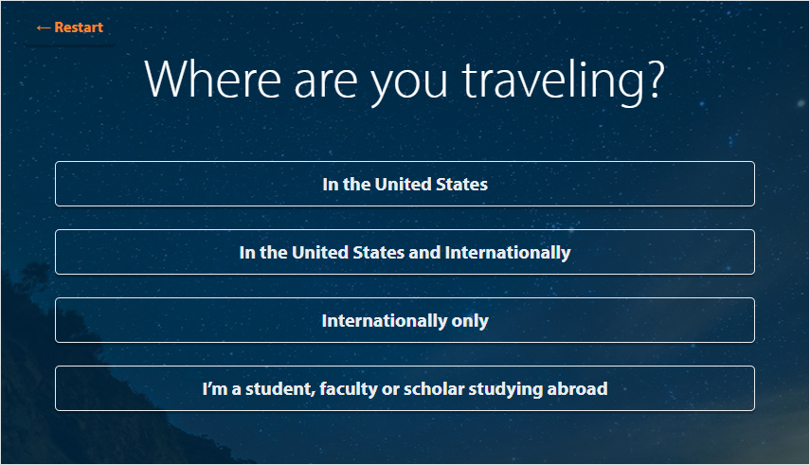

She then selected “Internationally Only.”

On the screen, there are 3 options:
- Roundtrip Travel Insurance
- Liaison Travel Insurance
- Wander Plus Frequent Traveler Plus

She then clicked “Liaison Travel Insurance.”

Then, it takes to the page, “Get a Quote.”

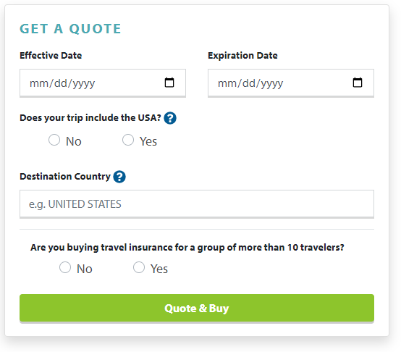

Filling out the dates: 10/24/2021, 11/09/2021…

…she continued to fill in the traveler’s information.

“My trip to and from Singapore and Malaysia has covered some necessary costs relating to pre-existing coverage from third parties such as Credit Cards with some essential trip protection and interruption.” She had used her credit card to book her airline ticket.

Insurance + Coverage

Before you consider purchasing travel and/or medical insurance, consider situations where some health/coverage may be covered in certain circumstances. For example, some pre-existing conditions may not be covered in case of injuries. It is better to think that insurance and/or coverage is worth it. Research and identify your necessary needs, such as emergency evaluations, trip interruptions, medical coverage (Medicare and Medicaid don’t cover costs abroad), etc. Compare your trip needs to actual needs, what actually covers and what doesn’t cover. Do your homework.

First, go on Travel Insurance or other aggregator websites for comparison and contrast. Look for:

• Cost

• Necessary needs

• Coverage

• Emergency

• 24/7 hotline

• Trip protection/including cancellation for any reason.

You can go to www.sevencorners.com and enter your traveler’s details and get a good deal if the price (is too high) and other benefits you are looking for. Be sure to read the details before you click to purchase.

Go to the next page to qualify if you need travel/medical insurance and coverage.

You asked yourself: Is travel insurance worth it?

Buy travel Insurance if:

• Your total travel cost is greater than $8,000 for 4 or more.

• Your total travel cost is greater than $6,000 for 2 to 3 people.

• Your total travel cost is greater than $5,000 for solo travel.*

- You are pre-taking risky activities; hiking in hazardous activities, skydiving, SCUBA diving, etc.

• Your trip is 30 days or longer.

• You travel abroad.

• You are on Medicare/Medicaid.

Skimp it if:

• Your total travel cost is less than $8,000 for 4 or more.

• Your total travel cost is less than $6,000 for 2 to 3 people.

• Your total travel cost is less than $5,000 for solo travel.

- If you are only touring a city, either yourself or on an escorted tour or independent travel through travel agencies who have trips booked with insurance.

• Your insurance has covered other basic needs and trip protection.

• Your trip is less than 30 calendar days.

*Elliott emphasizes one traveler and “should” be a “big-ticket” trip, not 2 or more people in a total of 5,000.

When purchasing Travel Insurance, look for a following:

• Pre-existing medical conditions

• Up to 100,000 to 1,000,000 USD in Coverage Care for medical expensive

• Emergency Evaluation of up to 300,000 USD

Others to look for:

• Coverage that covers most countries

• 24-hour emergency assistance

• Coverage for damaged, lost, or stolen possessions

• Personal/family emergencies

• Personal accident coverage

• Financial protection

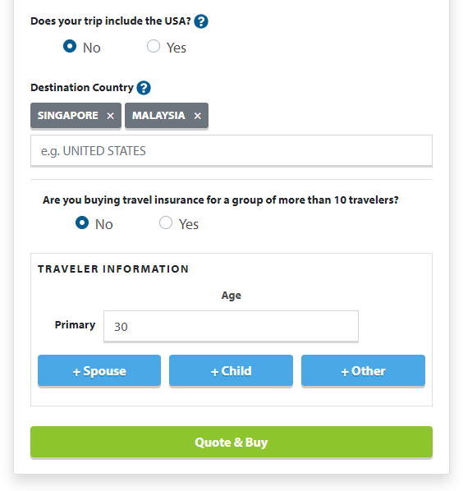

Clicked on the green button, there are 3 choices to select:

- Liaison® Travel Basic

  - $28.26

  - Essential travel medical benefits cover you up to 364 days.

- Liaison® Travel Choice

  - $29.96

  - Enhanced travel medical benefits available for up to 364 days.

- Liaison® Travel Plus

  - $38.89

  - Enhanced travel medical benefits available for up to 364 days.

On the left, she checked the Customize Plan.

Hence, she selected the coverage on the left.

- Medical Maximum: $100,000

- Deductible: $1,000 (after she checked her health coverage for the job and the job’s health coverage)

- Hazardous Activities as Declined (Her city trip doesn’t include hazardous activities for solo travel)

“From travel medical insurance, hazardous activities include SCUBA diving, rock climbing, extreme sports, etc. Therefore, you will need this coverage if you participate in hazardous activities and pay more for this coverage.”

Checked everything out on the countdown to departure worksheet, and she was relieved that she spent within the budget.

Advice: Medicare and Medicaid do not cover costs overseas, so purchasing additional medical coverage covering expenses in an emergency is essential. Health accidents do happen.

Not Recommended: Forgo travel health insurance, even though you are healthy and in optimal health. Accidents happen, so there is no perfect way to stay healthy while traveling.

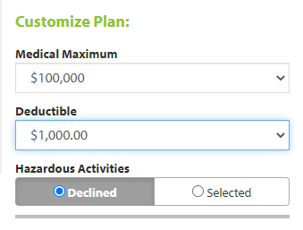

Your Details
Effective Date 10/24/2021
Expiration Date 11/09/2021
Does your trip include the USA? No
Destination Country SINGAPORE, MALAYSIA
Number Of People 1

Then, she looked, reviewed, and compared the coverage and benefits for each of the 3 choices.

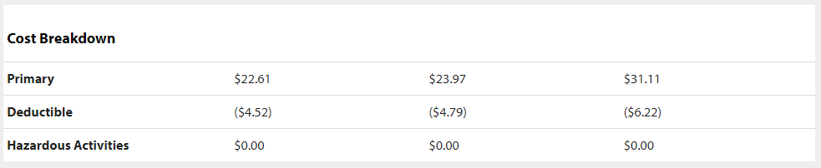

So, she selected the Liaison® Travel Choice as the best option.

On the left of the screen,

Your Details
Title Liaison® Travel Choice
Price $19.18
Coverage Start Date: 10/24/2021
Coverage End Date 11/09/2021
Does your trip include the USA? No
Destination Country MALAYSIA, SINGAPORE
Medical Maximum $100,000
Deductible $1,000.00
Hazardous Activities Declined
Number Of People 1

Filling out the traveler’s information, she finally used her credit card to buy her travel insurance.

She also has basic necessities for the 16-day trip, which do not count as extreme sports or equipment loss. She will tour or explore the urban area with minimum risk. She also checked Malaysia’s tour itinerary, and it didn’t seem that there were any extreme activities.

Tips: If you plan to go on highly demanding activities such as rock climbing or skiing, you will need additional coverage. However, for your upcoming (mostly general) trip, you don’t need additional coverage because purchasing items is costly and wastes money.

The cost of a Trip Plan was $19.18.

Then she posted a picture, traveling solo in Hong Kong, standing at the Observatory.

She mentioned a woman named United on Instagram during the live show last month, “I heard that one woman, 34 years old, who traveled solo to Hong Kong and she claimed that “I am healthy, I don’t need insurance to travel because I will be gone for 5 days. Then she heard that she had broken her leg and was sent to a hospital. She was forced to pay back around $130,000 once she returned home. She didn’t have the insurance covered abroad, nor was it covered by comprehensive health coverage in the US.”

Fact: Travel Insurance is cheap and affordable for all travelers. Solo Travelers generally need only medical coverage to cover medical costs, especially if they are on short or long trips, as per Janice Waugh.

She was ready to travel for 5 days. She packs her passport, state ID, and other essential documents and the I-Powers Travel worksheet she answers while researching her favorite activities in the red backpack. She remembered she responded to the question briefly, “What Activities suit you?”

She answered previously.

“I am an explorer with the right purpose of seeing a beautiful scenic view of beautiful places and attractions. I am fascinated by exploring areas or famous landmarks that benefit me to learn more about places such as “highly recommended places.” I am also enjoying shopping, exploring, and being adventurous. Therefore, I am a good fit for this ideal itinerary. These activities, such as day tours, rides, museums, and things, help motivate me to learn more about the places inside and outside my comfort zone.”

Reviewing her itinerary, along with the worksheet “Upcoming Trip Questionnaire,” She was able to check her intended trip as part of the trip preparation.

Indeed, her activities matched the answer.

She prepared for the trip by organizing her travel materials into a folder and backpack.

Wanderful Life (Part 1)

A few days ago, she went to the bank and exchanged money from the United States Dollar (USD) for Singapore Dollar (SGD). However, she only exchanged 140USD because she tried to limit the cash she could carry as safety precautions.

Tip: Try to exchange money before departure, so you don’t have to carry too much cash around.

At home, she photocopies all her important documents, including passports (front and back), her state ID, flight information, trip itinerary, insurance, etc., and shares them with her family.

She approached her parents and smiled.

“Hey, mom, dad. Here are the documents of all of the critical necessities. Flight itinerary, my trip itinerary, emergency contact, etc..”

“Oh, how sweet. You are a big girl. Thank you for letting me know the emergency contact.”

“Thank you.”

Recommended: Be sure to photocopy your essential documents and emergency contact information just in case of a problem or emergency.

Saturday, October 23

It was a beautiful morning in Philadelphia, a perfect day for an outing.

Rich wanted to walk to Fashion District, where the former Gallery Mall was. He hasn’t been to the place. Her parents have been invited to the Northeast Church service’s afternoon service for the last 5 weeks.

Mikey took her brother for a walk in the Fashion District. United took a few days off before her dream trip to Lansdale.

Tip: Take 1 to 2 days off from the pre-travel stress before departure if you travel internationally or to destinations with jet lag. That way, your body can adjust your body clock once you arrive at the destination.

“Mom, Dad, I learned not to stress myself before the trip, and I already finished packing for the trip. I learned not to overpack because I travel with only carry-on for my 14-day trip. So I researched how to pack things I needed.”

“United, good job. I know that packing too much can put me in stressful situations.” Her mother responded. “I am so proud of you for taking responsibility.”

“Thank you, mom.”

Then minutes later, her mother asked after United, and her father took her brother for outings.

“Guys, where are you going?”

“We are going downtown. Rich wanted to walk in the Fashion District.”

“Okay, be careful.”

“I will WeChat or call you and be sure to answer it.”

“Okie Dokie.”

United took the Market Frankford Line to 11th Street with her father and brother.

After the train passed Spring Garden Station, she briefly started conserving where she headed next.

“Well, dad, I am going to Lansdale.”

“What? United, what time is the train?”

“The train comes at 9:48.”

“Where are you going?”

“I am going to Lansdale.”

“Oh, okay, be careful. Try not to come home late.”

“Okay, dad.”

Just then, United and her father and brother got off at the 11th Street station and split apart to stop by Justice to buy some summer clothes for the trip.

“I will shop for a few clothes needed for both Singapore and Malaysian Trip.”

She brought a few items (from clearance) she needed at the last minute.

Tip: Don’t buy clothes or items at the last minute as you may incur additional stress from the “pre-trip.” You may not have time to repack before the trip. Instead, limit buying only 1-2 items you definitely need for the trip.

Exiting the store, she entered Jefferson Station, tapped the card, and went downstairs to wait for the train.

The train approached Jefferson Station on time.

On the train, she was amazed that the train ride went smoothly. But then, United saw more passengers get on the train at Temple University Station.

Soon, she got off at Lansdale and spent some time walking to take a picture of the historic house.

At the Starbucks café, she ordered a green tea latte and a lunch (spinach, egg wrap sandwich). Then, she sat at the table, turned on public wi-fi, and kept it a secret (sensitive information) until she arrived home.

Warning: When you are in a public place like Starbucks, entering sensitive information (on data or on wi-fi) steals personal information and compromises the phone’s data. If the wi-fi has a secure password, it is essential to clear the internet cache and browsing history once you are done. Clean up the phone’s browsing data too. Run a scan.

“I will not go on my personal banking information or enter any sensitive information until I get home to check my money or log onto websites.”

She used the portable battery to charge the phone.

Recommended: Use a portable battery rather than the public to charge the phones and other devices. In addition, there is ransomware worldwide that tries to steal personal information.

“If you must charge your phone in a public place, I highly recommend using a data blocker for just $8.99.” She holds the data blocker she brought last month.

“I only use my portable charger rather than a public outlet to protect myself and my data.”

Eating her lunch, she checked the weather for both Singapore and Malaysia.

Sipping a matcha green tea latte, she took a white index card to copy the weather forecast.

Minutes later, she checked the weather (Google: Weather) for the 15-day trip to Singapore, and it looked like there was a strong chance of rain and thunderstorms on some days.

Singapore:
- October 26: High 91, low 80, sun with some clouds with a few showers
- October 27: High 92, low 81, early showers, partly cloudy
- October 28: High 84, low 80, cloudy with periods of rain with isolated thunderstorms, then periods of sun
- October 29: High 90, low 82, sun and cloud
- October 30: High 92, low 81, mostly cloudy with some sun, some light rain, and thunderstorms
- October 31: High 91, low 77, sun with some clouds with afternoon thunderstorms

Malaysia:

Langkawi:
- October 31: High 84, low 78, partly cloudy with a chance of rain
- November 1: High 88, low 77, partly sunny and cloudy with a chance of thunderstorms evening
- November 2: High 88, low 81, partly cloudy with some sun

Penang:
- November 2: High 89, low 80, overcast
- November 3: High 87, low 78, overcast

Cameron Islands:
- November 3: High 79, low 75, overcast
- November 4: High 90, low 78, overcast

Kuala Lumpur:
- November 4: High 90, low 77, partly sunny with clouds
- November 5: High 90, low 76, partly cloudy with a chance of rain or thunderstorm
- November 6: High 91, low 78, partly cloudy

Singapore:
- November 6: High 90, low 79, morning showers, then clouds and sun
- November 7: High 88, low 78, scattered morning thunderstorms and some sun
- November 8: High 86, low 79, partly cloudy with some sun
- November 9: High 90, low 77, partly cloudy with a chance of a thunderstorm

Recommended: Check the weather a day before you leave to conform to the actual climate of the place you visit so that your trip won’t end in disaster. Even though you checked the weather before, you may want to consider rechecking the weather a day before departure to confirm my last-minute pack-ups to avoid putting on my stress related to my pre-trip preparation.

“I already packed her umbrella in my pink carry-on luggage, so I don’t have to stress myself for pre-trip stress.” She talked to herself.

She returned home at approximately 16:45. She was showering and washing her hair, relaxed, and thinking of cooking vegetables with chicken breast.

Then her father helped with the cooking with her brother.

She ate dinner with the family, chit-chatted about daily life, and then helped clean the tables, chairs, and floors.

Her brother took turns washing dishes while United took care of sweeping the floor.

After taking out the trash, she reviewed her I-Powers Travel working paper about tips. Then, she answered the questions and created her personalized itinerary.

Reviewing the I-Powers Travel working paper over the months, she kept up with her Singapore and Malaysia itinerary work, including her tour group of solo travelers.

“I am excited to travel abroad for 14 days because my work companies require employees to take vacation days to improve the economy and health. I also learned that American workers who don’t take annual vacations hurt the economy and lose important employee benefits. Other benefits include more time to develop valuable skills they have not encountered before. In addition, I have provided the importance of paid time off to all companies to improve employees’ health. I am surprised that my companies have 40 days of annual leave each year, and I planned to maximize it to help with the economy.”

She remembered posting the importance of Employee Health Awareness regarding the benefit during the economic collapse. It was published with the title “The National Plan for Vacation Day” in January 2021:

https://ipowerstips.travel.blog/2021/01/21/the-national-plan-for-vacation-day/

She mentioned during the presentation when she was at work. She showed off the importance of employee benefits, including paid-time leave to maximize the use of government funds and taxes needed for those in need, such as community projects, parks, roads, infrastructure, etc.

Minutes for her reflection during her probationary period, she has given positive feedback and earned her reward.

30 minutes later, she went downstairs to grab her passport to check in for her flight. Opening the United app, she checked in, scanned her passport, and entered her checked bags onto the flight database. Since she won’t travel with her checked luggage, she only travels with her carry-on as she only travels solo most of the time during her tour in Malaysia.

Then she put her passport into her purple purse so she wouldn’t forget.

Before bed, she has her flight information in the airline’s system.

Recommended: Checking in online or through an airline app saves time, so you don’t have to wait in a long line to check in at the airport.

“The check-in is available 24 hours before the flight time. Without checking in before arriving at the airport, it takes about an hour or longer during peak travel times or 30 to 45 minutes during other times. Member or non-member of the airline, I am introducing other travelers to check-in online if you don’t like to wait longer with the long line of people at the check-in counter. Overall, it is also convenient for us to save some travel time to wait in line.” She mentioned.

Then she went downstairs to put new clothes into the pink carry-on. She left her red backpack and pink carry-on bag downstairs, ready to take the flight the next day.

Before bedtime, she quietly did yoga and meditation while doing her stretching.

“Breathe in, breathe out!” Then, she closed her eyes, lying on the soft pink mat. Then, she finally lay down for about 5 minutes.

Not Recommended: Forgo mindfulness and stress management needed days before your departure, even though you have a tight schedule. Taking care well before you plan to depart for optimal health is essential. Self-care is critical when you travel, especially if you are traveling solo.

At approximately 22:30, she went to bed.

Departure

Sunday, October 24

Sleeping until 7:30, she woke up with excitement.

It was a sunny morning, and she felt excited. Her pink luggage was downstairs while she chose her clothing for her flight. Today, she wore her denim jeans and a cute grey top. She also wore her hair down.

Before not long, she had already brushed her teeth, flossed, and washed her face.

Checking her room, she left with a clean bed making.

She went downstairs with her red backpack.

“Good morning, United!”

“Hey! Good morning dad. How are you feeling now?”

“Okay!” He was napping in the chair.

“Today is the day.” She smiled at her father.

He added, “Hey, listen, I will drive you to the airport, okay? So don’t leave early.”

“No problem, daddy. You are the best.”

“What time is your flight? ... I can’t remember your flight time.”

“My flight is around 2:15 since my flight time has changed.”

“Oh, okay. So we will leave home at 9:15, so you can prepare for the flight.”

She ate her quick breakfast and sent her flight itinerary to her parents to remind her of flight times (departure and arrival).

She took time to prepare for the flight. She meditated while her mother went downstairs, smiling.

“Good morning, mommy.”

“Good morning United.”

“How was your sleep?”

“I slept very well, you?”

“I slept very well too. Come and sit next to me.”

“Thank you. You are my girl.”

United wants to sit next to her mother and tell her a little secret, chit-chatting with her mother.

Then, she drank a hot cup of matcha tea latte.

Recommended: Drinking other than coffee is better than caffeinated drinks to reduce the risk of dehydration. It is better to drink plenty of water and tea instead of soft drinks and coffee.

Advice: A long-haul flight may be a higher risk of dehydration. So taking care of myself is just as important as self-care. And it may have more challenging time adjusting to a new time zone once you arrive there.

Her brother soon came downstairs and felt excited but prayed for her daughter for a safe trip.

And a hug.

Before leaving the house, her mother gave her a big hug and a kiss.

“Okay, sweetie, be careful. Mommy and daddy love you so much... God is with you, okay?”

“Okie, I love you.”

“I love you too, be careful when you are in Singapore and Malaysia. Always follow the laws, and you will be fine. Send us some pictures of your travels.”

“Thank you, mommy and daddy.”

“You got everything, including your passport, state ID, and important travel documents?”

“Yes, mom. See ya when I get home. Did you receive my email about my flight itinerary and detailed itinerary?”

“Yes, I did. See ya later. Love you. And don’t forget to keep in touch by letting us know where you are, okay.”

“Okay, mom and dad. I will text you about the plans...”

Her mother and brother blew their kisses as she got into his car.

United listened to the music as her father drove off to drop her at the airport.

Driving toward US 1, her father reminded her, “United, I have to tell you something. Singapore is one of the most conservative countries in terms of laws... You know better, young lady.”

“I know, I know that, dad. I am confident about what to expect, such as no gum allowed. I also researched that.” She laughed.

She sat next to her father, discussing Singapore and Malaysia.

After their 30-minute conversation, she took her short nap, dreaming of flying first class to Houston.

10:57,

At Newark Airport, Terminal C, she arrived safely. Her father gave her a big hug and comfort, “Enjoy your trip, okay? Regularly let us know where you are so that we know you are safe.”

“Okie dokie, dad... love you.”

“Love you too. Have fun, and stay safe. Be careful...”

Hugs...

... and she entered the airport departure terminal.

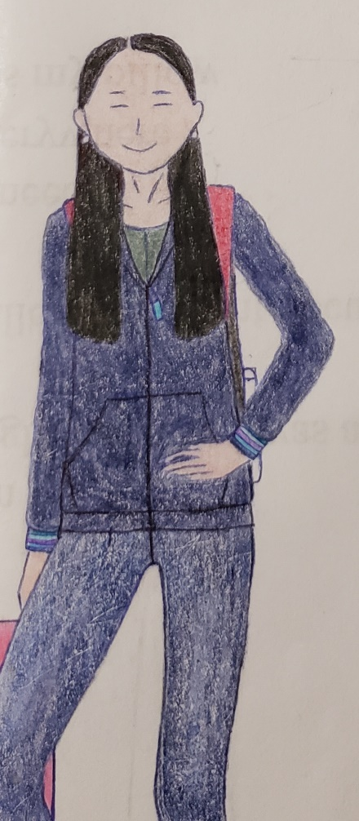

United entered the airport departure terminal C.

Inside the Terminal C,

Some passengers were waiting in line to check in for flights. Since Newark Terminal C is primarily on United, she will take the airline abroad.

She texted her mother, “Mommy, I arrived at the airport.”

“Okay... Have a safe flight to Singapore. Be safe, okay.”

“Love you ❤️❤️ .”

“And I love to fly on planes, especially as a United Frequent Flyer member.”

“Okay.” Her father texted back.

“Love ya.”

“Love you too.”

She checked online and did not check her bag, only a carry-on (full of summer clothes) for 16 days.

She received her TSA Precheck on her mobile boarding pass.

Despite Sunday morning, the terminal was busy. Many travelers were traveling from Newark.

She took her deep breath and waited in line to inspect her mobile boarding pass and passport.

“Next passenger in line.” A female TSA Officer called.

She showed her passport to the TSA officer and was ready to scan her boarding pass on her United Airlines app.

Smile.

“I am ready to go.”

She felt excited while passing through the security checkpoint. “Have a safe flight!”

“Thank you.”

Then she got through the TSA precheck along with the selected passengers.

Alone with the selected passengers, she was allowed to leave her shoes on while screening passengers for suspicious behavior and/or items that weren’t allowed on the flights or carry-ons.

There are lots of passengers who got through the security checkpoint in compliance with the 3-1-1 rule. The passengers do not doubt bringing forbidden items except empty, non-glass bottles.

United went through the security smoothly with her red backpack, a navy blue coat, and a pink carry-on.

Fortunately, her navy, empty collapsible water bottle was allowed in her carry-on.

Smiling with a pretty face, she gathers her personal belongings.

Then, heading to the gate, she looked at the flight information where the flight was located.

“Aha, my flight to San Francisco is on Gate C**.”

She headed to the C** Gate to the departure lounge and planned to explore the outlets.

She walked around the terminal to get enough exercise before her long flight to Singapore.

“I treated this as a boring layover but can occupy my time exploring the stores and outlets.” She thought. “I want to visit United Club, but it hasn’t opened. It is still in renovation. If I want to, then I must spend $118 when I plan a visit to both Newark and San Francisco. So today, I decided to visit when I landed in San Francisco to save $59.”

Sitting and relaxing, she took her quick break before exercising.

“Walking around the airport has been a wonderful traveling experience. I give myself plenty of exercises, especially on a long-haul flight.” So she thought while walking around in Terminal C.

Minutes later, she tried to browse the restaurant to grab something to eat.

And she didn’t plan to buy snacks at the airport because it was too expensive.

“I already have some snacks in my bag. This is cheaper than to buy here.” She chuckled.

At around lunchtime, she took off to order a light lunch at Flora Cafe, located at Gates C120-139. It includes a variety of Restaurants, Family Friendly, a Children’s Menu, Bar.

Warning: If you are traveling alone, always carry your belongings, including carry-on, even for short trips to the restroom.

Eating her lunch, she eats mindfully because, on the flight to San Francisco, there is only food and snacks available for purchase. Hence, there is a free drink onboard.

After her quick lunch, she walked around the terminal, taking responsibility for self-care.

Tip: If you are traveling, ensuring hydration and getting plenty of exercises and frequent stretching are critical on a long trip, especially on long flights.

And she took a quick rest, spotting some planes. It was a plane parked at gate C120, but few passengers were waiting for the flight to Houston.

Hours later, she heard flight announcements and…

...preparing to board the United Polaris passengers, she holds her phone, ready to board the plane. But instead, she sat in the departure lounge and texted her parents.

“Hi daddy; I am preparing to board the plane.”

“Okay. Be sure to text me once you safely arrive both in San Francisco and in Singapore.”

“Love ya!”

“Love you too 😊. Be safe.”

The economy class passengers boarded as United lined up to scan with the boarding pass.

She also has her passport with her but stored in her red backpack.

Minutes later, it was now groups 3 and 4 were welcomed to board the plane and...

... she used her airline app to scan her boarding pass.

They are at the jet bridge, waiting to step on the plane with her pink carry-on and...

... boarded the plane and saw a woman behind her, dressed in khaki pants.

It was then she waited until some passengers got to the seat.

She smiles as she finds the window seat selected after she confirmed her airline ticket earlier in July.

Then she gave the strength to put her pink carry-on luggage onto the overhead bin.

“Any help?” A male passenger asked her.

“I am good. Thank you.” She smiled.

She felt confident about her solo trip again. A young woman named Stephanie also sat beside United, traveling solo. She was adorable yet charming.

She was from Voorhees. She worked full-time as a tax officer at the IRS in Center City.

She was excited to discuss Seattle, where she will experience the Sky View Observatory.

“Aaa, that is my bucket list. I am enjoying climbing up and experiencing a 360-degree view.”

Preparing for the departure, the plane was taxiing to the main runway, heading south.

United seated in economy class as the plane took off to San Francisco.

Just then, United’s mate took a nap, and she wanted to get up and use the restroom.

Then, she didn’t force her to wake Stephanie up because she didn’t know her.

Advice: If you sit in a window seat and want to use the restroom, please politely if you see your seatmate sleeping. You can’t wake the seatmates up unless they are family members or friends.

Just then, as the plane headed west, United started a blog.

She wrote the title, “Singapore and Malaysia Trip.”

Brainstorming a topic, she then wrote for some 15 minutes later and...

...a male passenger reclined his seat quickly without his request.

Seconds later...

“Woah!”

...and he kept reclining the seat.

“Hey. If you are going to recline, ask me. It is a polite thing.” She requested him.

She was offended but didn’t say anything.

Then a female passenger sitting behind United felt her feet were up from the seat back. United politely asked her, “hey, hey, can you please put your feet down? That is not polite.”

“Oops!” She exclaimed. “Then she was not convinced it was on purpose.”

United also planned to watch the movie (Willy Wonka & the Chocolate Factory).

Then suddenly, a male passenger in front just inclined his seat, without knowing United, saw that the screen was “a little farther.”

“Respect the passengers.” She thought to herself.

Soon after, the cabin crew was offering drinks and snacks.

A female flight attendant asked, “Hey, what drinks do you like to order?”

“I would like to order an orange juice.”

“Certainly.”

United took some time to relax while watching a movie.

Again, a male in front of United just made another mistake. However, he reclined the seat quickly, and the plane just hit turbulence.

The drink knocked over, and it spilled her drink on her lap.

“Ahhhhhh!”

She used the napkin to wipe her drink.

Minutes later, she raised her hand, and the cabin crew was happy to provide napkins.

“Thank you.”

She then felt she had dealt with the spillage on her denim blue jeans and the seat.

“It happens here, and I can manage my messy pants.” She laughed. “I can change my outfit in San Francisco.”

Then after the movie, she took a quick nap.

Hours later, the plane safely landed at San Francisco International Airport, which was 15 minutes late.

It was a 5-hour layover in San Francisco, and she knew how to spend her time at the airport.

United was excited to take a walk around an airport, including the departure gate.

Before heading to the United Club, she knew how to gain access to the club.

Arriving at the United club front desk, a woman from the front desk requested, “Hello, what may I get you today?”

“May I grant access to a One-time pass?”

“Certainly. May I present your boarding pass, valid passport, and photo ID?”

She presents the necessary documentation to gain entry.

Then seconds later, she smiled, “here you go, enjoy your stay.”

“Thank you, enjoy your day.”

She smiled back and gained access to the club.

Immediately, she took her time to relax and enjoy herself in the airline lounge long before boarding her long-haul flight to Singapore.

There was complimentary food and snacks to eat in the club, and it was free to grab and go.

Feeling hungry, she grabbed some snacks because she didn’t know when the next meal was.

Walking around with her pink luggage and her red backpack, she took another exercise.

After that, she walked toward the back of the club.

Hence, there is a sign in front of the Polaris Lounge.

“This lounge is restricted to long-haul business passengers flying on United or long-haul business passengers flying on Star Alliance airlines.”

Turning around, she took considerable time to relax and enjoy the view while taking her deep breath.

Soon after 20:00 (8pm), she changed her clothes at the airline’s club while grabbing a dress to wear for the long flight.

At the restroom, she didn’t know some travelers were also changing their clothes for their international flights.

Starring at the bathroom stall, she didn’t see what these travelers were doing. she said, “It is perfectly normal to change their clothes because sometimes, we don’t have shower access, so changing clothes is the norm to keep us clean.”

Putting denim jeans and the grey shirt into the pink carry-on luggage, she smiled and...

...laughed when other passengers looked at her and thought.

“Why is she traveling abroad when she has only carry-on luggage and a backpack on a 2-week trip?”

But United didn’t convince them that she would do laundry while on vacation.

She then stowed her denim jeans inside the pink carry-on.

Glazing at her luggage, United quickly closed it and secured it while walking toward the sink and...

.. turned away, ignored, and washed her hands.

“Sometimes, someone looked inside my luggage and request not to look at what I packed. It is too private.” She said to herself.

Then she walked away to the main lounge.

Then, she ate another snack because it would be hours from dinner time on the long flight to Singapore. She then took some time to take a quick tour around the club and took a picture and...

...sent the picture to her father.

Then she texted, “Hey, I am in the United Club.”

“Okay.” He responded.

Sending 2 photos of the United Club, she texted, “me.”

“How much does it cost for the United club?”

“50 dollars.”

It was dark in San Francisco when many passengers arrived at the departure lounge, waiting for the departure.

At 21:40, the gate made an announcement for the flight to Singapore. Again, United saw many passengers relaxing. Others got up and retrieved their boarding pass.

She was almost ready to board the ultra-long flight abroad, using the bathroom near the departure gate.

Lined up to board the plane, she texted her parents, “about to get on the plane...”

Still, her parents didn’t respond because they were sleeping.

It was then she used her phone to scan her boarding pass and...

...it seemed like she loved to fly on a plane again.

Since it was a full flight, it was all of the passengers on the flight.

Some passengers were blocking the aisle while passengers were putting carry-ons overhead.

A female passenger in row 32 argued, “Hey, I already booked this (expletive) seat. Why don’t you just sit here, and after 8 (expletive) hours, we can change this seat right here. We’re switching...”

“Gracie, I have this chance to sit in those (expletive) window seats, okay? So I chose this seat 32L. No questions asked.”

“Hey, Mikey. Don’t have to argue about our seat selection. Just calm down. Let’s have fun on this flight together...” She offered him an opportunity.

Then the fight escalated by punching a passenger, seated 32J, and calling, “You are stupid. Get out. You are wasting your time.”

After settling down on the window seat, United just heard 2 passengers (she believes they were on a brother-sister trip to Singapore) arguing about the window seat.

She didn’t say anything, so she chose her window on the left in the last 6 rows.

The crew members and flight attendants were highly suspected of someone fighting over seats on row 32.

As crew members and flight attendants came over, they politely requested.

“Hey, I will get you off the plane if you fight with anyone.” A crew warned the 2 passengers.

“Why don’t you shut your (expletive)? You have no right to be removed from the flight.”

“Hon, I am going to get TSA workers to remove you. That behavior distracts the crew member, passengers, and flight attendants. Our flight to Singapore is supposed to relax...”

And the passengers were mad, simply because of the flight delay. United was also furious and texted her parents, “My flight is delayed. That passenger is misbehaving. I remained calm and tried to be patient.”

United closed her eyes and took a deep breath.

As 2 passengers refused to get off the plane, the crew members had one final chance. But, unfortunately, without listening to the crew’s instructions, they were hesitant.

“Okay, I am now calling to get the TSA workers to get you off the plane.” Captain Summers called security.

Suddenly, the crew members called the TSA workers to come to the plane and remove the 2 passengers.

15 minutes later, the TSA workers stepped on the plane to look for 2 passengers seated in 32K and 32L. Undoubtfully, the 2 passengers recently pushed and shelved with other passengers as TSA tried to handcuff them and take them into custody.

Since it was a full flight, the 2 passengers were removed, leaving 2 seats vacant, and the passenger wanted a window seat, so he sat on 32L. The passenger who got punched doesn’t need an emergency. But he needs some ice packs.

After 45 minutes, it took 3 TSA workers to help the crew members to remove the belligerent passengers from the flight and...

The departure was closer to 65 minutes late because passengers conflicted with seating arrangements. As a result, the 2 passengers were removed from the flight.

As the plane was in the sky, the passengers were amused as United took herself on her solo flight and planned to post on Instagram once she arrived at the hostel.

Hence, United took a selfie picture, smiling in her red dress.

Hours later, she was eating dinner on the flight when she inclined her seat.

After dinner, she planned to walk around, stretch her legs and use her bathroom.

At around 01:30, she slept on the long flight while leaning toward the window. Finally, she was asleep, dreaming about the imagery in the house. Finally, her basement, full of younger kids, came to the house and danced together. Her entire 6th graders were playing together on her 12th birthday, and she was a lucky girl.

There were games to play on, and it was a vast play space, which was 2 floors, and one was its own swimming pool at the lower end of the house.

A long hour goes on,

Once she woke up, she and the other passengers had breakfast.

Moments later, as the flight crew distributed its arrival card, she knew how to fill it out on the visitor card. She was confident to ask for help for clarification relating to the visit.

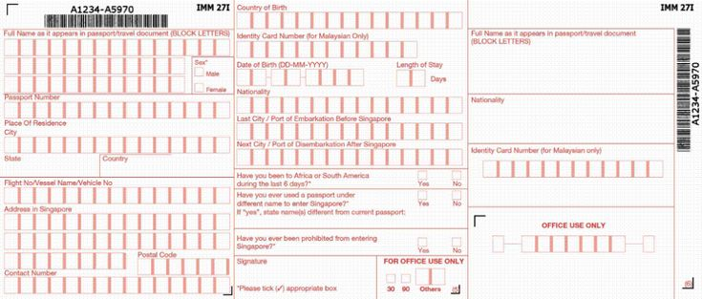

A Singapore Arrival Card when you are traveling abroad

Filling out her visitor card form in pen, she includes a hostel stay, her Chinese Signature, and her English Signature.

Full Name: United Acela Tse

Passport No. ********

Given Name: Tse

Sex: Female

Place of Residence: Philadelphia, PA, USA

Nationality: United States

Sex: Female

Flight/Vessel No.

Address: 172 Tyrwhitt Road, Singapore 207574

Contact number: *** *** ****

Country of birth: USA

Identify Card Number:

Date of Birth: ** ** ****

Length of stay: 05 days

Nationality: USA

Last City: Taipei, Taiwan

Next City: Langkawi, Malaysia

Finally, she checked “no” to 3 questions.

Then she signed her name.

Upon landing, it was early in the morning. She took her selfie, smiling while waiting for the immigration to be processed.

And post on social media with a picture. “Today, I learned how to survive the 18.5-hour flight in the wee hours. It was the thing I most occupied and distracted from my boredom flight - just watching the entertainment, sleeping, reading, journaling, listening to music, playing with the phone, and just relaxing. So my flight from San Francisco to Singapore isn’t bad.”



She also knew how to pass the declaration custom before entering Singapore for her 5-day visit.

With the fingerprints, it was stamped onto the passport, but the card remained until her departure.

08:10 (Singapore local time)

Once she got through the immigration process, the data roaming service received a text message that said:

“Welcome to Singapore! Your T-Mobile plan gives you unlimited data at up to 2G speeds and texts at no extra cost. Calls at 25 cents/min. Want our fastest data and unlimited calls? Get an International Pass for just $5/day... Enjoy your stay!”

Her phone coverage also gives unlimited texts and data at 2G speeds abroad. However, suppose she wants a call, for example, a voice call or a facetime. In that case, she needs Wi-Fi because it only works domestically and doesn’t cover the primary coverage abroad.

Not Recommended: Not researching the cost of communicating abroad. Roaming data costs a lot of money, so phone coverage is covered by the primary data. Therefore, if you want to text, for example, a friend or a family member, you can text at no cost. On the other hand, calling from home costs money, e.g., long-distance calling, so you only contact your family or friends via Facetime on Wi-Fi or VPN.

She plans not to call via phone but instead prefers to communicate with her parents over text, Facebook Messenger, etc., to save money.

Seconds later...

After she exited the airport, she stopped by to buy a pass, deciding which MRT pass was right for her. She then purchased a Singapore Tourist Pass and paid 80 Singapore dollars.

Outside the airport, she knew how to get to the hostel using Singapore public transport, such as Mass Rail Transit (MRT).

“I finally knew how to get there.” She smiled while walking with her pink luggage and her red backpack.

“No wonder MRT is a speculative station, especially Changi Station. It was the most well-designed station I have ever seen before.” So she thought while entering the subway system, using the Singapore Tourist Pass.

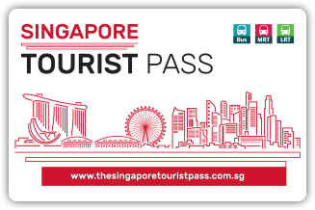

Finally, she looked at the sign, which was way to Lavender Station. And she knew how where she needed to go.

Day 0 – Learn from Itinerary, the Basics

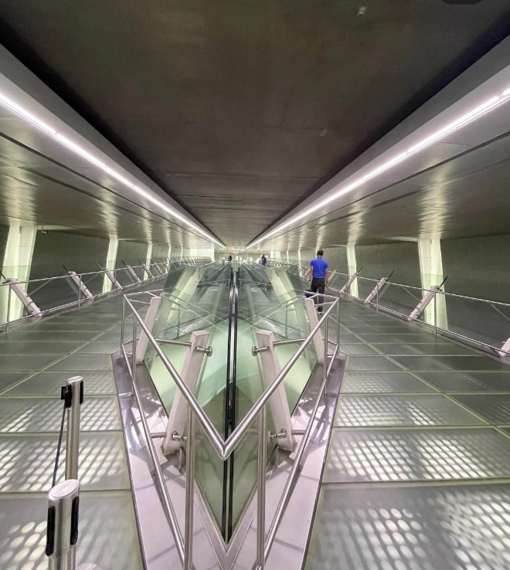

Changi Airport Station (Mass Rail Transit - MRT)

She took the subway (East-West Line) from Changi Airport to Lavender, and there were few passengers on the train. It was morning when many Singaporeans were heading to work.

Fact: For solo travelers, getting around in a foreign place can be challenging, especially if the language is not English or native. Before departure, it is essential to familiarize the place and know the transportation methods, including subways, buses, rail system, etc. Learn how to read the signs, e.g., to the terminal stop.

Tip: I highly recommend downloading subway maps (if planning a subway trip) and other maps. Also, I highly recommend using the map.me app, which works in many countries.

At around 9:00, she safely arrived at the Dream Lodge Hostel.

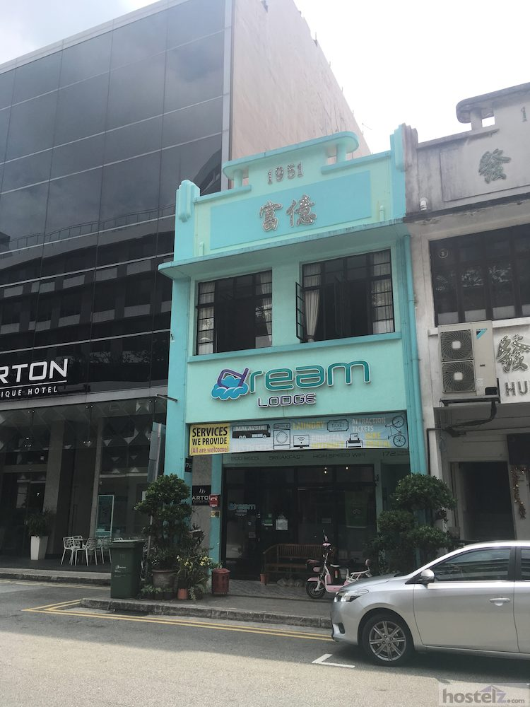

This is the Aqua building where United stayed for the first 5 nights in Singapore.

Approaching the front desk, she said, “Good morning. How are you doing?”

A female receptionist greeted her.

“Good morning! I am pretty good, you?”

“I am good too. But I would like to drop my bag here.”

“Certainly.”

Since her check-in time was 14:00, she then had spare time to go out and explore.

Applying her sunscreen, she then plans to take her easy.

She then plans to carry essentials into her purple purse, limited to just S$35 (US$25) in cash.

Tips: Always carry your passport and photo ID every time you go out and put them into secured compartments. That way, if the police or security officials stopped by for identification purposes and needed assistance or the embassy.

Warning: Don’t show that you are a tourist. Avoid displaying maps or pricy items in public. If you get lost, walk with confidence and take a break. Find the sign in which directions to go or ask security officers for advice who know the place. Do not carry valuable or expensive items around. Keep a low profile and avoid carrying things you don’t need. Leave any valuable items at home or the hotel/hostel.

Advice: Keep yourself to a low profile no matter how safe the city is. Also, don’t wear items like “I heart NY.”

Dressing in her plain dress and putting her hair down, she headed out and explored at her own pace, knowing the local laws.

“It looks like I didn’t bring any packs of gum...” She mimicked. “I checked my bag and carry-on to see if I didn’t bring gum before departure. But, unfortunately, Singapore has banned gums, so luckily, I didn’t bring them.”

Fact: Singapore is the only country that banned chewing gums, claiming that gum can deface private and public property. It contended that gums are unclean, meaning many people spit gum on the floor. It incurs high costs to clean up the gum litter, just how expensive it is for Singaporeans and visitors to keep the place clean and beautiful. The ban was enacted in 1992.

She first took off for a 25-minute leisure walk to Arab street and Haji Lane and took a stroll.

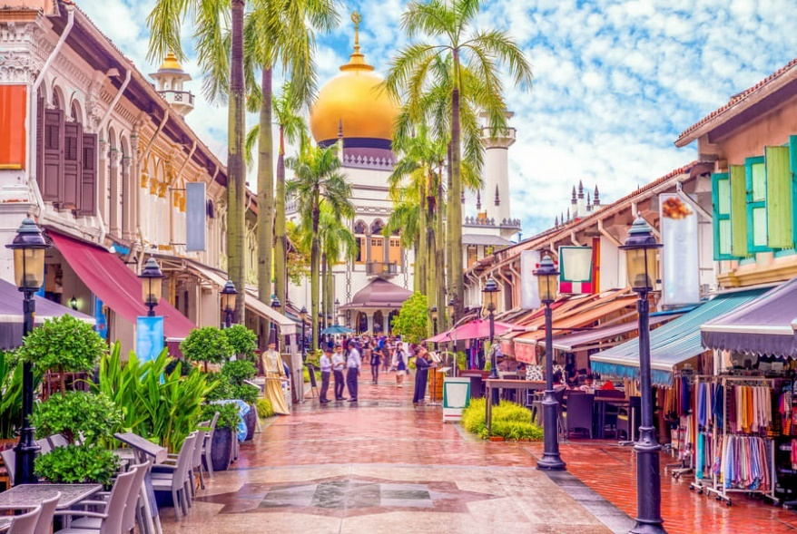

Arab Street

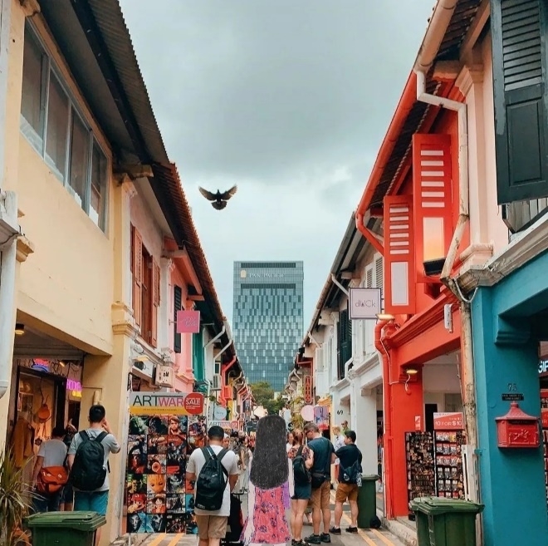

She was enjoying a breeze in Haji Lane.

It was around 09:45, and she planned to spend some time looking at Sultan Mosque on Muscat Street.

Minutes later, she took out the phone and pictures of Haji Lane and...

...she also planned to post pictures on Facebook, Instagram, Twitter, and blog to educate travelers on how to visit Singapore.

She thought, “I am not posting my pictures because others will tell me I am away from home. I just prefer to post some pictures after returning home for safety.”

Walking in Kampong Glam Neighborhood, she enjoys the view of the shops and outlets. Then she took her phone and took another picture of the Sultan Mosque.

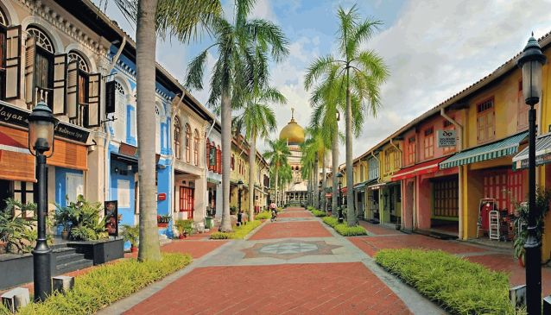

Sultan Mosque on Muscat Street

Advice: Before posting your vacation photos on social media, wait until you return home. For example, suppose you are at Haji Lane and recently took a picture. Wait until you leave Haji Lane before you post on social media with the friends you trust. If your profile is public, wait to post any trip photos or your trip until you return home. Then, other people will know where you are, and thieves and hackers can tell that you are away.

Recommended: Share your vacation photos with your family or relatives via private message. They know where you are. If you have close friends, you can share your photos too. Set it to private mode.

Resting in front of the Sultan Mosque, she started a journal.

“The places Haji Lane, Arab Street, and Kampong Glam are beautiful and vibrant. It is the most visited place, especially when you “spy” something. I recommend this place, especially if you are looking at cultural aspects.”

Just then, she felt hungry because she hadn’t eaten a meal since her flight to Singapore. So then, she felt like she needed food to keep her energy up for the day.

At around 10:30, she had a quick halal lunch at “Zam Zam Restaurant.” Then, sitting at a table, she enjoyed solo dining.

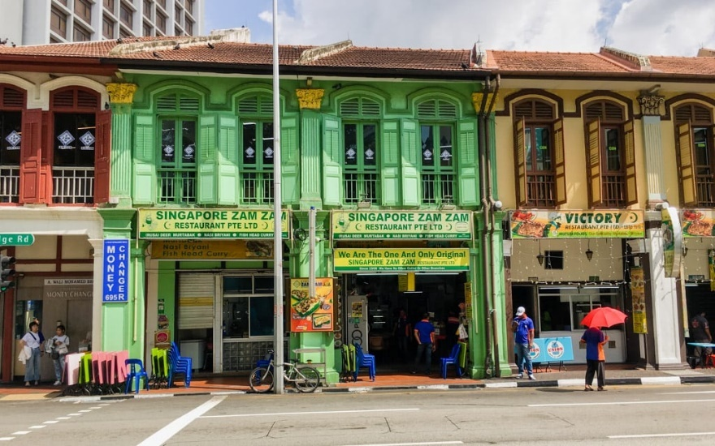

Solo Dining
Solo dining allows a single person to eat mindfully at the restaurant. She had already experienced solo dining before and learned to share the safety tips on the blog with some solo travelers.

She already knew the dining etiquette when traveling to a foreign country.

Fact: Solo Dining faces unique challenges for some people. It is common for solo travelers to be seated in a bar or other places where people are around and where they can have some conversation.

Tips: You are not alone. You can read, do puzzles, write, take pictures, or text if boredom happens. The behavior can rely on other people’s perspectives.

Warning: Don’t leave your bags unattended, even though you leave your table for a second. Carry your belongings with you.

Took her time to eat her lunch, and she was still carrying her purple purse (on her lap) for protection.

She brought her own utensils, chopsticks, spoon, and fork to eat with her meal.

After finishing her lunch, the waitress receives the payment and has paid the meal amount, including the tips.

So she only paid for her lunch in cash.

Recommend: Research the countries where the tips are or aren’t required before eating out at a restaurant.

Fact: The restaurant a waitress includes a 10% Service Charge and 17% Goods and Service Tax (GST), so tipping is not the norm in Singapore.

Then she left the restaurant and said, “Thank you. Have a nice day.”

“Thank you.”

Around 11:30, she walked again to Kampong Glam Park for an afternoon stroll.

Sweating from the high humidity, she planned for quick relaxation. Again, she took some pictures of the park and planned to send them to her family and friends via private message.

She didn’t take a picture of Hajjah Fatimah Mosque but planned to text her parents.

She texted, “I am at Kampong Glam Park and spy Hallah Fatimah Mosque.”

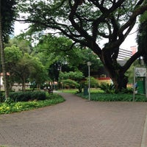

Kampong Glam Park
Texting her family back in Philadelphia, she took a deep breath. Then, resting and enjoying the park, she planned to walk back to the hostel.

Walking for 1.7 km (about 1 mile), she slowly walks to break off her sweat.

Back at the hostel...

...she requested the receptionist to tour the hostel’s common area, including the kitchen, to see what’s featured.

Tip: Before checking in at a hostel, it is essential to ask questions regarding any features included in a hostel stay. Without a doubt, request an overall tour before your visit.

Advice: The hostels’ features may not include a kitchen or laundry, so it is vital to be skeptical about it. Ask and clarify information before you arrive. If in doubt, ask.

After a quick tour, she checked in at the hostel, signed the house rules, and paid the full amount for 5 nights.

Given the room key, she assigned the room and bed number on the 2nd floor.

Once she arrived at her room, she booked her ideal room; it was quiet with 1 other girl.

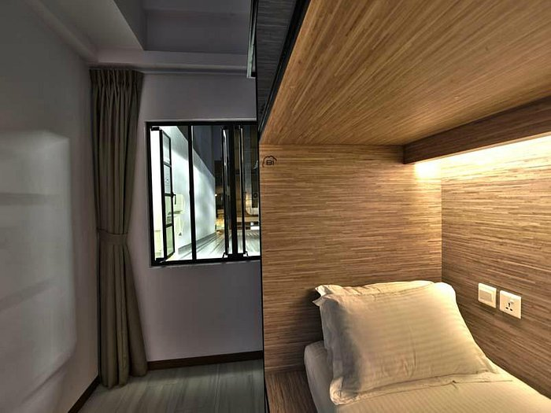

The other girl took her afternoon nap with the bed curtains closed.

“Shhhhhhhh!”

Then she saw the bathroom; it was well maintained while touring around her room.

But there aren’t any complimentary amenities.

She was an expert in staying in a hostel and knew she had already brought soaps abroad.

Tip: After checking and entering the room in the hostel, you don’t know what it looks like. The hostel is not a hotel, where there are some kitchen facilities, free soaps, etc. So pack your soaps, towels, collapse cup, toothbrush/toothpaste, etc., and you are good to go.

Assigned to the lower pod, she knew how to confidently sleep in the pod and was tested for comfort. It was a well-cleaned bed, pillow, and blanket.

She stored the red backpack in the lockers, then locked her pink carry-on luggage after settling.

Soon after 14:25, she wandered,

“Before heading to Chinatown, I followed the schedule I created months ago and places I wanted to see and inspire.”

Taking her quick rest, she laid down in the pod.

“It was unbearably hot and humid in Singapore compared to Philadelphia, where it was not as humid.” She took a quick nap and cooled down with the cooling towel she had brought.

Later at 15:30, she woke up, then she decided to put her hair in a low ponytail and change her earrings for her reddish look.

“I am headed to Chinatown, my next destination, and dinner at the Maxwell Food Centre.” She filmed while she was walking to the subway station.


She took the Downtown Line subway from Bendemeer to Chinatown and texted her parents.

“Hi, I am on the way to Singapore Chinatown. Will send some pictures.”

Still, her parents didn’t respond because they were sleeping, and Philadelphia was 12 hours behind.

Still sleeping, her mother heard the phone in silent mode.

Her mother was happy to see some photos she took while vacationing solo.

Then she texted her with an emoji, “👍.”

Shortly after getting off the subway, she walked east on Mosque Street.

Minutes later, she took pictures of Chinatown, Ann Siang Road, and the Buddha Tooth Relic Temple.

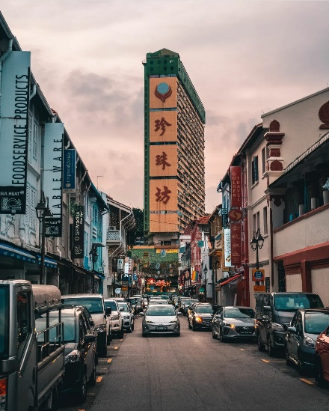

Chinatown



Buddha Tooth Relic Temple

Then she had an early dinner (16:45) at the Maxwell Food Centre and met a girl named Gracie, who likes to learn more about Singapore. She was a resident of Singapore, so small talking more about Singapore and its culture. They enjoyed having conservation together.

At the Food Centre, many people spoke both English and Mandarin Chinese. Others speak Cantonese. United understands English since many Singaporeans speak English, but the accent is a little different. But, then, it was the English called “Singlish.”

Because English is her primary language, United also understands and speaks Singlish, where Gracie was having a short conversation.

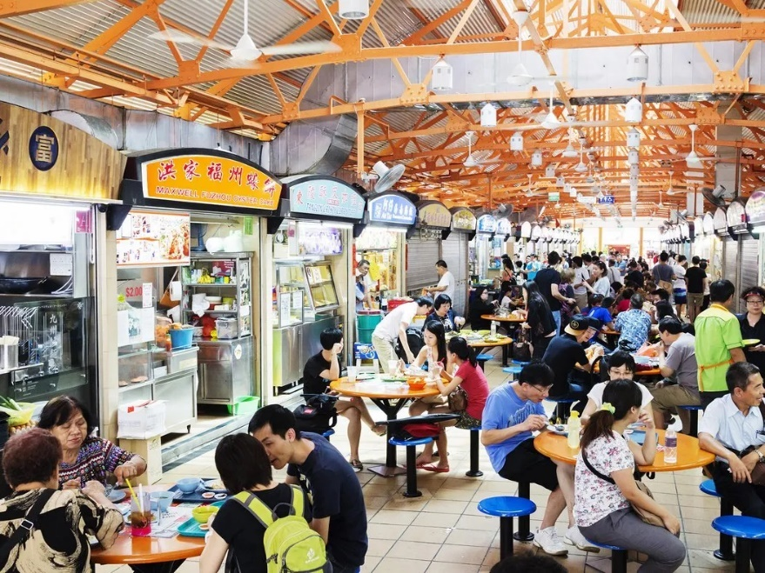

Maxwell Food Centre

Advice: The topics for the people you just met aren’t appropriate depending on certain circumstances. For the small talk, the appropriate topics are travel/places, weather, culture, food, arts/entertainment, etc. Politics and religion are the worst topics.

After their short conversation, she gave her Instagram, and they followed each other.

Walking down the Chinatown Street market for a brief shopping trip, she also enjoyed viewing the places, including Sri Maria Mariamman Temple and...

...enjoying their evening at Ann Siang Hill Park.

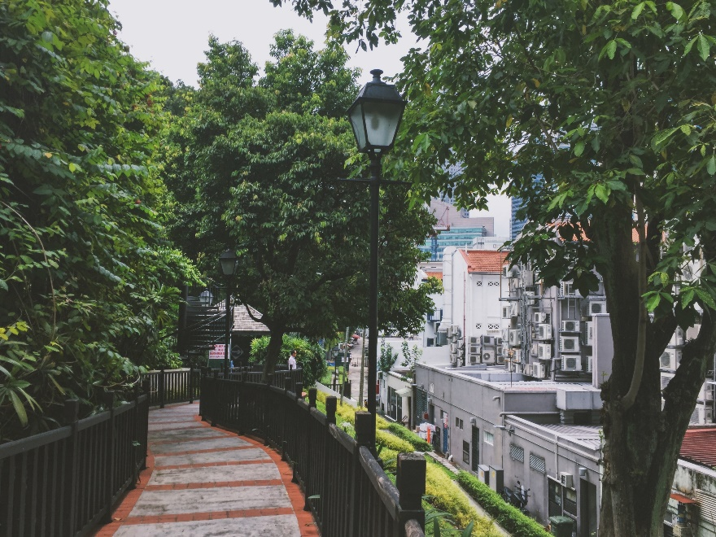

Ann Siang Hill Park

Groceries
Later that evening, she took the subway back to Bendemeer and went to the grocery store. Then, she went to the AS FreshieMart Supermarket Singapore to buy some produce she had created for the meal plan.

“Eating out is not always the best. Instead, there is a better way to save some money by making my own meals. I am shopping groceries where locals do to blend in and to immerse in the culture.” She said.

Entering the grocery store, she saw various fresh produce, including fruits and vegetables. She then looked at the food plan for the 5-day solo trip on her phone.

Shopping for food, she only buys what she needs during the first 5 days of her solo trip.

“It can be harder to introduce fruits and veggies as part of the traveler’s wellness.” So she thought while waiting in line to pay for groceries.

Fact: Travelers don’t eat enough fruits and veggies when traveling, especially on a tight itinerary where accessing produce is complicated. It is essential to incorporate a serving or 2 of fruit or veggie that is better than no other.

She paid S$79 in cash with her black reusable bag and carried them back to the hostel with her black reusable shopping bag.

Walking and waiting for the traffic lights, she looked both ways before crossing Jin Besar Blvd.

Returning to the hostel...

...the microwave and the fridge were located at the Dream Lodge Hostel (Kitchen Facilities).

Hence, there are toasters, bread, cereal, coffee maker, etc.

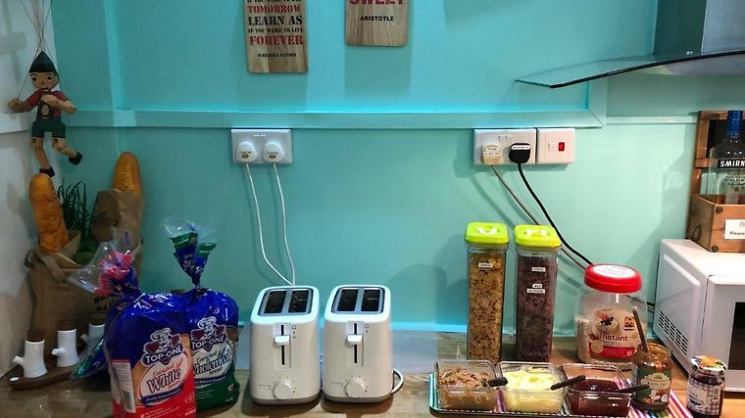

“Wow, it has everything for breakfast.” She smiled.

Putting her groceries into the refrigerator, she marked her bag as “United’s Food.” She packed them in reusable bags before putting them in the fridge. It was 3 packaged foods she brought from their microwave to reheat the food.

Tip: It is essential to ask questions about what you have in the facilities if you are confused. For example, if a hostel kitchen has a microwave or a fridge, use them to store food or leftovers.

“Before coming to the hostel, I called or emailed about the hostel’s available facilities, including the kitchen or dining area, and said there are a stove and kitchen utensils. I just let it be known that I can cook food for leftovers and food I bought for the 5-day solo.” United said while closing the refrigerator and organizing her meal plan for the next day.

Then she returned back to her room.

Locked in her locker, she began to shower while her roommate was gone. Others were just napping.

Setting her Wi-Fi, she was getting in the shower after another girl had just gotten out.

She took her shower with her own pink travel towel.

Relaxing in her room, she was assigned the lower bunk. The two other girls were on the bed. One solo traveler was sleeping while the other was reading a book with the reading light. It was a relaxing movement before getting a good night’s sleep.

She said softly on the bed while looking at the itinerary she had created.

She settled in the room, reflecting on her flight experience on a long flight.

“Getting a good night’s sleep is important, especially if I want to get beautiful on my face. It is also important for my body and health to clean myself during sleep. Once I wake up, I am ready for the day. Without enough sleep, I will feel tired during the day, especially in the middle of nowhere. I also get bored at traveling, and I just want to have fun in Taiwan, especially because I love to travel and explore places.”

Looking at her flight experience from San Francisco,

“When I was on a very long flight, sleeping in planes can be difficult, especially in economy class, where I have limited space. Respecting other passengers can also be difficult because the space I have is available to take long naps or sleep. The neck hurts after falling 4 to 6 hours later. I better use my travel pillow to sleep on my flight. It takes time to adjust my time from one another, passing several time zones. That is known as Jet Lag. Jet Lag is a common symptom for most frequent travelers, especially business travelers who traveled for work that flew through several time zones.”

While tomorrow’s itinerary did not happen until 7am, she had already planned before coming abroad.

“First, I will visit Clarke Quay, where I will buy my lunch at the mall and head to the ArtScience Museum. That is the plan for tomorrow I created weeks before.”

After her 15-minute quiet briefing, she settled on the pod bed and reviewed her next-day itinerary.

Sleeping at 23:00, she tucked her blanket. She slept with her money belt and her passport close together.

Day 1 – Singapore River Walk + Merlion Fun (Part 1)
It was then a warm, cloudy morning when she woke up at the Dream Lodge, had a quick breakfast, planning to walk to Clarke Quay and then the shopping mall for lunch.

Before leaving the hostel, she first applied her sunscreen. She also planned to bring her hat and her pair of sunglasses.

Recommended: Be sure to apply sunscreen every time you plan to go outdoors for a considerable amount of time. Don’t forget to wear sunscreen, no matter the sun or cloudy, pale, or dark skin. You don’t want your sunburn to ruin your vacation, where it can be painful. Sun protection is essential, coupled with sunscreen and a hat or an umbrella.

At around 07:30, she left the hostel to catch the bus.

She then took bus 139 and...

...seated on the right side of the bus, looking quietly and wondering,

“I can’t wait to visit Clarke Quay for a morning walk, then at lunch, I decide what I want to eat.” She thought to herself.

Just then, she got off River Valley Road, walked on Kam Yam Road, and turned left on Marton Place to find the start of the trail.

She took pride in being aware of the surroundings, even though Singapore is a safe city. Thankfully, she only carries her essentials with her.

Tip: Be extra vigilant when walking down the street; you don’t know the surroundings if you aren’t aware. Don’t listen to music, play with your phone, or read while walking. If you are, you aren’t paying attention to the traffic. Other people are around you. Always obey traffic laws.

Entering the start of the trail, she confidently enjoyed the quiet morning walk.

Walking briefly, she took a picture of the Robertson Bridge and headed east.

Tiptoeing, she closed her eyes and meditated while walking under the Pulau Saigon Bridge, amazed that the walking spree was her ideal exercise.

Hence, few people are walking along the trail and...

...there are several solo travelers taking pictures of their adventures too.

Minutes later, she took another picture of the Alkaff Bridge and crossed the Singapore River.

“Wow, the bridge has very vibrant and colorful decor.” She commented.

Walking on the Alkaff Quay, she continued to walk on the trail, spying on something familiar.

Taking a picture of Ord Bridge, she continued the route to Read Bridge (Malacca Bridge) and crossed to get to Clarke Quay.

She stopped to relax, take a water break, and chill off at one of the malls and shops.

Then, she was off to Aramex Intl Exch P/L (MoneyChanger and Remittance Services), located at High Street Centre.

Exchanging Money
She first stopped by exchanging some US Dollars for Singapore Dollars. A woman spoke English very well.

“Hello, I want to convert US Dollars to Singapore Dollars.”

“Sure. How much would you like to convert?”

“150 USD.”

Seconds later, a woman responded politely, “It’s 210 Singapore Dollars.”

“Sure!”

Finally, she gave 210 Singapore Dollars in cash and put it into her money belt.

Advice: Put your money, passport, and credit cards close to your body and store them in the safest place. Also, it is safer to display only a tiny amount in public. Cash theft does not happen only in Singapore but around the world. Be sure to bring what you only need and what you need to buy or want, especially abroad.

Not Recommended: Exchanging currency at the airport because exchange rates are more expensive than at shops, shopping malls, or train stations.

Walking along the Singapore River, she took another water break at the trail’s end.

Walking on the Queen Elizabeth Walk, she planned to take a picture.

Taking a short walking break, she continued to write a journal about her fantastic solo trip to Singapore. In addition, she reflected on her safety tips when traveling abroad to the general public.

“I am amazed that every I worked out became a reality.”

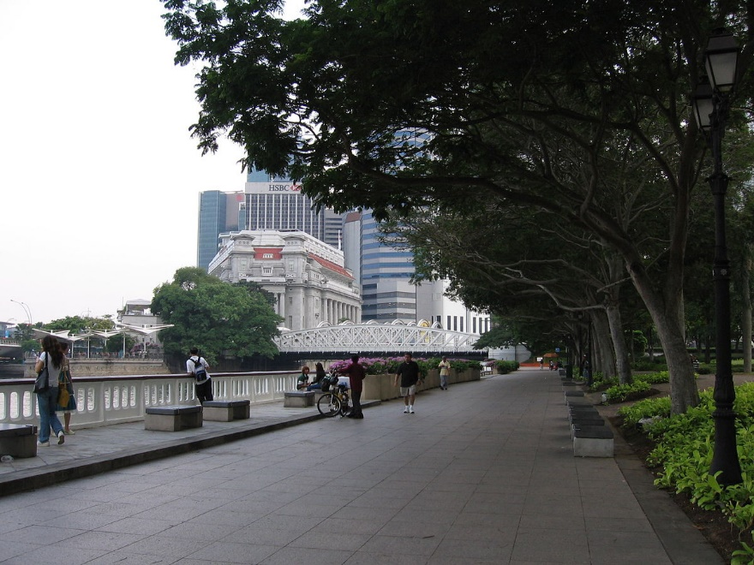

Queen Elizabeth Walk

Turning back, she decided to get to another side of the Singapore River and cross the Esplanade Bridge. She took a picture.

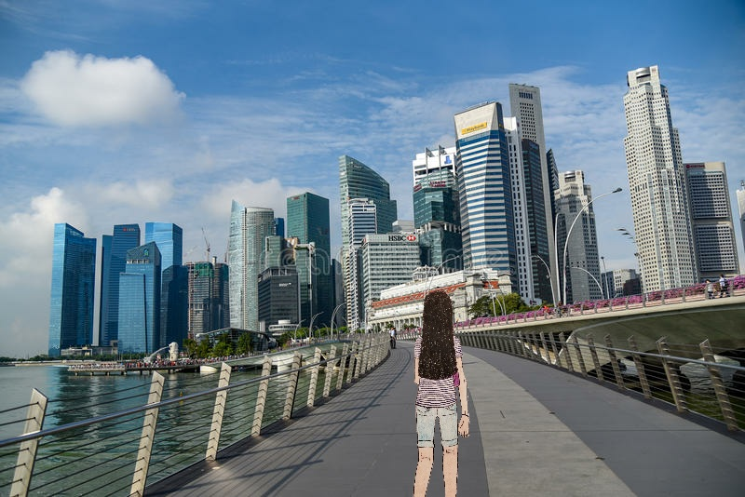

Then, she walked with confidence.

She continued to walk to the Merlion Statue and took a break at Merlion Park.

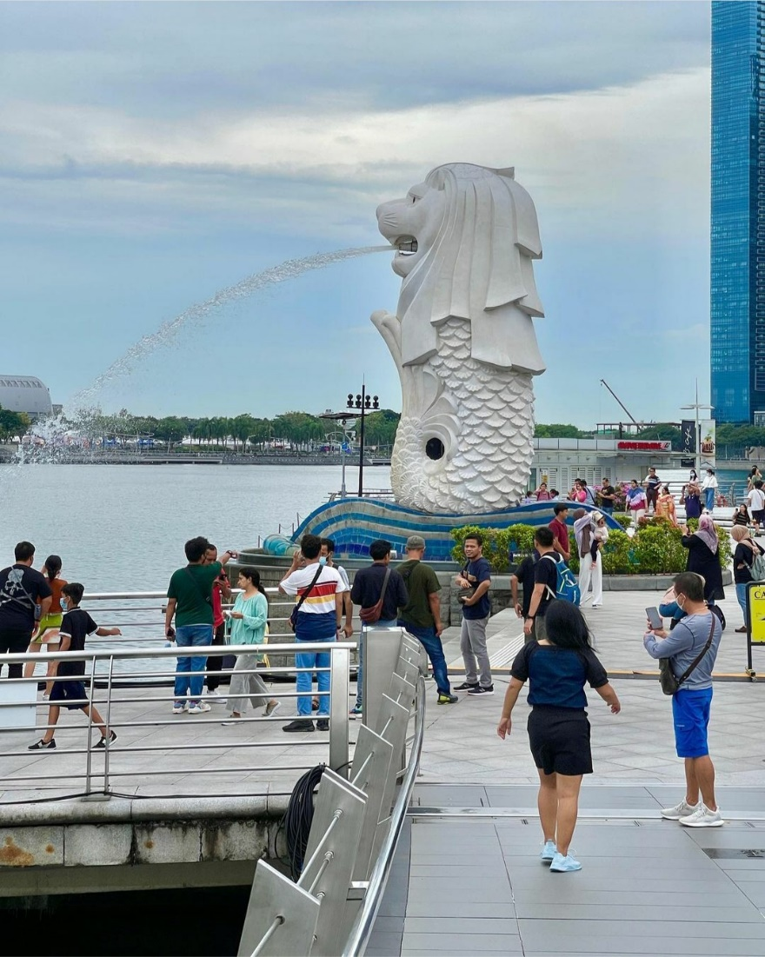

Merlion Park

Asked one of the strangers. She took the picture, posting it as drinking water from Merlion park.

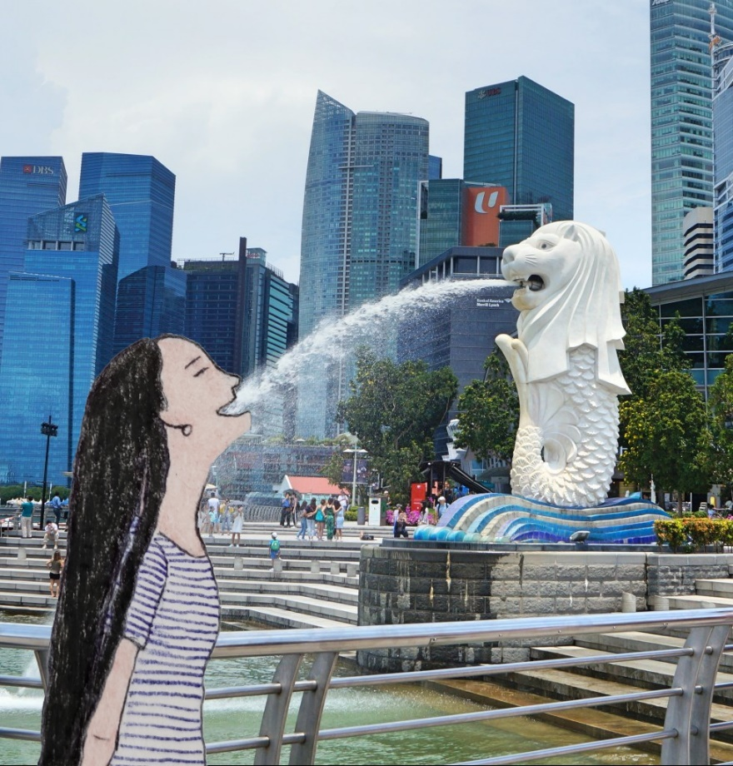

She was sweating profusely and wanted to take a cool-off.

Walking south, she was hungry and checked the time. It was around 11:00, and she planned to shop at the One Fullerton Mall for a quick cool-off.

Sweating, she decided to have a quick lunch, including an iced drink at Starbucks.

She didn’t eat out often, especially if she tried to eat healthily and cheaply.

“I believe that cooking at home saves money because traveling is expensive. That includes eating out, so I have opted for nights where I spend some time eating at the hostel.”

After lunch, she took a walk south of the Marina View Link. She then turned left and took the picture.

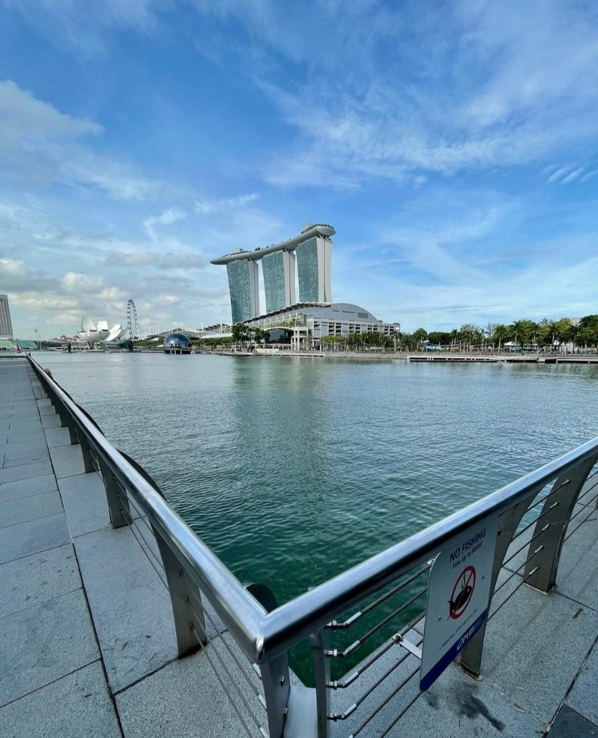

A stunning view of the Marina Bay Sands

Minutes later, she arrived at The Promontory, where she took pictures, enjoying herself.

5-minute water break and…

…she was walking past the ArtsScience Museum. Then, she crossed the Helix Bridge, where she wanted to improve her physical and mental fitness.



On the other side of Marina Channel, she was at the Youth Olympic Park, where she spotted the dome.

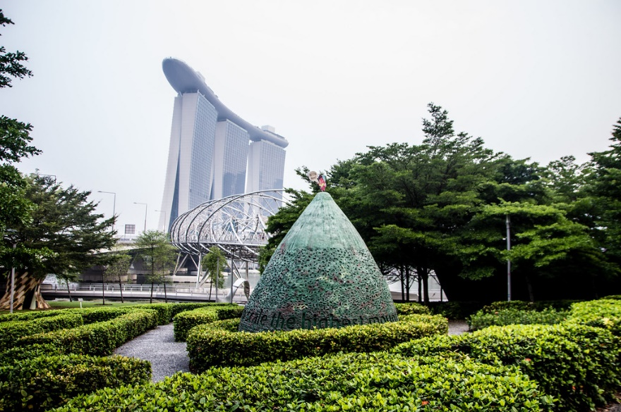

Youth Olympic Park

Later, she returned to the trail and relaxed before heading to the ArtScience Museum, which was scheduled for 14:30.

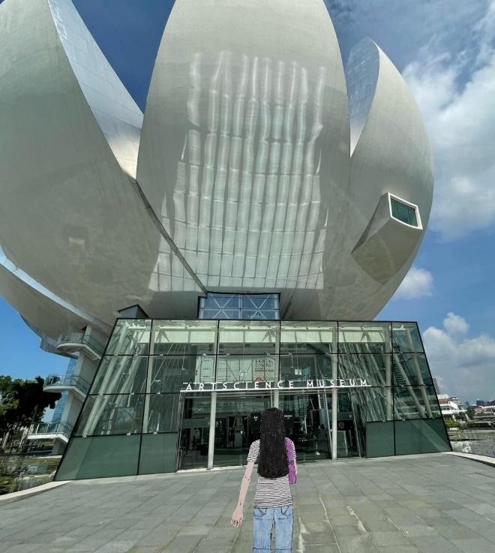

And she took these pictures inside.

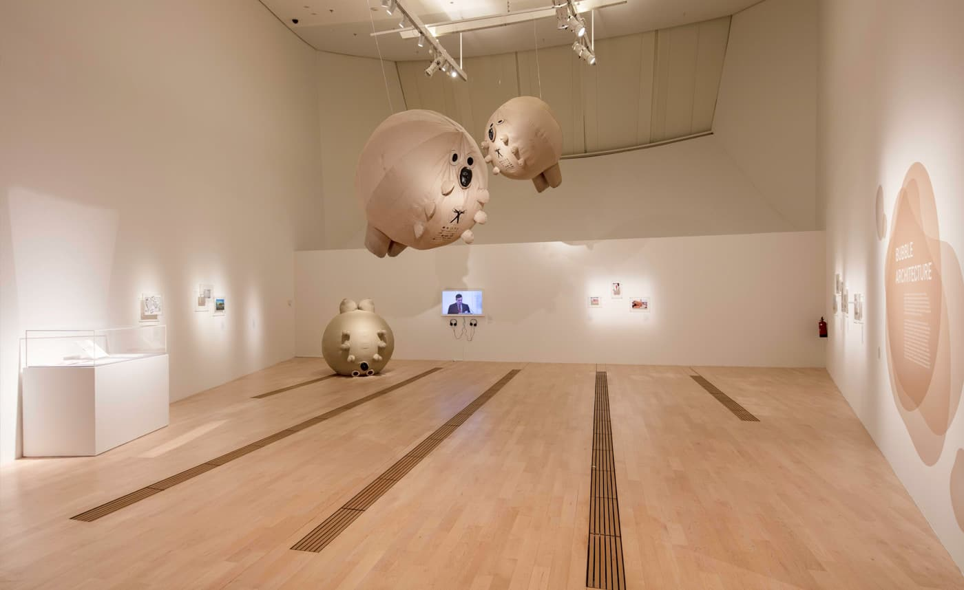

Inside of ArtScience Museum

After an hour, she planned to walk and cross the Helix Bridge again.

“Yep, there is a Singapore Flyer, which I will ride on tomorrow.” So she thought while looking, standing while crossing the bridge.

After spending a little time at Suntec City, she chilled and went on quick shopping before heading back to Dream Lodge Hostel for relaxation.

Just then, United planned to join a group’s dinner at Dynasty Fried Porridge with some hostel guests, starting at 18:00. Again, she was excited to meet new people.

The group’s dinner tour was organized by the hostel’s social event.

Introducing Wai-Wai, she was a bit shy and engaged in conversation. She then talked about where they were from.

“Hello?”

Smiling neutrally, she greeted, “Hello!”

She accepted and responded, “What’s your name?”

“My name is United. What’s your name?”

“My name is Wai-Wai.”

“Nice name. Where are you from?”

“I am from Hong Kong. You?”

“I am from the USA.”

“USA is a fantastic place. By the way, I have never been there in my entire life, but this is my bucket list. So what is it like in the USA?”

“For me, the USA is where people can enjoy various cultures, life, happiness, ultimate freedom, and liberty...”

“Yep. Hong Kong has competitive economic development and economic freedom over liberty and freedom. But there is some freedom for certain economic purposes too...”

“Wow, that is totally different in work culture.”

“Exactly. Also, your culture may be different in terms of different symbols.”

“Yes, Wai-Wai. Besides work, what did you usually do during the dining culture?”

“Dining in Hong Kong is all about manners in terms of using chopsticks instead of forks or spoons. We used to eat them and pick up the food in the middle of the table. People share different food, such as veggies, fresh meats, dim sum, and some appetizers. After meal times, they serve fruit such as oranges. Also, dining in Hong Kong is mostly a social time. How about your eating culture?”

“Also, in my hometown, people occasionally enjoy different foods such as hot dogs, chicken, salad, and fries. Others try to enjoy their favorite food as part of the culture and celebrations. They typically eat a balanced diet such as salad, pasta, pizza with veggies, etc., making them healthier. Unlike in Hong Kong or Asian culture, people used to eat food with a spoon or fork or with their hands or fingers. They also used a knife to cut up smaller foods too. After their meal, they sometimes eat cookies, ice creams, or fruits. Table manners are important too. So dining is a social life, some alone time, and some family time. It is a balanced American dream, eh. People work, but they don’t overwork like in your hometown, right?”

“Right!” She laughed.

Seconds later...

“So, unlike Hong Kong, there is little chance of spending time with my family because it is based on hard work to earn some living.”

Talking more about different cultures, United learned more about the culture and rituals between Hong Kong and the USA.

Wai-Wai’s life in Hong Kong and United’s life in the USA differed in daily life and culture.

Then, they share the story about their different hometowns: Hong Kong and the USA.

Their conversation enables her to meet new travel friends, and she sometimes has a good sense of humor. However, for Wai-Wai, it was her overcoming her nerves socially that helped her overcome her nervousness.

Tip: When you meet new people, don’t discuss personal information, including family, finances, personal issues, or sensitive information that people do not like to talk about. Instead, talk about where you are from, the places, weather, food, and culture.

They were on the way back to the hostel,

At around 21:00, their conversation ended as Wai-Wai’s mother called her (via Facebook Messenger).

United returned to the hostel’s room, showered, and brushed her teeth. Once she was out of the restroom, she took out the clothing for the next day. She also took relaxing yoga (to smooth herself) and went to bed at 22:35.

Day 2 – Merlion Fun (Part 2), Sole Tour
It was a cloudy morning when she planned different daily attractions and activities.
She woke up feeling a little tired. She then took turns using the restroom while one of her roommates got out of the bathroom.
United took turns brushing her teeth and getting dressed.
Then, after breakfast with Wai-Wai, she talked more about Singapore and had other plans.
Wai-Wai has her own trip plan to Chinatown, while United’s plan was pretty packed. Today’s plan includes visiting the Gardens By the Bay and Cloud Forest, riding the Singapore Flyer, and experiencing Time Capsule.
And United left the hostel to catch the subway.
Riding the subway to the Bayfront, she first headed to Gardens by the Bay, where she planned to take her time to enjoy and visit the spectacular view of the unique designs.
“It will be the best view I have seen.” She shivered while bypassing the line to access Gardens by the Bay and...
...she presented her ticket before gaining access.
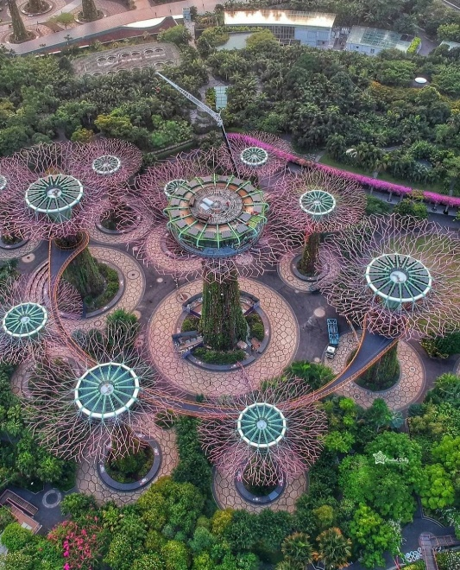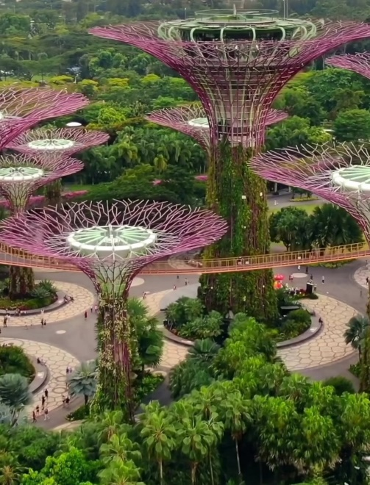
Because she has free mornings, she spends about 4 hours in Gardens by the Bay.
While walking on the walk, she saw several 50-meter-tall Super Tree Groves, which would be lit up in the evening.

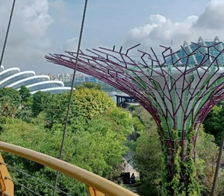
“I may not be able to visit at night...” She said while continuing to stroll.

Minutes passed; she continued taking pictures, having fun.

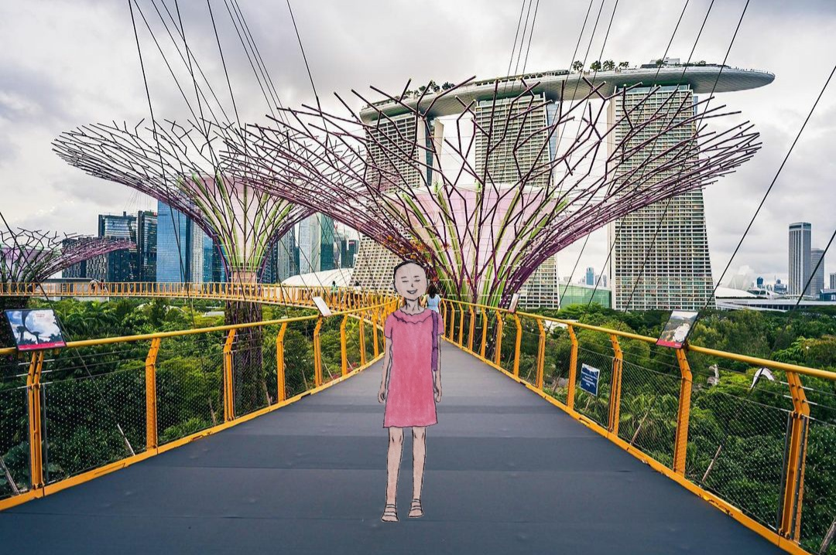

“Wow! I am sending pictures and selfies to my family and friends.” She took her phone from the purple purse and took the best view.

About 2 hours later, she planned to take several pictures on the ground and share them with her friends and…
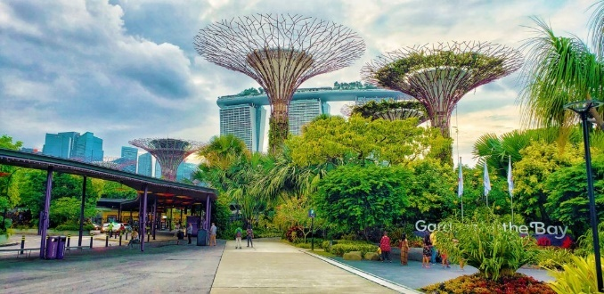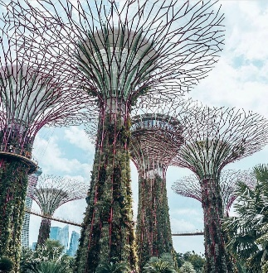

…she spotted another woman traveling solo.

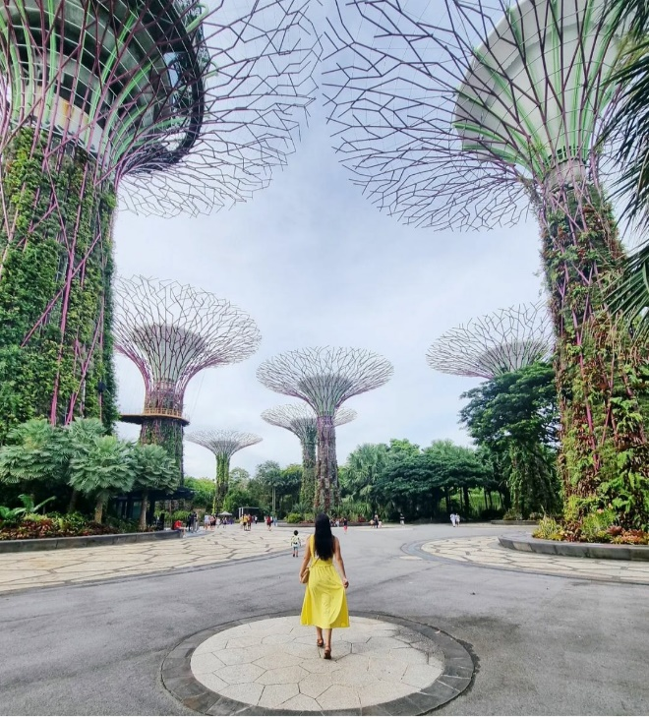
After her quick tour on the ground, she decided to eat lunch at Shake Shack Gardens by the Bay.
Then she planned to visit Cloud Forest by experiencing the most fantastic place inside the greenhouse.
After gaining entry to the Cloud Forest, she also spent another 90 minutes relaxing and took time to reflect and listen to the sound of a 35-meter waterfall.
It was the most indoor forest she had ever experienced, and to see a green conservatory indoors.
First, she planned to look at 9 different cloud-filled levels and wonders of Cloud Forest: Cloud walks, Lost World, Crystal Mountain, Treetop walk, Secret Garden, Cloud Forest Theatre, Waterfall view, The Cavern, and Cloud Forest gallery.

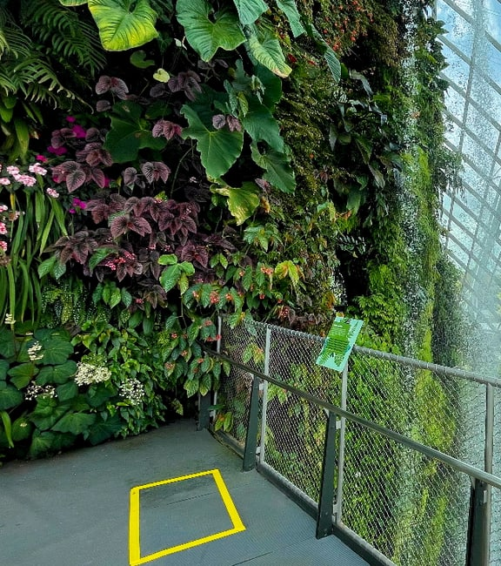
Hence, taking a discovery tour amidst the lush green conservatory will be worth her journey.

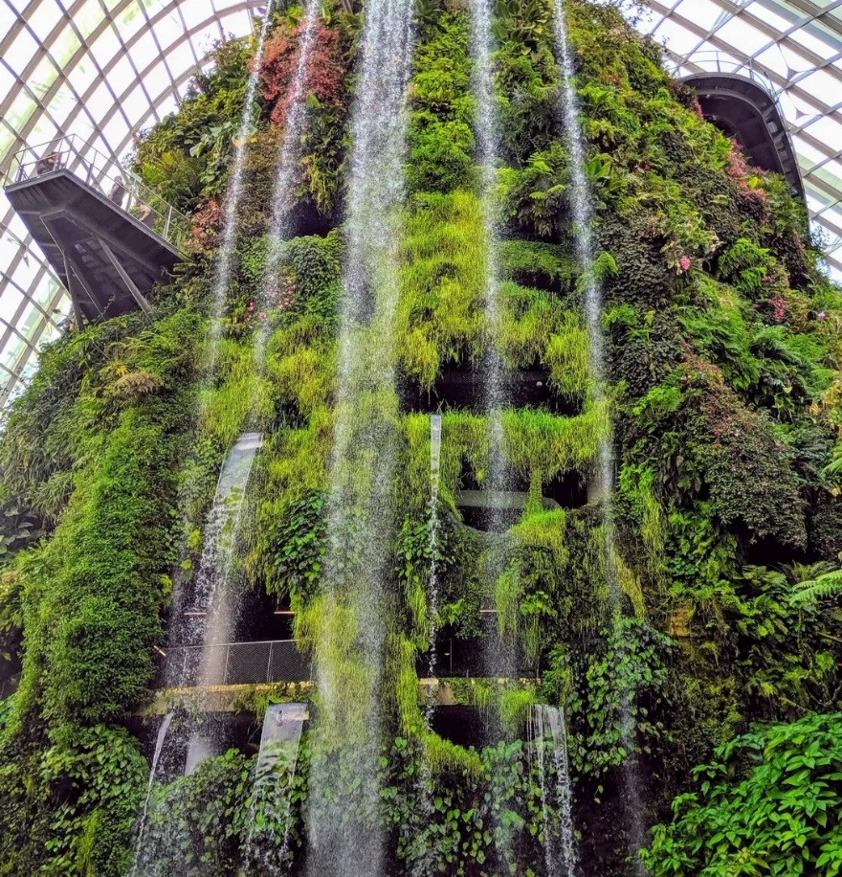

And just then, United asked a stranger to take a picture of herself and planned to share it with her family and friends.

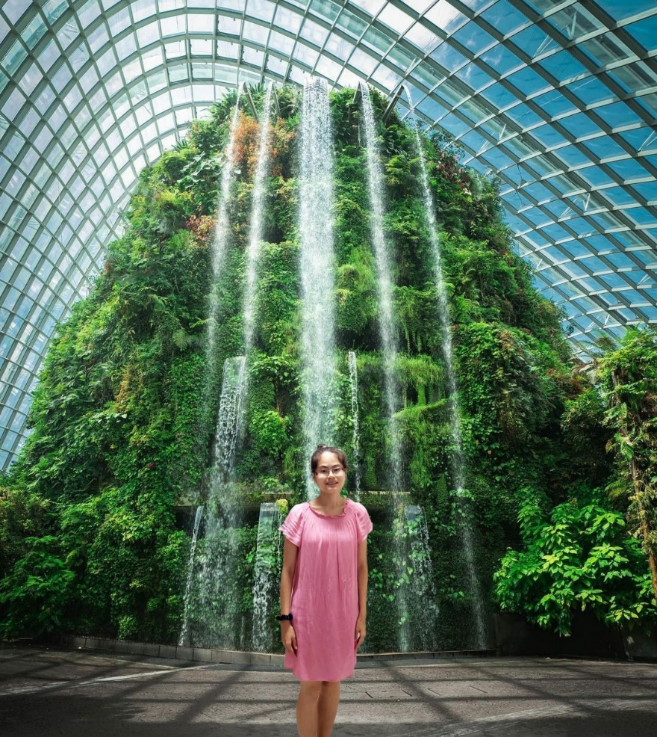

She smiled while a stranger took a picture of herself in the pink dress. Her purple bag was on the floor.

Minutes passed, and she walked on the “Cloud Walk” Still, no one responded because it was 1 in the morning in Philadelphia.
“Okay, guess no one was responding, so I will upload my pictures into my Instagram once I am back at the hostel.”
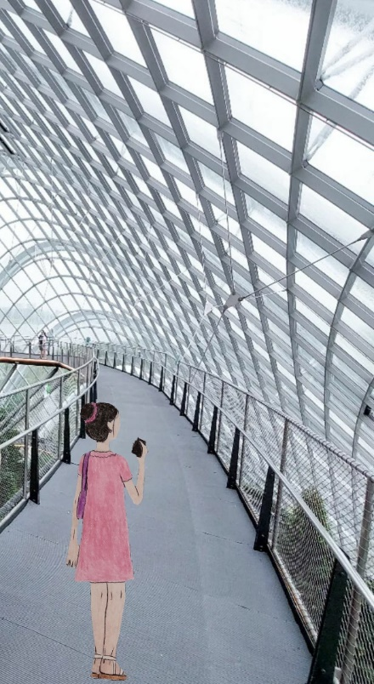
Holding onto her phone, she took a short break while touring around inside the “greenhouse.” She learned how plants and vegetation thrive and preserve inside a humid environment.
90 minutes later, she crossed the Benjamin Sheares Bridge to get to the other side of the Singapore River.
While there was a long line, she still bypassed the line to get on the 30-minute ride because she had also purchased a ticket days before arriving in Singapore.
As United and others were boarding the pod, she hadn’t ridden on the Ferris wheel for a while. She was ecstatic to ride on one after seeing her friend riding back on social media in February 2018.
“My childhood friend Yassamine and 3 others have also been on the Singapore Flyer ride. She suggested I take a quick glimpse.” She smiled on her Instagram.
And here it goes.

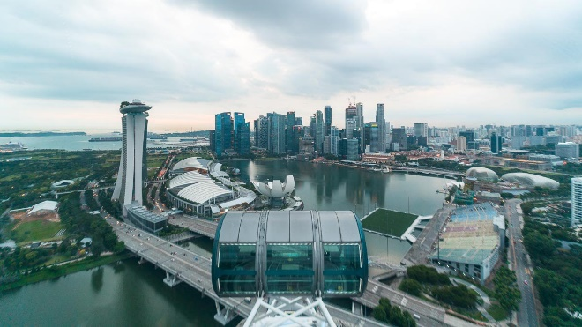

She took this picture while riding on the Singapore Flyer.

After the short ride, she was also excited to visit Time Capsule, which opened last year (2020).



She also planned to experience it inside the Time Capsule.



Soon after, she headed back to Dream Lodge Hostel and made her dinner in the kitchen.

Taking turns making a meal, United spends some time eating her dinner.

Seeing Wai-Wai again, she smiled and…

…United briefly talked to Wai-Wai and introduced and talked more about their travel experiences. First, she spoke about the Gardens by the Bay and discussed how beautiful the place is.

“I heard Gardens by the Bay is the greenest place I have ever seen. It was my heart.”

Laughing out loud, she giggled, “Yes, I would love to since I didn’t plan a trip once I arrived. And I didn’t know if there are fun-filled places until you mentioned Gardens by the Bay. And today, I only went to Chinatown, um...”

Eating dinner, United gave suggestions to Wai-Wai, who was unfamiliar with the place, especially since she enjoys traveling.

“Wai-Wai, if you want to travel to Singapore, research and include activities you love and want to admire...”

Still, Wai-Wai wasn’t convinced.

“I have no idea why I was traveling there without a purpose.”

Advice: Be sure to know the trip’s purpose (including a detailed itinerary of activities) before you travel. You don’t know where you are going without a trip purpose and intending to travel from point A to point B. Then the trip will be lifeless. All trips should have a purpose and a reason.

30 minutes later, she finished her dinner. Then she cleaned up the dining area and returned to her dorm, where she relaxed.

Opening up the email, there are several email messages. Many of them were from social media.

Still attempted to find her flight to Langkawi, but she scrolls down for many junk emails and...

...she found her flight itinerary mail, sent on October 25, 2021.

“I didn’t know that my father had already sent me an email about my flight to Langkawi, which will be on a fun tour. So I have to check my flight now so I won’t forget.”

It said:

[Re] Your Flight Itinerary to Langkawi

Sent from ******

Confirmation Number: ******

October 31, 2021

Scoot 476
3:55pm Singapore to 5:2pm Langkawi
Class/Seat Assignment: Economy
Flight Time: 1h 25m
Meals: None

Total 150.00 USD

Then, United took a quick shower after her roommate (Delta) left the restroom.

“It is important to be patient when my roommate is showering before me. It is just a patience skill I need for life.” She smiled.

Just brushed her teeth; she was relaxed but quietly writing her blog about her trip and texted to her parents/friends.

Before bed, she sent pictures of Gardens by the Bay to her parents and wrote, “Me at Gardens by the Bay.” Next, she sent some photos of the Singapore Flyer to her family.

Her parents smiled after she sent some pictures to the family group. Her sister went to school and did not look at the text via WeChat.

And she was off to bed at around 23:10.

Day 3 – Orchard Road + Speculator Garden Visit
She planned to visit the mall all day. But unfortunately, it was a hot Friday on October 29, just 2 days before flying to Langkawi for the fun tour.

“Today will be the mall morning and afternoon will be the Singapore Botanic Gardens.” So she vowed before heading out for the day.

She headed to the Orchard Road shopping strip and took the Mass Rail Transit. She was amused that the plan went well. She then took the East-West Line to City Hall, then transferred to the North-South Line.

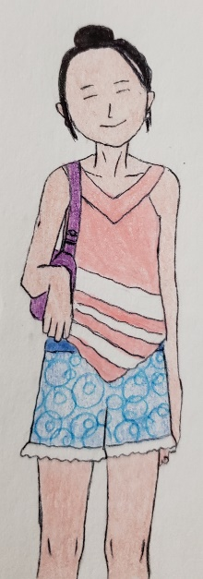

A girl, United, was on the subway to Orchard Station for a morning shopping spree.

Riding the subway, she tried to keep solo travelers to a low profile, no matter how safe is the city. She wanted to protect herself from “dangers.”

“I can’t wait till the shopping spree begins.” So she said to herself while getting off at the Orchard (inside the ION Shopping Mall). She was eager to walk around the Orchard Road shopping strip in the morning.

Chilling from the high humidity, United leisurely walked and spent her morning browsing the stores.

Then, she shopped for some clothes she wanted to bring home. But unfortunately, she didn’t find what she was looking for.

Hours later, she was off to take a picture outside of the ION Shopping mall.

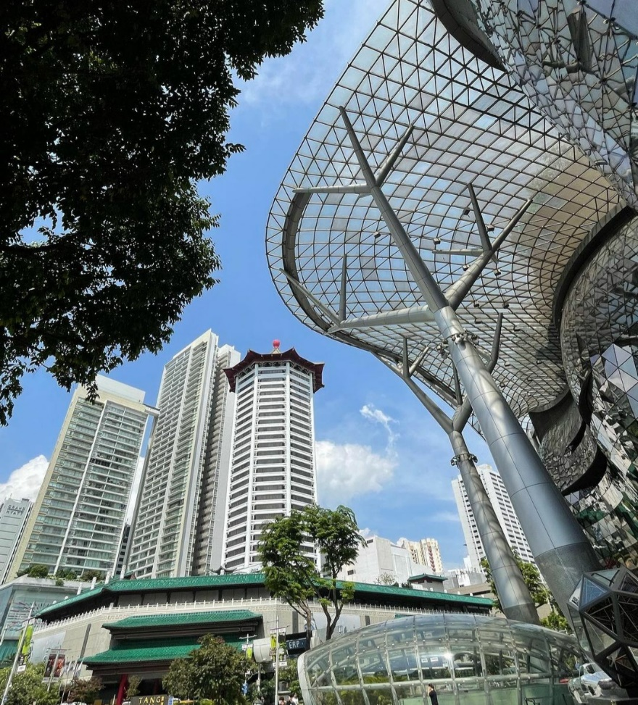



ION Shopping mall (Entrance)

11:30 in Singapore,

She planned to eat lunch at Orchard Central after walking east on Orchard Road, browsing some stores and relaxing.


Orchard Central

Eating her quick lunch at Tanuki Raw at Orchard Central, she took some time to reflect on her prior travel experience,

On her travel blog,

“I remember and reflect on how to meet travelers on last year’s trip to Taipei. I met another stranger at the night market in Taipei the last time. I was frightened that Andi was talking about inappropriate topics.”

She wrote in the title, “How to meet new people while traveling solo?”

Reviewing her blog about meeting new people while solo travel, she learned how to meet new people, like Jessei, who sticks to appropriate topics for the new people.

Jess was now working at the City of Anchorage. She Facebooked her, and she was doing well at work. She recently traveled to Frankfurt after seeing a picture of her solo travel.

Now, she focuses on don’t topics when meeting new people.

While taking a lunch break, she daydreamed at the mall, reflecting on August 2020 in Taipei’s night market.

She wrote on the blog,

“At Shida Night Market before my departure home, I met Andi. Feeling shy about what topic she wanted to discuss, she wasn’t ready for it. Instead, she was aggressive and reminded that “the topic wasn’t appropriate.” Suddenly, she was agitated and annoyed. Then I stepped away from aggressive people... Finally, I stepped up and pretended that I was traveling with my parents.”

She recalled when she was sitting across from the table, she started to talk to them. A woman with awkward movements.

United knew the social cue as she looked at her. However, she did not know how to meet new people.

“Hello! Are you a ...”

United did not say anything and focused on eating her dinner.

“Psst, hello! Are you there? Answer me.”

“Ahh, yes.”

She spends less time socializing with her because she doesn’t sound engaged in the conversation.

After waiting for 2 minutes, she has nothing else to talk about.

She remembered when Andi avoided eye contact when talking to her when she met new people.

“My name is... un, Andi, and I am m...married with an autistic husband. He doesn’t listen to me, and so...”

She wondered, “Why are you saying that?” The conversation was too personal.

“Why did you need to know?”

Because she was shy of social conversation, she sometimes asked about United’s marital status, responding briefly.

Then the topics started to escalate unexpectedly.

Andi was convinced about the dangers of traveling alone and...

“Hon, I got to tell you this, where is your husband?”

“Well, my husband is eating his dinner at the hotel.”

“Ooo, I think that you should get a husband then....”

While United felt uncomfortable talking more about Andi’s personal status, she proactively responded by telling her husband they were at a hotel, traveling together (in reality, he was not).

...and she tried not to offend her and give her advice.

Feeling uncomfortable, she learned how to protect herself from these situations.

United tried not to offend travelers with disabilities and engage in conversation with Andi. The conversation ended with a friendly, grateful conversation. She finally ended the discussion with a brief message, “I gotta go. My husband is picking me up in front of the night market. Thank you for inviting me to chat.”

Not Recommended: Talking about inappropriate topics can make some travelers feel offended. When someone or a stranger asks you about personal information, politely tell them that the topic is uncomfortable or too personal. You can also say, “I am uncomfortable talking about this. Let’s talk about the weather, travel experience, etc., that are easy and interesting.”

Warning: Do not say or let someone know that you are traveling solo. They can give you unwanted advice and draw unwanted attention. Instead, pretend that you are traveling with your family members. For example, you can say to someone, “My husband is staying at a hotel, eating his own dinner.” You can also say that “My family is traveling together. I am waiting for my family to ride home.” Be vigilant about what you respond to. Finally, do not tell them that you are a single or solo traveler or traveling alone because they can take advantage of you and, in some cases, bully or spread rumors about you. Do not say then. Lie to defend yourself.

Since it was too hot to walk to Botanic Gardens, she decided to take the bus. And she waited.

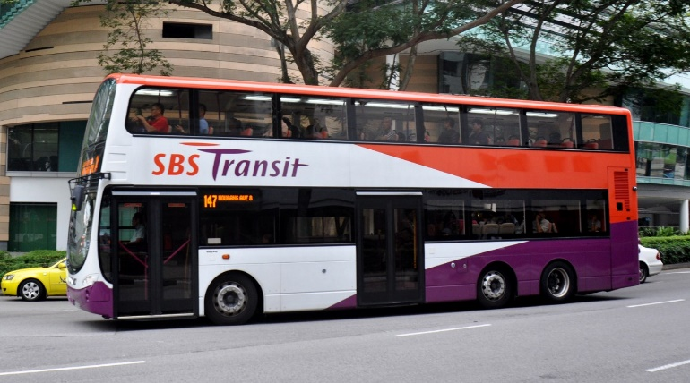

Taking the double-decker bus to Singapore Botanic Gardens, she also has her fake wedding ring on her left finger. It was known as SBS Transit Singapore.

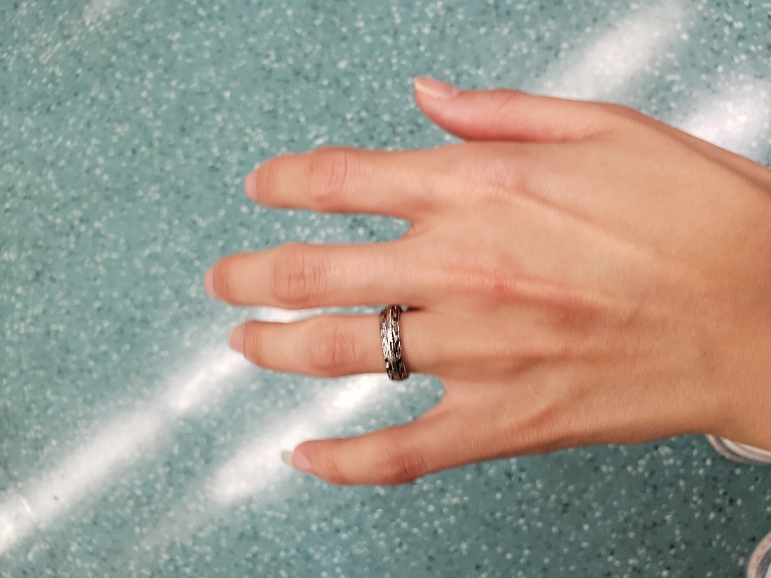

Recommended: Married, single, widowed, whatever your marital status, wear a wedding ring (real or fake) to avoid unwanted attention. You can also show your husband, claiming your brother or father, saying that this real husband is on your phone. Women can be primarily targeted for unwanted attention or conversation. We don’t want that to happen.

Arriving at the gardens, she got access and took several pictures.

She also visited the Sundial Gardens in Singapore Botanic Gardens, where she took her time to reflect and experience the new greeny environment.

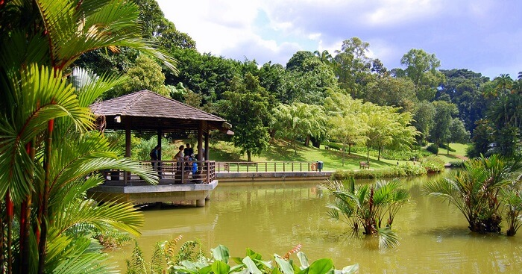

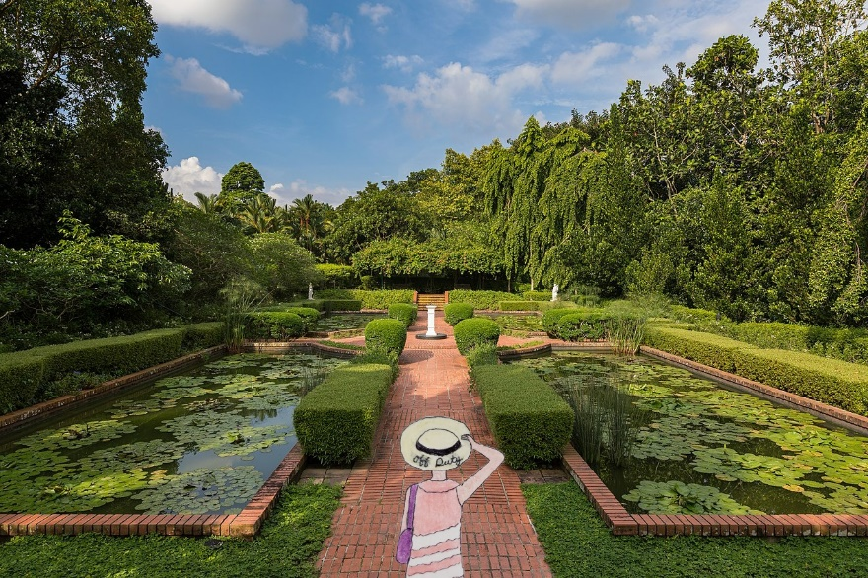

United, above, was enjoying a breeze afternoon in the gardens.

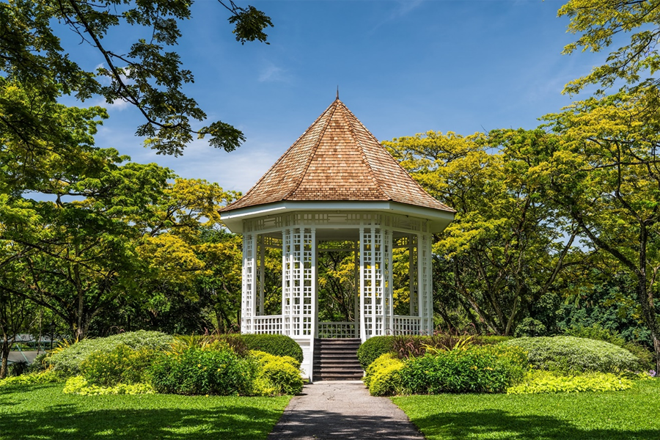

Then, afterwards, she paid $SG$5 to get into the special exhibits, know as National Orchid Garden and proceed to the gateway to the garden.


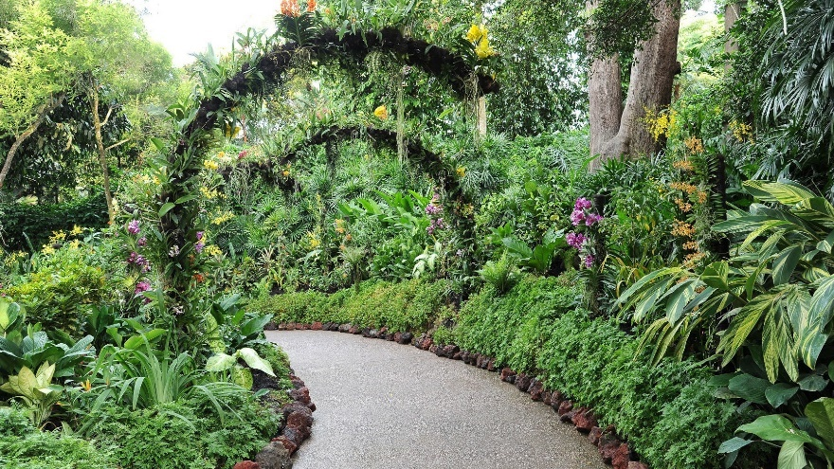

She also took this picture of the Orchard Gardens. She smelled fresh flowers and plants harvested inside the specular gardens.

Soon after the fun-filled relaxation afternoon...

...sweating.

“What time is it?”

And she took out her phone and looked at the time. It was 16:40 (4:40pm).

“It is time to head back.”

After the sweaty afternoon, she took the bus 67 and...

...saw the bus turning left while passing by Little India.

Finally, she safely returned to the hostel and planned to meet a new traveler.

“Today, I am making dinner and planning to meet new people.” She talked to herself.

In the hostel’s kitchen, the microwave and the fridge were located. United marked her bag before putting them in the refrigerator. It was 3 packaged foods she had brought 3 days ago.

Cooking her dinner in a microwave, she was hungry after her day trip, so she planned to replenish her sweat from the humidity.

Then, she met another girl. Her name was United, and she was from France. She then talks more about her hometown and French culture.

And after her short conversation, she then smiled and closed the discussion.

Since United was tired after walking and spending hours outdoors, she took a quick shower and brushed her teeth. And she relaxed on the bed.

Before bed, she sent some of the pictures to the family. In addition, she posted some of the images on Facebook, Instagram, and Twitter.

“Before I sleep, I am just looking at my itinerary for tomorrow. So that I won’t forget.”

Hence, tomorrow is her laundry morning, then an afternoon at Fort Canning Park, and, if time allows, to the Toa Payoh Town Park.

Then late in the evening, United was asleep. Her parents likened it after she sent some pictures to the family group. After that, her sister went to work and did not look at the text via WeChat. Nor her sister looked on Instagram.

Day 4 – Dreamy, Greeny Epic Places
Saturday, October 30, was a hot morning in Singapore. But, first, it was the partly sunny view of the skyline.

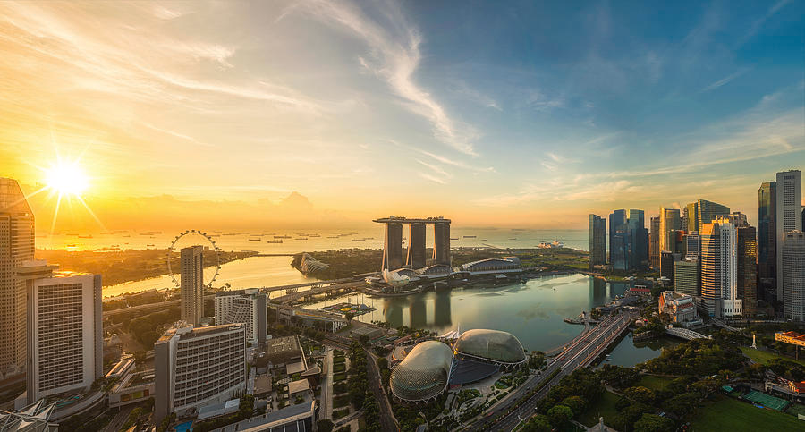

As United woke up at around 8:30, she first prioritized her breakfast time before planning to do the chore - laundry.

Dressed in her blue dress, she decided to eat breakfast at the hostel, where she enjoyed making her own breakfast.

Arriving at the kitchen area, she said, “it seemed like little bread slices and jelly were available.”

And United tried her best to eat something to keep her energy up.

“I tried not to neglect myself from hunger pangs. I need to eat to support my daily activities when solo traveling... But even though I ran out of money, I must spend my money to buy food so I can eat to nourish myself.” While making her own breakfast, she thought it would include a hard-boiled egg.

She also had leftovers for the day and planned to eat her lunch at the hostel before going out. Because her tour was coming up tomorrow evening, the itinerary was partially packed with fun places and sightseeing.

“Today, I am doing my laundry because I don’t have time to do it in Malaysia and don’t have time during the solo travel tour. It will be an exciting opportunity to meet new people and gain new experiences and culture.” She said while writing more blogs while she waited for the clothes to clean.

Tip: If you plan to do laundry while traveling, it is best to do it in the morning rather than the evening. That’s why many people were doing laundry in the afternoon or evening and may need to wait longer for the available washers/dryers. Also, budget the money as some hostels/hotels may charge you for additional services. Plan and budget accordingly.

Soon after the laundry, she folded the clothes and packed for the trip by preparing for tomorrow’s departure.

Bringing her purple purse and a water bottle, she left the room and headed to the kitchen.

It was around 11:05 when it was time to eat lunch. She felt that she was hungry earlier than usual.

“It looks like no one was there, but a few people were making lunch to save money.” She said while taking turns making a quick lunch.

And then...

Smiling, she took time to eat the meal she had brought in the last 3 days.

An hour later, she left the hostel on the way to Fort Canning Park with a water-filled up. She was excited to travel to the park again.



She took the Downtown line from Bendemeer to Fort Canning Station and...

...she saw many passengers holding onto the food and drinks inside the bags until they got off the train. Hence, the subway was exceptionally clean and well-maintained. And there was hardly anyone eating and drinking on the train.

Instead, many passengers were just listening to music and playing with their phones.

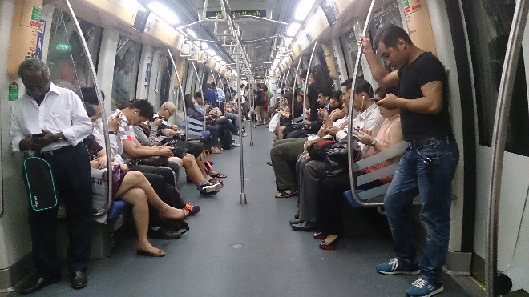

Arriving at the Fort Canning Station, she walked upstairs and north toward the entrance. Since the park was free, she learned how to save chunks of money by balancing the free and fee-structuring activities.

Tip: It is essential not to overindulge in activities with fees. Take a break by going to free public parks, attractions, and places. This gives you a balanced time between free and fee-structuring activities.

“Wow, it’s beautiful here.” She smiled while taking some pictures and planned to send some photos to her parents to know where she was.

And she took several breaks and had a few snacks and a water break.

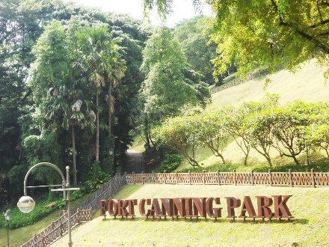

She also spent some time taking several pictures of the park. She spied a glimpse of the beautiful theme, including the Spiral Staircase.

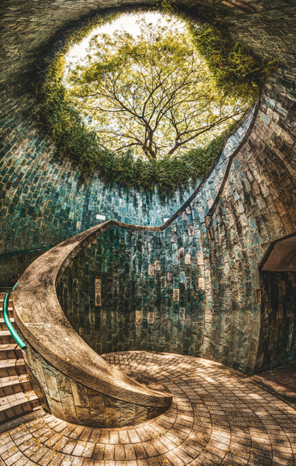

And soon after, she took her water break and ate some snacks she had brought. Unfortunately, it was a cloudy day as it would rain late in the afternoon.

Looking at the sky’s clouds, she thought it was not raining hard.

Spending only 1.5 hours in the park, she looked at the time on the phone and said,

“Okay, it’s still 14:25, and I still have enough time to visit Toa Payoh Park.”

Since her time allowance, she also planned to explore Toa Payoh Town Park, which she also wanted to include as part of the travel experience on a solo trip.

She then took the subway from Fort Canning Station to Toa Payoh with a transfer to Newton Station. She was an expert in getting around by looking at which direction she wanted to go.

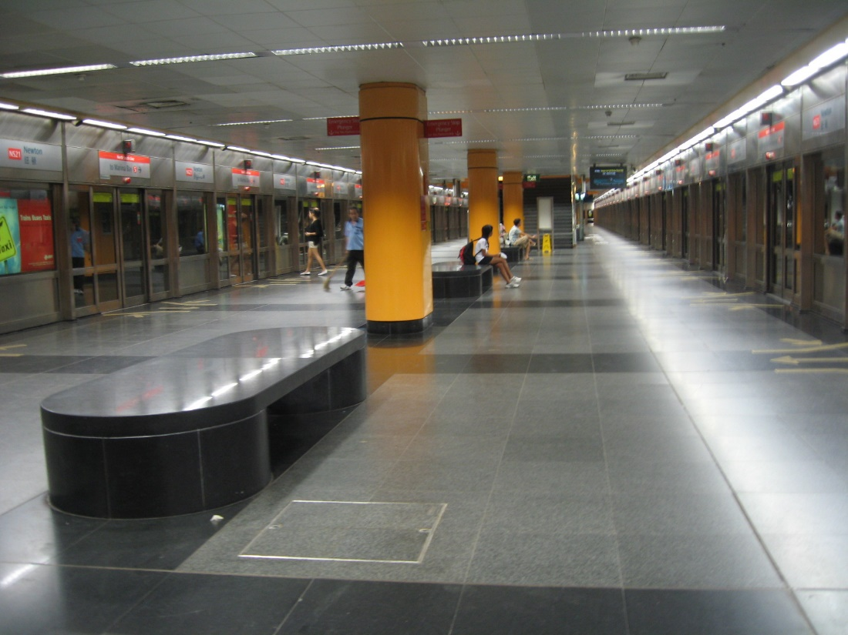

Heading to the Jurong East, she was quite proficient in getting around.

“It seems like I am very good at looking at the signs of the destination I am headed to, especially since I began to travel in Hong Kong, where the subway system is complicated.” She smiled while waiting for another train to Toa Payoh on the North-South Line.

Arriving at Toa Payoh Station, she headed to Toa Payoh Town Park for another glimpse of the beautiful, epic gardens.

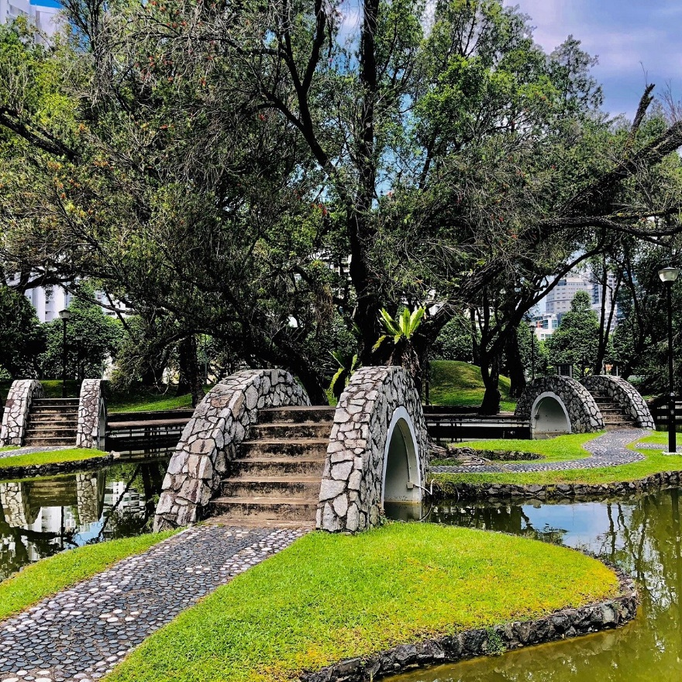

Soon after, United skipped on a trail at Toa Payoh Town Park. Even though the weather wasn't pleasant, she enjoyed the afternoon breeze at the park.



And she also spotted the 27-meter Observation Tower, which she wanted to experience climbing up. But, since it was closed to the public, she said, “That tower looks like a spaceship, so I am spying on this. Then I show it to my family and friends. This tower was built in 1973 and used to open to the public. But unfortunately, I cannot climb up this because of the deteriorating function, so I can find another one in another location...”

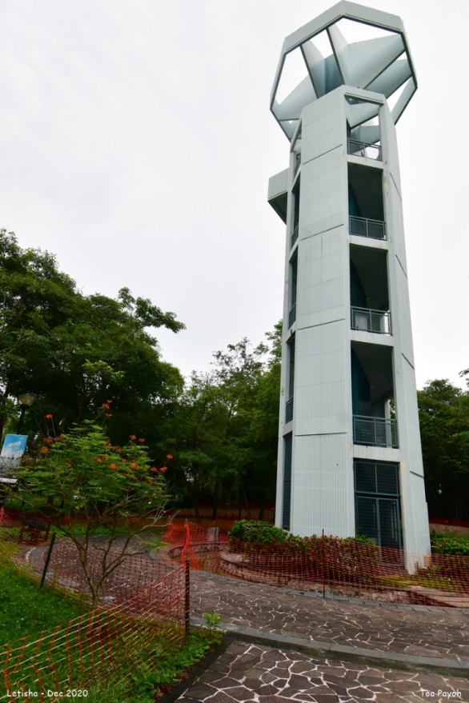

She smiled and moved on.

United steered away from the tower and took her to break again. This time she settled down and finished writing her blog about her trip in the past 3 days.

After that, she decided to buy food at Oasis Taiwan Porridge, order Taiwanese cuisine, and take the subway back to the hostel to spend her final night.

And she held onto her dinner while returning to the hostel via Singapore Mass Rail Transit.

After safely arriving at the hostel, she settled in the room, relaxed, and showered quickly.

At the hostel’s kitchen, United was preparing dinner. She brought her dinner from Oasis Taiwan Porridge, which she experienced last year’s trip to Taiwan.
She sat down and, feeling shy, she wanted to have the small talk again. This time, she meets another girl named Nina.

She was from Uzbekistan.

Having a shared culture, United listened as Nina told a story about the culture.

It was then a short 15-minute conversation and gave contact information, including Instagram.

Returning to the dorm room, she shared a few pictures of Fort Canning Park and other photos of Tom Payoh Town Park, which she took her selfie. She then texted her family about her day trip.



“Wow, nice pictures. Where is that?”

“Fort Canning Park and Tom Payoh Town Park.”

“👍”

10 minutes later, her father texted to remind her that the flight to Langkawi was tomorrow afternoon.

“Hey, do not forget that your flight to Langkawi is tomorrow afternoon, so be sure to be at the airport tomorrow. Please, bring your passport with you.”

“Thank you, daddy. I won’t forget.”

“Oh, listen, if you are going to Malaysia, try not to travel alone since Malaysia isn’t safe for women. Try to stick with a buddy system.”

“👍 Daddy, I will travel with a tour group from Contiki. And it will be a fun week.”

And after a short conversation, she decided to head out for the movie night at the hostel with some guests.

After the movie night, United prioritized her bedtime and went to bed around 23:00.

Wanderful Life (Part 2)

October 31, 2021

It was around 7:30 when she woke up feeling refreshed and excited to travel to Malaysia.

After breakfast, she carries her pink luggage and red backpack.

“Okie Dokie, I have food packed ready.” She said, dressing in a light pink top, a denim skirt, and her high ponytail.

Checking out at the Dream Lodge, she slowly walked southeast on Horne Road and took the subway (East-West Line) to the airport.

Around 10:15, she checked in for the flight to Langkawi online and...

...her flight didn’t depart until 15:55, which was over 4 hours of spare time.

She spent some time at the airport, taking pictures of the beautiful lights and waterfalls from the top.

And she said...

“I am passing my time to explore, take these pictures, and experience Singapore again. It can be boring, but I can manage myself with fun-filled activities.”

She smiled while being patient until her flight time, making herself motivated.

So she took her time to view the dome waterfall, which was a speculator.

Browsing around the Changi Airport, she then took a quick tour around.


Relaxing and standing at the airport, she tried to relax and distract herself from boredom. She then took her breath and said, “It was breathtaking.”

She then took a picture of the Changi Airport Jewel.



Minutes later, she texted her parents, “Hey hey, this is Jewel Changi Airport with a beautiful dome – waterfall.”

And she had her quick lunch as her snack while taking her personal break and updating her personal travel blog.



And she had her quick lunch as her snack.

Around 1:30, she decided to go through security.

After she passed through security with fingerprints, she successfully made it to terminal 1, her flight to Langkawi.

An unexpecting event was when people were traveling to Langkawi.

Despite going to the small airport, she didn’t notice that many people traveled on the same flight to Langkawi.

“I didn’t know many people. Perhaps they were on holiday or vacation like me.”

Many passengers (who will be on the Contiki tour) were on the Scoot flight for the exotic Contiki tour. Others were just looking forward to a dream trip on their own.

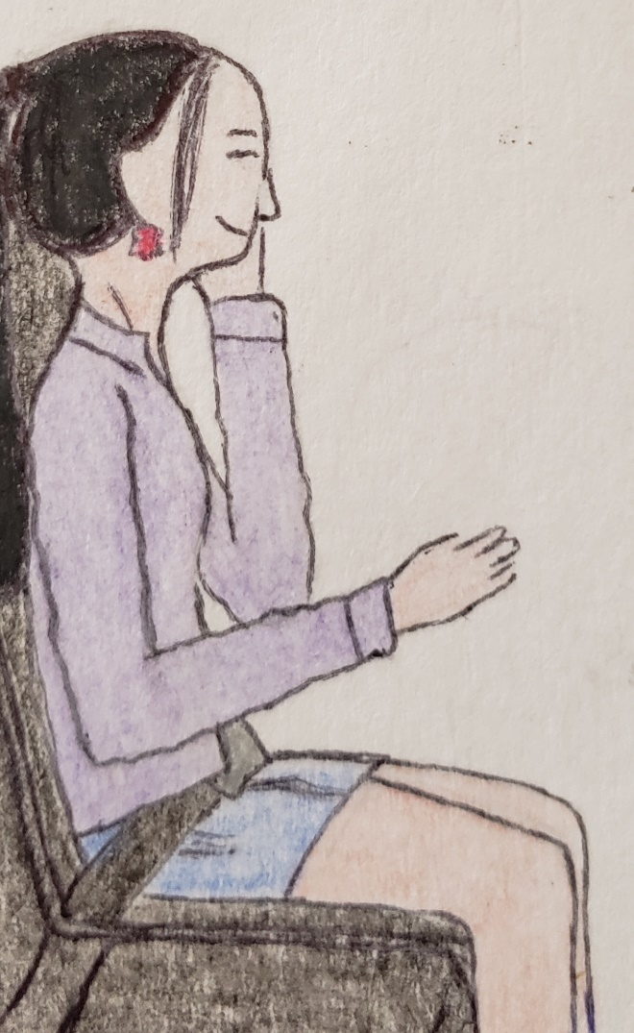

As the flight to Langkawi was en route, United was sitting in the window seat. With no in-flight entertainment, she listened to some music while eating a bit of a snack.

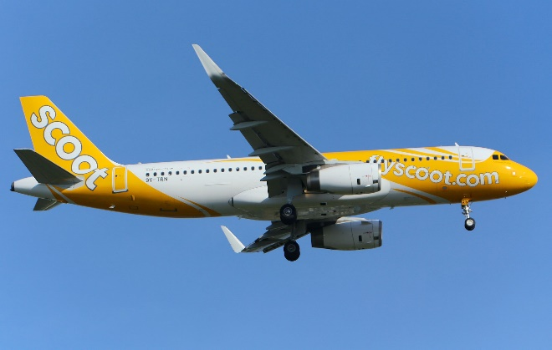

It was a 1 hour and 15 minutes flight, which was a short flight but international.

Minutes passed, the flight attendants gave another arrival card, and United used the pen to fill out the information.

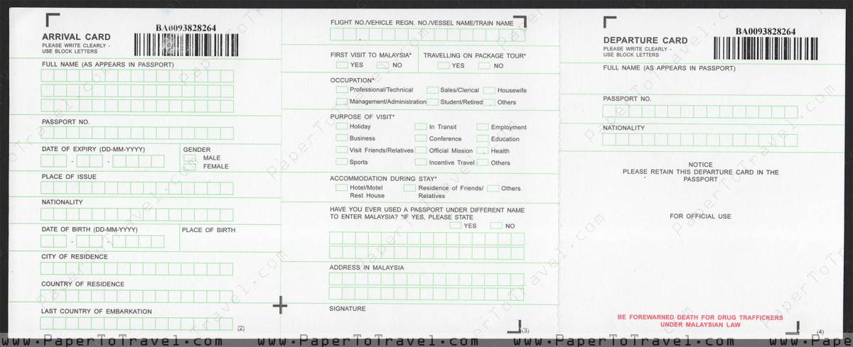

Around 17:35, United arrived at the Langkawi airport as 32 participants arrived and waited for more travelers.

Passing through the customs, she was settled down, listening to music, and seeing more strangers come by.

Still, there were 3 more left, and some arrived by land or sail.

Shortly, she greeted the Contiki tour operators and introduced them to the participants.

She first introduced a girl named Sandrine, whom she met on Instagram, and became a fellow follower.

She learned that Sandrine learned from United, a solo travel expert who shared the stories and experiences of solo travels.

Laughing together, she enjoyed learning from her safety and security experience.

Standing and waiting for 35 minutes, the tour operators and leaders, Fanny, Gavin, Shannon, Pete, and Xhamster, were very experienced and knowledgeable in learning more about the place. Also, all tour operators have proficient in English. In addition, they have experienced touring around Malaysia and others since the 2000s. Finally, after counting 35 participants, they soon left the arrival terminal together.

Doing the count, they had 35 participants and exited the airport and into the Contiki Bus.

Loading onto the private tour bus with their luggage, they sit in unassigned seats. United chose the window seat and sat smiling beside a tall, blonde girl named Saudia.

“Hello.”

“Oh, hi.”

“What’s your name?”

“My name is Saudia. What’s yours?”

“My name is United.”

“Cute name.”

“Thank you.”

As they discussed where they came from, she started a conversation about the culture and...

...as the bus departed from the airport, they were excited and cheered. The tour operator (announcer) cheered, “Welcome to Langkawi... we are looking forward to joining in and having a fun, dream-filled tour of the Langkawi, Penang, Cameron Highlands, Kuala Lumpur, and Singapore...”

“Woohoo!” United and others cheered as the bus headed to the hotel to check in.

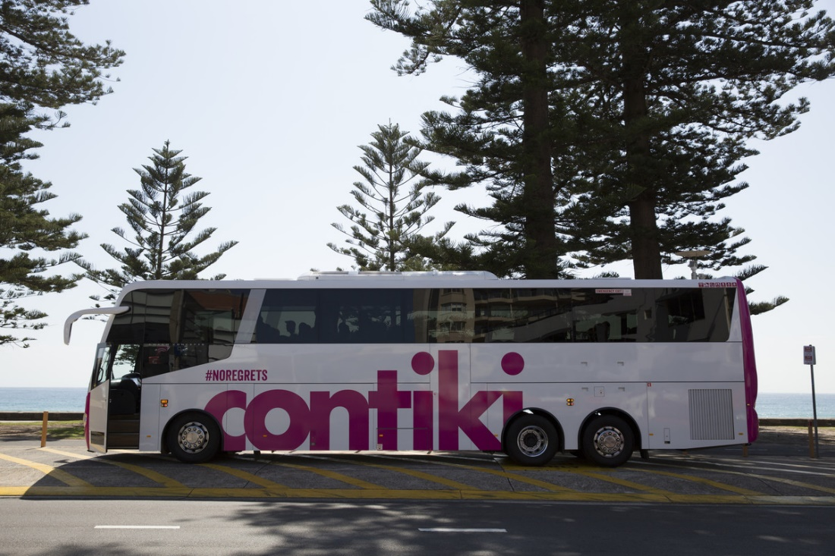

Then the travelers cheered again as they had a fun-filled conversation with the tour guide about where they will travel during the tour and will gain and step out of their comfort zone.

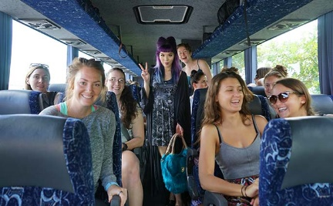

United then met a girl on the first day of the tour. Her name was Wendy, and she was from Seattle, Washington. She was shy at first but overcame it by talking more about Malaysia.

Minutes passed, and they safely arrived at the hotel to check-in.

The tour began when they began a night at the Fave Hotel.

And before they were assigned to the room, they were first given the number by the participant.

And after 15 names and numbers were called, United was called and was assigned as a number 65-447. And she was given the room with Sandrine and Saudia.

Xhamster smiled as she mentioned, “United, you will be staying with 2 other girls.”

“Thank you.”

“Here we go. The room is on 3**, so we have to find our room together,” United said. “Let’s come with me.”

United smiled, gave the hotel room card, and went to the room with 2 girls.

“Woohoo! Thank you.” Sandrine chuckled.

Soon after, they have free time around the neighboring area before their welcoming dinner, scheduled for around 19:30.

Soon after the welcome dinner, United checked the email. Contiki sent the email, and United received it days before the tour.

Malaysia and Singapore Highlights

It has all of the detailed itineraries:

Day 1: Welcome to Langkawi

Afternoon: Waiting at the Langkawi Airport and free time
Evening: Welcome to dinner and free evening

Day 2: Langkawi

Morning: Langkawi Skybridge (free time and lunch on your own)
Afternoon: Kilim Geoforest Park for a 14:00 tour
Evening: Optional - Sail the islands of Langkawi on a luxury catamaran with BBQ buffet dinner - MYR 280

Day 3: Langkawi to Penang

Morning: Sail a ferry to Penang with lunch on your own time
Afternoon: Melaka and George Town, Historic Cities of the Straits of Malacca
Evening: Free time around Penang’s Street and dinner

Day 4: Penang and Cameron Highlands

Morning: Independent travel around Penang (Georgetown)
Be sure to ask the tour guide where you are heading around Georgetown.
Free lunch at your own time
Afternoon: 3-hour drive to Cameron Highlands
Evening: Taste a selection of traditionally steamed dishes at a ‘Steamboat’ dinner in the Cameron Highlands, Malaysia

Day 5: Cameron Highlands to Kuala Lumpur

Morning: Take a tour of Malaysia’s lush tea plantations in the Cameron Highlands and then take a 3-hour drive to Kuala Lumpur
Afternoon: See Kuala Lumpur’s hotspots, including the Petronas Towers, on a guided city tour
Evening: Free time in Kuala Lumpur

Day 6: Free time in Kuala Lumpur

Morning: Optional - Guided Tour of Batu Caves (3 hours)
Afternoon: Free time in Kuala Lumpur and a group lunch
Evening: Free time in Kuala Lumpur and dinner on your own

Day 7: Kuala Lumpur to Singapore

Morning: Flight to Singapore (10:30 flight on Singapore Airlines)
Afternoon: Guide Tour around Clarke Quay and walking tour
Evening: Chinatown, Marina, and Gardens by the Bay for the light show

Day 8: Farewell to Singapore

Morning: Reflection from Malaysia and a day in Singapore

She was excited to get ready for the next day as some girls were the only ones slow to get ready.

..and United went to sleep at 22:35...

... and some girls were off to bed at 23:30.

Day 6 – Langkawi Day
The next day at Langkawi, most girls were still sleeping. Still, the only girl from the other room, Alinia, just woke up at 06:15, quietly eating the granola bar she had brought for herself.

Then after 07:25, United woke up, got dressed, and brushed her teeth. She finally did her long hair and face. She was dressed in casual clothes with her ponytail.

It was around 08:00. United and others were headed out for breakfast.

Bringing items (including a navy collapse bottle) she needed for the day, she was ready to head for breakfast. Some had already had breakfast before 8am. Hence the tour was already covered for 7 breakfasts.

After eating breakfast together, the Contiki tour bus was parked in front of the Fave hotel. United and other Contiki participants ate breakfast at the hotel before getting on the bus for a fun morning and afternoon.

While they were still waiting for the participants to get ready for the day, another girl, Flannelynn, walked around the hotel lobby. United had some snacks to eat to have enough energy for the day. She also has her bottle of water filled up because she noticed today was an exciting day to explore the Langkawi Skybridge.

And it was time to head to the Contiki tour bus to the Langkawi Sky Bridge.

It is then scheduled to depart the hotel at 9:00.

Suddenly after the driver had breakfast and refreshed, they discussed where they were headed for the day according to the itinerary.

Carrying her breakfast, Sandrine met her while finding a seat and asked,

“Hey, good morning, Sandrine! What’s up?”

“Nothing much.”

“How’s a good night’s sleep?”

“My good night’s sleep is good, and the other two girls were sleeping with no distractions. You?”

“Mine is okay and wasn’t a distraction, per se. It is a smoother sound, and they were reticent.”

“Good to hear,” Sandrine expressed joy while looking at the email about today’s tour.

Eating breakfast together, she asked her, “Excited for the Skybridge?”

“Of course. We are going there today. Woohoo!”

“Yay. We are going there. Take funtastic pictures.” United smiled back.

Just then, a private Contiki Tour bus was soon to pick up the girls from the Fave Hotel to Langkawi Sky Bridge.

Then the bus headed north toward the west side of the island of Langkawi and had tickets ready to distribute to participants for entry.

At around 09:30 opening time,

United and the group of 6 were the first to get on the cable car.

Riding the Langkawi Cable Car together, Sandrine and United each take pictures while laughing at one of the girls.



A tall, blonde girl named Saudia hasn’t experienced the all-in-one travel sense since working back home. But she was now enjoying herself together and said, “Woah, we are up in the air.”

“Yeah-yes! It is like we are picking up the line.” United laughed and commented. “Weeeeeee! Here we go.”

“Yes. Let’s take more pictures together.”

Picking up their phone, United held her Galaxy S9 phone, captured the all-green forest over them, and said, “It looks like forestry.”

And…

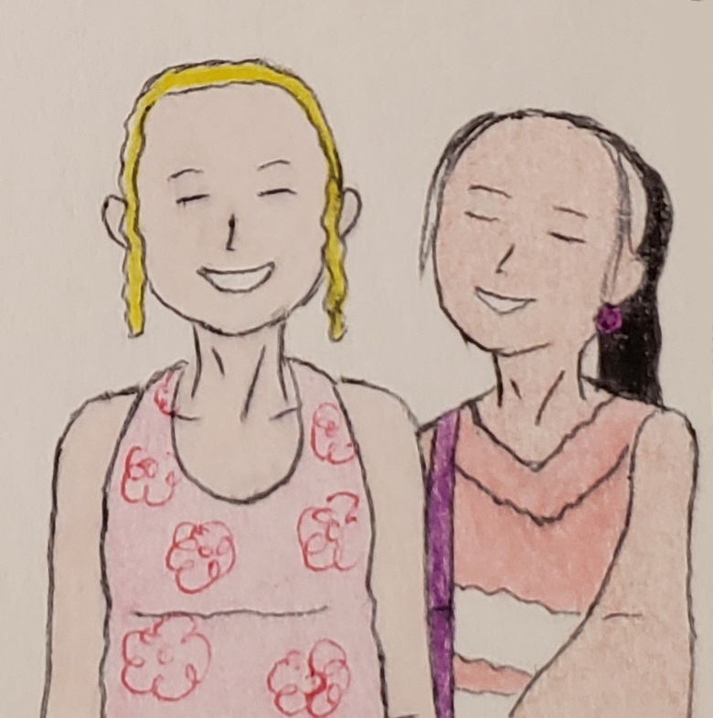

Saudia and United took their selfie while riding the cable car.

...and she posted on Instagram.

Once they arrived at the Skybridge minutes later, the tour operators Fanny, Gavin, and Xhamster requested departing the parking lot at 13:15 to have enough time to explore Kilim Geoforest Park.

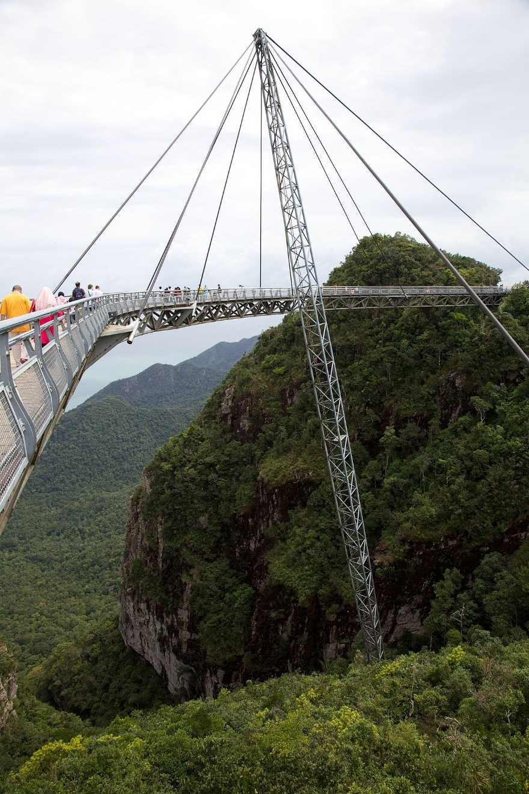

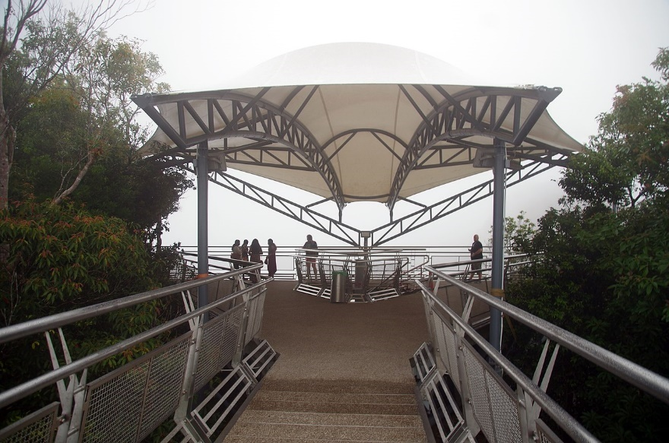

United was alone, taking this picture before sauntering on the sky bridge.

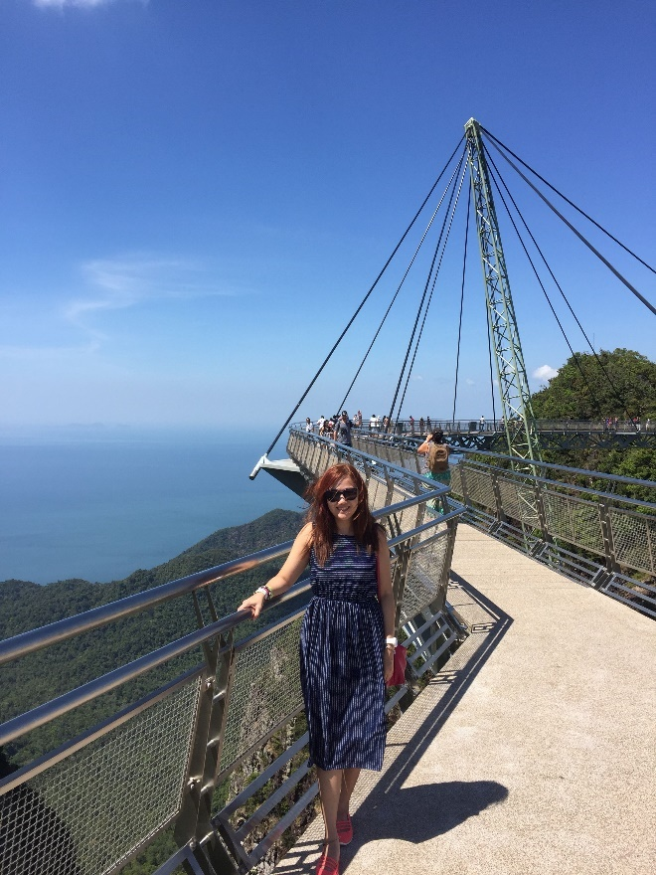

One of the tour operators (Fanny, above) was, too, enjoying herself.

Suddenly after their fun of exploring alone at the Skybridge, United brought it as a gift. It was an excellent memory, and both girls, Wendy and Sandrine, brought gifts and souvenirs for the family back home.

Then suddenly, United took the 15-min cable car alone with some unknown passengers to the other side of the station. But unfortunately, it was not time to return to the meeting spot, just after she had already eaten a quick lunch. It was 11:35.

“Now, it is time to visit Langkawi 3D Art Museum.” She said while relaxing in the cable car.

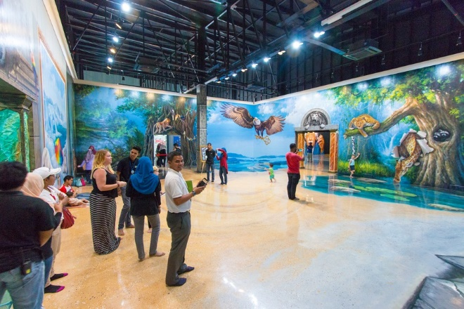

The girls United, Sandrine, and others were already at the Langkawi 3D Art for a quick theme of fantastic photos.



Then, United asked Sandrine to take the picture, posting it as “stepping into the hole.” And she smiled and took a picture.

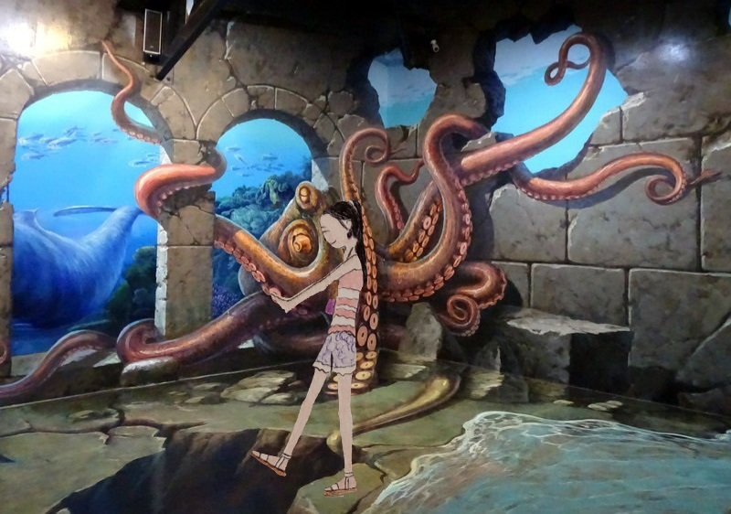

Then just after 13:21, they were scheduled to drive to Kilim Geoforest Park, where they planned for the afternoon tour at 14:00.

At the same time, they were first going on a speedboat ride. United and others were excited to get on the boat with their participants.

Some girls give her some time alone to refresh their minds while on tour at the Bat Cave (Gua Kelawar).

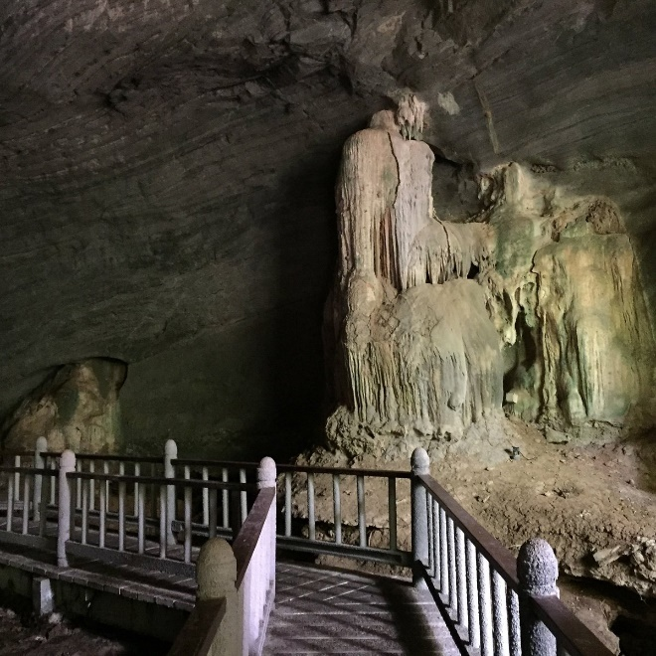

Later, they were off to The Floating Restaurant and Fish Farm, where both United and Sandrine took pictures of the scenic view.

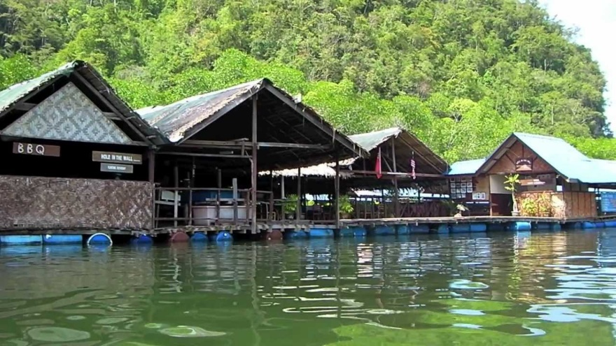

And they went to Crocodile Cave (Gua Buaya), Brown Eagles, and The Faces and Shapes of Kilim.

At around 18:17, they were ready to head back to the Fave Hotel since United, and 11 girls decided not to sail the islands of Langkawi on a luxury catamaran with a BBQ buffet dinner.

Driving south of Highway 112, they took pictures of the beautiful view. It was the mountain and terrain.

Then the tour guide announced that the check-out time for the hotel was at 09:00, so they could travel to Penang via the ferry.

Shortly after they got off the Contiki Tour bus, some returned to the hotel to settle down. The rest of the 23 girls were scheduled to have dinner at the luxury dinner at around 19:30, so they had enough time to relax and take a short nap.

Showering quickly, United was in the hotel room.

She was not alone in the same hotel room. Another girl named Susie also decided not to go on a luxury dinner. Instead, she and United chose to eat their quick dinner together in the hotel’s restaurant.

At the dinner restaurant, some girls and she had some conversation together.

While she was eating a quick dinner, she opened the blog journal and wrote,

November 1st, 2021

Day at Langkawi:

Today, we settled on a dream-filled trip to Langkawi’s Skybridge and said, “Woohoo.” The other girls were thrilled and excited to be part of the travelers’ bubble. They talked more about visiting the Langkawi 3D Art...

Back in the hotel room, she looked at the photos of Langkawi SkyBridge and sent some pictures in text messages to her parents. She said, “Girls on Langkawi Skybridge.”

After hours of free time, 23 girls returned to the hotel at around 21:33 with full bellies. United and Susie took a quick nap on the hotel bed, getting ready for the day.

Another girl named United S returned to the room and said, “The food was delicious, and it is the best food I ever had.”

Then around 23:00, all 3 girls went to sleep with the lights off. They were chit-chatting with their food and sharing food photos.

Day 7 - Sailing to Penang
As the girls checked out at the Fave hotel with their luggage, they were excited to travel to the new place they hadn’t experienced - Penang.

Another girl named United S felt tired when eating breakfast in the hotel dining room.

Yarning, she couldn’t get enough sleep because her roommate woke up in the middle of the night, went to the bathroom, and...

...she mumbled, “Around 2:20, my stomach wasn’t feeling good, and I had no idea what I ate something last night... and I threw up, and I have no idea what triggered this.”

“United, are you okay?”

“I am okay, thank you for asking.”

“Need any meds or remedies?”

“Nah, I am good. I am better.”

United’s parents have told me to “taking care of yourself is the most important priority.”

Tip: Before ordering food, it is essential to know where it comes from. It is crucial to request peeled and washed items for fruits and vegetables. For meats, ask for a well-done meal. Never eat uncooked meats and seafood as they can get sick quickly. You don’t want your sickness to ruin your dream vacation.

Not Recommended: Forgo self-care and your health. Taking care of yourself is not only for your solo travel goal but for the rest of your life. In addition, your health depends on your unique strengths, so loving and accepting yourself is utterly essential.

While standing, vlogging on Instagram, “Hello, I am back. I am here to learn more about solo travelers’ health and wellness. Speaking of that, taking care of yourself is all it takes. Self-care, nourishment, meditation, and loving yourself are all equally important. Unfortunately, solo travelers sometimes forget to take care of themselves, so it is a “Don’ts.””

And she posted a video of herself feeling energetic.



And they were at the seaport, waiting together for the 10:30 departure, Wendy laughing together with United. Then Sandrine joined in a conversation. She talked more about Penang.

At the seaport, the announcement was finalized for the departure to Penang.

Looking on Instagram, Sandrine posted with a caption, “Bye-bye, Langkawi. See you soon.”

After they boarded the ship with the emergency lecture, they were seated together.

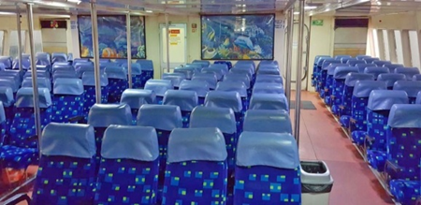

Then there was an onboard video, but they were not worth watching. And many passengers were reading a book, and others were just listening to music.

And others were just taking a quick nap.

It was freezing inside, and United wore a light purple sweater.

Minutes later, after departing the island of Langkawi, another Contiki participant, Neil, mentioned,

“The tour guides let us know that the ferries are air-conditioned and often the temperature is way too low. So we suggested bringing something warm to wear to keep us warm.”

“Yes. The air-conditioned ferry is colder than expected, so I also brought a navy blue jacket.” Another Contiki participant Hannah added.

As the ship was cruising, the Contiki participants were excited to sail to the other part of the Island – Penang.

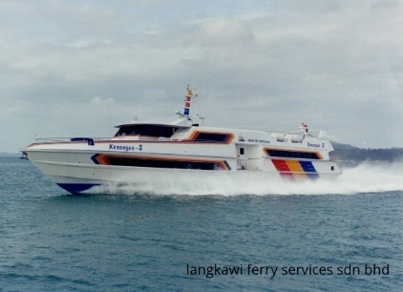

United listened to the music while writing her travel blog about Malaysia “Why is Langkawi a “Dream” place?”

Bring some snacks with them. Wendy ate the granola bar she had brought from her hometown.

United was also hungry, so she ate the candies she had brought before coming to Malaysia.

Thus, the ferry passengers didn’t sit or stand outside on the deck. Instead, they hang out inside the deck, standing and sitting.

They were still sailing to Penang, and the Contiki participants were hanging inside the ship.

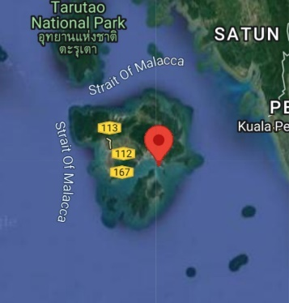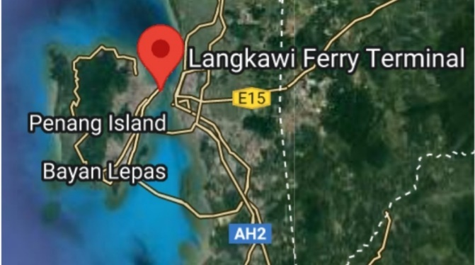

3 hours later, they safely arrived at the island of Penang and immediately took the Contiki Bus to the hotel for check-in. United was excited and talked more about Malaysia to tour guides after checking in at a Neo+ hotel.

Fellow participant United S didn’t know what to expect because she had too much time exploring and discovering places. In addition, she was too busy taking many pictures.

30 minutes later, they were back on the bus, traveling to Georgetown UNESCO Historic Site and the Street Art and Temple in a group of 34 participants.

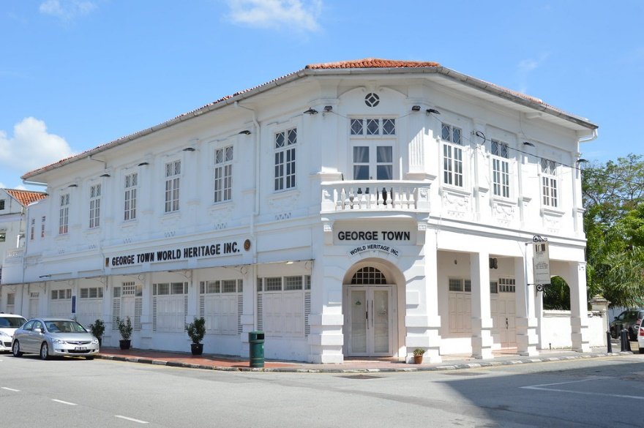

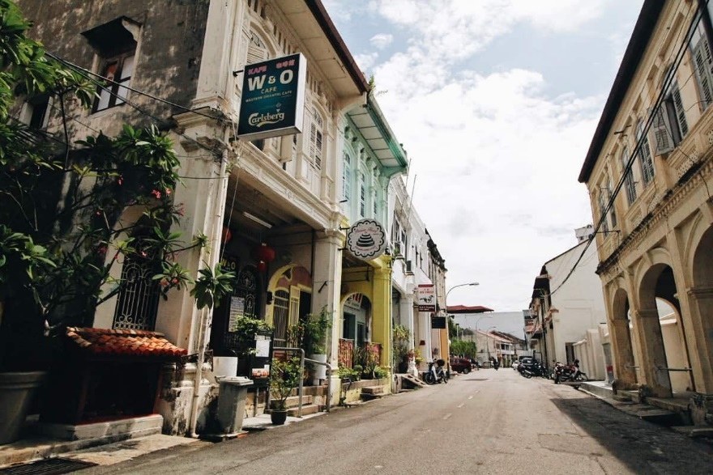

At the site, the girls, United, Wendy, Sandrine, and Saudia, took some time to discover the place and educate on why Penang is unique, lectured by one of the tour guides, Xhamster. They were given the information and took turns answering the questions.

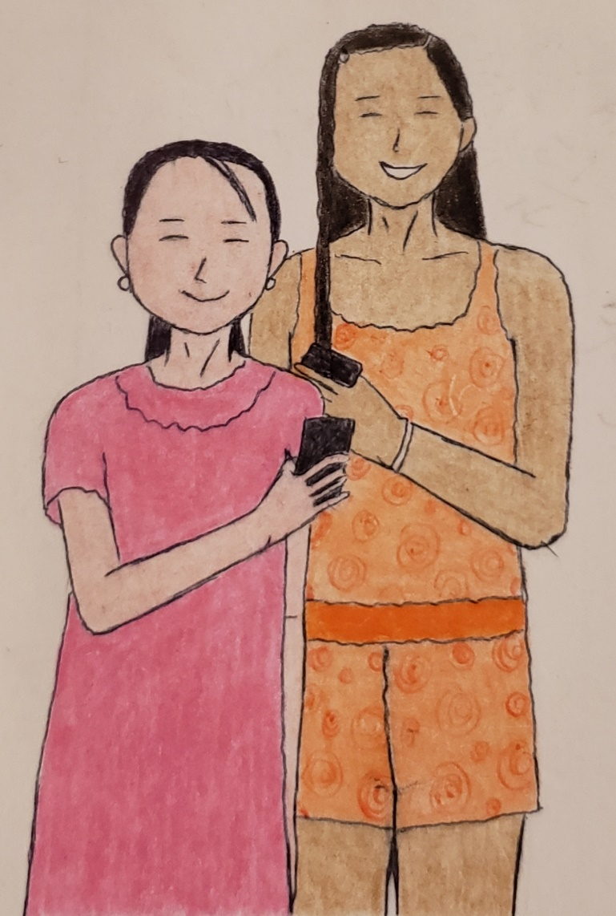

United gave Sandrine a picture sharing on mobile sharing and on Instagram. Now, they became fellow travelers.

Several minutes later, they only stick in the area alone and as a group, talking and having a casual, educational conversation about the culture. Others were walking freely and taking some pictures.
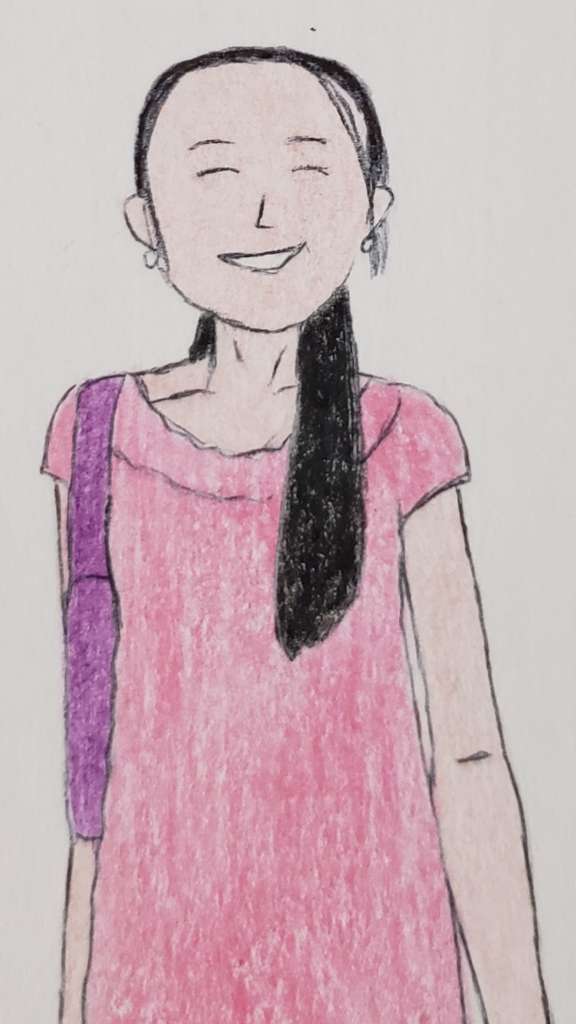

Then United and others split the group to explore on their own and at their own pace to visit the store and outlets.



Wendy requested United to take this picture at Georgetown's UNESCO Historic Site (Street Art).


Pretty soon, they returned to the bus and dropped the participants at the Kimberley Street Food Night Market for the spicy eats (dinner).

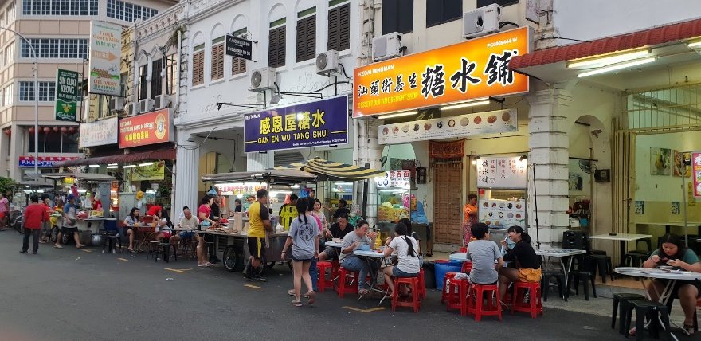

Kimberley Street Food Night Market

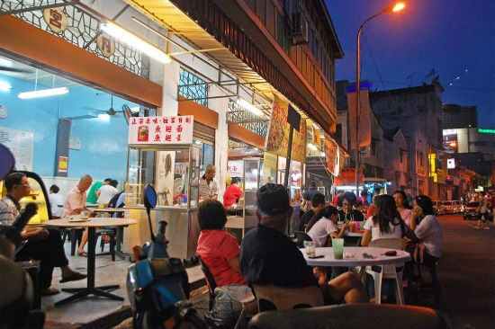

United, Sandrine, and Wendy eat together at the Kimberly Street Food Night restaurant.

After dinner, they have free time to explore on their own or as a group and enough time to explore as a free night.

United and 13 others have decided to head back to Neo+ Hotel together with the tour guide’s permission. The hotel is about half a kilometer away. Others decided to take a short Contiki bus back to the hotel.

And finally, they relaxed and prepared for the next day’s tour.

Day 8 – A Free Time in Penang + Cameron Highlands
It was a warm morning when United dreamed of riding on a regional rail. She missed Philadelphia, but only a week left before she returned home. She was both excited and homesick too.

Feeling lonely, she was not alone. There were 35 Contiki participants there to have fun together.

Texting her parents, she sent some pictures of Georgetown’s UNESCO Historic Site and Street Art. Then, she texted, “Enjoying the new people I met - Sandrine, Wendy, and Saudia. We also sail from Langkawi to Penang.”

United got dressed in plain clothes with a hair bun for the day.

And finally did her face before heading for breakfast.



Still no response, she grabs breakfast and eats with her new friends. She met Sandrine and Saudia.

And…

…her father texted, “Nice, looks like you have a good time.”

United texted, “Dad, today we are still in Penang and later headed to Cameron Highlands for the Steamboat dinner.”

After the group had a hotel breakfast, United and others independently checked out a Neo+ hotel.

Some were with a guideline.

Loading the luggage onto the Contiki tour bus, they walked to Penang Little India and had free time.

Then United talked to one of the female tour operators about Penang.

A short moment later,

She talked more about “Why is Penang unique?”

“Well,” Xhamster said. “Penang is a beautiful, vibrant place for both residents and visitors... It is one of the unique places with many sights and scenery to see. It is undoubtedly eye-blowing since you can explore...”

“Yes. Xhamster, where we went to see once we caught it.”

“That’s an excellent question... you can look at the view of Market Street (Lebuh Pasar).”

“Aha! Can’t wait to show the picture.”

And the group decided to split up for a brief moment and take some pictures.

United and Sandrine were hanging around the small island of Penang solo. United headed to Armenian Street to glimpse different cultures while others were just hanging in small groups.

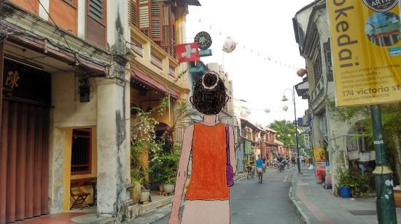

And she was at the Indian outlet, shopping for “goods.”

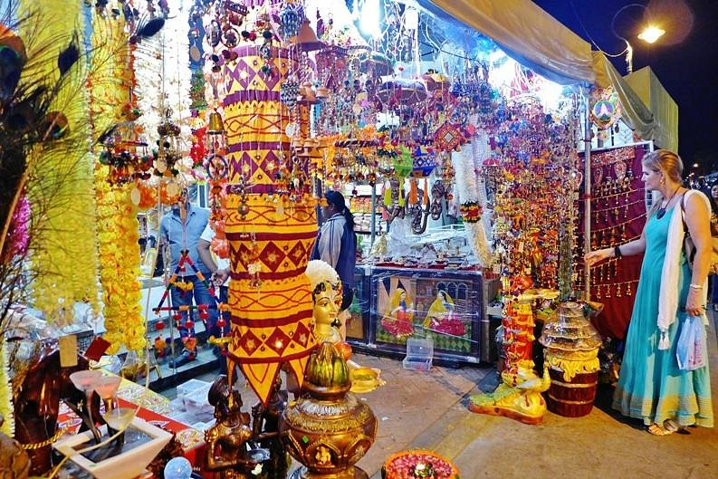

Another tour traveler, Quinlan, was not afraid to “explore on her own.” It is her first time walking solo abroad without her parents.

She was hanging out at the Penang Street Art and took her breeze in the morning.

She was brave to have an opportunity to explore “on her own.”

Minutes later, United walked back to Penang Little India, she took pictures of Market Street (Lebuh Pasar).

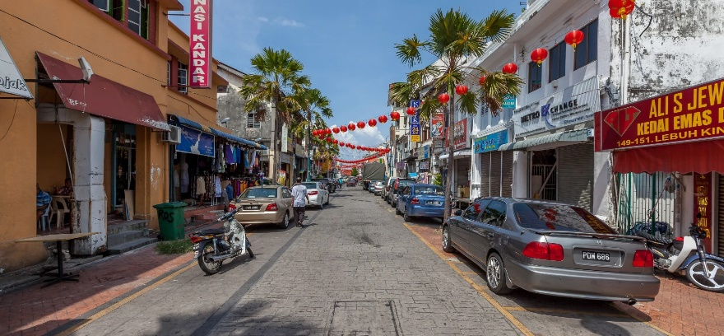

Later at 12:00, she and others brought a quick lunch while many travelers stopped by to grab lunch before boarding the bus. United was hungry and ate a bun she brought from the streets of Penang Little India.

Boarding the bus at Penang Little India, they headed to Cameron Highlands.

Crossing the N36 route bridge, United and others listen to the fun lecture for a brief conversation.

45 minutes later, they took a quick nap right after eating their quick lunch and...

...soon after a 4-hour bus ride, they settled at Cameron Highlands, got off the bus, took a quick excursion, and checked in at the Nova Highlands Resort Hotel.

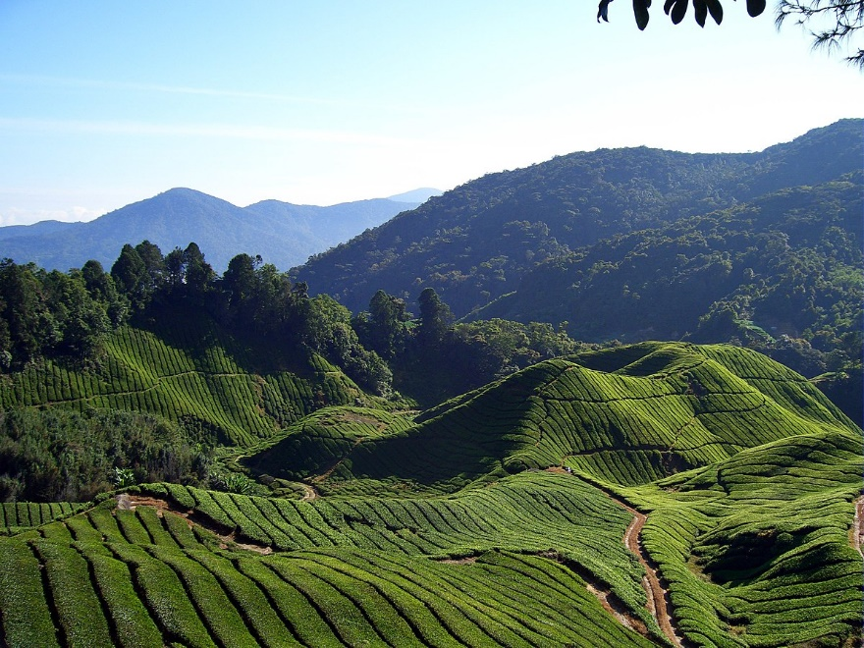

Cameron Highlands

Then they had a “Steamboat” dinner, scheduled at 19:00, with the locals at Restoran Taman Apple Cameron Steamboat & Grill...

...and they have opportunities to create their taste bud’s adventure.

Having their conversation, United and Sandrine learned about their different culture in the Cameron Highlands.

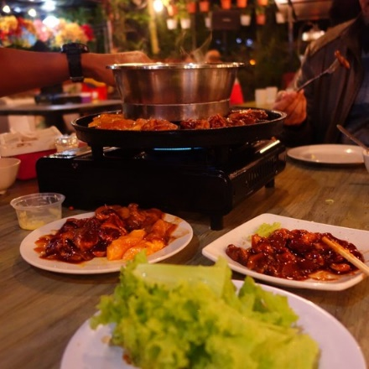

At around 22:00, after the free evening at the Tanah Rata, they returned to the hotel resort, enjoying their free time until bedtime.

Day 9 – Cameron Highlands Experience + Off to the Capital, the KL
It was a foggy morning in Cameron Highlands as some participants woke up and had a hotel breakfast.

United yawned while she slept well; some of her roommates, Saudia, had already woken up and dressed for the day.

As United and Contiki participants brushed their teeth, United picked an outfit for the day. She then dressed in blue and white striped tops and blue denim shorts.

“Okay, I am finally leaving my hair down today.” She finally did her face.

And they had a quick breakfast at the hotel before heading for the bus.

Just then, they headed to the lush tea plantations to tour around Cameron Highlands together.

First, they took off to Cameron Adventurous (Kuala Terla Tea Plantation), where they first learned more about where the Kuala Terla Tea came from.

Took a ride on the ATV, and some decided to take the jeep to get to the Kuala Terla Tea Plantation.

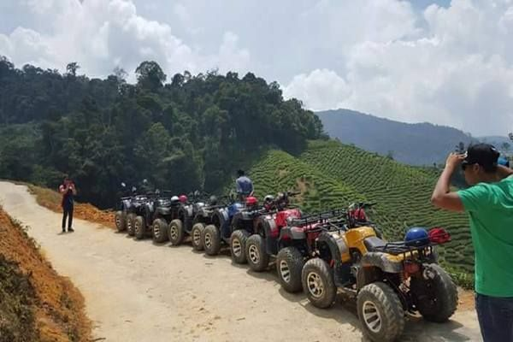

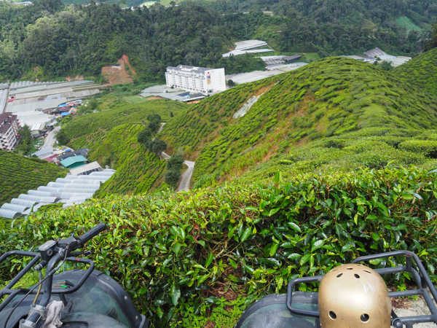

United hadn’t experienced a ride on an ATV, so they decided to take a positive risk.

Along with United, Sandrine, Wendy, Saudia, and 15 others have experienced an ATV ride.

Sightseeing together, they discussed Cameron Highlands culture and its importance in Malaysia.

Then after the experience, they headed to the Cameron Valley Tea House KT to buy some tea to bring home.

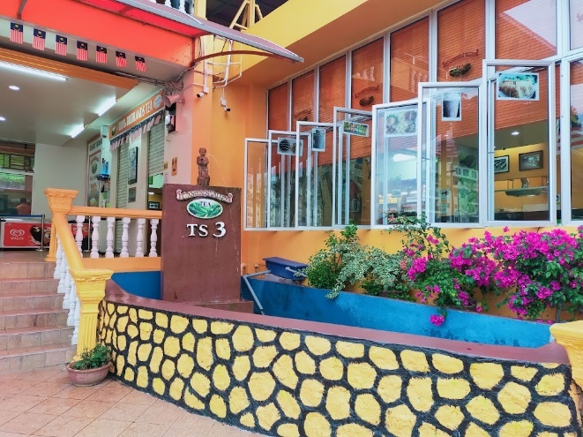

Hence, they have some free time to explore for a short time before heading on the 4-hour bus ride to Kuala Lumpur.

It was when a tour guide, Shannon and Xhamster, had a fun lecture about Kuala Lumpur about a 30-minute discussion. They then laugh together, playing some games...

...and many were taking a nap on the way to the capital.

Then after a 4-hour ride, they safely arrived at the capital – Kaula Lumpur.

Minutes later, they checked in at the Swiss Inn Hotel and settled for an afternoon before the group excursion.

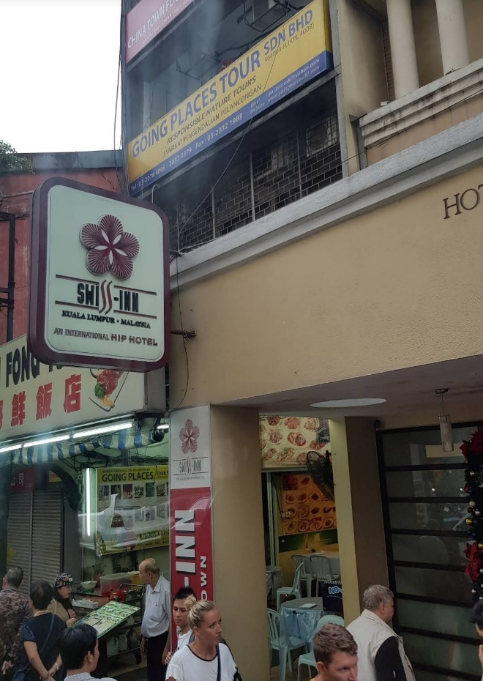

United was assigned to stay with 2 other girls named Saudia and Heather. They were having a good time together.

Around 16:30, they were walking on a group tour swiftly and excitedly.

Soon after walking to the Petronas Twin Towers, they decided if they wanted to climb up the towers.

Many had the option to explore inside and climb up the towers.

United looked together and said, “Xhamster, I am taking myself a picture.”

“Certainly.”

“Thank you.”

And she took from United’s phone and took a couple of pictures.

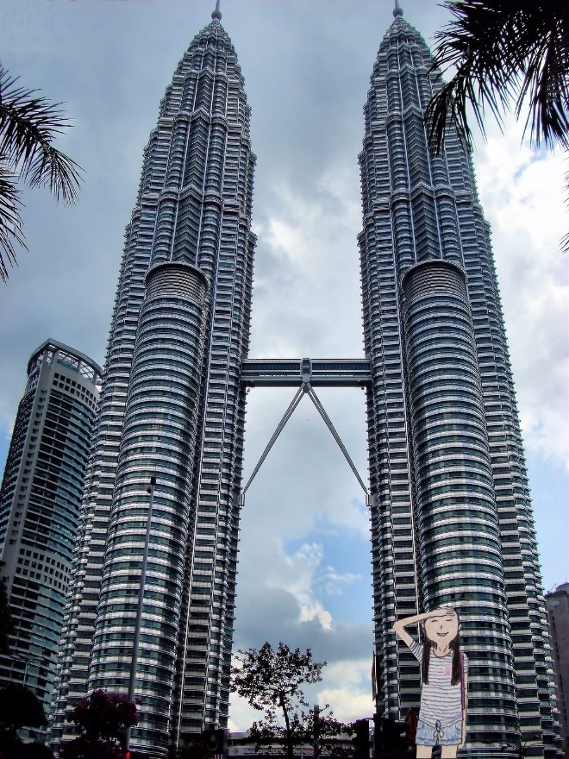

Suddenly, they headed inside, and United and her Instagram follower Sandrine decided to climb up the towers. Hence, the tour guide purchased the ticket for the participants interested in climbing up the building.

The ticket was RM 28.00 and was paid by using MyKad.

Just then, 23 out of 35 participants climbed up the towers. The other 11 stayed inside the cooling shopping area, where they hung out with the other tour guides.

Taking the picture, United saw an overview of Kuala Lumpur.

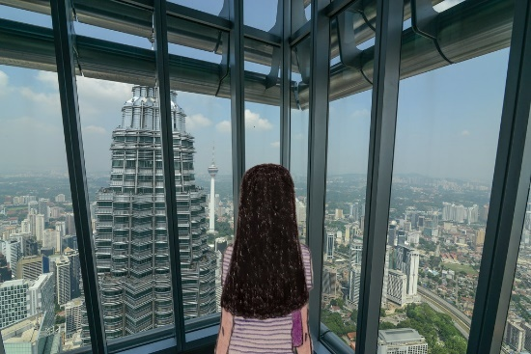

She took her time to view the 360-degree view of the Kaula Lumpur and took a picture of the observatory.

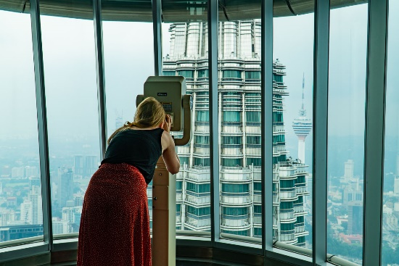

Fellow Contiki participant Quinlan also enjoyed viewing the observatory.

Pretty soon, it was time to have dinner together at Jalan Petaling and Chinatown and a free night out as a group.

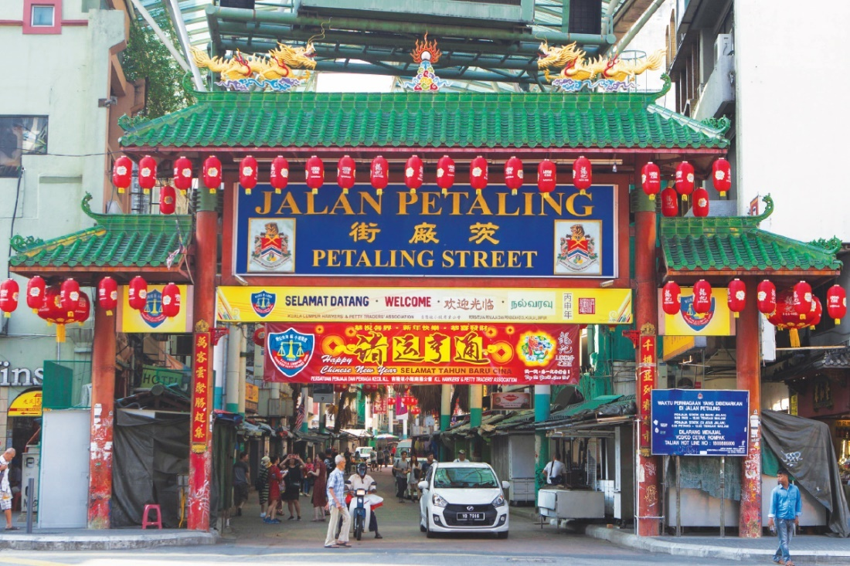

After dinner, United decided to spend a free night with Sandrine, Sandrine, and a tour guide, Xhamster, who enjoyed conversing about their food. However, moments later, they realized they had eaten full-on street food.

Moments later, United requested Xhamster to take a picture of Petaling Street - Chinatown with her new friends, Saudia and Sandrine.

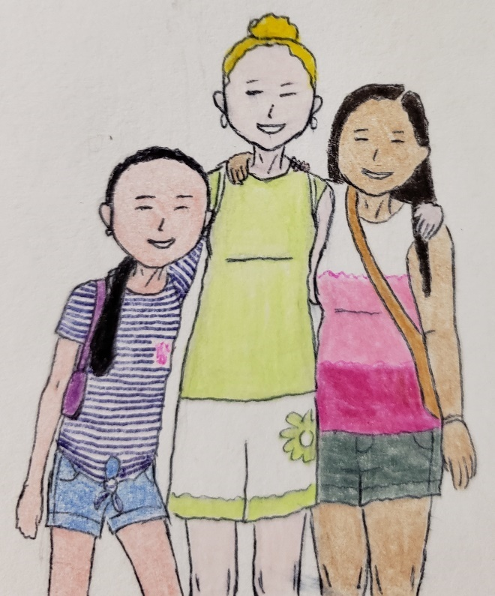

Just then, they finally headed back to the hotel at around 21:35 together, relaxing in the room, taking a quick shower, and preparing the clothes for the next day.

United was excited to travel to Batu Caves, which she initially signed up for after making a payment to Tourradar.

Day 10 – Free Time in Kuala Lumpur + Batus Caves
It was early in the morning in the city when many were still asleep. Nevertheless, some were excited about the remarkable exploration, including Batu Caves for some participants who signed up for the guided tour.

United just woke up, deciding which dress to wear because the activity requires dressing in a specific look, such as covering up the shoulders.

“Okay, now I know what I will wear, this long dress with coverings, just to ensure the dress code is in place.”

Her roommate, United S, and Saudia got dressed and ready for the day. Unfortunately, only Saudia decided not to come to Batu Caves because she was diagnosed with heart conditions preventing her from intensive exercise.

Then United and United S had breakfast, chatting with the new person named Henry. He was also a solo traveler who traveled to Thailand before joining a group tour. This is also his first time in Malaysia.

Unfamiliar with the place, he decided to join a day tour of Batu Caves. Also, he didn’t know why he signed up for the Contiki tour because he said, “I decided to go on a trip to Malaysia.”

Scheduled for the cave, they were super excited later in the morning.

United recalled signing up for the day tour in Batu Cave weeks before departure.

Checking the email, it said:

Your scheduled tour from Viator:

Batu Caves Tour from Kuala Lumpur

Overview Pack in some of Malaysia’s most cultural sights during this Batu Caves tour from Kuala Lumpur. First, take time to explore the caves and its Hindu shrine. Then, head to the Malaysian Batik Centre and Royal Selangor Pewter Visitor Centre to learn about some of the country’s most essential handicrafts. This tour of Batu Caves includes all entrance fees and round-trip transport.

• Batu Caves tour from Kuala Lumpur

• Be greeted by monkeys at the Batu Caves

• Climb the 272 steps that lead you into the spectacular caverns

• See the art of Batik silk designing, and learn about pewter arts at the Malaysian Batik Centre and the Royal Selangor Visitor Center

• Hotel pick-up and drop-off included

What’s Included

• Hotel pick-up and drop off

• English-speaking driver and guide

• Doesn’t include food and drinks

• Doesn’t include Gratuities

Departure & Return

Swiss Inn Kuala Lumpur, 62 Jalan Sultan

Pick-up Time

After booking, the operator will contact you about the pick-up time.

Please Note

We pick up from city hotels in Kuala Lumpur.

What To Expect

Your cultural tour of Malaysia kicks off with hotel pick-up. Meet your friendly local guide and professional driver in Kuala Lumpur and begin this memorable Batu Caves tour.

The scenic drive ends at the Batu Caves. These natural limestone masses are home to Hindu shrines that house various religious deities. Learn from your guide about the deep Hindu roots of this nation as you make your way up the 272 steps to the golden Lord Murugan.

Once you arrive at the top, head to Cathedral Cave—the largest in the complex. Your guide offers background on the significance of this space, which houses intricate Hindu shrines.

1) Batu Caves

Batu Caves is an iconic and popular tourist attraction in Selangor. A limestone outcrop located just north of Kuala Lumpur, Batu Caves housing temples and Hindu shrines. Its main attraction is the giant statue of the Hindu God at the entrance, besides a steep 272 climb up its steps to finally view the stunning skyline of the city center. Monkeys frolic around the caves. Batu Caves are an unforgettable excursion from Kuala Lumpur.

1 hour • Admission Ticket Free

2) Batik Chong

Next, we bring you to Batik Chong for a guided tour of how Batik is made. Take this opportunity to bring back a piece of Malaysia’s Handmade Batik as a souvenir.

30 minutes • Admission Ticket Free

3) Royal Selangor Visitor Centre

Royal Selangor is a Malaysian pewter manufacturer and the largest of its type in the world. You can also take a picture with the world’s largest pewter tankard, recognized by the Guinness Book of Records. In addition, you will be shown the different processes involved in pewter production.

30 minutes • Admission Ticket Free

Additional Info

- Confirmation will be received at the time of booking

- Not wheelchair accessible

- Not recommended for travelers with back problems

- Not recommended for pregnant travelers

- No heart problems or other serious medical conditions

- Not recommended for senior citizens

- Travelers should have a moderate physical fitness level

- This tour/activity will have a maximum of 15 travelers

-Operated by Tour & Incentive Travel

Cancellation Policy

- You can cancel up to 24 hours before the experience for a full refund.

- For a full refund, you must cancel at least 24 hours before the experience.

- If you cancel less than 24 hours before the experience’s start time, the amount you paid will not be refunded.

- Any changes made less than 24 hours before the experience’s start time will not be accepted.

- Cut-off times are based on the experience’s local time.

Wearing her navy top, long skirt, and grey sweater, she was ready to go with 15 Contiki participants.

She was excited to join her fellow travelers, including Sandrine and other Contiki participants. The excursion starts at 9am, so the tour guide will pick them up from the Swiss Inn Hotel at around 08:15.

United and 15 Contiki participants were excited to visit the place without their Contiki Tour guides on the bus. Still, the Batu Caves tour guide was around the participants.

The 15 participants relaxed on the bus to Batu Caves.

Upon arrival, United and 15 participants got off the bus and processed to the Batu Caves.

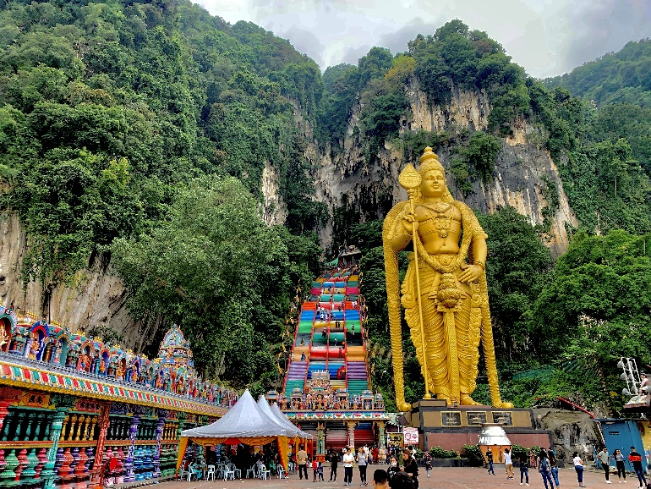

She saw almost all visitors wear pants or long skirts at the Batu Caves.

“I didn’t know the rules at this place until I researched this dreamy place - Batu Cave. It said there were no shorts, miniskirts, or items hanging above the knee. So I really knew what it was really like to visit there.” United familiarizes the place and expectations.

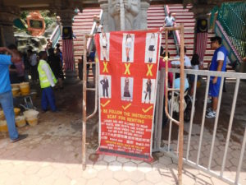

Then she proceeded into the cave with some of the participants.

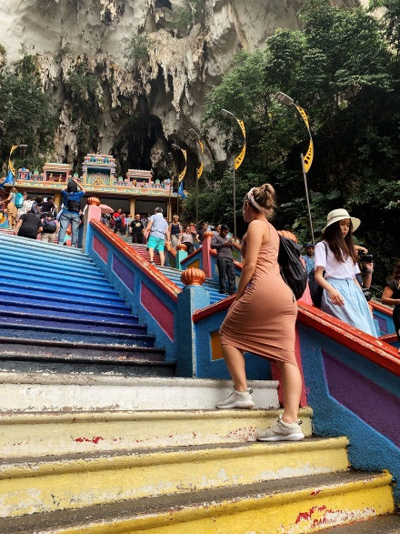

Then, inside the cave, she started to take pictures.

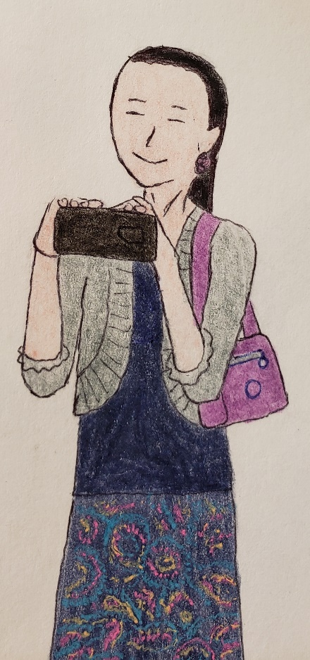

Tips: Always research places and include the dress code before packing your bags. Know what to expect so the visitors don’t offend.

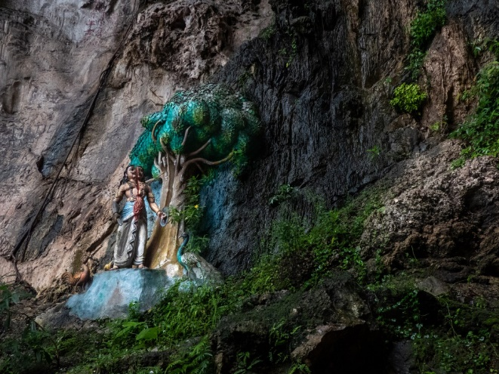

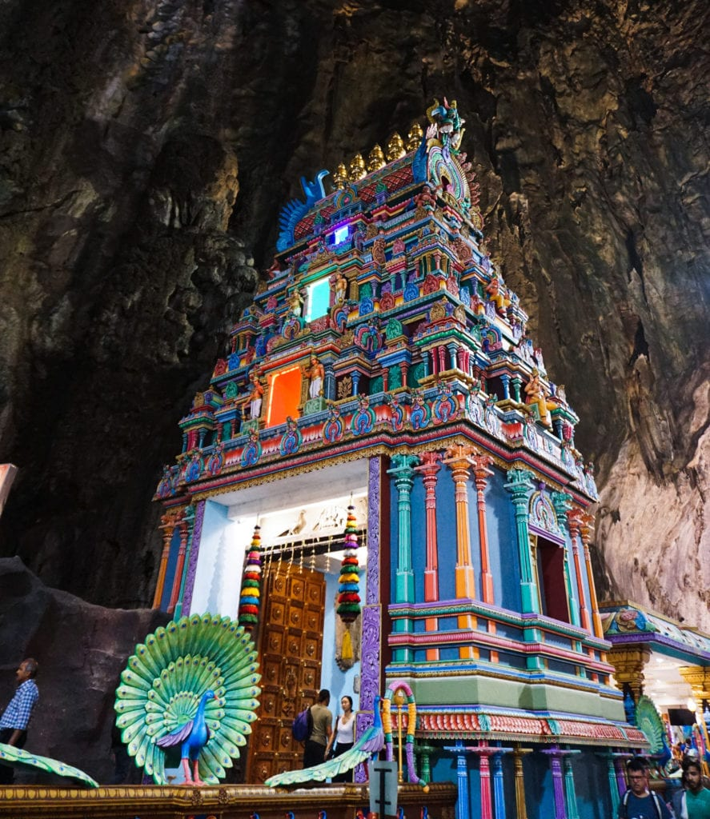

She took a picture of Batu Cave Temple with Sandrine.

Later, she traveled with Sandrine and was frightened that something was happening.

She was at the stairs and saw many monkeys present. United and the monkeys bothered United, Sandrine, and 5 others and tried to escape.

And after a few attempts, they tried to escape with much effort.

United said, “hey, Sandrine, the only way the monkeys will leave us alone is if we don’t have any food with them. So definitely, don’t provoke them, and don’t make direct eye contact. Never feed them. Just leave them alone, and you are good.”

“Good to know that,” Sandrine chuckled. “I didn’t know that monkey could do to us. You know that this place isn’t a convenience, but it is worth the visit. Use the buddy system, hehe.”

Laughing out loud, she replied back, “so do we.”

“Monkeys can be very entertaining to watch from afar and excellent subjects for photos. In addition, they tend to steal coconuts and bananas from the temples inside the caves, giving you enough picture material without having to feed them themselves.”

Hours later, United, Sandrine, and 15 participants safely returned to the hotel, ate some snacks, and relaxed.

After taking a short nap, United decided to go out with some Contiki friends around Chinatown Kuala Lumpur.

This time late in the afternoon, they each went to different free activities with a tour guide or as a group of participants and...

...all activities were granted tour permission for the group’s travel around Kuala Lumpur.

United, Saudia, and Sandrine independently hung out near the Jalan Sultan. They had a quick dinner at Chinatown Seng Kee.

Each took a picture of a stunning view of the place and food.

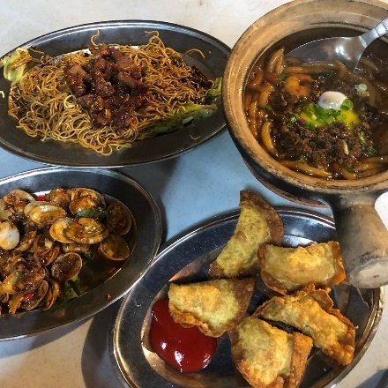

After their quick dinner, all 3 stick together, walking north and crossing the Jalan Tun Tan Cheng Lock, which was the boulevard.

And then went to the mall to shop at Kompleks Kota Raya (Kuala Lumpur).

As they enter the store, they each think about which items they want to buy.

Unfortunately, they have yet to buy anything and...

...looking at which way to walk, 3 girls saw a tour guide and 6 Contiki participants smiling at them and asking, “Hey, what are you up to?”

Saudia replied laughingly, “We are just walking around because we have so much to eat. It is so beautiful here, and we just want to explore together. That’s all.”

“Good to hear that... We just finished our dinner together, so we are walking around the area... Be sure to be back around 9.” United S mentioned.

“Great, we will see you then.”

They also took a picture walking toward the Medan Pasar Clock Tower (Old Market Square Clock Tower).

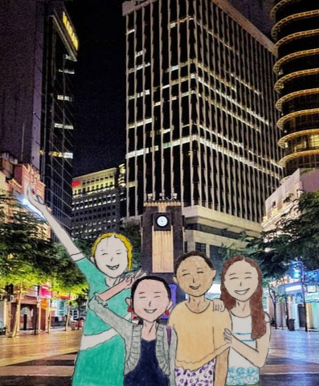

Left to right: Saudia, United, Sandrine, and Wendy were enjoying a night out in Kuala Lumpur. They were at the Medan Pasar Clock Tower (Old Market Square Clock Tower).

After a quick glimpse of the clock tower, they decided to head back to the hotel for relaxation because they felt it was starting to rain.

“Let’s headed back right now. It was starting to rain. What do you think?”

“That’s a great idea, Wendy.” United laughed. “Since we don’t have an umbrella.”

“Let’s go home,” Sandrine laughed back.

And all Contiki participants enjoyed a city excursion with a buddy system. They laughed as they took the final pictures before returning to the hotel before raining for the evening.

Then around 21:55, they returned to the hotel, showered, and went to bed. It was the final night in Malaysia before the short flight to Singapore.

Except for United, many participants hadn’t been out of Changi Airport before the tour.

Day 11 – A “Weeeeee,” Short Flight back to Singapore
It was Saturday morning in Kuala Lumpur a few participants were saddened; they wanted to stay in Malaysia and experience its Malay culture.

But unfortunately, the tour was scheduled for a flight to Singapore at 8:55.

They finally said goodbye to Malaysia when they checked out at the Swiss Inn Hotel and loaded onto the Contiki Coach Bus.

United and Sandrine conversed about Malay culture while going to the airport and...

...they independently check-in for Singapore Airlines.

Many participants were sad that their flight to Singapore was around 08:55. United was still unhappy to leave the place of a lifetime.

A few of them passed the security checkpoint with the assistance of Xhamster and Gavin.

Passing the security checkpoint, Sandrine, Quinlan, and Maggie tried to find the flight information and the gate location.

“Hey, our flight is at the gate **. We should go this way, so come with me.” So Maggie follows the group to the gate.

Minutes later, at the departure, United and Saudia were at the departure lounge, chit-chatting about plans around Singapore before leaving to go home.

Saudia mentioned that she would depart Singapore on Sunday, November 7, to return home. Then, she will take the SAS back to Copenhagen, where her hometown is.

All 35 participants and 5 tour guides passed through security for a 1-hour flight to Singapore.

However, it was not until another participant Xiamen, another Chinese girl, reluctant to leave Kuala Lumpur and Malaysia, started to cry.

With tears on her face, one tour operator (Shannon) comforted her.

“Are you okay, Xiamen?”

“Yeah. I am okay. I dearly missed the place and wanted to stay longer.”

“A tour guide comforted her and said, “Awwwwww, you are not alone. See? Many travelers were feeling that way. So you will have lots of chances to revisit Malaysia in the future... you will travel there in the future.”

“I don’t want to go home...”

“So do I.” She cheered her up. “And you are not alone. Everyone had the same feelings...”

Xiamen felt much better after a small talk to cheer her up.

On the short flight, United sat on the window seat after the trip organizer had flexibility in selecting the center at the Swiss Inn Hotel just before bedtime. On the plane’s left side, she was taking a picture of the plane’s wing. During the 1-hour flight, many participants laughed together. In addition, the tour guides were there together, discussing a Singapore tour.



Smiling herself, Saudia then chit-chatted with another female participant named Eliyahu. She then met more about Singapore after United suggested visiting the Maxwell Food Centre for dining in Chinatown.

Just then, United was chit-chatting with a tour operator named Xhamster. She discussed her solo travel to Singapore and suggested places such as Fort Canning Park, Toa Payoh Town Park, Chinatown, etc.

“Yeah, I just heard that Singapore is a beautiful city; I took many pictures before coming to Malaysia for the dream tour.”

“Singapore is my dream. Or course, there are many places to take pictures of Gardens By the Bay, especially at night.”

“Oh, I want to see the place once we land there.”

She had an experience when she traveled before joining the tour, including tips, tricks, and warnings to the public.

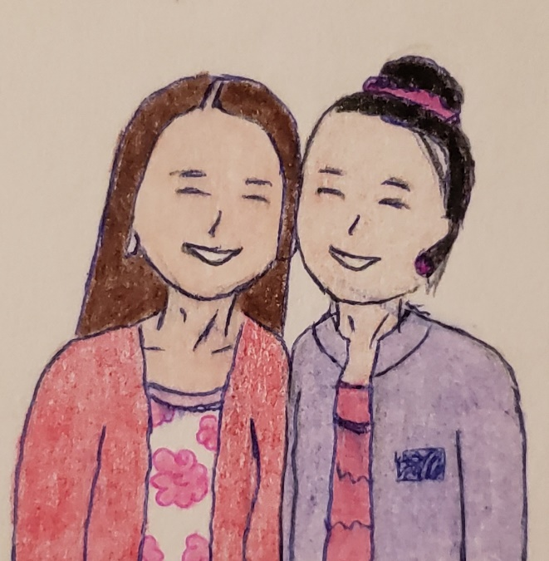

After the plane landed at Changi Airport, they disembarked the plane to pass through customs.

United was the only participant to successfully pass the customs. However, while waiting alone with some participants, they needed help passing the customs and needed their tour guides to assist.


And they were excited to go explore for one more day.

Smiling at herself, Sandrine hadn’t seen United since the beginning of the flight; now, she smiled while waiting for her luggage retrieval at baggage claim.

On the Contiki bus, they bussed again; this time, they were headed to the Singapore River.

They finally check for one night at Aqueen Heritage Little India Hotel before United has the option to explore independently in Singapore for 2 nights after the group leaves.

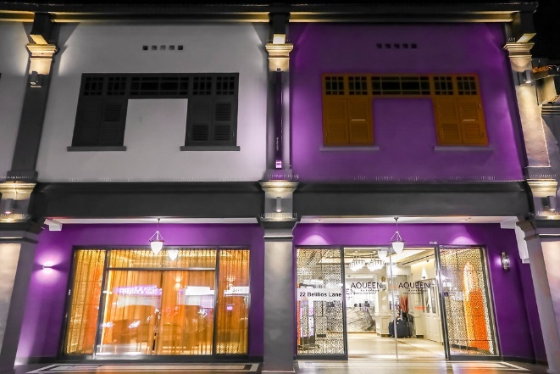

Then, they took the Contiki bus to the Singapore River together, enjoyed the first attraction, Clarke Quay, and took a group picture.

United and 34 others were joined in together.

And after the group picture, all of the participants have the option to send out a book about Malaysia and Singapore. United decided to purchase the photo album book of Malaysia and Singapore.

As she purchased the album, the album book will mail to her home in about 8 weeks.

United then guided some participants on the Clarke Quay tour with two tour guides, Xhamstar and Fanny. The two were very impressed when United had an experience when traveling to Singapore, and they knew her very well. She was also an expert in solo travel knowledge and safety sake of general travel tips.

Afterward, they took the Contiki bus to Chinatown, where they had a quick brunch. They finally spent the rest of the day at the Central Area, including Gardens by the Bay.

She then decided to teach solo travelers lessons with their travel guides before they took off for the free afternoon and evening,

“..I remembered that in the evening, it was safe for solo travelers. So I stayed at a hostel for 5 nights. I safely learned how to protect myself by returning to the hostel by 8:30 and have the ambition to teach solo travelers not to go out alone at night. Instead, the buddy system is highly recommended, and try not to wander away after dark because I will be scared...”

Advice: Even though Singapore is a safe city for solo travelers, I prefer to return to the hotel or hostel, or lodging before it gets dark. In other words, it isn’t safe to travel alone at night.

Recommended: Use a buddy system whenever possible in the evening.

As the Gardens by the Bay lit up colorful, some visitors and residents yearned to see the bright lights. Others, such as solo travelers, weren’t interested in seeing the beautiful lights despite safety concerns over traveling alone at night. However, United and others were enjoying the glimpse of light lit up.

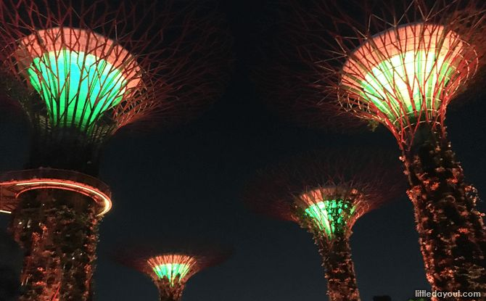

After around 21:30, they took the Contiki bus back to the Aqueen hotel for the night. United was in a hotel room with 2 girls; Xiamen and Saudia.

That night, her parents called her and had a short conversation, saying she was safely back in Singapore.

“Dad, I had a wonderful time in Malaysia and am still at the hotel...”

“That’s wonderful, United. Send me some pictures so we can share.”

“Thank you, daddy.”

After she hung up, she sent some pictures of Gardens by the Bay at night. Then she sent some photos of Chinatown, including the Maxwell Food Centre she went to on her arrival.

She then texted a final word, “I love you, see you in 2 days.”

And her mother texted, “Good night, love you,” and went to sleep at around 22:32.

Day 12 – Farewell + Little India + Specialized Gallery
After her fun days in Malaysia for an 8-day tour, 35 participants finished the fun tour in Singapore around 9:30. United wanted to extend their stay in Singapore.

Then, 28 participants were checked out, and United wanted to extend their stay for 2 nights by requesting additional nights.

“Hey, good morning. I would like to extend my hotel stay for 2 nights.

“Certainly.”

She handed in her passport, paid her cash of SG$135, and was assigned to a different room.

And she rechecked it on the 2nd floor; the room looked lovely and...

...settled down with her personal belongings.

Hence, she planned to spend a few days reflecting on the trip by exploring again before her departure. In addition, she had a good time with some of the solo travelers she met during the tour.

Since she had no plan to spend an entire day on an excursion, she was scheduled to do the laundry late morning after being assigned to a hotel room for 2 nights.

“After laundry, I am going to walk at Little India this afternoon, which I planned to visit as scheduled. I promise that the trip will come true again. Finally, I am also planning to visit the Singapore Mobility Gallery.” She laughed to herself after planning her itinerary with her laundry day.

A girl, Sandrine (now a friend), just checked out at the Aqueen hotel to catch the flight back to London via Qatar Airways. She was from Edinburgh, Scotland, and couldn’t wait to return home for her family affairs.

Texting her friend Sandrine, “Can’t wait to hang out again, la live...” she didn’t respond since she was still in the airport, ready to board the flight back to Doha in the evening.

While finishing her laundry, she planned to fold her clothes, put them into pink luggage, and have a quick snack before heading out.

In the afternoon, United went out of the hotel and visited Little India by spotting some places she hadn’t seen before.

She then retook the picture of Little India. This time, she dressed in her red dress, low ponytail, and “off-duty” hat, walking with confidence.



First, she spotted The Indian Heritage Pte Ltd, the Tan Teng Niah.

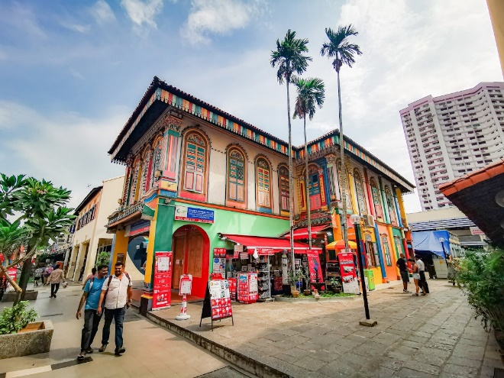

She took a picture of Tan Teng Niah, the historical remarks.

As she strolled along, she explored different Indian cultures and shops. So she studied some of the shops similar to Penang Little India a few days ago with some participants.

Soon after shopping, she spotted Sri Veeramakaliamman Temple and took a picture.

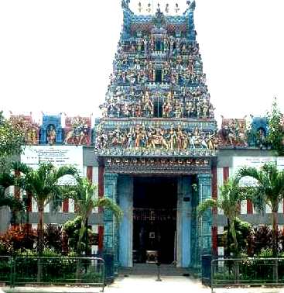

Soon after, she planned to visit the Singapore Mobility Gallery for a sleek discovery of the technology and free admission. She was booked in advance just before her trip to Kuala Lumpur.

Walking west on Serangoon Rd, she then right on Bukit Timah Road to get to the Singapore Mobility Gallery.

And she had access to the museum and discovered its new technology theme and...

...and said, “It is an eye-opener.”

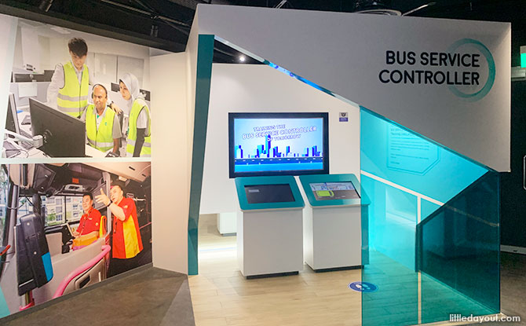

After the 75-minute tour, she took a quick stroll at the Tekka Centre, the shopping mall.

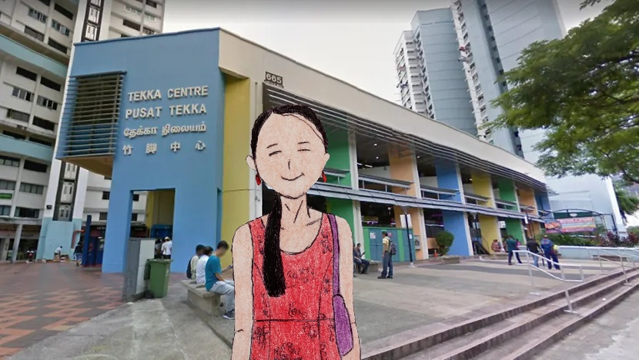

She then brought dinner at Ananda Bhavan Restaurant Vegetarian, took out, and returned to the hotel.

And she had dinner in a hotel after she showered.

After dinner, she texted her parents, “Hey, mommy, daddy, how are you doing?”

“Good. You?”

“I am good. I am going to send some pictures.”

She then sent some of the pictures of places she took today.

“Hey, look, it’s little India, and I have tried Indian food for dinner. And I have experienced different cultures in 2 countries - Penang Little India.”

“Wow, nice pictures.”

Eating her dinner, she saved it for breakfast and dinner as she was looking at tomorrow’s itinerary.

It will be an exciting day tomorrow - a cable car ride to the Sentosa, a blinking event, an amusement day, and finally, a dreamy island resort she wanted to visit.

Soon at 22:30, she tucked into bed, getting ready for 1 final day.

Day 13 – Sentosa + Farewell Day Trip
It was a warm morning when she woke up alone in a hotel. But, unlike the hostel, it was quieter. No more snoring from other roommates.

And she was alone in her room, preparing for the day and...

...went to breakfast, trying to keep her to a low profile.

After eating breakfast at the hotel, she decided to travel to Sentosa for a final day.

Before she left for the hotel, she said, “I forgot. Today, I have no plans but wanted to visit the Sentosa to see what it is like on the other side of the island.”

Waiting for the train at Little India Station, she also planned to ride the cable car she experienced in Langkawi.

As she boarded the train, she saw many passengers either playing with their phones or listening to music.

Getting off at the Harbourfront Station, she also headed to the cable car station to ride the specular cable ride.

She paid SG$26.40 to ride the cable car (Mount Faber Line). It was valid for a round-trip.

Stepping into the car, it was time for departure to the other side of the river.

She was sitting on the bench with some passengers, ready to take off from HarbourFront Station.

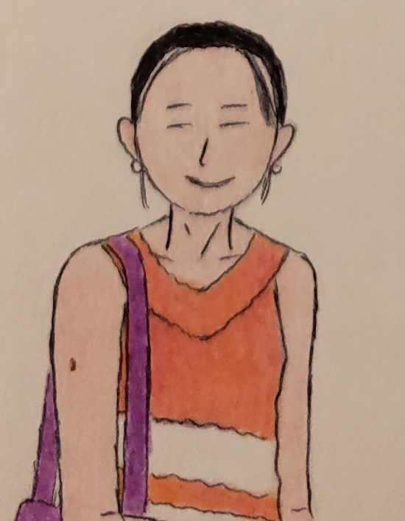

United was sitting in the cable car, relaxing while preparing for the departure.

Taking the picture, United felt relief before landing on another side of the river.

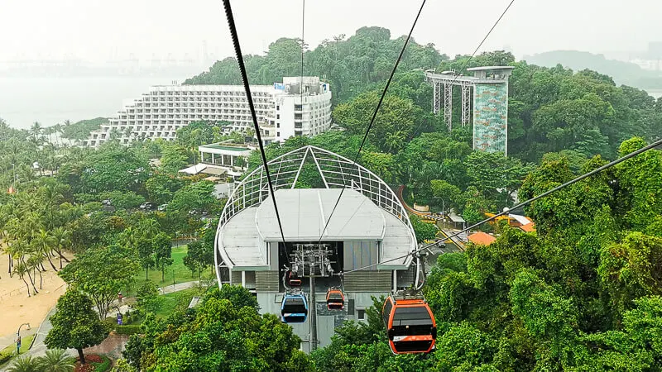

10 minutes later, it landed at the Sentosa Station.

Getting off the cable car, she decided to take a morning walk on the Imbiah Trail, where she experienced a natural and nature view.

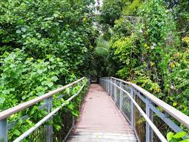

A picture of Imbiah Trail in Sentosa.



United enjoyed a scenic view of the hiking trail in Sentosa.

Taking a picture, she continued to walk and returned to the Megazip Adventure park (trail).

Hence, she then decided to head east and...

...spotted, “Amusement park resort.”

Suddenly, she passed by Imbiah Station and kept walking.

Just then, she was at the shopping mall for souvenirs at The Forum shopping mall.

Then she had her lunch at the Toast Box and took a picture of the food.



After her early lunch, she decided to take a picture outside.

It was Universal Studios Singapore Rotating Globe and...

...a stranger took the picture.



And she took her breeze in the hot afternoon.

After her break, she went to the Candylicious Resorts World Sentosa Singapore, where she looked at the candies.



Walking back, she also decided to bring some items and attend a Sesame Street Show. Surprisingly, she saw one girl from the Contiki tour group; her name was Wendy, and she remembered yesterday when the group left the Aqueen Hotel for checkout.

“Hey Wendy, what are you up to?”

“Nothing much. What are you up to?”

Laughing aloud, she responded excitedly, “I am headed to the Sesame Street Spaghetti Space Chase, which will be the fun-filled theme.”

“Aha, so do I. I am excited too.” She laughed back.

And Wendy was excited to know United more than just to introduce.

And they took the selfie together.

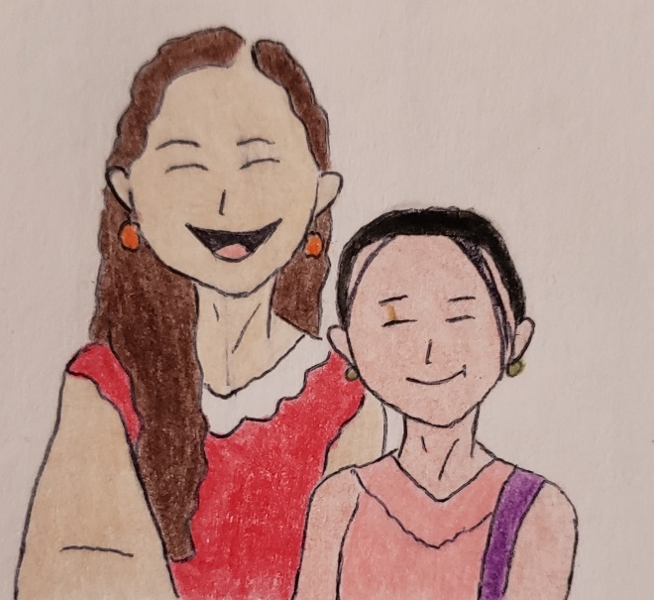

United and Wendy were Sesame Street Spaghetti Space Chase together to watch the Sesame Street Show, which was the “dark ride.”

Finally, United and Wendy chatted while visiting Minion Mart to buy one of the souvenirs and...

...as Wendy gave her Instagram information, she immediately followed her. She left, headed east for her exploration, and then stayed in the resort for 1 night. She will depart Singapore tomorrow for Seattle via United.

Minutes later, she walked briskly back to where she had arrived (Sentosa Station) and decided to head to Mount Fabor for an afternoon stroll.

Then she rode the cable car to Mount Faber, allowing them to experience a natural way to visit Singapore. She was excited to share some fun-filled experiences when she returned home and worked.

Looking down, she couldn't believe the view of the greenly sense, and it was an "eye-opener."

As she got off the cable car, she hiked, took a walk, and took the picture.

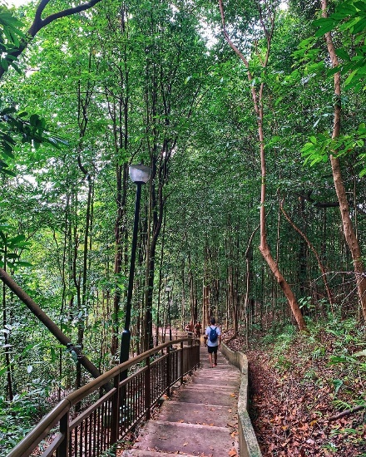

Heading east, she saw many people hiking alone and with their families. Smiling, she then took a deep breath.

She stopped for the water break at Mount Faber Lookout Point and cooled off for 8 minutes.

Checking the time, it was 15:55, and she still had time to hike and enjoy the smell of a fresh scent.

After around 16:35, she headed back to the hotel via the subway, ate the final dinner she brought yesterday, and reflected on the days she had over 2 weeks. Still, she recalled when she was in Malaysia with 34 participants, her favorite activity was to visit the Cameron Highlands with Sandrine.

Looking at the photos she took, reflected,

“I enjoyed being in the sense of nature because it was breathtaking... We rode the ATVs with Sandrine and still wondered where she was headed on her next trip. But she hasn’t messaged back since she already returned home...”

Reading and writing a trip journal, she read between the lines online, then decided to finish her short script once she arrived home.

While packing for the trip home, she planned to organize her items and check in online on the airline app and...

...took a shower and relaxed.

While she missed some friends she met during the 8-day tour, she texted Sandrine again on Instagram, “Hey, how was your flight home?”

No response; Sandrine probably took her time to relax while flying to Qatar as a layover.

Around 21:00, she planned to catch some sleep and...

…she was dreaming of shopping at the largest mall in the world. It was an “imagery mall” with over 710 stores with 7 floors. It was beautiful that she spent over 10 hours at the mall. It was the most prominent mall she had ever been to.

It was a dream of Iran Mall in Tehran, the largest mall in the world.

Coming Home

Day 14 – Farewell + Return Home
At 4:15 at the Aqueen Heritage Hotel, she woke up to her phone’s alarm.

She dressed in her denim jeans, ready to fly back to the USA. She prefers a girly look with her beautiful face and decided to put her long hair down for her sleek look.

She checked the room before leaving to go to the receptionist.

Checking out, she gave the card back to the receptionist, who gave her a receipt.

She was taking the East-West Line from Bugis Station to the airport after she checked out.

It was still hot and humid, even though it was early in the morning.

At the airport, she was at the security checkpoint. She was sad that her vacation days were over.

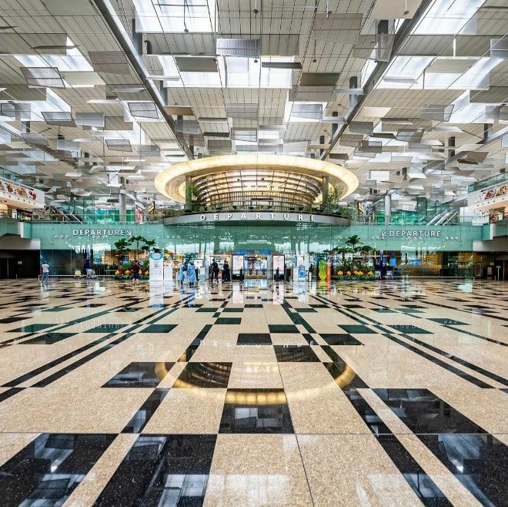

Departure Terminal in Changi Airport

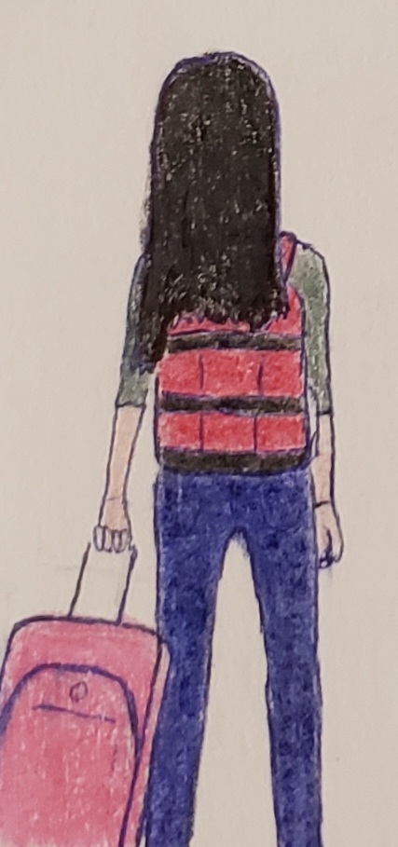

United headed to the security checkpoint after the fingerprint clearance.

The items she brought were allowed because it falls under an allowable TSA rule for carry-ons. So she researched what’s permissible under the current TSA rule of forbidden carry-ons.

“Just want to know that any frostings, cakes, or tea bags with sauce or gel are counted as 3-1-1 rules for carrying on. It must be less than 3 ounces. The tea I brought from Singapore is neither liquid nor gel or sauce. It is solid.” She said happily.

Just then, she and the passengers pass the security checkpoint without incident.

While waiting for the flight back to the USA, she was saddened that she had had a great time abroad. And she had her quick snacks while spotting the plane parked at the gate.

And after walking around the airport terminal, United saw Wendy in an olive jacket with white pants, waving and smiling. She was carrying her black Jansport backpack, smiling, and said, “Hey, United. What’s up?”

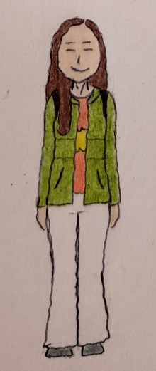

“Hey, Wendy, again. What are you up to?”

“I am heading home to Seattle, waiting for my flight to the USA. What are you up to?”

“Me too, I am heading home too….”

Wendy and United will be on the same flight, so she talked about Seattle as they shared the fantastic trip together, especially in Malaysia.

Sharing the flight to San Francisco, Wendy selected the window seat on the right. In contrast, United chose the window seat on the left (back of the plane). Therefore, they were 6 rows apart. Hence, Wendy’s luggage was checked and was inside the baggage department, ready to board the plane.

Minutes later, Wendy and United waited for the flight to San Francisco together. She smiled and had a short conversation about plans for the next trip. She has no plans for next year because she has a new job beginning next week.

She will work at the Boeing Company and be busy with her work schedule.

While on the flight to San Francisco, she took a quick nap, watched movies, listened to music, and wrote stories.

She felt better when it was time to use the restroom after the seatmates got up. Then several minutes later, it was time for dinner after many passengers returned to their seats.

United selected the vegetarian meals before her departure, and she enjoyed the meal.

Several hours later, a flight crew gave passengers a declaration card.

She knew how to fill out the customs form, including the amount of merchandise she brought abroad. She estimated the cost at $180.

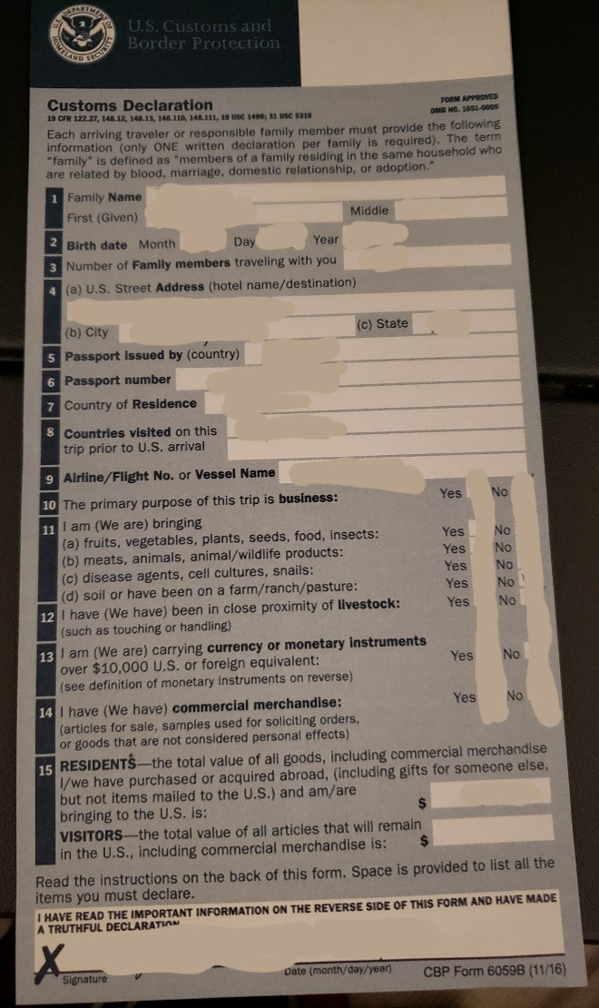

At San Francisco International Airport, she texted her father once she disembarked the plane, connecting back to the US data coverage.

The time has changed back to 16 hours behind.

Waiting for the disembark, she texted her parents, “Hey, Dad, I just landed in San Francisco. You can check my flight on www.flightaware.com; type in United *** to see my flight and status.”

Her mother texted with a thumb up and then texted her back, “Hey United, okay ma?” in Chinese.

“I am okay. I am about to enter the immigration customs before checking in for my domestic flight.”

“Glad to hear that. Can’t wait to see you home, okay.”

“Me too, love ya.”

“Love ya too.”

Minutes later, at 08:25,

She successfully passed through the immigration custom before checking in for her domestic flight with only one carry-on and her personal bag. It was then morning, as her flight to Newark was scheduled to depart at 1:35pm.

Since United hadn’t seen Wendy, she was on the flight to Seattle at around 11:30. She tried not to text her because she believed Wendy was tired and needed some rest.

Sitting down, waiting for departure to Newark, United texted her church friends, saying she was still in San Francisco.

“Hey, Sistine, how are you? I sent some photos of Singapore and Malaysia with friends I met. It was a wonderful time here. Isn’t that pretty?”

She said, “I’m 3 hours behind Philly, so my father is at home; he will pick me up at the airport.”

United plans to hang out at the airport until her departure when she arrives at the gate and flight status.

Around 11:45, it was then realized that her 1:35pm flight was canceled due to extended aircraft maintenance.

So she texted her father, “Hey daddy, my 1:35pm flight to Newark is canceled. So I am trying to bump myself into the later flight. Check my flight on www.flightaware.com after I get my new flight asap.”

“Oh my, there is little else to do but try our best to get home...” The family of 3 was about to get on the 1:35pm flight.

Hence, the passengers can bump into their flight at a later departure.

United said, “there is little else to do but to wait until my flight is available to Newark. And I still need to be patient since I am desperate to get home with my family... Now, I am in line to bump into an afternoon flight. But I also enjoyed the airport.”

United didn’t mind, so she had her experiences relating to flight cancellations.

And one of the passengers on the 1:35pm flight to Newark retorted, “you gotta be kidding me... What the (expletive) you are talking about….”

Then his mind escalated to an outburst. Finally, he cursed under his breath and walked away, throwing a fit.

“Calm down. Everyone has to deal with these flight cancellations. You are not alone... my flight to Newark is canceled too. Be patient. But, you know...” another passenger recalled to a belligerent passenger.

Walking away from the gate, he started to damage their airport’s property and...

...a belligerent passenger threw a fit and punched/assaulted another passenger. The airport security personnel and passengers called to get help in removing the combative man from the airport.

United ignored the incident, walked to get flight assistance, and waited in line for the next flight availability.

United then asked the gate agent if she wanted to bump up to the next flight.

“Hey, good morning. How are you?”

“I am well. You?”

“I am well too.”

“How may I help you?”

“My 1:35pm flight to Newark is canceled, so I want to reschedule at the earliest flight to Newark.”

Her flight to Newark before 9pm was full, so no seats were available.

A female gate agent has offered a choice.

“So we have an 11pm or a 12am flight to Newark.”

“I would like you to assign me to an 11pm flight.”

“Certainly.”

A minute later, she asked, “would you like a window seat?”

“Sure!”

A lady gave her a boarding pass with a new flight number.

“Here you go. Your gate is at **.”

And she was assigned to her overnight flight with her new boarding pass. She was assigned a window seat at the back of the plane. It was on the right side.

Then United was unhappy but manageable. She then wanted to motivate while walking around the San Francisco International Airport terminals.

She thought, “There is nothing I can do right now, so I am occupied with something to lessen the boredom until the 11pm flight.”

Since she wanted to leave the airport, she wondered, “If I attempt to leave at the airport, how will I carry my red backpack and pink carry-on? Then it will be a hassle to take this all the time. No one will take care of the pink baggage, eh.”

So she decided to eat her lunch at the airport and started to take a walk around the airport, taking some pictures of planes.

After finding the departure for 11pm, the plane was parked at the gate. The smaller narrow-body aircraft replaced the wide-body aircraft as the departure information still needed to be confirmed.

“It was a big plane, eh.” She commented and took the picture.

Laughing, she sent a picture to her family.

Still, no one was at the gate except 5 passengers were sitting at the gate **.

And United frequently took a walk around the terminal, enjoying herself.

Hours later, around 15:00, the departure information was now the 11pm flight to Newark, and she took her nap.

Around 7:30 in the evening, she was in the United club. She changed her clothes to black leggings with a striped top and...

...ate her dinner at the United club before returning to the departure gate.

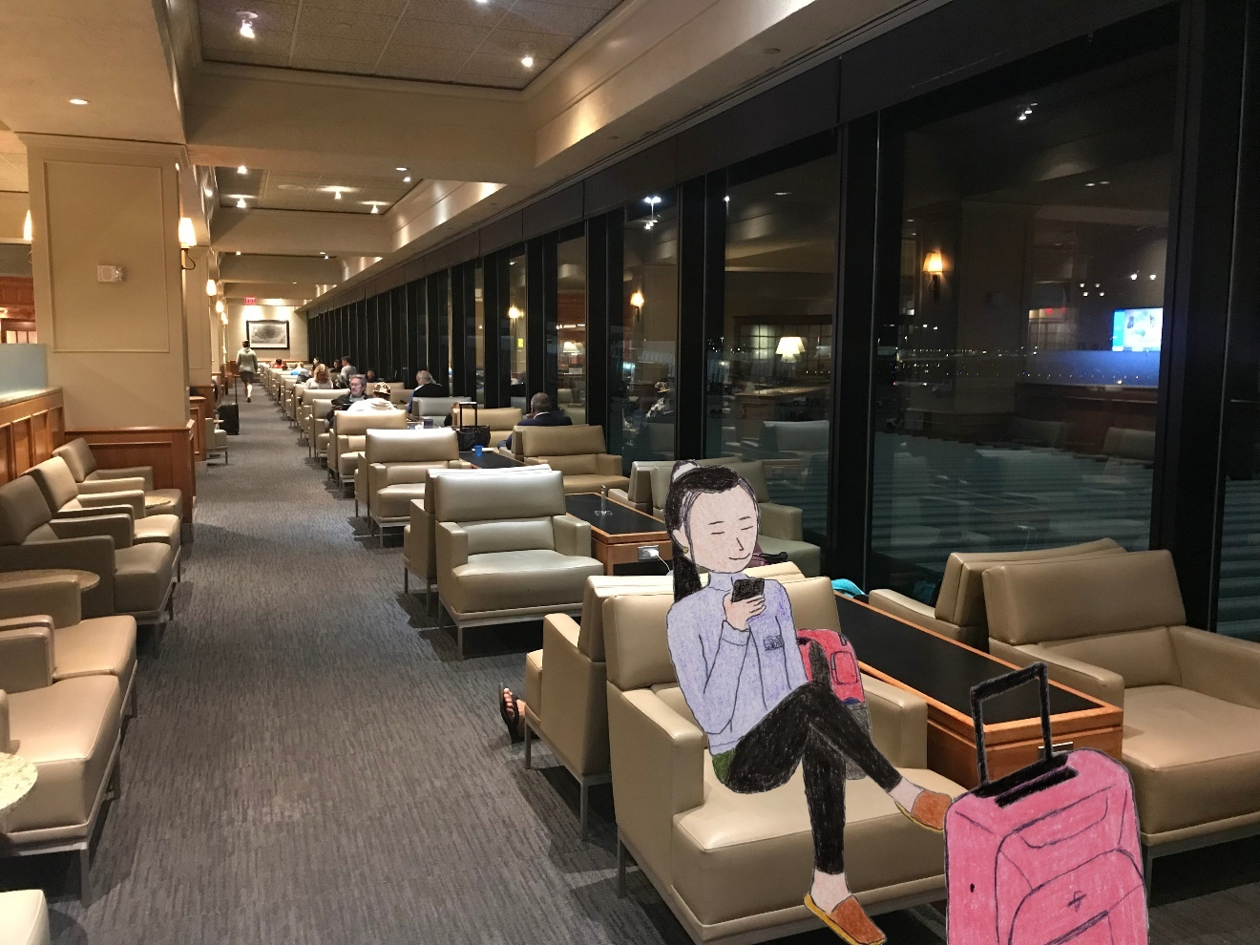

Around 21:50, she sat in the lounge and checked the flight to Newark before leaving the United Club. It was on time.

10 minutes later, she exited the club as she was prepared for the overnight flight to Newark.

Hence, she heard it was time to board the plane to Newark. First, United and other passengers lined up to scan the boarding pass. Then, United used the paper boarding pass.

“I hope my flight is going to be fun.” She recalled.

She planned to take a day trip around San Francisco while on a layover but decided not to. She also must carry her pink carry-on. Still, She decided not to because she had to go to work (associate) in just a few days.

“I know that flying home can be a difficult time for me. But I love to go on vacation, especially because I love exploring places. I know that.” She smiled, still trying to sleep.

Sitting on the plane’s right side (window seat), she stared at other aircraft parked at the gate.

Finally, she texted her father.

“Hey! I am on the plane to Newark, ready to take off.”

“Hey. Enjoy your flight, United.” Her father woke up and texted back.

“Dad, don’t forget. Come to pick me up at Newark Airport Terminal C. My flight will arrive at 6:45.”

“Okay, have a safe flight home. Daddy will come and pick you up. I’ll let you know when I arrive at the airport.”

Minutes later, as more passengers boarded the plane to Newark, she turned on the plane mode.

As the plane left San Francisco, United was very tired, so she took a nap.

Several minutes later, she felt the plane no longer turbulent.

Still dark, United dreamed of the trip of a lifetime she eventually dreamed of – Thailand with 34 other participants.

Daydreaming about her trip to Thailand, she walked around the Thai beach, taking pictures. It was the moment when she and the 34 participants were smiling and giggling back then.

They then took the group picture together, dressing in swimming suits.



A blue swimsuit is Sandrine; a red and black swimsuit is Saudia; a pink top with a peace sign in United; and a black floral dress is Wendy. All 35 Contiki participants traveled on the same flight to Bangkok via Thai Airways after a meeting at the Narita Airport in Tokyo. Unfortunately, there were no tour guides whatsoever.

“Wow, it’s beautiful,” United commented.

“Yep! This is my 1st time here since I had been there for solo travel back as a group.” Sandrine added.

“This is my first time.” United smiled.

“So we do, jumping into the shallow water but not diving,” Saudia mentioned.

At the same time...

United initially planned to take another solo trip next year. Still, her parents have planned a family trip to Australia with their friends for the Chinese New Year.

She also has opportunities to travel solo in the upcoming months.

Some passengers got up and walked around the cabin as the plane flew east. Others were using the plane’s lavatory. The aircraft was cruising smoothly.

An hour later, she woke up, grabbing a light snack.

Eating the snacks she brought from San Francisco International Airport, she played with the phone, looking at the pictures of her 16-day trip. It was a wonderful memorable trip she had.

While the plane was halfway to Newark, United took another nap. She was experiencing jet lag on her 15-hour flight from Singapore to San Francisco. However, she knew how to handle her flight fatigue and planned to nap once she got home.

4:45 in the morning,

After her father woke up in Philadelphia, her mother made breakfast and discussed today’s to-do list.

“Mikey, I want to let United know that our trip to Australia is scheduled for February. Be sure to talk to United and let the supervisor know the trip plan this week, okay.”

15 minutes later, her father talked about picking up her daughter at the airport. United’s mother, Katherine, was happy that she was returning home from her 16-day trip.

“Katherine, I know that, and I understand why she changed when she traveled abroad solo... Now, I will pick my daughter up at Newark Airport.”

“Aha!”

“Well, she texted me last night that her 1:35pm flight to Newark was canceled. So now I am relaxed.”

“Okay, hon, be safe. We will give her a big hug when our daughter arrives home.”

“Oh, okay...”

And his brother planned to walk to work to get some exercise while her father drove to the airport to pick up her daughter.

Pretty soon, the plane was approaching Newark. Then, finally, the announcement was heard that the plane was starting to descend toward the airport.

Around 5:48 in the morning, she stared out the plane’s window. She saw the sky was dark but turning a little brighter. Still, the plane cabin was dark.

Some 45 minutes later, the captain turned on the sign, many passengers were still sleeping, and United fell asleep.

And United and other passengers felt the plane turn left and right as the aircraft began to slow and descend as passengers returned to their seats, strapped in with seat belts and tray tables stored, and set their seats upright.

As her father drove to Newark to pick her up, he was still on the way via New Jersey Turnpike. Some cars and trucks were on the road together, heading northbound.

Just then, United felt the plane making a noise (landing gear) as the aircraft continued to descend to the airport. However, it was when she and the other passengers felt bumpy as the plane touched down on the runway.

As the plane landed, she smiled and cheered, “Whew, I just landed safely. I am at home.”

The plane slowed down on the runway, ready for the gate at Terminal C.

At Newark (07:35), the plane parked on the tarmac for 10 minutes, waiting for the aircraft to pass.

15 minutes later, the plane arrived at the gate, and the captain turned off the seat belt sign, ready to exit.

As the passengers waited for the plane to disembark, they were excited but sad. Some travelers missed their vacation, even United. She was sad too.

As the passengers in economy class waited to disembark, they sat down, looking at their phones and chatting; others stood to see more passengers from the first class had already left the plane.

Some passengers called their parents/friends to come and pick them up from the airport.

Turning off the phone’s plane mode, the clock changed from 05:05 to 08:05.

“Dang, the plane safely landed on time. And it is not that bad since I love United. Woo.” A male sat 1 row in front of her.

Laughing, all the first-class passengers disembarked the plane through the jet bridge.

She texted her father, who was on the way to the airport (arrival terminal).

“Dad, I arrived at Newark safely.”

“Okay, I am almost there.”

“Thanks. You are the best. Terminal C.” She replied.

Minutes later, United and other passengers finally disembarked the plane, smiling at flight attendants, and...

...and exited the security area, waiting at the baggage claim.

While waiting, she smirked, “I have no checked luggage, and I was traveling internationally with one carry-on and my personal bag for 2 weeks. I couldn’t believe I had achieved my goal of packing lightly.”

Around 08:50, her father texted her, “United, I am here.”

She gathered to leave the airport building.

She went outside to find her father’s car behind a taxi. Her father noticed she was standing, waving, and...

... saw her father sitting in the front seat, smiling.

Smiling and waving at him, he gave her a big hug.

“Hey, daddy!”

Smiling, “Hey, what’s up? How was your trip to Singapore and Malaysia?”

“It was great. I enjoyed exploring places there. I took many pictures and spent days with girls from hostel activities...”

“That’s wonderful.”

He got out of the car to load her pink carry-on and said, “United, what’s all this?”

“It is a tea pack from Cameron Highlands.”

“What the? Is it allowed to bring it to the USA?”

“That’s fine as long as I declare it to the US Customs and Borders Protection as food. I was in San Francisco to clear the immigration once I landed. It is supposed to be checked as food, and the tour guides have extensive knowledge of what they can bring home legally. Otherwise, it will be confiscated.”

As she got in the car, her father drove home from the airport.

Playing with her phone and listening to music for a bit, she took a nap back to Philadelphia.

At 09:48,

On the Turnpike, he stopped by the service plaza, and United woke up, used the restroom, and grabbed her quick eats. She hasn’t eaten since she was at San Francisco International Airport.

Pretty soon, at around 11:00, she arrived home safely. Outside, it was still cool in Philadelphia and not as humid in Singapore and Malaysia.

“Not that hot and humid,” as she exited the car.

“I know, right?”

“Singapore and Malaysia are hot and humid, and I sweat a lot. It is like Hong Kong in the summer, eh.”

He retrieved her pink luggage and...

...returned home.

It was empty and had a different kind of smell.

Seconds later, United carried a pink carry-on and her red backpack into the room and...

...her brother was still at work at the grocery store. Still, he planned to walk home because her father needed a break from driving.

Feeling tired, United had already taken a shower and went downstairs to drink some water.

And afterward, she took her afternoon nap.

Hours later, around 17:30, she woke up, trying to unpack, and unpack; she then dumped the dirty clothes onto the laundry basket.

As her mother came home from work and errands, she smiled as United came downstairs and...

...her mother was happy and gave her a hug and a kiss.

“Hey United, how was your trip?” her mother smiled.

“My trip was fun... I tried different food in Singapore and climbed up the Singapore Flyer, a Ferris wheel... And I also had a wonderful time in Malaysia with a tour guide. Still have a good time.”

“So glad that you enjoyed your trip.”

“Mom, did you like the pictures I sent?”

“Yes. I like the pictures you sent. It is beautiful, and I like it. It makes me want to go visit there.”

Smiling, she had a brief conversation about her trip before dinner time...

...and they had a conversation together.

Eating a salad, her parents were blessed that their daughter had changed a lot since her pre-trip event. Now, she was more energetic and happier than ever.

She had a good conversation together before spending time alone, preparing for the day by running errands.

Around 20:30, her sister Wawa came home from classes. She then smiled and gave her a hug and smiled at her room and...

...United was still tired and went to sleep promptly at around 22:00.

Wrapping Up

November 11,

She woke up at 03:45 to brush her teeth and had her post-trip blues. She can’t remember the days before her dream trip.

She then went back to sleep because she felt so tired after her fun trip, jet lag, and beautiful experiences.

She was a bit tired in the morning but planned to unpack in the late afternoon. However, because of the paid leave, she did not go to work during the day due to rest. So instead, she decided to work on Friday, November 12.

The sun was rising and shining. It was around 07:45, and it was an eerie quiet morning.

While sleeping, she was daydreaming about her plane ride to Singapore on October 24. It was her favorite thing, especially frequent flyers. She hoped to hop on a plane in the future.

She remembered sitting on the window seat on her flight. So then, staring out the window, I thought it was a dark night.

Around 10:00, her dream became imagery. Although aircraft aren’t designed to fly above 38,000 feet in the air, they went beyond. The plane went to outer space and to the edge of the universe.

3 hours later...

Yarning, she slowly woke up at 10:55, brushing her teeth, getting dressed, and eating brunch together.

While working, her mother had already made breakfast of eggs, sausages, and porridge.

She went downstairs and ate her brunch.

Her father took Rich for the outings.

Her brother came back from Giant for a work movement later.

Feeling a little down, she misses her vacation while she starts to eat her lunch.

Eating alone, she was enjoying her lunch before heading out.

Took the SEPTA to Fresh Grocer at Temple University. She was using the reusable shopping bag she used on her trip abroad. She likes to save the black shopping bag from deposing and ending up in a landfill.

She bought only 1 pack of vegetarian meat, some healthy snacks, and a box of whole-grain cereal.

She continued to brainstorm more on her blog on the way home.

She had a wonderful time in both Singapore and Malaysia. She wrote a journal, including a blog she wrote on WordPress. Working on her blog a bit, she felt tired after writing some more information about her trip.

The name was renamed “The Truly Singapore/Malaysia Vacation,” and it was scheduled to be published at the end of 2021.

But there was work to be done. United’s trip started with an itinerary, some pictures, and her experience during her trip.

Fact: On her blog “The Truly Singapore/Malaysia Vacation,” it was stated that her trip had included examples of virtual vacation (5 senses), not her actual vacation. She would have gone abroad if the pandemic did not happen. Instead, she safely traveled there for 16 days without incident.
﻿

Friday morning, she woke up at 6:45, ready for work as an associate. Her friend Sistine texted her this time, “United, we are having fun tonight at the movie. Do you want to come?”

“Sure. Can’t wait. Where are we going to meet?”

“We are meeting at the Philly Mills.”

“What movie will we like to watch?”

“I have no idea, eh.”

As United’s friend Sistine was working as an accounting/audit clerk at the CCC&C, she was on her commute via Septa.

She changed her perspective and started to work, feeling energetic and confident.

Checking on her work email was relatively easy, but she kept motivated by working on the blog in her free time.

At around 12:00, it was lunchtime, and she planned to meet Donna to learn more about the story.

She met Donna last month at work, talking about her job interests. She said her hobbies are travel and creative arts.

During her 1-hour lunch break, she had her vegetarian lunch; a veggie sandwich with cheese. She discussed how amazing her trip was during her vacation.

Becoming socially able, she laughed at Donna while listening to her conversation and gaining knowledge from each other. Donna was generously interested in learning from United, an expert in solo traveling.

“Donna has been doing this work for 8 years and has been to 15 countries. She hasn’t visited Singapore, Hong Kong, and Taiwan, but she was determined to travel in the future. They have fun conserving. The only places she traveled to were China and Japan.” She was lucky to get to know more about Donna’s social profile.

Looking at her trip to Singapore and Malaysia, she missed traveling. But, she said, “I know I have enough days for traveling. I only have 17 days to travel more for health and step out of my comfort zone to learn. Now, I can set up my own boundaries.”

She was trying to keep herself motivated on her next solo trip abroad.

Feeling less irritable and stressed after her trip, she performed daily tasks without feeling tired or drained. As a result, she doesn’t have to deal with her solo trip’s problematic situation annually, even though it’s complicated.

Just then, she prepared for the work for the day by rotating to do the challenging task.

It wasn’t easy for her since she hadn’t experienced a tedious task.

“I am trying my best.” She smiled, looking for opportunities.

She has the energy to survive her 7-hour shift but only has 2.5 hours left.

Working on the difficult task, she took a 15-minute break before returning to her daunting task.

Several minutes later, she was put off until next Friday’s deadline to have the offer to enable employees to take mental breaks when needed.

United finishes the tedious work and prepares for the employee’s wellness presentation.

Joining Victoria and Etihad, United also set up employee wellness to overcome employee burnout and stress.

They set up Friday’s fun by serving a stress ball, toys, incentives, and healthy snacks.

As many workers working at the hospitality industry, they had a complimentary relaxed lecture after their 10-minute meditation.

United added, “It is important for your guys to take necessary breaks before working on difficult things. Taking a break from difficult things enables the brain to think clearly, have mental focus, and have less burnout. But, unfortunately, who has experienced burnout?”

“Okay, almost all of you.”

“You are not alone. According to the research, more than 55% of Americans experience burnout... I have experienced this before and after.”

Feeling less burnout, United always keeps working in the hospitality industry she enjoys.

United and Victoria tried hard to remind all workers who work and try their best mentally.

Just then, co-workers (with severe mental problems) stared at United and Victoria’s faces and then made deteriorating comments.

“Hey you (expletive), why don’t you just leave. You are an (expletive) slow performer. Get out. Go die. Go kill yourself.”

She turned toward him and politely asked, “Hey, I am in the middle of the presentation about employees’ health and wellness. Also, the comments you just made aren’t appropriate and acceptable here. If you want to talk, just see your supervisor or boss for help or concerns. Thank you.”

Having a bad afternoon, United tried not to get mad while trying to finish the presentation.

A bad guy then threw something at her and urged him to stop and leave. The audience and presentations were rapidly aware of the incident.

At around 15:50, it was time for the shift to conclude. But, again, United was trying to report the incident of workplace discrimination.

As some workers refused to take action, she notified the manager and wrote about the incident around 16:10.

Investigating the incident relating to a possible hate crime, she was the only one who took charge of the actions.

She said, “Once I felt irritated at work, I am still concentrating on completing my project. Overall, an aggressive worker came over, saying things like, “I don’t like you working with you because you are Asians.”, “I hate you,” or “racial comments,” trying to get out. He was trying to be selfish mainly because I wasn’t fully productive, but I can try.”

United was angry as she was waiting for the incident response.

At around 16:45, her friend Sistine called her, saying she would meet at Philly Mills.

While she missed her vacation, she focused on taking charge of the hate crime incident before leaving to catch the subway 1 hour later.

Her friend Sistine wasn’t out of work but planned to eat her dinner before leaving her worksite.

She left the job around 18:00 and was on the way to Philadelphia Mills Mall. Her husband, Kinny, picks her up.

The next day, she did the laundry and rested.

A week later,

She opened United Airlines App and...

Her miles were credited to her United Airlines account. She said, “I earned more than 20 thousand miles. That’s a lot.”

Then she went to online banking and saw that she had accumulated $115 and paid it back in full.

“I know I have a credit card bill in which you must pay back the balance if I can. If I must pay with a credit card for a large purchase, please pay it back as I did by the due date. I paid around $935, along with the hostel and other purchases before June for airline/bookings/other purchases.”

Warning: Using a credit card can be a risk if not careful. Credit cards are not debit cards; you can access a checking account from the bank. On the other hand, credit cards are only accessible with a limited balance, paid with interest for borrowing. If you pay late, then you have to charge a fee. Suppose you consistently pay with a minimum balance. In that case, your credit score will be affected, and you will have to pay more interest.

Since she was busy with blogging and other paperwork, she offered an application online for the solo women’s event.

She was busier than before.

Working on the Post-Trip Blues, she went on the blog and answered the questions:

Trip Recap Questions

When you return home, there are some uneasy feelings of loneliness and feeling sad if you return home, right? Don’t worry! Lots of travelers have experienced a symptom called “Post Travel Blues.” You will learn more about Post Trip Blues in the following sub-category. I-Powers Travel has created some questions:

- Why did you return home? What makes you want to return home instead of traveling continually?

- What happens if you decide to travel immediately? How will it affect your home-work-life and your family, friends, parents, spouse, children, etc.?

- If you must return to a favorite dream place, what makes you feel about planning another trip?

- Based on the above answer, what makes you feel this way?

The Question “What makes you feel” is a 3-Step important question (3-step Feeling Process) to cope with the post-trip blues before you move onto the 7th and last trip cycle.

She then reflects on her dream trip by writing a short paragraph.

“I returned home because I had enough time to change myself. Since I have only 14 personal days left for year 1, I also save up for the next trip. Thinking of my family and friends back home, I decided to return home and was excited to talk more about my travel experience. On the other hand, If I decided to travel now, I would miss my family and social life, leaving me feeling lonely, leaving without my dream job I love. Finally, if I wanted to travel, I would be unhappy because I would miss my career and personal growth opportunities, leaving my family and friends. So I decided to work as much until my next trip, which will be in a few months. I would be happy if I stayed in Philadelphia.”

Then on November 20, she learned to overcome her personality, and she gladly accepted the way she is. She never gives up doing things she enjoys, although she doesn’t like: working under pressure.

Just after breakfast, she reflected on how solo trips have changed her thinking about her personal and professional life.

Her mother and father were in the kitchen, preparing Thanksgiving meals. United’s friends came over to her house to celebrate.

She said while lying in bed,

“I know working under pressure is my biggest weakness, but I can handle it. I am trying my best to be happy.” She was working and working on projects which were due next Friday.

“There is nothing else I can do for myself right now. So if I felt overwhelmed, then I took a break and meditated. Then I resumed work time for a bit. Work and play is my part of life...”

When she was not working, she enjoyed hiking at the park, working on arts and crafts, drawing, traveling the world, budgeting money, playing on computers, and writing fiction stories.

“At the worksite, figuring out my ideal job title can be difficult. My interest is money and finance, with a creative/artistic career in arts and crafts and tourism knowledge. Even though I don’t really like this job with working under pressure, it can be rewarding to take it seriously so that the job dreams come true.”

She takes her job seriously by applying her preexisting knowledge, math, and English skills. Speaking of that, her communication and business writing are her weaknesses and progressively improve her skills.

Tip: Making your choice is the most critical responsibility of your life. For example, suppose you enjoy solo trips but prefer to be financially independent. In that case, it is best to stick to working at the job instead of quitting. Once you quit the job, finding another job that suits you may be harder, mainly if you have limited funds available for food, groceries, housing, bills, etc. Finally, you may not have enough money to save up for the next dream trip or things you want.

“I felt shy around people sometimes, and when I was on vacation to Singapore and Malaysia, I wasn’t comfortable. Suddenly, I learned how to meet a girl named Wai-Wai, Sandrine, and a tour guide named Xhamster. They learned from their travel experiences... I realized that stepping out of my comfort zone gives me the skills and abilities needed to build my character and my values. It also gives me a sense of skills I have not encountered before.”

As she improved her weakness into her strengths, she was happy that she accepted herself, inside and outside.

At home, she thought of writing a letter, saying that her solo travels to Singapore/Malaysia have helped with the lives and empowered women. She then thought of what she wanted to write to her family, friends, and church friends.

November 24, the day before Thanksgiving and her holiday off.

At home,

United worked hard to gain valuable skills needed for the job while working on the blog about why solo travel enabled her to change her personality. She explained that solo travel helps overcome nervousness and anxiety, even though the trip can be stressful. It also allows her to tolerate her ideal working environment.

While taking a short work break, she played with the phone (Instagram). She looked at someone’s Instagram she followed who went on a 5-day trip to Jerusalem. She was delighted that the upcoming trip to Jerusalem was valid, but instead, Sydney.

Feeling confident, she wasn’t jealous of a woman who traveled solo to Israel. Now, she is happier and more energetic at work.

“I guess that solo trip to Jerusalem is a mess, but it will be a fun, enjoyable experience I have ever encountered. However, due to financial restrictions and job aspects, I am setting it until 2023 due to the family’s planned trip. However, I also can’t wait for my travel friends to invite me to Jerusalem.”

Instead, United wasn’t planning a solo trip but her family trip to Sydney. She was unsure if she wanted more miles, and the airline ticket was expensive.

“It is something that I am really on the bucket list.” She recalled publishing an Australia blog in March 2021.

Fact: The title “Why I expected to Travel Solo to Australia?” was published on March 1, 2022, instead of March 2021.

The blog gave an excellent example of her upcoming trip to Australia. It includes detailed information regarding preparing a safer, more convenient trip/itinerary for the general public.

“Especially for solo travelers, it gives comprehensive information about safety, health, and more through research because many do not plan a trip. They simply don’t feel like doing enough homework. I know that, but using this example of this I-Powers Travel Cycle will help travelers plan and research trips based on their interests and personality. I applied the trip planning by using holistic methods.”

After lunch, she spends her free afternoon working on her blog about her travel and then does her yoga. Although she had no plans for the rest of the day, she also spent some time with her friends and travel friends for the Thanksgiving dinner at their house.

Pretty soon, at 17:00, after United was at the friend’s house, her brother planned to cook dinner. But unfortunately, her mother wasn’t at home. She was also hanging out with their church friends. So his father intended to eat fried rice with Chinese sausage, veggies, and some eggs.

The white rice was almost finished after he cut up the carrots, spinach/celery/red pepper.

He cooked 4 eggs and learned how to prepare and cook, including cooking and washing utensils simultaneously.

Minutes later, he used the frying pan to fry the remaining vegetables, which were almost finished. Then, he left the kitchen to wipe the table and wash the 1 bowl with a fork.

The next day, it was Thanksgiving. United was tired. She returned home at around 23:15.

She was at home, spending some time alone and with her family.

After lunch, she and her family ate turkey and a feast.

Her father showed the picture of the Sydney skyline, “so nice. What is this place.”

“Sydney!”

Her brother said, “I wanna travel!” and pointed at himself.

“Yep, we are going to Sydney for a week’s vacation.”

United said, “I didn’t know my trip would happen on Chinese New Year. However, we mentioned it when I was in Singapore, chatting with my dad about the upcoming Australia trip.”

“United, we told you we are going on a vacation to Sydney on Chinese New Year. We will also be touring Chinatown and an overall fun tour on February 2 and 3. The tour will be on February 2 to 5.”

“How exciting. Have you booked your flight yet?”

“We confirmed our flight on November 10.”

“Oh, okay.” She said sarcastically.

Seconds later, United asked, “What airline will you be taking?”

“I think we are taking American and Qantas. January 30 and will return on February 6.”

“Never been on Qantas. And when is your flight?”

“Our flight is on January 30 and returns on February 6.”

“Nonstop?”

“No. There is no nonstop from Philadelphia to Sydney. We will have a layover in Los Angeles and Dallas.”

“By the way, I mostly took United, Air Canada, Lufthansa, All Nippon, and Asiana, among others. All are eligible for miles accrual, depending on the class of service.” She said, emphasizing her Frequent Flyer Membership.

“Interesting! United, if you want, you can change from the returning trip to United or other airlines. Sounds good?”

“So good. I will change before departure.”

United was then marked on the calendar.

“Where are you taking on the flight?”

“Philadelphia!”

“Is your return flight to Philadelphia?”

“Yes.”

“Okay!”

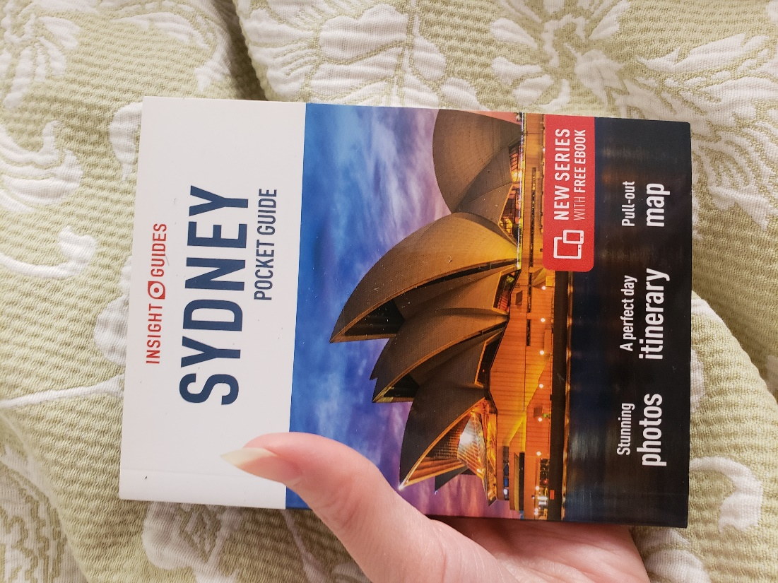

After the family’s time, she showed another I-Powers Travel Cycle, which was a project.

“This is the amount we will spend depending on circumstances. Also, we will visit various places we mentioned last week, including Sydney Opera, etc., from February 4 to February 5. Here is the final cost for each person.”

Her parents were proud of her.

“Wow, you are a money saver and a researcher.”

“Thank you, dad.”

She then wrote a short journal about herself and the quality of life before and after vacation.

“Dear Family and friends,

Work-life balance is essential for humans, so the quality of life is important too. Like taking a break, I spend about 16 days abroad solo and with a solo travelers group, remember? I got used to being moody before my solo trip abroad and now reported less irritability and more confidence. As a result, my quality of life has improved too. So, finally, I believe that Work-Life Balance improves human health and wellness.”

Just after 1 annual trip a year, she reported improved quality of life and productivity. She also remembered that just 5 days of vacation (remember in 2020) helped her with health and wellness improvement. Her mental health improved too.

Fact: Spending away from work for a short period is a good sign of “taking healthy risks” because traveling abroad enables creativity, sharpened 21st-century skills, and collaborates with the situations. It is an ongoing learning process you will face for the rest of your life. In addition, you give yourself a mental and emotional break from daily life, like stepping out of your comfort zone. Finally, your mental, emotional, and physical health has improved, but this is just a starter.

“And so, working but not taking a break are the biggest regrets for most of you...

...and can lead to health problems. I don’t want my health to sabotage my quality of life. God Bless. I successfully made a solo trip to Singapore and Sydney solo.”

Hours later, she checked her email.

Looking at the flight itinerary, she saw that both airlines aren’t eligible for miles accrual on MileagePlus.

She took more risks by changing the flight itinerary her father sent.

“My sister is not going to Sydney because she will travel to Honolulu for her important Chem Trip for 5 days. Also, she still has a final semester. So we are praying for her trip on January 31. So there are 4 tickets, but I will be on a different flight.”

She then emailed the travel agent.

Hello, I am United A. Tse, who is a current MileagePlus Member. I want to change the airlines to United, All Nippon, Singapore, Air Canada, SAS, Lufthansa, and Star Alliance. I regularly travel on United along with the partnered airlines to earn miles.

My MileagePlus number is ******.

The flight confirmation number is ******.

The travel dates are from January 30 to February 6.

If you have any questions or concerns, please call me at ***. My email address is ***.

Regards,
United

Waiting for the response, she kept occupied by finishing the story.

On December 26, was a Christmas Party at their friends’ house late in the afternoon, ending at 21:00 (9pm). The Church Christmas Party started at 16:00 (4pm), and she dressed in a nicer, cozy outfit. She was the only girl who liked to dress up when she was a child.

Telling more about her Christmas and the New Year, her friends, were excited about the 2022’s revolution.

She remembered her favorite holiday when there was more food on the table. She also enjoyed celebrating with her family/friends to keep their relationship going. And some of her friends were invited too, and United was happy to share her travel experiences.

Finally, the storytelling was over, and…

There was free time with treats, chocolate, cakes, and cookies with their fantastic Christmas gifts.

Hours after her Christmas Party with her family/friends, they headed home just in time before 9:45 in the evening. Her brother still expects to work at the Giant Grocery store tomorrow.

It was cold outside in the evening as United first took the showers and tucked in the bed.

Feeling tired after eating a bit of mint, she showered, brushed, flossed her teeth, and unwound an hour before going to sleep.

“I just relax from the long day of work, play, and leisure. And I am blessed that I returned to my daily life post-trip.”

She finally reviewed her trip itinerary again and felt happier after her trip went well.

She checked her email. Her flight itinerary was changed from American to United and All Nippon Airways, which incurred no cost.

It was a success.

She smiled and said,

“Hooray! I am excited to travel to Australia on January 29 from Philadelphia, with layovers in Houston and Tokyo. My return date was on February 9, with a layover in Houston. Now, because I have only 14 days left, I marked from January 31 to February 9, which is 9 days. It also worked well. I am trying to use all the paid personal days to boost employees’ health and wellness. So I also marked the calendar about my revised trip itinerary from January 29 to February 9. This gives me time to step out of my comfort zone.”

She rested, almost ready to go to bed, putting aside her I-Powers Travel working papers and phone before turning off the lights.

And finally, the new year began on Saturday, January 2022.

***The End of the Story***

Acknowledgment

United was nicknamed “I-Powers Travel” after creating her name after her travel/life experience. Her bio is available at https://ipowerstips.travel.blog/meet-travel-writer/. She specializes in solo and women’s travel information, including tips, tricks, and warnings. In addition, she listed creative ways to help travelers plan a trip more efficiently and effectively and change their travelers’ world in the future.

She dreamed of specializing in travelers with safety tips, health, and wellness, general information, travel guides, etc., that fit her ideal itinerary.


